
Understanding Shiism for dummies
The Majlis · Voice of Islam
Mujlisul Ulama of South Africa

About this edition
This is a reproduction by The Majlis Archive (themajlisarchive.com) of a publication of The Majlis, Mujlisul Ulama of South Africa, made and published with their permission.
The PDF as The Majlis issued it is the original. This edition was read from that PDF's own structure and checked against it letter for letter; where the two differ, the PDF is correct.
Checked: 361 paragraphs, 0 differing; a second, independent PDF reader finds 82.5% of the PDF's words here.
Nothing has been reworded, added or removed.

UNDERSTANDING S H I' I S M FOR DUMMIES By Shaikh Salahuddeen 'Azzam
== Published by ==
November, 2014
1. Are there Muslims in the world who claim to be
2. The bogus call of "Unity" by the Shi'ah …………………………………….……………
3. A Comparison of the Origin and Structure of
4. A Comparison of the Seven Articles of Faith
5. Some other Significant Jurisprudential differences
Between Islam and Shi'ism …………………………………………………………………...
8. Some Common Shi'ah Discourses and how

INTRODUCTION
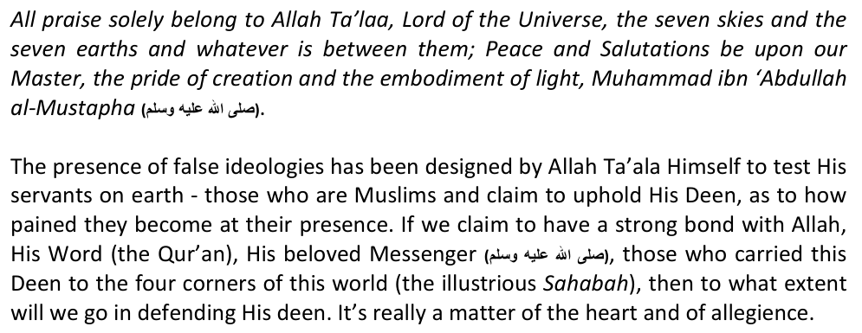
If Allah so wished, He could've not allowed His disodience to take place at all on earth. The angels in the sky, the stars and planets, the creatures beneath the sea, and everything in nature follows a law that Allah has stipulated for them, so a few people here and there disobeying Allah doesn't really affect His Majesty and Status. But if Allah's Majesty is not affected, what should be really affected is our hearts, the heart that bears the love of Allah Ta'aala and is willing to die for Him in order to meet Allah on the Day of Judgement with a sense of satisfaction - for surely this is a meeting that none can avert. Alhough Allah does not need me and you to defend His Deen, this is a challenge that all people of honour and dignity should willingly embrace.
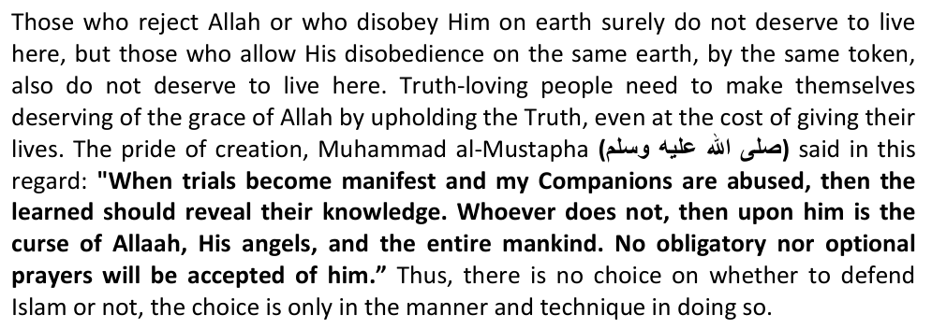
In South Africa, Muslims barely constitute 2% of a population of 50 million, so we are living amidst 98% of disbelief. Some systems of disbelief are open (like Christianity and Zionism), some so are not. Some come in the disguise of belief (like Shi'ism), whilst others state their deviation openly (like Qadianism). The vast majority of disbeleivers practice their religion peacefully, without causing hostility towards others, but two cults do not do so: the Shi'ahs and the Atheists, also known as the Secular Imperialists. Both of these sinister ideologies have huge resources at their disposal, as well as political and military might to enforce their devilish agendas in the world. If others are living in peace besides them, they will ensure that such peace is broken.
Confronting the above two forces in today's times is not confined to academic debates and religious discourse only. Appealing for good sense to prevail, or for their good conscience to prick them, or the sight of the suffering humanity in this world, means nothing to the crafty and conniving blood-thirsty Shi'ah. Both have evolved over many centuries, and both have agendas that are devastating to both our worldly and spiritual lives. The fight of which 'Aqeedah (dominant ideology) and religion prevails in this world is not like choosing a soccer club like Manchester United over Liverpool, but it's a fight of who will emerge dominant and who will ultimately win. More than often, the outcome is determined not on paper, but on the battleground. One would be incredibly blind not to realize the truth of the above in the light of all modern-day wars.
Sadly, the spread of Shi'ism has reached pandemic proportions in South Africa. This did not happen suddenly. We were aware of this scourge from 1980 already, but a unified and a popular effort was not made to dispel it. Shi'ism is a chameleon in the tree. It advances under the very noses of man. If you are not looking for it, you will not find it. In the 35 years since the Revolution, this is exactly what has happened. They have made friends with our friends as well as our enemies, they have made political allies with our political allies and adversaries, they have made our country their country, and our family and community their community. And all the while we knew, but didn't know.
But it's never late. A believer is never despondent. This is where we have slipped up and what we can do to remedy the situation:
1) Our erudite scholars have not made the protection of 'Aqeedah and the struggle to purify Islam from foreign ideas, their priority. Rather, each one is busy in their respective fields of activity, oblivious of this great danger. The time has come to reverse this;
2) Many sincere Muslims have been brainwashed by the poison of secularist thought. For them, a successful life means a steady income and a comfortable life. If this is achieved, everthing else means nothing. There is no need to challenge anyones beliefs, or create unnnecesary tension in society. Everyone is entitled to belief in whatvever they want to, no matter how obnoxious it is. The mindset of a "cushiony lifestyle" being the ultimate objective of one's life needs to be changed;
3) No one really knows how to confront the advance of Shi'ism in SA. When news of the Shi'ah opening a new temple or a new centre is heard, everyone is at a loss as to how to confront it. Unity and a clear strategy are needed on all levels to stem this tide. We need to put our petty squabbles aside and unite on issues such as this. Writing and speaking about it alone is not sufficient;
4) We need to attach ourselves to authentic sources of knowledge like the learned 'Ulema to seek guidance from, or to movements to safeguard our imaan so that we are not unwittingly led astray. Remember that you can be a practicing and sincere Muslim, with a desire to do good, but you can still be led astray. Without the correct knowledge and the correct 'Aqeedah, all your efforts can be wasted away.
Lastly, every Muslim must know the basics of Shi'ism in order to be aware of it. Loving Islam or attending a Seeratus Sahabah jalsah alone is not sufficient to protect your imaan. In the world of propaganda, the golden rule is: "He who influences you first, wins." If you know what Shi'ism is really all about, and when an attempt is made to cast doubts in your mind about Islam, then you will be saved. But if you do not know the basis of Shi'ism, doubts will easily be planted in your mind, even whilst being an ardent lover of the Sahabah. Then to reverse these doubts will be very difficult, and maybe even impossible.
This booklet by Shaikh Salahuddeen 'Azzam is designed to achive this purpose. We pray to Allah to accept this humble effort, crown it with the grace of His acceptance, and protect our imaan from corrosion – Ameen.

Was Salaam
Awakening of Islam, SA K. Dhorat 10th November 2014

CHAPTER 1: ARE THERE MUSLIMS IN THE WORLD WHO CLAIM TO BE MUSLIMS, BUT WHO ARE NOT?
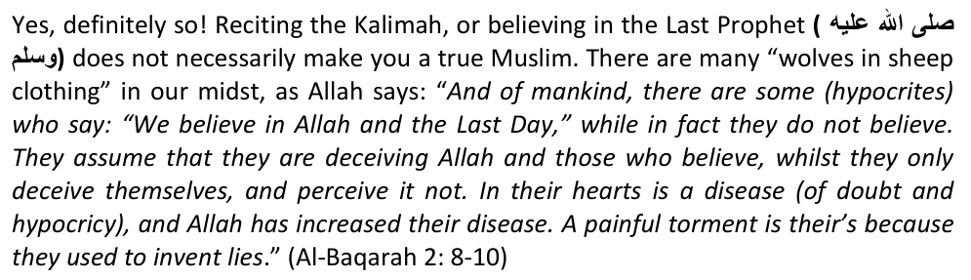
The matter of Imaan (faith) is not a SIMPLE one. You can not say, as Allah warns us in the above verse: "They also recite the kalimah, so they are also Muslims." Don't be deceived in this regard. Know what constitutes IMAAN before offering an opinion that can cost you your imaan!
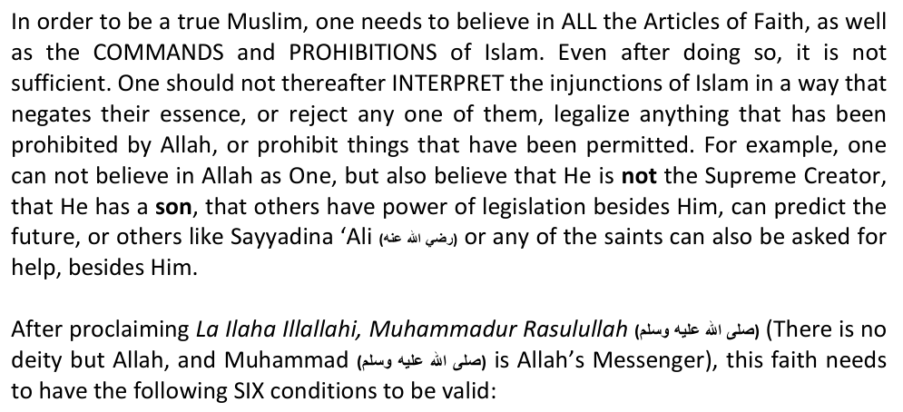
1) One should KNOW that Allah alone is worthy of worship i.e to have enlightened knowledge of the demands of being a Muslim. Mere proclamation of the creed of Islam on the tongue without realizing that Allah will now be the FOCAL POINT of your life, is meaningless. Muslims should contemplate upon His lofty attributes, and His perfection which is manifested in nature, then totally submit to Him. Allah creates and disposes, He is the Bestower of all conditions and gifts, and we should know that idols and entities such as wealth and fame can not be regarded as having any power to help. Allah says: "So Know, O Muhammad, that none is to be worshipped but Allah." (Zukhruf 43:86)
2) After knowing HOW to belive in Allah, we should have CERTAINTY of it: "Only those are the Faithful who believe in Allah and His Messenger, and thereafter doubt not, and strive with their wealth and their lives for the cause of Allah. They are the truthful." (Al-Hujurat 49:15) Having certainty of belief, even if one dies upon unforgiven major sins, will entitle one to enter paradise;
3) After havig being imbued with convincing and unshakable faith, one need to add SINCERETY to it. All one's devotions should only be done for Allah, and all guidelines and directions in life should only be sought from Allah: "Is not to Allah that SINCERE devotion is due? Those who take as guardians others besides Allah, they worship them nought but as an intermediary to Allah.." (Az-Zumar 39:3) Ones worship should not contain an iota of shirk (polytheism) and nifaq (hypocricy), as these negate Tauheed (The Unity of Allah).
4) One should add authenticity to one's sincerety i.e one should be able to overcome trials and tribulations for the sake of one's faith and give it preference over worldly considerations. Allah says: "Alif Lam Mim, do people think they will be left alone because they say: "We believe," and will not be tested. And We indeed tested those who were before them, and Allah will certainly make the truth of those known who were truthful, and He will certainly make the falsehood of the liars known." (Al-Ankabut 29" 1-3) All those in the struggle to upkeep their faith will be TESTED without a shadow of doubt. One should be prepared for severe trials for being a Muslim in the true sense, and should also know that one can not afford to FAIL the test that will determine its authenticity or not.
5) After regarding all those who do not have the above vital ingredients as part of their faith as Kuffaar (Disbeleivers) or those who betray Islam, one should have strong LOVE for Allah, and also a strong ENMITY for disbelief (Kufr). Allah describes true believers as those who are "merciful among themselves, but stern against the disbeleivers," and who are "never afraid of those who ridicule them from their ranks, or those who oppose them from the enemy." (Fath 48:29). Allah also says: "Those who believe, love Allah more than anything else." (Al-Baqarah 2:165).
6) As all of the above qualities change your entire worldview, you then need to
SUBMIT and place Islam over your worldly desires and ambitions. Allah says: "And who can be better in religion than one who submits himself to Allah and does good?" (An-Nisa 4:15) When a Muslim truly submits and has great love for his religion, he now has the courage to face any ugodly system, tyrant, or man-made belief or ideology with courage. No amount of torture and trial will swerve him from Allah and from attaining paradise.
After one's faith has settled in ones heart and manifested in one's life according to the above pre-requisites, then carrying the message of Islam, upholding the flag of pure Tauheed, exposing and combating those who seek to corrupt it (like the Shi'ahs, Secularists and Qadianis of our time), naturally follows. Allah says: "Truly when it was said to them: "La Ilaha Illa Allah," they puffed themselves up with pride, and they said: "Are we going to abandon our gods for the sake of a mad poet?" (As-Saffat 37:36) A true LOVER OF TAUHEED will not tolerate disbelief to flourish in his midst. He will exhaust all avenues to make Islam the dominant religion on earth.
After perfecting one's faith which is only the FIRST article of faith, Muslims in addition, believe in the qualities (Sifaat) of Allah. They believe in them in a way that does not detracts from Tauheed and would expel one from Imaan (faith). Giving Allah physical dimensions, for example, or equating paradise and hell to a pleasure or pain experienced in a dream and succumbing to human reason, rather than divine light in this regard, would expel one from Islam.
Believing falsely in any of the above things, and YES THE ITHNA 'ASHARI SHI'AHS (TWELVER) ARE GUILTY OF MOST OF THEM, makes you a Muslim in name only, but in reality, such people are NOT Muslims, and should not be called Muslims too. In fact, they have to be exposed, made to see the light and asked to repent. In a Muslim State, such imposters will be given time to revise their beliefs and if they do not, the punishment for apostasy will be meted out on them. In a non-Muslim State such as South Africa, UK or Australia, such deviant sects should be academically refuted from the Qur'an and Sunnah, and the public be made aware of them. This is essential as living with Muslims or with non-Muslims have different set of rules as far as marriage, schooling, burial, food, business etc is concerned.
Can you call an "outward Muslim" a non-Muslim after investigating his belief system? Certainly yes, and the proof of it can be found in the Qur'an: "And most of them believe not in Allah without associating (other as partners) with Him." (12:106) Here, Allah states that most of the disbelievers of Makkah had some belief in Allah, but due to its contamination (they believed the idols to be essential intermediaries, having divine powers), it was rejected. In another place of the Qur'an: "If you asked them, "Who created the heavens and earth and subjected the sun and the moon?" they would surely say, " Allah ." Then how are they deluded?" (Al-'Ankabut 29:61)
The Mushrikeen thus recognized the Oneness of Allah, but not His Rubooobiyyah (Quality of Nuturing). They believed Allah to be the owner and protector of all creations, but they used to supplicate to others, slaughter on the names of deities besides Allah and would call upon their dead ancestors, just like the Shi'ahs do today in relation to their Imams and scholars. This expelled them from Islam. You will learn that Shi'ahs believe in one Allah, but ascribe divine powers to their Imams, they ascribe lies to Allah, and employ misinterpretation upon the words of the Qur'an.
Allah tells us about such Muslims who are not Muslims at all in yet another verse of the Qur'an: "The Bedouin Arabs have said, "We are believers." Tell them, "You are not believers, but you should say that you are Muslims. In fact, belief has not yet entered your hearts. If you obey God and His Messenger, nothing will be reduced from your deeds. God is All-forgiving and All-merciful." (49:14)
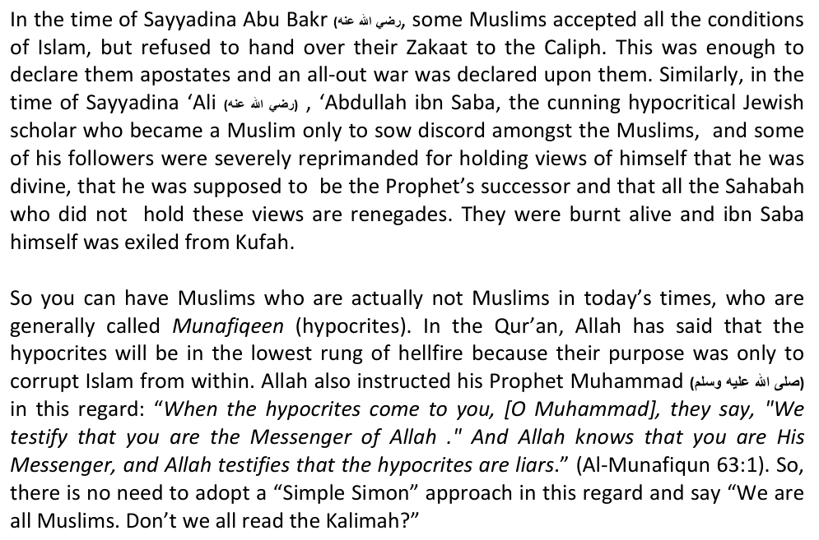
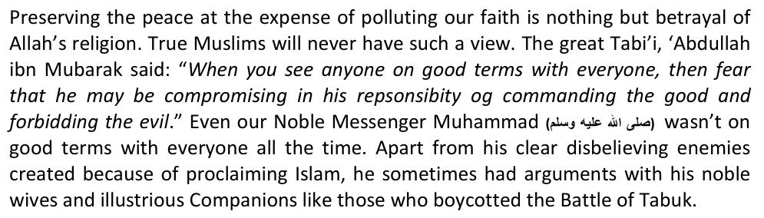
Before ending this chapter, there are two issues here to briefly touch upon. The first is that in today's times, many people do not accept Shi'sim fully. They will deny that they believe that the Qur'an is corrupt as per Shi'ah doctrine, but will agree to the belief of reviling the noble Sahabah. Such people do nothing but follow their desires, accepting from Islam what they wish, and accepting from other false religions what they wish. Allah is pure and does not accept polluted belief. Such an attitude is nothing but clear kufr (disbelief) as stated by Allah himself in the following two verses of the Qur'an: "So do you believe in part of the Scripture and disbelieve in part? Then what is the recompense for those who do that among you except disgrace in worldly life; and on the Day of Resurrection they will be sent back to the severest of punishment. And Allah is not unaware of what you do." (al-Baqarah 2:85)
"Indeed, those who disbelieve in Allah and His messengers and wish to discriminate between Allah and His messengers and say, "We believe in some and disbelieve in others," and wish to adopt a way in between. Those are the disbelievers, truly. And We have prepared for the disbelievers a humiliating punishment." (an-Nisa 4:150- 151) So, there is no "mix and match" Islam. Allah is pure and only accepts pure belief.
Now, the second issue is about those who mock true Muslims for their orthodoxy and strict rigidity, calling them "old-fashion," "anti-progressive," and "anti-unity." Allah has also come to the aid of such true believers in the Qur'an, and has Said that ridiculing those who have firm belief empties such person from all belief: "Indeed, those who committed crimes used to laugh at those who believed. And when with their people, they would return jesting. And when they saw them, they would say, "Indeed, those are truly lost." But they had not been sent as guardians over them." (83: 29-33)
"The Hypocrites are afraid lest a Surah should be sent down about them, showing them what is (really passing) in their hearts. Say: "Mock ye! But verily Allah will bring to light all that ye fear (should be revealed). If thou dost question them, they declare (with emphasis): "We were only talking idly and in play." Say: "Was it at Allah, and His Signs, and His Messenger, that ye were mocking?" Make ye no excuses: ye have rejected Faith after ye had accepted it. If We pardon some of you, We will punish others amongst you, for that they are sinners." (Al-Anfal 9:64-66)
So, the matter of Iman and Kufr is a delicate issue. It must not become a plaything like how it has become today, lest we fall in to the category of "waking up in the morning with Imaan, and sleeping in the evening with kufr." May Allah save us all - Ameen.

CHAPTER TWO: THE BOGUS CALL OF "UNITY" BY THE SHI'AH
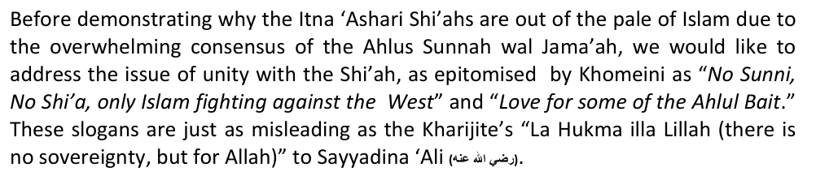
This misleading slogan, which is normally only used in places where Shi'ahs are in the minority, is the biggest farce in history which has corrupted many sincere people wanting to find the path of truth. Muslims can never unite with the Shi'ah, except in some limited economic, political or social issues, for the following reasons:
1. The structure and nature of Shi'ism is such that it's anti-Islam. History testifies that Shi'ahs or Shi'ah governments never raised their sword against infidels, or conquered their lands through Jihad. All their efforts have been to divide and weaken Islam. Even today as Palestine and the Sunni world is under attack and experiencing severe internal chaos, Iran is aiding Shi'ah governments in Syria, Afghanistan and Iraq to butcher Sunnis; 2. The Shi'ahs have historically discredited themselves on a number of occasions in
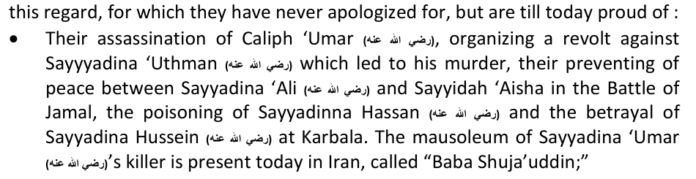
• Instigating the revolt of the Zanj (Black Slaves) against the 'Abbasid Caliphate between 255 AH -270 AH in which one and a half million Muslims were slain, and many Masjids destroyed. (Tarikhul Khulafa of At-Tabari, vol. 3, page 224);
• The Qaramita, a branch of the Batinite Shi'ahs, who believed that liquor was allowed and it was not necessary to obtain purity from defilement, also attacked the Abbasid Caliphate and killed many Sunnnis. During the Hajj of 930, it's leader Abū-Tāhir Al-Jannābī, laid siege to Makkah and for six days, killed many people in front of the Ka'bah, dumping their bodies in the Zama Zam well. He then removed the Hajr-e-Aswad to Bahrain, where he kept it for seventeen years, regularly urinating on it, before breaking it into pieces and returning it to the 'Abbasids for a hefty ransom;
• In 618 AH ibn al-'Alqami – a trusted Shi'ah minister of the last 'Abasid Caliph, invited the Tartars to raid Baghdad and bring an end to this glorious dynasty. He reduced the army from 100 000 to a mere 10 000, whom he assigned menial jobs such as guarding Masjids and bazaars. In their 40-day stay in Baghdad, 1.8 million Muslims were slaughtered, except for those who took refuge in ibn al-'Alqami's home;
• The Ismaili Shi'ahs wrested power from the 'Abbasids and established the Fatimid Dynasty in 909 AH, making a huge part of North Africa, including Egypt, Shi'ah. Thus began a long, but unsuccessful period of Sunni persecution and conversion which only came to an end in 1171 AH when it was reconqured by Ṣalāḥ ad-Dīn Ayyubi. During this time, the Fatimids enlisted the help of the Crusaders on numerous occasions in order to weaken the Sunni Seljuk state. Jerusalem was also stormed and many were slaughtered;
• In 905, Ismail founded the Safavid Empire in Iran and made Shi'ism the official state religion. He mercilessly slaughtered all the Sunni scholars, and brought their legacy to an end. In 1590, Shah Abbas, with the help of English, fought against the Ottomans in Austria and diverted all pilgrims from Makkkah to Mashad in Iran;
• In 1971, Iran refused to return the Arab Islands (Al-Kubra, Abu Musa, Tunub al-Tunub, Surra and Al-Sughra) after the British withdrew to the Arabs. Shah Ridha Pahlavi recognized Israel in 1948, and even annexed Bahrain as it's 14th province in 1957. Bahrain only gained independence from the Shi'ahs in 1971. The Shi'ahs also showed the Zionists the way into the Sabra and Shatillaa refugee camps in 1984, which led to the merciless slaughter of 1000s of helpless refugees. After the 1979 Revolution by Khomeini, Shi'ism is being viciously propagated worldwide.
3. The existence of numerous sects, the majority of which are deviant, is a predetermined fact: "And if your Lord [Allah] had so willed, He could have made mankind a single unified community, but they will not cease to dispute and differ; except those upon whom your Lord has bestowed His mercy. And for this did He create them, and the word of your Lord will be fulfilled: l will fill Hell with jinns and men altogether." (Qur'an 11-118-119)
4. It is not the system of Allah to unite the whole of humanity: "If Allah had so wished, he would made you one nation, but He misguides whomsoever He wants and guides whosoever He wants. And you will be surely about your actions." (Qur'an 16:93) Our salvation lies in purifying Islam by challenging these sects.
5. The Shi'ah only call for unity in places where they are in the minority. They cleverly do this to gain credibility and acceptance of their kufr in the name of unity. In places where they are in the majority or have political clout, they slaughter the Muslims like in Iran, Iraq, Lebanon, and Syria.
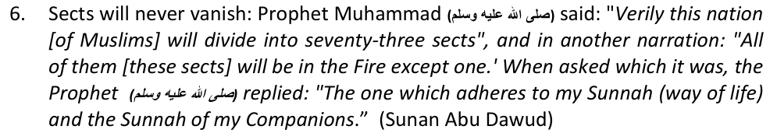
7. It has been the established practice of this ummat to respect the acceptable schools (Madhahib) within it, and not to unite all of them. If this is the case with the Haqq, why should we unite with an open deviation (Shi'ism and its Fiqh Ja'fari) which is not even regarded as Truth, and nor is its Mazhab based on the Qur'an, Sunnah, and Ijma of the Sahabah?
8. If Shi'ahs want unity, why don't they clean up their corrupt beliefs regarding the imperfect nature of Allah, the Messengers, the divinity of their Imams, the Sahabah, the incomplete nature of the Qur'an, taqiyyah (holy hypocrisy) and other such beliefs. Why should Muslims unite with the Shi'ah and give up their salvation for them?
For the above reasons and many more, Sunnis can never unite with Shi'ahs. Curse be upon such unity which criminalizes the Sahabah, legalizes prostitution and declares the Qur'an as fabricated. Even if unity is forged, there will always be fear that it's based on taqiyyah (holy hypocrisy). For such efforts, we offer Surah 109: "Say, "O disbelievers, I do not worship what you worship. Nor are you worshippers of what I worship. Nor will I be a worshipper of what you worship. Nor will you be worshippers of what I worship. For you is your religion, and for me is my religion."

CHAPTER THREE: A COMPARISON OF THE ORIGIN AND STRUCTURE OF ISLAM AND SHI'ISM
There is one easy way of determining the authenticity of any sect that claims to be Muslim, and this is by investigating their origin and the legal structure of their religion.
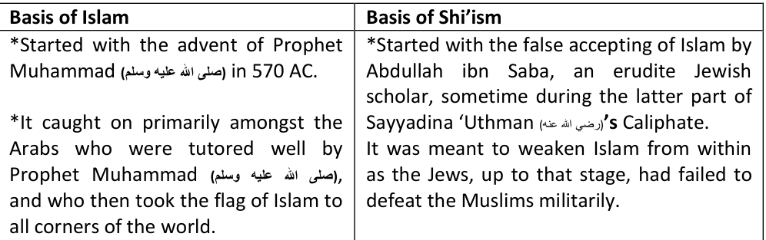
*It caught on primarily amongst the new Persian and Egyptian converts who were not well-grounded in faith. They all contributed towards the anarchy in the Muslim world and imported all their foreign ideas into it.
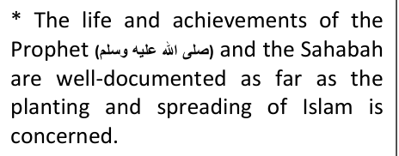
* The role of ibn Saba and his devoted band of instigators like Malik al-Ashtar is well documented as far as their role in creating political turmoil, disunity and religious discord in Islam, even by Shi'ah scholars themselves!
*The first primary source is the present complete Qur'an which we have before us. It will be safeguarded from distortion until the Last Day.
*The first primary source is the Qur'an which is fabricated and incomplete.
*Besides the Qur'an, there are various other scriptures like the Mushaf-e-Fatimi and the white and red Jifr (leather containers) which are not in our midst, but with the fictitious "hidden" Imam in the cave.
*Muslims believe it to be a perfect source of guidance, whose authority can never be cancelled or overridden.
*The understanding and interpretation of the Qur'an follows strict principles known as 'Ulum al-Qur'an. Anyone can learn these principles and understand Allah's Word. There is no clergy in Islam.
*The Qur'an has an "inner" dimension which only the Imams or their representatives know, or are in a position to interpret. There is a privileged clergy class to perform this function.
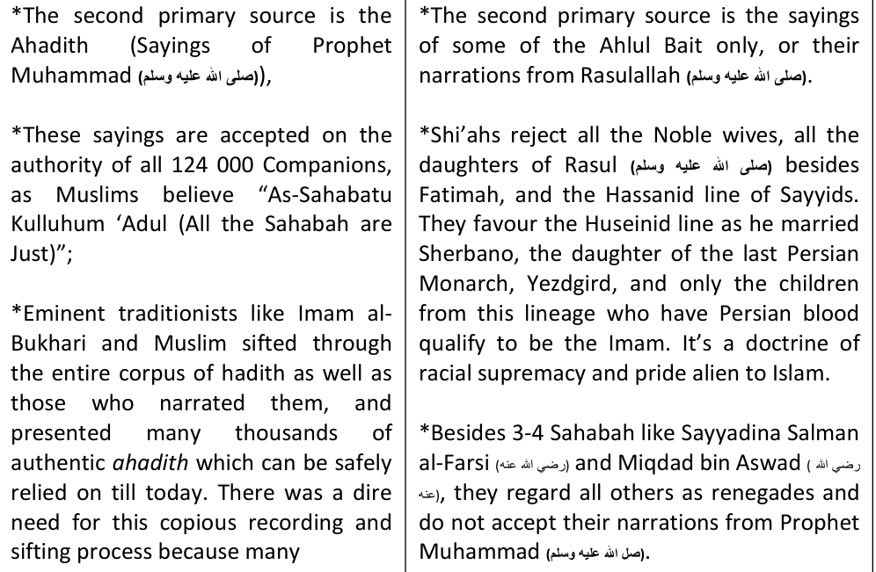
*These sayings are accepted on the authority of all 124 000 Companions, as Muslims believe "As-Sahabatu Kulluhum 'Adul (All the Sahabah are Just)";
*Eminent traditionists like Imam al-Bukhari and Muslim sifted through the entire corpus of hadith as well as those who narrated them, and presented many thousands of authentic ahadith which can be safely relied on till today. There was a dire need for this copious recording and sifting process because many
*The chief narrators of Shi'ah ahadith are all known as liars, devious and innovators. Even Shi'ite scholars regard them as unreliable. These include Zuraarah the Liar (upon which half of Shi'ah narrations depend), Abu Busair the Drunkard, Abu Mikhnaf and Abdullah ibn Abi Ya'fur of Kufah who falsely attributed many lies and shameless sayings to Imam Baqir, Imam Musa Kazim and Ja'far as-Sadiq.
*The third source of Islam is the Ijma (Consensus) of the Sahabah.
*The third source is the sayings and directions of the 12 Infallible Imams, whose words are regarded as binding and divine. The lives, actions, words of the Sahabah and the Khulafa al-Rashidun have no weight in this regard.
*Muslims believe that the Sunnah of the Khulafa al-Rashidun and the Consensus of the Sahabah are binding on this ummat and constitute a source of law.
*In the absence of the Imams, the Ayatollahs and Shi'ah Mullahs act as their "representative." They have wide-ranging powers of legislation, based mostly on "inspiration," which is nothing but devilish whispers.
The fourth source is Qiyas (Systematic Analogical Deduction) in the absence of the above three sources.
*Shi'ahs do not accept this fourth category, as the word of the "Infallible" Imam is sufficient.
*The Imams of the four recognized Mazahib used this principle based on a methodology gleaned from the Qur'an, Sunnah and the Sahabah.
*There is no systematic methodology in Shi'ah fiqh, called Ja'fari Fiqh, and nor can it be called a Mazhab.
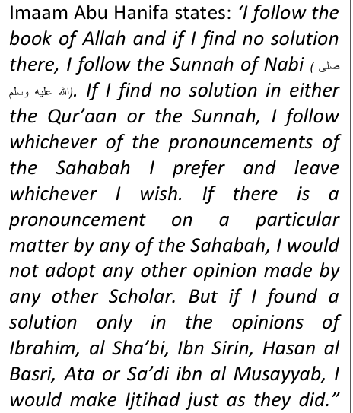
*Shi'ahs believe that the Ja'fari Fiqh is not developed via Shar'i legal sources, but wholly attributed to an Imam who is equal to the Qur'an and can make Haraam-Halaal and Halaal-Haraam. They believe that this Imam is divinely appointed, nominated and does not need the Qur'an or the Sunnat, and is above the law. Ironically, this "Imam" as well as his teachings and correct Qur'an, are all missing, leaving a void for any Tom, Dick and Harry to opine in Islam according to their whim!
*There is a vast difference between an Imam of Fiqh who is not ma'sum (innocent) and can make ijtihadi errors, to an Imam of the Ja'fari Fiqh who is ma'sum (innocent)
(Tarikh Baghdad Vol. 31, p 368)
and receives revelation.
*Included in this are various other fiqhi devices like Masalih al-Mursalah (expediency), urf (customary law) etc.
*Ja'fari fiqh is not an acceptable "fifth" Mazhab amongst Muslims as it's not a fiqh at all!
Shi'ahs account for approximately 15 percent of the total Muslim population. It has the greatest influence presently in Iran where nearly 90 percent of its people are disbelieving Shi'ites, but they are also the majority in Iraq, Bahrain, and Yemen. However, they differ in the PRIMARY SOURCE OF LAW WITH MUSLIMS, SO YOU BE THE JUDGE, CAN THEY BE CALLED MUSLIMS?

CHAPTER FOUR: A COMPARISON OF THE SEVEN ARTICLES OF FAITH IN ISLAM AND SHI'ISM
Article 1: Belief in the Oneness of Allah:
Islamic Belief Shi'ah Belief A. Shahaadat: "Ashhadu an
A.Wilaayat: "Ashhadu an la ilaha ilaha illAllah, wa Ashadu an Muhammadan Rasulullah wa Ashadu an 'Aliyan wali Allah Wasiyyu Rasulillahi wa Khalifuhu bila Faslin" (Khomeini in Wahdat-e-Islami, June 1984)
la ilaha ilaha illAllah, wa Ashadu an Muhammadan Rasulullah."
B."O you who believe! Believe in Allah and His Rasool and the Kitab which He hath revealed aforetime. Whose disbelieveth in Allah and His Malaaikah and His Kitaabs and His Rasool and the Last Day, he verily hath wandered far astray." ( Qur'an 4:136)
B. Allah speaks lies. (Usul-e-Kafi, vol. 1, pge 148) C. Obedience to 'Ali and Hasan is obligatory, not only to Allah. (Usul-e-Kafi, vol. 2, pge 42)
D. 'Ali is also God. (Jila-ul-Ayoun, vol. 2, pge 66) E. All 12 Imams are God. (Jila-ul-Ayoun, vol. 2, pge 85)
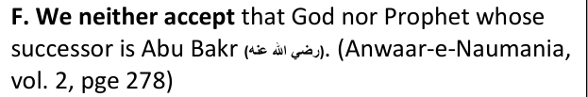
G."All Imams are in possession of divine attributes." (Basair-ud-Darajat, Page No. 23)
"The most beautiful names belong to ALLAH, so call on Him by them…" (Qur'an 7:
H. Kalma Tayyibah without "'Ali Waliullah" is false. (Shia Mazhab Haq Hai, Page No. 2)
180)
I.When God becomes happy, He talks in Persian, when He becomes annoyed, talks in Arabic. (Tarikh-ul-Islam, Page No. 163)
J. "Muhammad and his descendants are omnipresent and omniscient, and this is only their quality, not of Allah." (Jila-ul-A'yoon, vol. 2, pge 85, Lahore)
Shi'ahs seek help from other than ALLAH asking for help: O Hussain!, O Ali!, O Mahdi!." Indeed, they excessively love members of the Prophetic Household to the extent that they
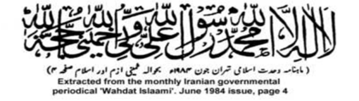
have given them a status of divinity, without observing the fact that they are mere humans.
In Usul ash-Shariah fi Aqaaid as-Shi'a by Muhammed Hussein, he writes regarding the differences between the Ahle Sunnat wal Jamaat and the Shi'ahs, on page 422:
Trans: "The tenth difference - Kalima of Wilaayat - This also warrants no explanation that our kalima comprises of Tauheed, Risaalat and Wilaayat (divine ordainment). But the Kalima of this group (i.e. Ahle Sunnat wal Jamaat) is like that of all other Muslim groups. They do not accept the portion of Wilaayat to be permissible nor part of the kalmia. However we consider this to be an integral part of the kalima Tayyibah."
ALL THESE ARE BLATANT ASPECTS OF SHIRK AND DISTORTION OF ISLAM. YOU BE THE JUDGE, ARE THEY STILL MUSLIMS?
Article 2: Belief in Angels:
Islamic Belief Shi'ah Belief
The existence of angels is a reality. Angels can not disobey Allah and the arch-angel Jibra'il was trustworthy. He didn't make a mistake in delivering the message to the Anbiya.
A."All Angels, Jibrail and Mikail will take the oath of allegiance upon Imam Mehdi's hand." (Chouda Sitaray, pge 94 – Lahore)
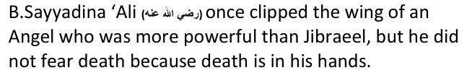
Article 3: Belief in all Divine Scriptures Islamic Belief Shi'ah Belief The Qur'an is the FINAL revelation of Allah, that will protected until the Last Day.
A."A man said that someone was reciting the Qur'an in the company of Imam Ja'far. The narrator said that he heard certain verses in the recitation which were not according to the recitation of the people. Imam Ja'far told the person reciting: 'Do not recite like this. Recite as the people recite until the (promised) Mahdi arrives. When the Mahdi arrives, he will recite the Quran according to its original revelation and the Qu'ran compiled by Ali will be recited". Usul-e-Kafi, vol. 2, page 632.
Allah says in the Qur'an:
"Today I have completed for you your religion, and have completed My favour upon you, and I have become happy with Islam as your way of life." (Qur'an 5:3)
In the commentary of 3:33 of the Qur'an: B."Certainly Allah has chosen Adam, Noah, the family of Abraham and the family of Imran above the (families of the) worlds," 'Allamah Ali ibn Ibrahim AI-Qummi - one of the early Shi'ite commentators – said: 'The Imam said: 'The words: "The family of Muhammed" were also revealed along with "the family of Ale Imraan." They (referring to the Companions of the Prophet) removed the words "The family of Muhammad" from the original text." (Al-Qummi, Tabriz edition, pge 54, 1315 AH)
C."It is clear from all of these traditions and quotations from the Family of the Prophet that the present Qur'an is not the complete Qur'an which was revealed to the Prophet. In fact, there are verses that contradict that which was revealed; verses that have been distorted and places where omissions have been made such as the names of Ali, the Family of Muhammad and, on several occasions, there were the names of the hypocrites. Moreover, the present order of the Qur'an is not according to the preferred order of Allah and His Messenger. Ali ibn Ibrahim (a renowned commentator) also holds this opinion.' (Mullah Muhsin Kashani in his Tafseer as-Saafi, vol. 1, pge 32)
C."Jibraeel used to talk with Fatima after the death of Muhammad." (Jila-ul-A'yoon, vol. 1, pge 198, Multan)
Shi'ahs believe that the process of revelation did not end with the Last Prophet, which is in direct contradiction of verse 5:3 of the Qur'an. Can anyone who contradicts the Qur'an be called a Muslim? Never, in fact, such baseless interpretations renders one a Zindeeq, a worse form of disbelief. A zindeeq is not even asked to repent from his deviant beliefs, he is directly executed on the orders of a Muslim judge.
Article 4: Belief in all the Messengers of Allah:
Islamic Belief Shi'ah Belief Muslims are obligated to believe in and honor all of the prophets, and to testify that prophethood has been completed with the coming of Prophet Muhammad.
A."Every prophet came to establish justice on Earth. His aim was also to establish justice but he was not successful. The same is the position of the Seal of the Prophets who came to reform human society and establish justice but failed during his lifetime.' (Ittihad wayak-Jihat, pge 15)
B."It is related that Muhammad declared that on the night of Ascension, the Most High commanded me to inquire of the past prophets for what reason they were exalted to that rank, and they all testified, "We were raised up on account of your Prophetical Office, and the Imamate of Ali Ibn Abu Talib, and the Imams of your posterity". A divine voice then commanded, 'look on the right side of the empyrean'. I looked and saw the similitude of Ali, and Hasan, and Husain, and Ali ibn al-Husain, and Muhammad Bakir, and Jafar as-Sadiq, and Musa Kazim, and Ali ibn Musa-ar-Reza, and Muhammad Taki, and Ali Naqi, and Hasan Askhari, and Mahdi all performing prayers in a sea of light. 'These', said the Most High, "are my proofs, Vicegerents, and friends, and the last of them will take vengeance on my enemies."
"Say, 'We believe in God and in what was sent down to us and what was sent down to Abraham, Ishmael, Isaac, Jacob, and the Tribes, and what was given to Moses, Jesus, and all the prophets by their Lord.
We make no distinction between any of them, and we devote ourselves to Him.'" (Qur'an, 2:136)
Bihar al Anwar, vol.9 page 76 Now look at these ridiculous beliefs: Usul-e-Kafi, vol. 1, 221: "There are three fundamentals of kufr. Greed, pride and jealousy. Greed was in Aadam. When he was prohibited to eat from the tree, greed prepared him until he ate from that tree." Hayatul Quloob, vol. 1, page 50: "So, Aadam and Hawwa looked at the Aimmah with an eye of jealousy. Because of this Allah handed them over to their souls and withheld His help."
Muslims believe that no person can surpass the rank of the Prophets, but according to the Shi'ahs, the Imams even surpass their ranks and were more successful in their mission. This is clear Kufr and a divergence from the essentials of faith.
Article 5: Belief in the Last Day:
Islamic Belief Shi'ah Belief On the Day of Judgment, every individual will be resurrected to account for their lives. Allah describes this event in the Qur'an: "On that Day, people will come forward in separate groups to be shown their deeds: whoever has done an atom's weight of good will see it, but whoever has done an atom's weight of evil will see that." (99:6-8).
A."When Imam Mehdi will appear, he will first dig out Ayesha from her grave and will apprehend her." (Haq-ul-Yaqeen, Pge. 347 – Iran)
B. "Imam Mehdi will resurrect Abu Bakr and 'Umar, and punish them by hanging them from a tree. Then all the scholars of the Ahlus Sunnah will be hanged." (Haq-ul-Yaqeen, pge 361 – Iran)
For Shi'ah whose enmity for Muslims continue even after their death and the afterlife too, the purpose of the Last Day is merely to punish the Muslims and the Sahabah. People who hold such perverse beliefs can never be called Muslims!!
Allah will weigh everyone's good and bad actions according to His Mercy and His Justice, forgiving many sins and multiplying the reward for many noble deeds.
One who excels in goodness will be rewarded generously, but one whose evils and wrongs outweigh his virtues will be punished.
Article 6: Belief in the good and bad of Predestination: Islamic Belief Shi'ah Belief Muslims believe that Allah knew everything before it came into being, and what will happen to it afterwards.
Badaa is to learn something unknown. According to Shi'ahs, Allah is ignorant, until some situations unfold for HIM. In Usul-e-Kafi, vol.1, page 84: "If people knew what reward there is in acknowledging "Badaa" then never would they abstain from acknowledging it."
He then brought them into existence, all in accordance to His Knowledge and Measure.
Article 7: Belief in Resurrection (Life after Death): Islamic Belief Shi'ah Belief "Allah is the Owner of the Last Day." (Qur'an 1:4)
A."After death, when the Angels of the grave start questioning, then Maula 'Ali's chair is brought and sins are pardoned only after recognizing him." (Jila-ul-A'yoon, vol. 2, pge 85 –Lahore)
In all seven Articles of Faith, there are glaring differences in the Belief and Concept between Islam and Shi'ism. These are all Fundamental differences which determine belief and disbelief, and clearly the Shi'ah do not make the mark. Do you think otherwise? Is the facts presented in this chapter not logical?
CHAPTER FIVE: SOME OTHER SIGNIFICANT JURISPRUDENTIAL DIFFERENCES BETWEEN ISLAM AND SHI'ISM
Shi'ism is a horribly distorted religion. It bears very little similarity with Islam. Here are a few jurisprudential examples:
1. The Shari'ah (the divinely revealed law) is all-inclusive and accessible to all Muslims. There is no need to add anything to it. Shi'ahs, on the other hand, see the Shari'ah as being merely a set of rulings which concern the common folk. As for the Haqeeqah (reality), no one knows it except the Imams of the Ahl Al-Bait (prophetic household). These Imams secretly acquire these sciences through inheritance, one generation after another. They believe that one may communicate with Allah only through these intermediaries;
2. Muslims adhere strictly to the legal rulings of the Qur'an, as clarified by the Sunnah, as well as the sayings of the Companions and the generation of trustworthy scholars who followed them. Since Islam has been completed, no one has the right to formulate new legislation or directives. However, in order to apply Islam to new situations, one must refer to the qualified Muslim scholars who must work solely within the bounds established by Allah's Book. Shi'ahs, on the other hand depend on exclusive sources which they claim for their Imams (who have the right to create new rulings in contradiction to the Qur'an) and upon their farfetched interpretations of the Qur'an. Examples of random Shi'ah changing of the Shari'ah is: a) Their adhan is different (addition of some words); b) Their times of salaah (only three times daily), as well as some postures in salaat, have been altered; c) The specified times for beginning and breaking the fast; d) The rulings with regards to zakaah (alms-tax), its distribution, and a new tax called Khums which is fraudulently extracted by their Imams from the masses, and e) Variation in inheritance laws;
3. Muslims believe that strict loyalty (Al-Walaa) is only for Allah and His Messenger, but for Shi'ahs, this also extends to the Ahlul Bait and all 12 Imams, including the Hidden One. One who does not have strict devotion to Ahlul-Bait has no faith;
4. For Muslims, it is considered impermissible for a Muslim to deceive others. Deception is permitted only during war. Shi'ahs, quite the contrary, all agree that this type of deception, called Taqiyyah, is a prescribed duty in order to falsely represent themselves for their survival, or to whom they consider deserving of destruction like Sunnis;
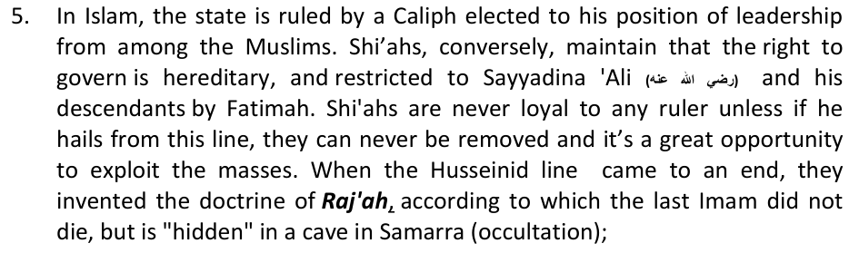
6. Muslims believe that Temporary Marriage (Mut'ah) was permitted in the early days of Islam only during times of war and travel, but it was abrogated thereafter. Shi'ahs, on the other hand, maintain that Mut'ah is not only permitted, it's a virtuous practice and there is no difference between this and prostitution. It can be practiced with a non-Muslim, with a married woman, for a minute too, and for any amount of money;
7. There is no concept of satr (compulsory covering) in Shi'ism, mahrams can view each others private parts, and there is no compulsory bath after sexual intercourse. In fact, semen is pure according to the Shi'ah. A niece and her aunt can also be combined in one person's marriage and donkey flesh is permitted;
8. One's fast is not broken by having anal sex with a woman, reciting the Qur'an in the bathroom is allowed, washing one's privates with saliva is allowed and other such ridiculous beliefs.

CHAPTER SIX: HOW TO IDENTIFY A SHI'AH IN THE STREET?
When walking in the street, or in public places, it's becoming increasingly important to become vigilant as to who may be a Shi'ah, and who may be not. Here are some general guidelines:
1. Their ladies normally don their Hijaab a little differently from Muslims. In some parts of the world, they prefer wearing an Aqeeq stone or a Durood-e-Najaf ring on their right finger;
2. The beard of Shi'ahs are generally shorter than those of Muslims who choose to wear a fist-length beard. It's normally well-groomed too;
3. Some Shi'ah youth wear a miniature sword as a necklace; 4. They have no noor (light) on their faces. There is a matt-like coating of darkness on their faces and bodies. In some situations of war when the bodies of Muslims and Shi'ahs are mixed, it is generally seen that the blood of Shi'ahs turn black and their corpses stink, whilst that of Muslims remain red;
5. The menfolk sometime carry a stone (called a Turbah) made from the clay of Najaf or Karbala, upon which they prostrate in salaat. Shi'ahs only pray three times a day, and keep their hands suspended on the side;
6. Shi'ah Masjids are generally called "Huseiniyahs" (community centres) and have no domes and minarets. However, this is not the general rule as some of their Masjids have very prominent domes and minarets. However, their Imambarahs (places where their Imams and saints are buried) have a distinct straight arch-like architecture;
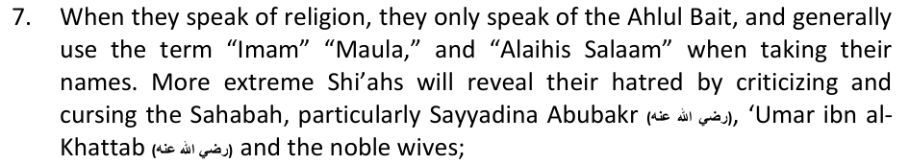
8. They generally have names like Hassan, Hussein, Naqi, Reza, Mehdi, Abdul- 'Ali, Fatima, Zahra etc. They rarely keep the names of the general Sahabah, but those of their Imams and their families. Some of their surnames are Zaidi, Rizvi, Ismaili etc;
9. Shi'ahs generally keep their trousers below their ankles; 10. If confused, draw them into a discussion on politics. Ask them what they think of America and the unrest in Karbala. You will get your answer sooner or later;
11. You could also politely ask them: "Are you a Shi'ah or not?"
12. Engage them in a discussion about mut'ah, Imamah, the Sahabah, Imam Khomeini. From how they speak, you will be able to quickly establish their identity;
13. Their homes, vehicles and businesses generally have Shi'ah signs on them like "Ya 'Ali," "Ali Waliyyullah," or "Ali Madad."
14. If they are carrying a book, look at the title discreetly or ask them what the book is about;
15. In Muharram, they generally wear black and attend all the mourning rituals, jalsahs etc. In some countries on such days, they will have a black flag outside their home, and on the balance of the days, a red flag. On the doors of some Shi'ahs, is a hand-like knocker with some inscription on it;
16. If you sitting in their vehicle or a taxi, you will make out by the type of music or lectures being played in it;
17. In their home, it will be choice of satellite channels and the types of portraits found therein. Shi'ahs love depictions of Karbala, portraits of their Imams etc;
It is important for lay-people not to engage in a discussion with Shi'ahs on topics which they are not acquainted with. Such discussions normally lead to planting doubts about vital matters of faith in one's mind, which can very easily lead to losing one's imaan altogether. Debating with Shi'ahs is generally useless as they have no desire to learn the truth.

CHAPTER SEVEN: HOW TO ENGAGE WITH THE SHI'AH?
Recently, we had the opening of the Qadiani Temple inn Wynburg, Cape Town. It's patron, Dr Taj Hargey, openly came on air, announcing his blasphemus beliefs like rejection of the Finality of Prophethood, rejection of the Sunnna, acceptance of homosexuals, and free-intermngling of the sexes even during salaat. The Shi'ahs, on the other hand, do not proclaim their blasphemous beliefs openly. They use tact, diplomacy, cunning and taqiyyah in doing so. In addition, the Shi'ah are economically, politically and socially a much more powerful cult, thus to challenge them is much more difficult.
There are three categories of Shi'ahs in South Africa, and all three have to be approached differently:
1. The hardcore Shi'ah, their leaders and their Preachers: This is the "converted" category whose mission in life is only to spread mischief, initiate mindless debates and corrupt one's imaan so that they can have your company in hellfire. Many of these people will be on the payroll of the Shi'ahs and will be schooled in not only Shi'ism, but the subtle art of making its ugly and controversial aspects attractive.
Characteristics: Such people generally openly admit that they are Shi'ah. If they hide their identity, they can easily be identified by their activities, affiliation to Shi'ahs, to Shi'ah organistions, and by the friends they keep. They portray exemplary character, their appearance is neat, and their tongues glib and sugary. Such people have sold their imaan for a worldly pittance, and have given the pleasures of this world preference to the hardship and sacrifice required to acquire the Aakhirah.
Thus, they would generally lack integrity, morality and a sincere desire to seek the truth and be rightly guided. Most of their discourses are about "unity," criticizing the Sahabah, love for the Ahlul Bait, and they will be very clued up on the political happenings of the day, especially of America and the Middle East. Never think you can easily convert them, they are thinking of how to do the same to you and are ten steps ahead of you in this regard !!
Where can they be found?: This class would previously be only found in majority-Shi'ah countries like Iran, but today they have spread worldwide. In democratic South Africa, they have spread like wildfire and can be found amongst the Black and Indian population too. Many local South Africans have received, or are receiving training in Iran at the moment, and they can be identified by their speeches and activities. They occupy positions in the many Shi'ah organizations in SA or are attached to them.
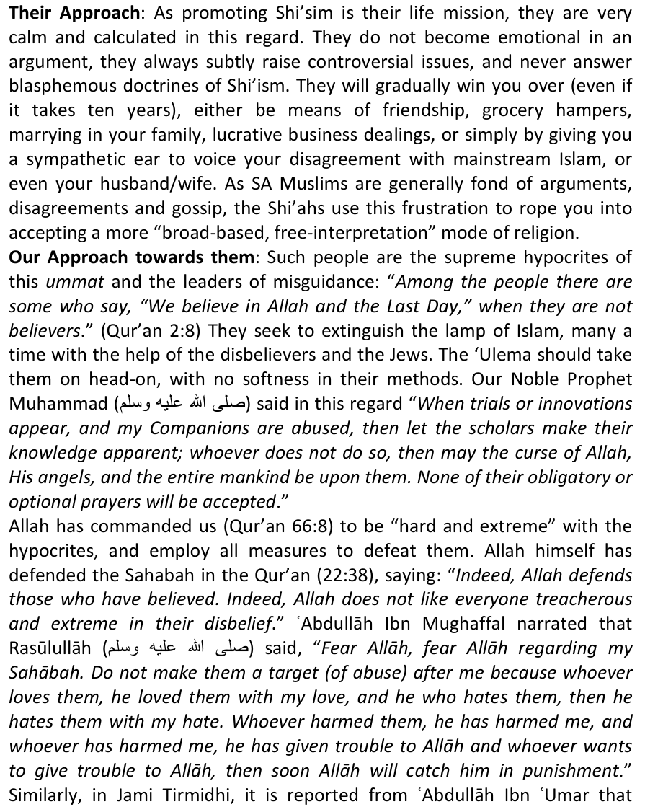
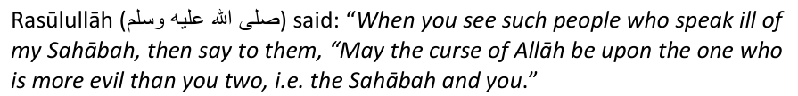
Thus, the above category of people are cursed, clear disbelievers and don't deserve any compassion or diplomacy. We should be firm and confident when rebutting them, but never resort to violence or damage to property. Show them the fallacy of their belief and ask them to repent. If they refuse, warn others about them.
2. The Shi'ah-sympathetic one's or the Shi'ah Ignorant Masses: These are the one who due to close contact with Shi'ahs, either through friendship, politics, business, being a workplace colleague, neighbors, sharing the same Masjid or working in the same organization, have come into contact with zealous Shi'ahs who have been slowly indoctrinating them with various aspects of Shi'ism. They have no in-depth knowledge of both Islam and Shi'sim, and are thus vulnerable. Slowly, their confidence is won over and they become the unknowing agents of falsehood. They are the enemy within the enemy. This class is spreading like wild-fire in SA.
Characteristics: Such people are generally ignorant of both religions, but think that they are an authority on both. They do not bother to seek the truth and seek the correct answers, but join the pleasurable pastime of indulging in the polemics fed to them. They regard mainstream Islam as backward, Iran as their savior and secularism as their methodology. Chances are that they are not connected to an Aalim, a Masjid, a religious institute or a movement like the Khanqah or the Tablighi Jamaat where their religious need are being fulfilled. They are the lone wolves who have been devoured by the devil.
Where can they be found? Most of these people either hail from the intellectual class, the rich, or the very poor. The intellectual class find Shi'ism open to following their desires and free-thinking, the rich to gaining permission to indulge in any vice they would like, and the poor to filling their stomachs. They can be found in every strata of society.
Their Approach: As such people would be hail from within our society or families, they wouldn't openly speak of Shi'ism as they fear for their reputation or being isolated and shunned. They will adopt a diplomatic approach i.e their values are not firm, and can change any time. They do not actively promote Shi'ism unless if by doing so, some of their worldly desires are being fulfilled, if they gain name and fame in the process, or if Shi'ism has become an "acceptable" ideology in such a society. Many "Unity Forums" which are comprised of influential members of the society, strive to make Shi'ism attractive just to be different and more "savvy", whereas it lacks many of the essential principles of Islam.
Our approach to them: The level of Shi'ism accepted by these people first need to be ascertained as sometimes such people claim to believe in Shi'ism, but they don't know exactly what aspects of it. Sometimes, such people are only politically aligned to Iran, this is not Shi'ism, but is a stepping stone to it. If they haven't accepted any heretical beliefs of Shi'ism as yet, then this is a relief, but ask them too be wary. Those who have accepted any heretic belief of Shi'ism, partially or totally, should be shown be gently shown the error in their ways and asked asked to correct it. They should ask Allah for sincere guidance and attach themselves to an authentic Aalim, and seek answers for their confusion. They should also learn 'Aqa'id (Fundamental Beliefs) and know the importance of correct belief on their salvation in the eternal Aakhirah.
We should be soft and diplomatic with them, but if they persist in their disbelieve or become a threat to others, they should be accorded the same treatmed as proper Shi'ahs. Compromising 'Aqa'id or mixing beliefs is just as bad as total disbelief. Don't give up trying to win them back and praying for them.
3. The confused general masses exposed to Shi'ism: Thankfully, most SA Muslim fall into this category, but it may not be for too long. Besides Shi'ism, there are many other false ideologies which one can fall into.
In order to safeguard the imaan of the masses and to take preventative measures, we suggest the following: 1) Our Madrasah syllabus should be made more 'Aqeedah-intense and a separate section be dovoted to all the deviated sects. These should be taught from Grade 4-12, every year; 2) Our 'Ulema should speak openly on Shi'ism and other deviated sects from the Masjid platforms, highlighting who they are and what is wrong with having such beliefs; 3) Community awareness campaigns like workshops, seminars etc should bbe held; 4) Authentic Islamic literatre and audios should be consulted for more information.
The most important is to have the desire to be rightly-guided and affiliate yourself with a recognized Aalim, Institute or Movement in which you can be spiritually protected.

CHAPTER EIGHT: SOME COMMON SHI'AH DISCOURSES AND HOW TO COMBAT THEM
We have already written how Shi'ahs differ from mainstream Muslims in terms of their Kalimah, the concept of the Qur'an, and their blasphemous belief in Imamate. However, Shi'ahs do not introduce their sacrilegious cult to others in this way. They use different techniques, mainly by way of historical incidents, to create doubt and stir enmity, rather than positively educate.
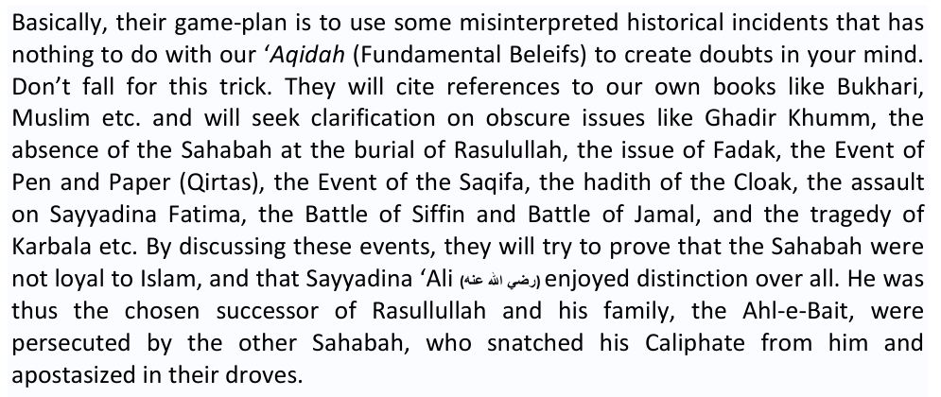
Do the Shi'ahs think that they can convert Muslims with such an absurd narrative of history? These are some of the issues. The broad Shi'ite argument is first given, as well as a brief rebuttal which you may use on the spot to silence your Shi'ah friend:
8.1: THERE ARE DIFFERENT TYPES OF SHI'AH. WE HAVE TO BE SPECIFIC, WE CAN'T PAINT ALL WITH THE SAME BRUSH:
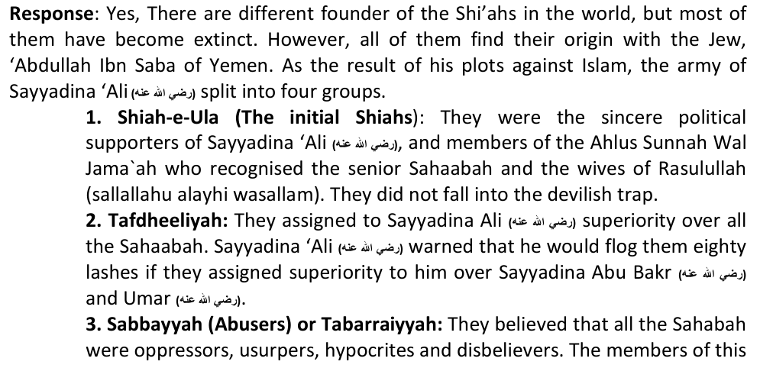
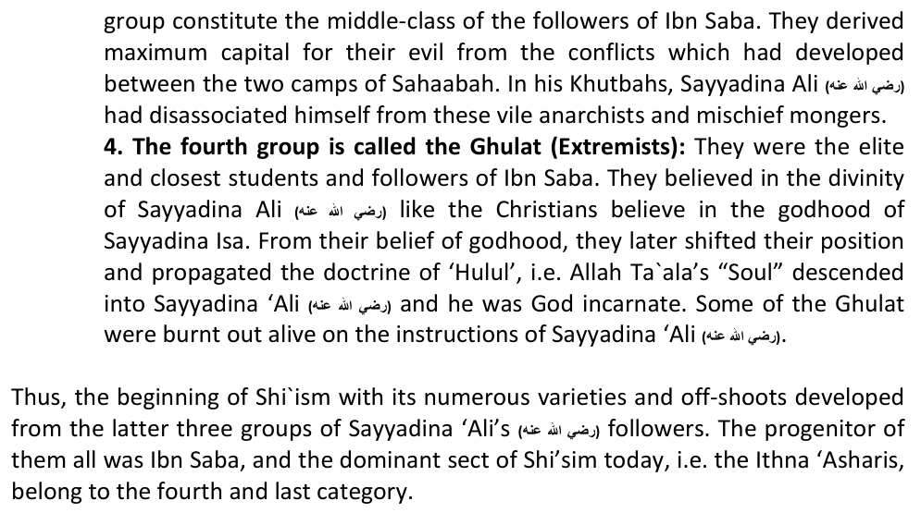
8.2: IF SHI'SIM IS BASED ON JEWISH BELIEFS, WHY IS IT THAT WE FIND FAMOUS SCHOLARS, IMAMS, MUHADDITHEEN ETC AMONG THEM? SURELY THIS IS A SIGN OF THEIR AUTHENTICITY!:
Response: If anything has a structure and a system, it doesn't mean it is authentic. The reality of the matter is that all the scholars of the Shi'ah are all fakes. Their scholars pretended to be among the Muhadditheen of the Ahlus Sunnah Wal Jama`ah. Overtly they projected the image of piety, and when they gained the confidence of the masses, they introduced thousands of fabricated narrations amongst the Ahadith. Differentiation between true and false narrations became an onerous task. However, Allah created master Traditionsists like Imam al-Bukhari and Imam al-Muslim who discovered this fraudulent manipulation and sifted the falsehood from the collections of narrations.
Fake Shi'ah scholars like Jabir Ja`fi and Abul Qasim Sa`d Bin Abdullah Ibn Ubay Khalf Qummi attributed fake virtues to the Ahl-e-Bait, and fake condemnations of the Sahabah. This wasn't an easy task, so they adopted the following methods in doing so:
Attribution: To attribute their forgeries to authentic Muhadditheen whose names and titles resemble those of Shi`ah narrators, e.g. Ibn Qutaibah. The one Ibn Qutaibah is the Sunni who is the author of "Al-Ma`arif". The other Ibn Qutaibah is the Raafidhi who also named his book, "Al-Ma`arif" to create confusion and perpetrate deception.
Fabrication: To write books and attribute authorship to senior 'Ulama of the Ahlus Sunnah, e.g. Sirrul Aalameen is attributed to Imam Ghazali.
False References: To substantiate their baseless and false claims by citing such books of the Ahlus Sunnah which are no longer extant or are rare. In the absence of the books, denial becomes difficult and ordinary people are misled.
Converts: Some gave the impression that certain Shi`ah scholars are members of the Ahlus Sunnah. Once this impression became rooted, they commenced narrating from them such matter which refutes the Mat-hab of the Ahlus Sunnah. For example, Zamakhshari, the author of Kashshaf,"belonged to the Tafdheeli sect and he was also a Mu`tazili; Ibn Abil Hadeed, the commentator of Nahjul Balaaghah, combined Shi`ism with Mu`tazili`ism, Mas`udi, author of Murawwajuth Thahab, and Abul Farj Isfahani, author of Al-Aghaani.
False Authorship: Sh'iah theologians prepared a book, Al-Hasanah, in which they refuted the Mathhab of the Ahlus Sunnah and falsely attributed it to a slave-girl of the Ahl-e-Bait. Then they claimed that the Sunni Ulama were unable to respond to this refutation supposedly written by a stupid slave-girl. The actual author of the book is the Shiah, Shareef Murtaza.
Another powerful trick is to prepare a refutation of the Ahlus Sunnah and attribute authorship to an imaginary Muslim who tells his story of conversion firstly to Islam, then ultimately to Shi`ism. The imaginary story-teller then claims in his book that the Ulama of the Ahlus Sunnah were unable to respond to his doubts. "Youhanna Ibn Israeel", whose author is Shareef Murtaza and "Then I was guided" in English by Samawi Tijani are examples of this.
Books of Fiqh: Another devilish trick of the Shi'ahs which has confused even some Ulama of the Ahlus Sunnah is to compile books on Fiqh in which fabrications are recorded. They then attribute authorship of the book to some Imaam of Fiqh of the Ahlus Sunnah. For example, the "Mukhtasar" which is attributed to Imam Malik. In this book it is said that it is permissible for the master to commit homosexuality with his slaves. The Shiahs have succeeded to some extent in this ploy because a forged fabrication of Imam Abu Hanifah will be distributed in regions where Malikis predominate while the book attributed to Imam Malik will be circulated in predominantly Hanafi areas.
Interpolation: At times, Shi'ahs have interpolated even well-known books of Hadith and Tafseer of the Ahlus Sunnah. Books such as the "Sihah Sittah"were beautifully written and bound, and Shi'ah fabrications were incorporated. Another ploy is the introduction of a forged word or two in a narration which they reproduce from famous Kitaabs. When Sunnis read such narrations, they become confused.These types of forgeries is to be found in profusion in "Kashful Ghummah" of Ali Bin Isa and in Ibn Muttahhir's "Alfain," "Minhajul Karamah" and "Nahjul Haqq."
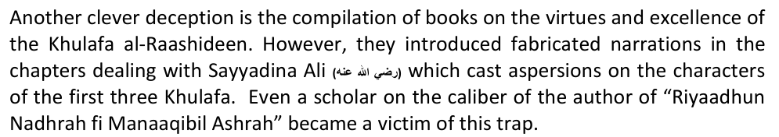
Deletion: To save their skin from the criticism, some Shi'ahs like Sayyid Murtazaa, Ibn Mattahhir Hilli and Ibn Taaus, have completely deleted many contentious issues from their later publications. They then disseminate the deleted narrations claiming that they are the views of the Ahlus Sunnah. Another example is the abridgement of "Tarikh at-Tabari" by 'Ali Bin Muhammad Adawi Abul Hasan Simsati which contained many fabricated tradition not found in original.
Taqiyyyah: The greatest device of deception of the Shi'ahs, especially when they become helpless in a debate, is their doctrine of Taqiyah (holy hypocrisy). If it was not for this principle of concealment of beliefs, Shi`ism would not have acquired followers from even the ignorant masses. Remember that the practice of Taqiyah is not restricted to occasions of danger as Shiahs attempt to mislead Sunnis. Shi'ahs claim that the Imams had to conceal the truth to spread Shi'ism just like how the Anbiya did, but persecution, torture and hardships were never considered grounds for proclamation of falsehood by the Anbiya.
Saints: Lastly, Shi'ahs to claim that certain great Auliyaa of the Ahlus Sunnah were Shiahs. In the Shi`i book "Wafayatul A`yan" by an Iraqi Shi'ah, Bayazid Bustami, Ma`ruf Karkhi, Shaqiq Balkhi, Sahl Bin Abdullah Tastari and others are enumerated as Shiahs. Another such book is the "Majaalisul Mu`mineen" by Qadhi Nurullah Shaustari.

8.3: THE SAHABAH WERE THE ENEMIES OF THE AHLUL BAIT, THEY MUST BE REVILED:
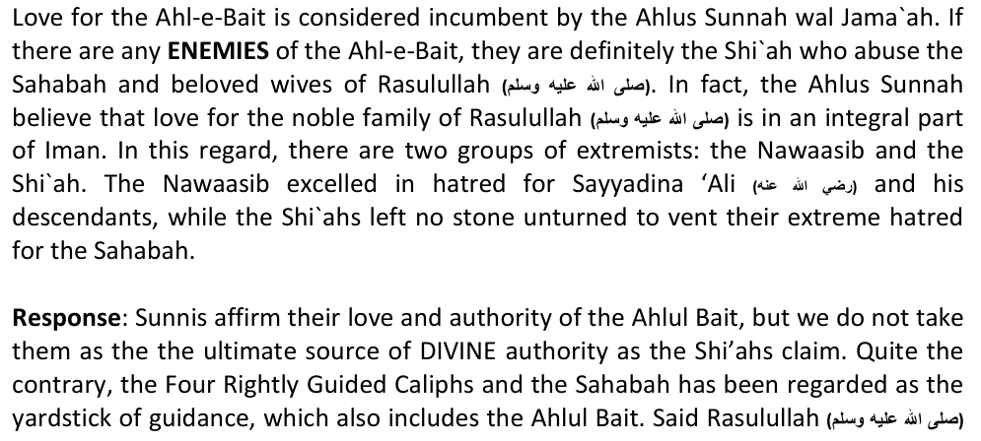
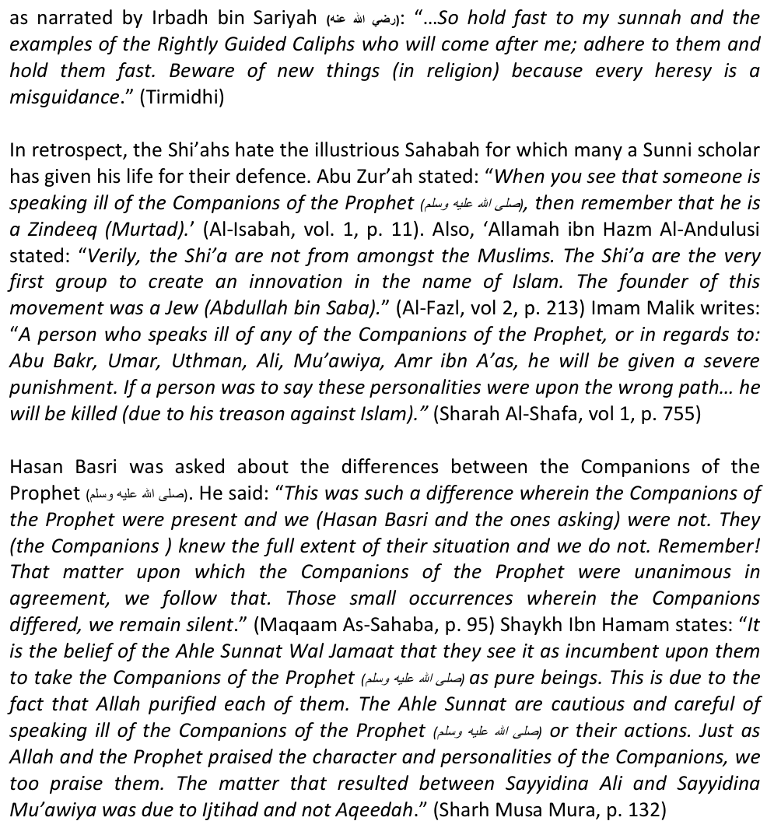
It is related from Imam Ahmed bin Hanbal: "For us, the ruling of the Sunnah is that way upon which the Companions were." (Fatawa Ibn Taymiyah, vol 4, p. 155) Imam Shafi states: "The Companions of the Prophet, in knowledge, sense, Deen and virtue are greater than us. In every condition, it is better for us to take the opinion of the Companions above our own." (Fatawa Ibn Taymiyah, vol 4, p. 158) Hafiz ibn Taymiyyah states: "Upon the foundation of the Holy Qur'an and Sunnat and Ijma of the Ummah, the status of the Companions of the Prophet is second only to the Prophets and Messengers of Allah. For this reason, you will not find a person from the Muslims who will not accept the greatness of the Companions. In this matter, the only ones who cause disputes and problems are the Rawafid Shi'a, in reality they are ignorant." (Minhaj us-Sunnnah, vol. 1, p. 167)
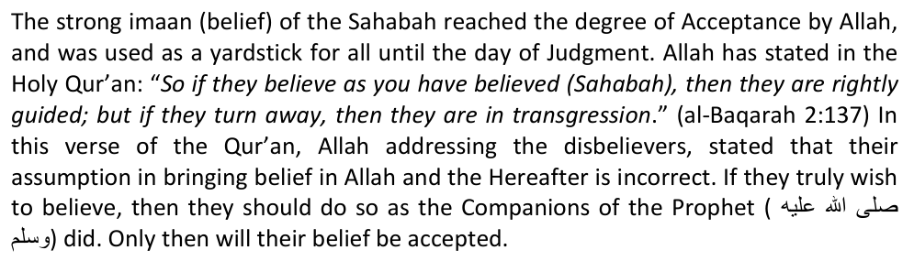
The disblievers used to curse the Sahabah for bringing faith in his message and had unrivalled hatred and enmity for the believers. Allah responded in favour of the Companions: "And when it is said to them (the hypocrites) "Believe as the people (Sahabah) have believed" they say "Shall we believe as the fools have believed?" verily, they are the fools, but they know not." (Al-Baqarah 2:13) Remember, the
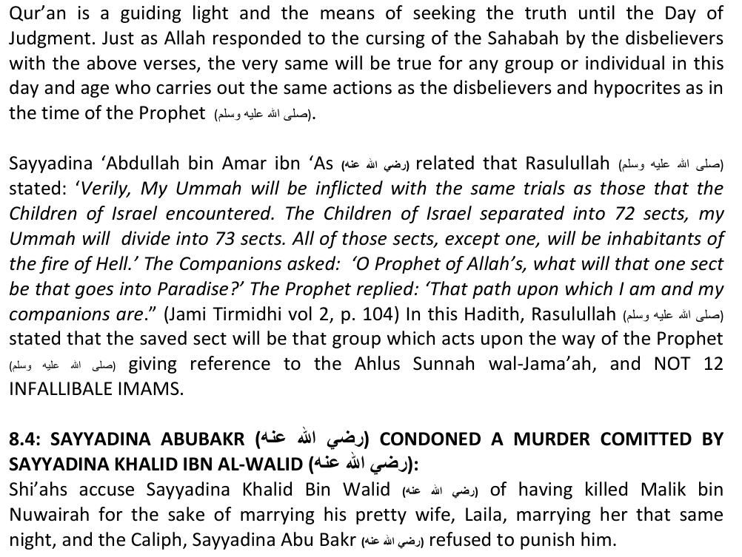
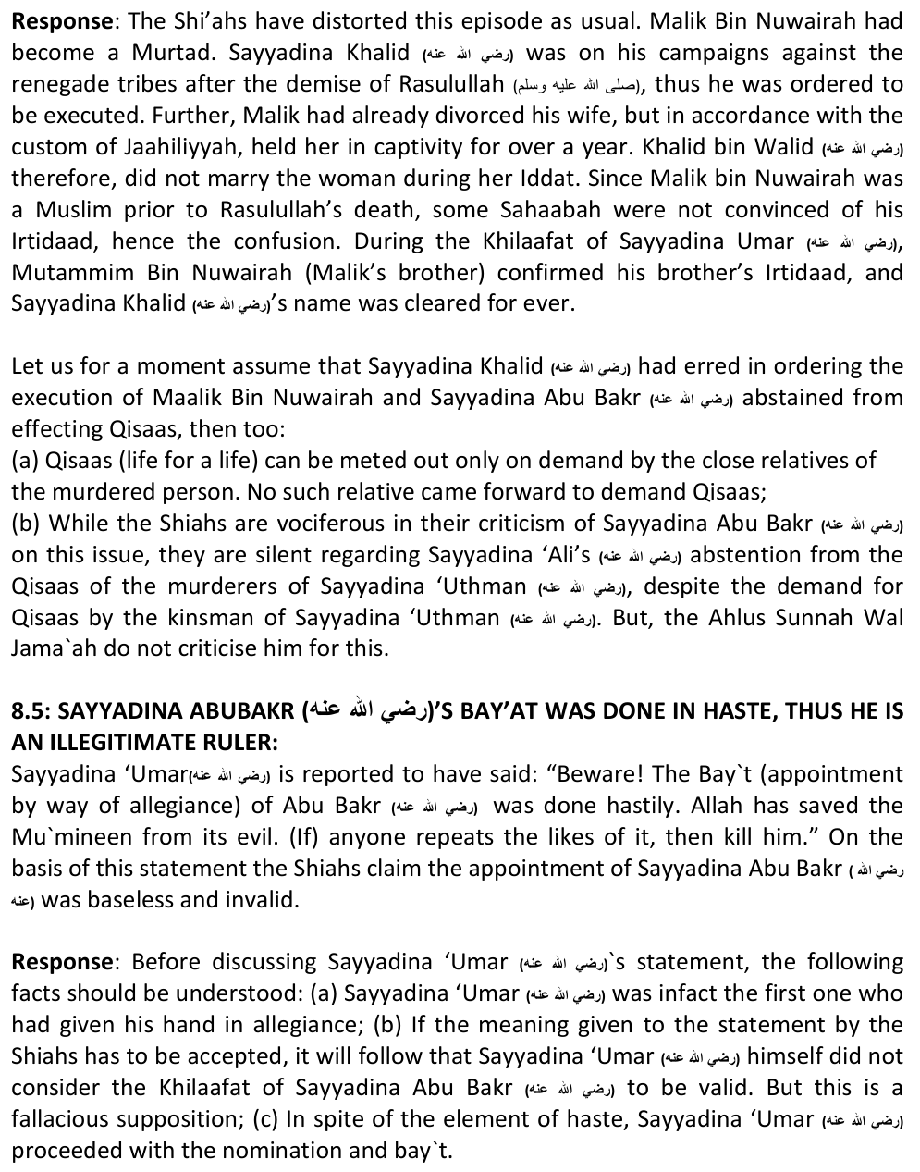
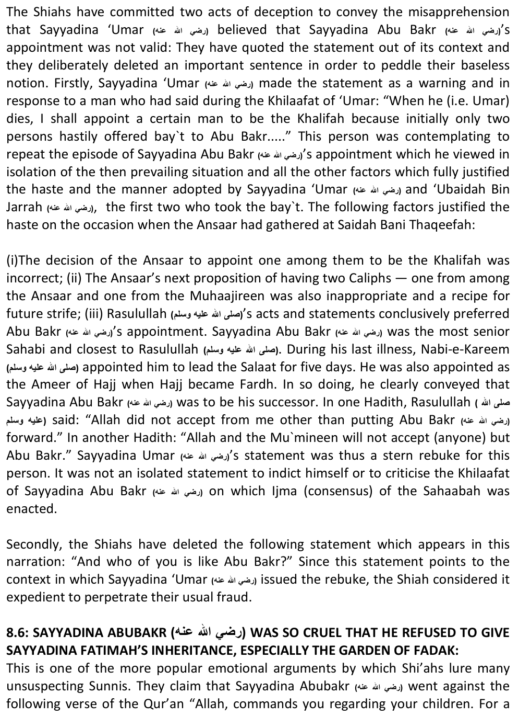
male is a share of two females." They insist that Prophets also do leave inheritance as it's mentioned in the Qur'an that Sayyadina Sulaiman inherited from his father, Sayyadina Dawud."
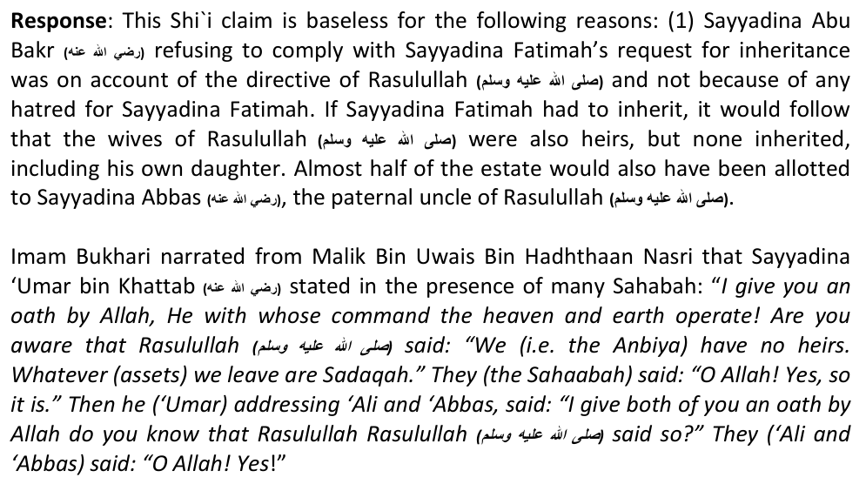
Regarding the reasoning that "Verily, Sulaiman inherited from Dawud," and thus Fatimah would inherit from her father, this refers to prophethood, not wealth. Sayyadina Dawud had 19 sons, but the Qur`an describes only Sayyadina Sulaiman as his heir. If the verse literally referred to inheritance of gold, silver and tangible assets, it would not have been distributed to all his children, and not only one son.
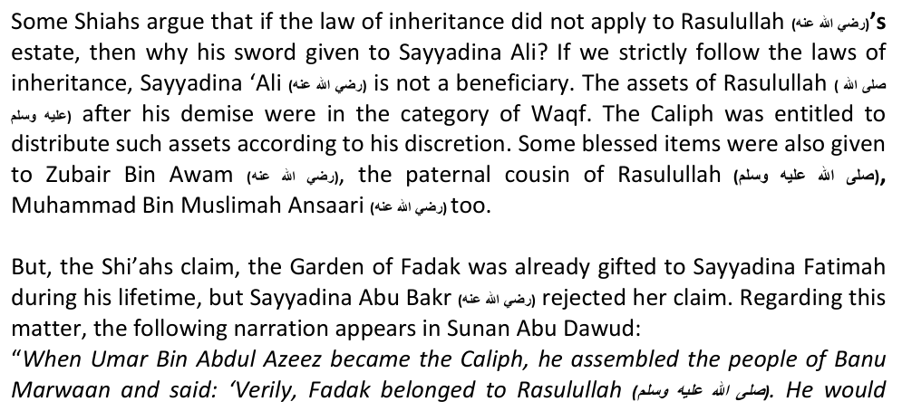
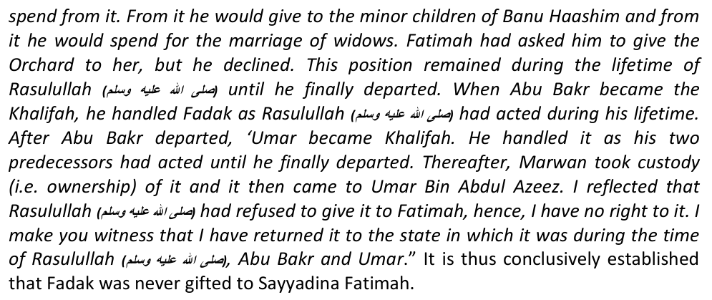

8.7: THE EPISODE OF QIRTAS (PEN AND PAPER):
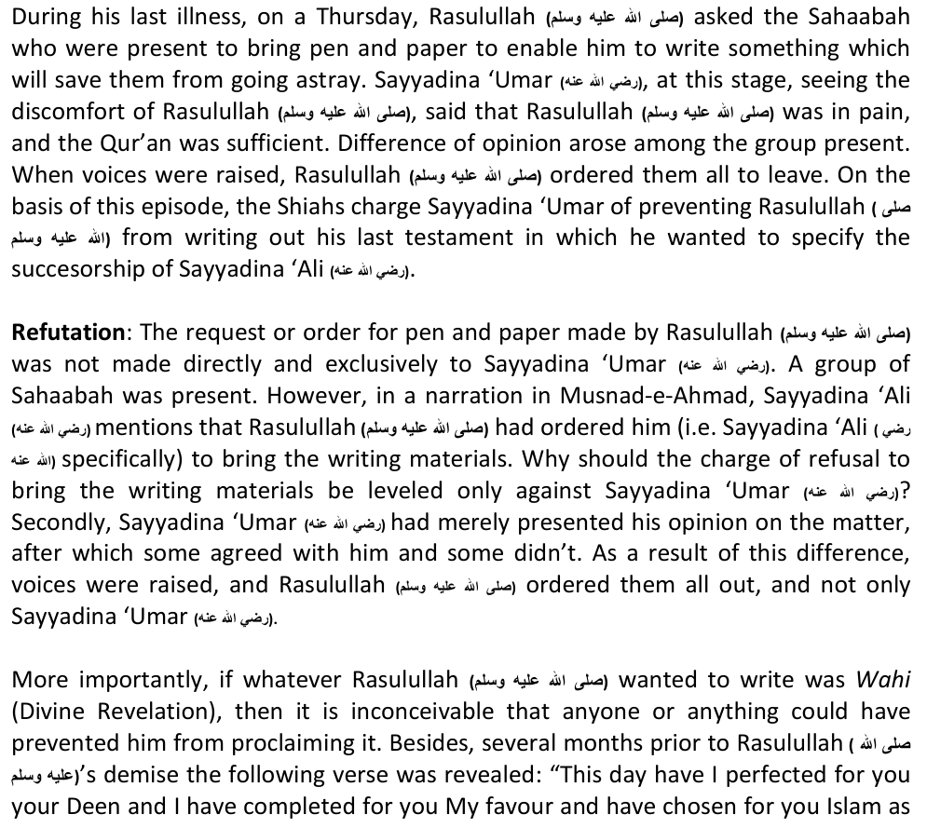
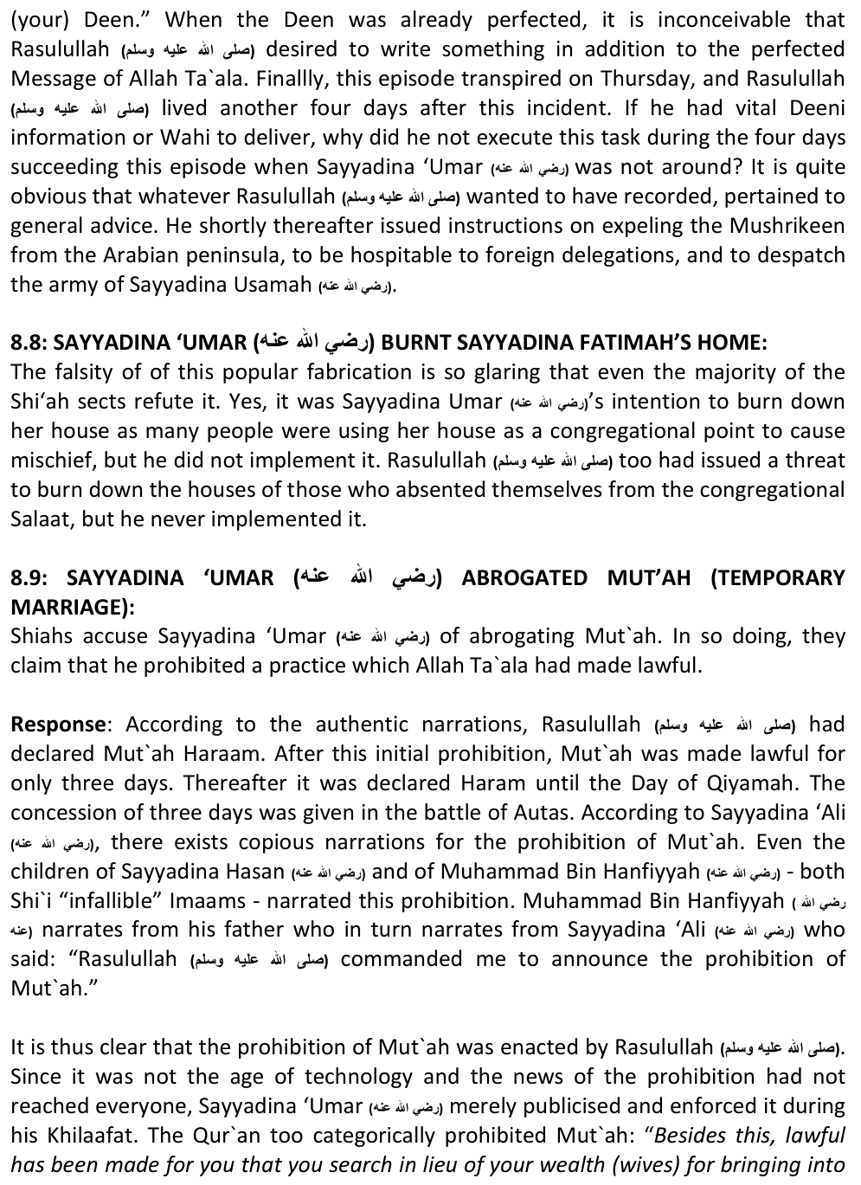
your custody, not for isfaah (i.e. not for illicit lust)." (Surah Nisa, Aayat 24) Also: "And, Muhsinaat (chaste women) from the Mu`minaat and Muh`sinaat from those who were given the Kitab before you, when you give them their dowries according to law, taking them into (permanent) custody, not for the sake of isfaah (i.e. carnal pleasure)." (Surah Ma`idah, Aayat 5)
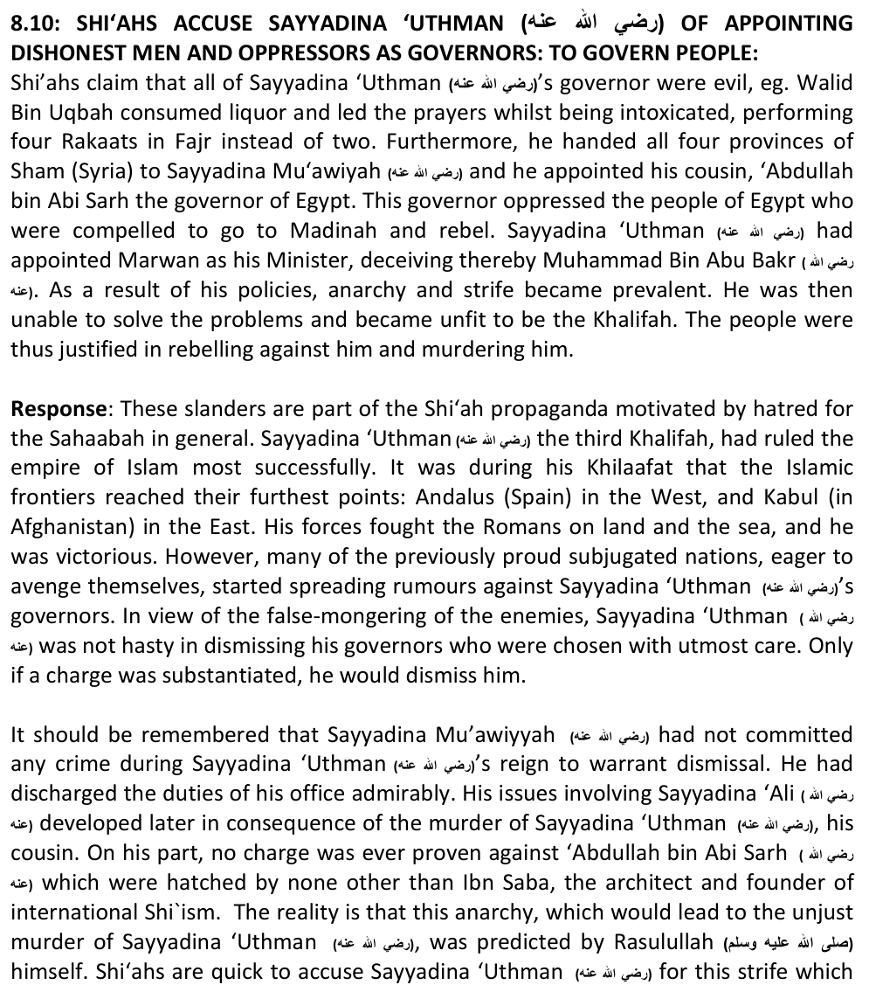
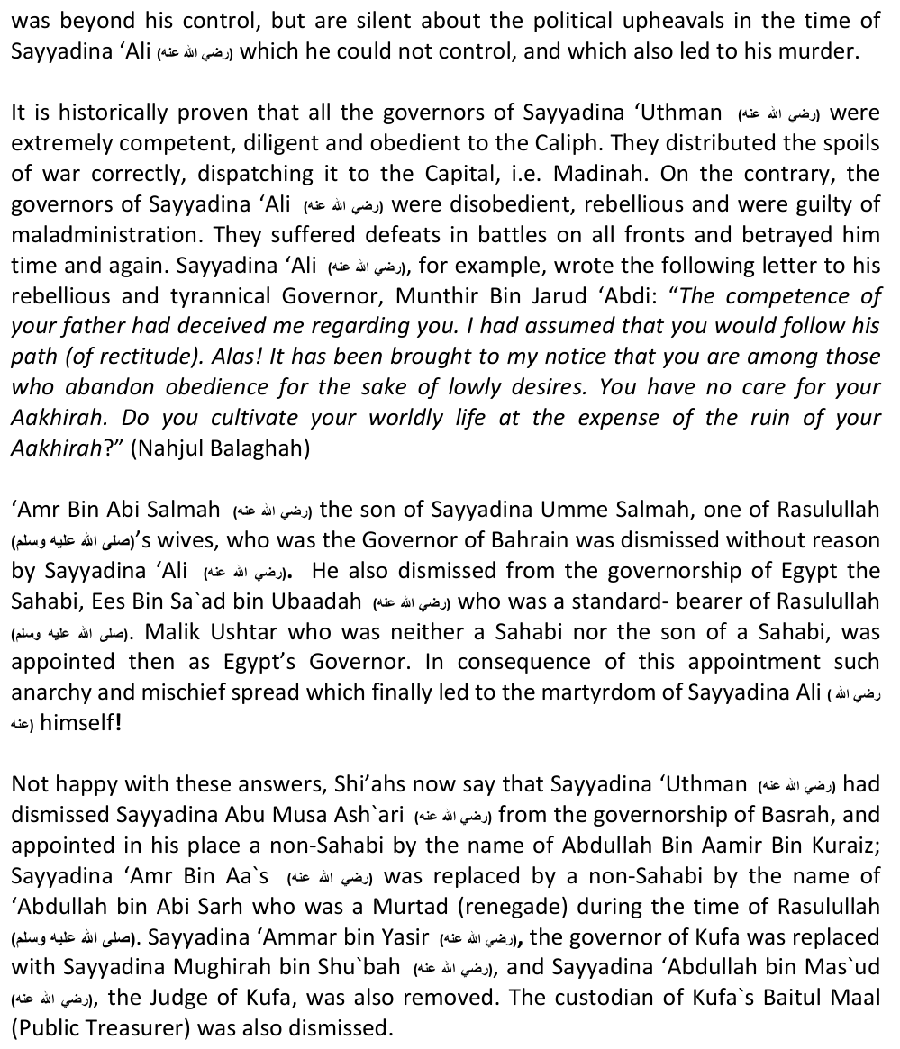
However, all of the above changes were necesarry, and it had nothing to do with the incompetence of these great Sahabah. The numerous victories and expansion of the Islamic empire warranted changes in the administration which had become extremely intricate and complex. Competent officials are replaced by those who may have greater competence. An official may develop weakness due to age or illness,
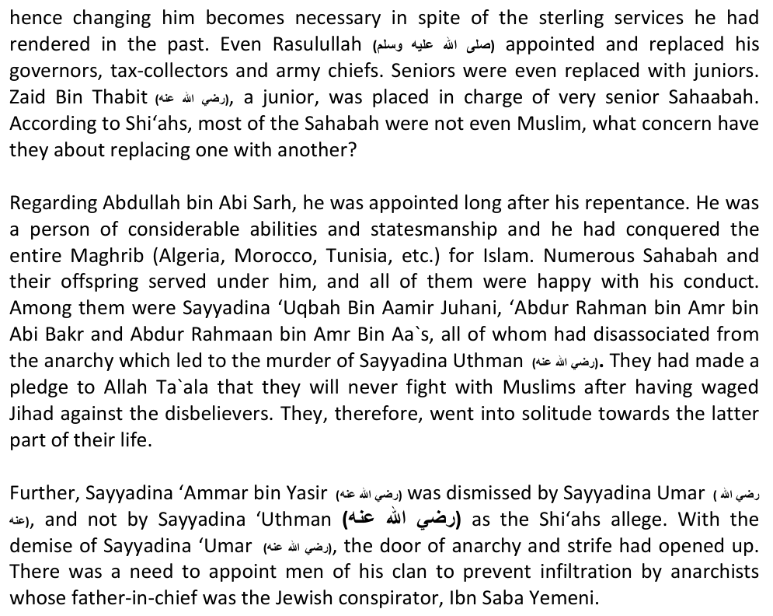

8.11: THE HADITH OF THE TWO WEIGHTY THINGS:
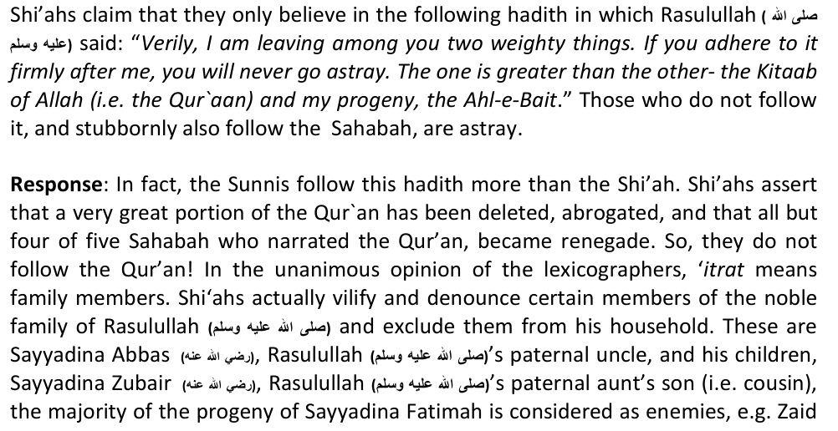
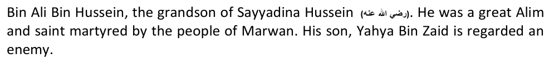
Ibrahim Bin Musa Kazim and Ja`far Bin Musa Kazim are similarly denounced. The Shiahs have branded the latter as a Kaththaab (great liar) while in reality he was a pious man. Ja`far Bin Ali, the brother of Imam Hasan Askari is also given the title, Kaththab. Hasan Bin Hasan Muthanni, his son 'Abdullah and his (Abdullah's) son Muhammad are branded Kaafir, and the following too: Ibrahim Bin Abdullah, Zakariyyah Bin Muhammad Baqir, Muhammad Bin Abdullah Bin Hussein Bin Hasan, Muhammad Bin Qaasim Bin Hasan and Yahya Bin Umar (the grandsons of Zaid Bin Ali Bin Hussein).In addition, the Sayyids of the Hasan and Husseini lines, who accept Zaid Bin Ali as the Imam are said to be deviates.
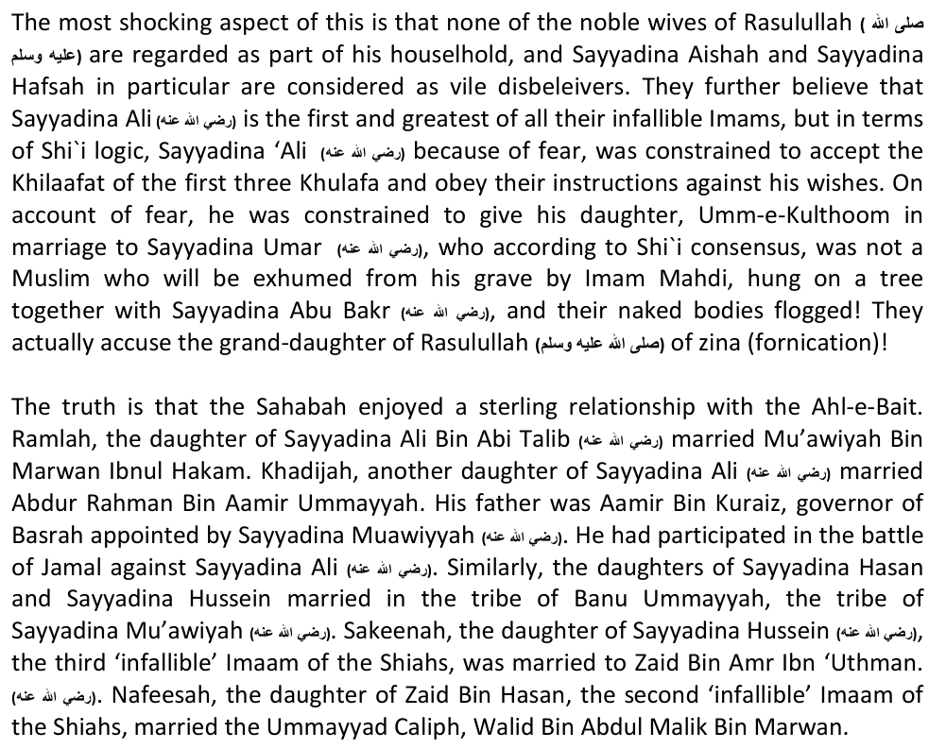

8.11: SHIAH SLOGAN OF UNITY AND HELPING THE PALESTINIANS:
Khomeini's popular slogan: "NO SUNNI'ISM, NO SHI'ISM, ONLY ISLAM" and today's popular perception of Iran being the only helper of Palestine and the only force to challenge America, has won over many Shi'ah sympathizers from the Sunnni world. Is this true?
Response: It is surprising that even in today's age of technology and information, people do not take the time to verify information and double-check news! Iran has never attacked the USA nor Israel, despite having the military means for doing so. And their military help of Palestine, Iran has only put the Palestinans in a worse situation!
The verbal professions of unity is based on their doctrine of Taqiyah. How is it possible for the Islam and Shi'ism to unite when the foundation of Islam is based on pure tawheed the love of the Sahabah, whilst the cornerstone of Shi'ism is based on compounded Shirk (polytheism) and rank hatred for our heroes of Islam? The two are irreconcilable opposites. The slogan of Khomeini is nothing but political trickery to gain the support of the Muslims for the fulfilment of Iran's despicable motives of political power. Khomeini stated in a message for a youth rally: "The Islamic and non-Islamic powers of the world will not admit our power till such time that we establish our hold over Makkah and Madinah because these are the centres and citadels of Islam. Hence our domination over these places is an essential requirement.. . when as a conqueror I will enter Makkah and Madinah, the first thing to be done at that time by me would be to dig out two idols (i.e. Sayyadina Abu Bakr and Sayyadina Umar) lying by the side of the Prophet's grave." (Khomeinism & Islam - by Abu Rehan Faruqi)

CHAPTER NINE: QUESTIONS THAT SHI'AHS CAN NOT ANSWER
After your Shi'ah friend tries to unucesfully confuse you with the above issues, now it's your turn to confuse him by asking him the questions below:
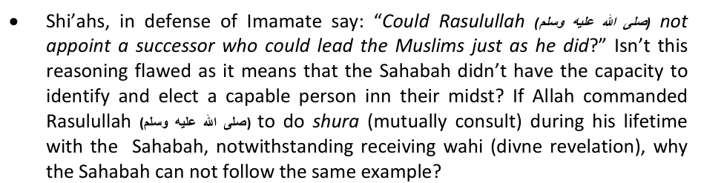
• There are over 40 different Shi'ah sub-sects, each one branding the other as Kaafir. Kindly state which Sh'iah sect is the correct one, and why?
this sect? Can a religion flourish werein thousands became apostate, and only three or four remained faithful?
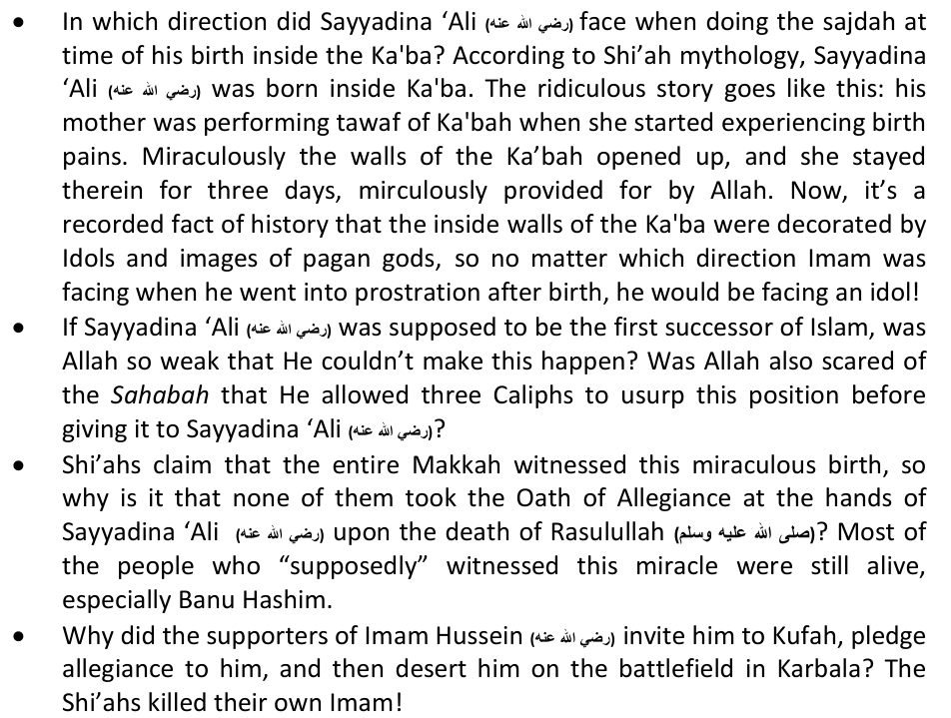
• You will hardly find a reliable narrator for any of the saying attributed to the "divine" Imams. Why rely on spuriousness when Shi'ahs can rely on the Sahabah and on trustworthy narrators whose trustworthiness are known to all?
• Please regale us with the story of the mother of the twelfth Imam who is hiding in the cave presently. Was his mother a Persian princess who appeared in his father's dream and impregnated her? Does the twelfth Imam really exist?
• Why do Shi'ahs beath themselves up on 'Ashura? Can all this lamenting bring back youor Imam Hussein? Isn't it too late? Maybe, the Shi'ahs are till today paying the price of betraying their Imam by lashing and slicing themselves!
• Why do Shi'ahs celebrate the Eid al-Ghadeer? The Ghadeer incident took place after the Hajjatul Wida (Farewell Pilgrimage) at a small pond in the desert. Does anyone proclaim important decisions of state in the middle of the dessert, or in the Capital?
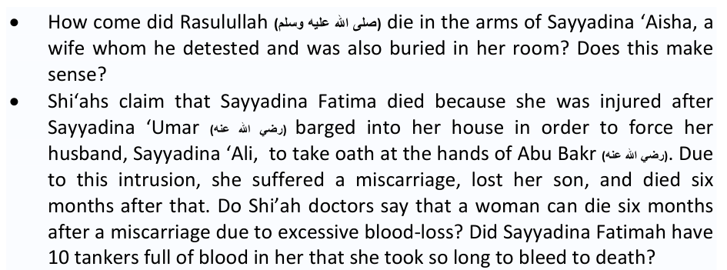
• What happened when the designated Imam died before his father who chose him as a successor? Due to your treachery, didn't you ascribe lies to Allah and say he doesn't really know when a person dies?
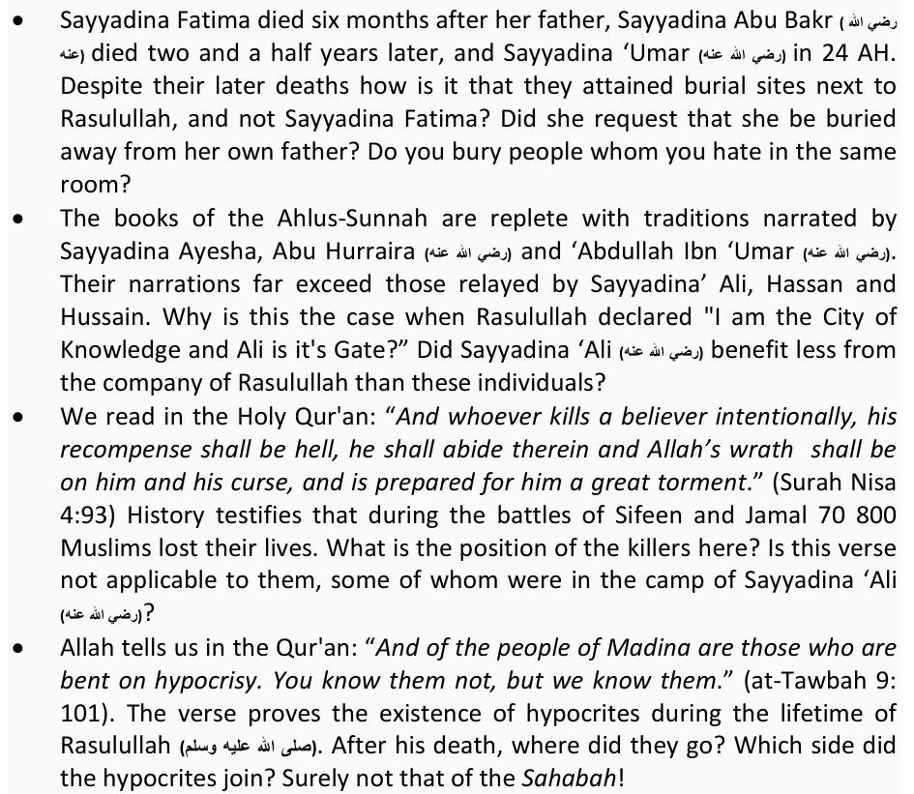
• There is not one Shi'ah Temple in Iran where the Taraweeh salaat is performed in Ramadaan wherein a completion of the Qur'an is made. Why don't you rather join the mainstream Muslims who have love for the Qur'an?
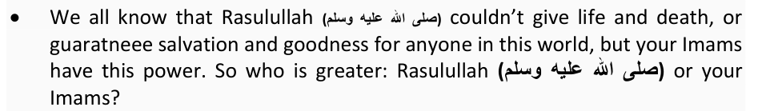
• Allah has mentioned in the Qur'an that He sent His Messengers in this world so that Islam can become dominant. At the moment, who are in the majority, Muslims or Shi'ahs? Which group of Muslims dominate?
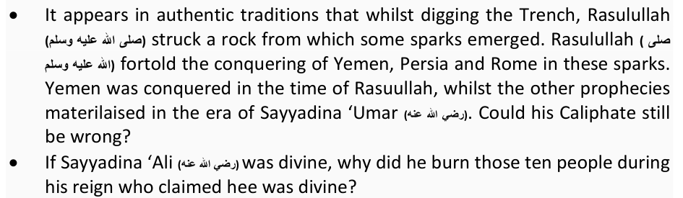
• Idolatory is nothing but entertaining hopes that the idol will intercede on one's behalf before Allah: "Yaquloona Ha'ulaa'i Shufa'aauna 'Indallah." Don't you Shi'ahs have the same belief regarding your Imams?
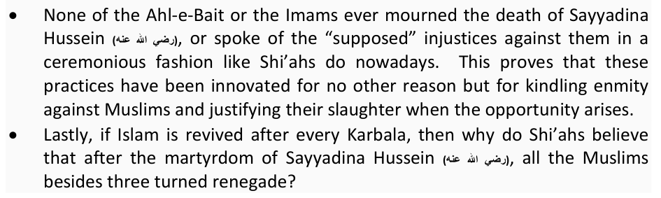
Have fun with your Shi'ah friend. Taunt him and see him squirm, turn red and blue! Then finally ask him to re-embrace Islam and make him recite the Shahaadah. Explain to him true Islam, ask him to give up this mischieveous game of his, and earn paradise by saving a lost soul. Good luck. May Allah be with you – Ameen.

CHAPTER ELEVEN: SOME USEFUL AUTHENTIC INTERNET RESOURCES TO ASSIST YOU
http://answersforshiafriend.wordpress.com/ http://www.shia.bs/ www.mahajjah.com www.anti-majos.com www.khorasaan.net www.theunjustmedia.com http://www.kr-hcy.com http://youpuncturedtheark.wordpress.com/ http://gift2shias.com/ http://twelvershia.net/ http://islamistruth.wordpress.com/ http://devilsdeceptionofshiism.wordpress.com/ http://www.sunnidefense.com/ http://lies-of-answering-ansar.org/ http://aaunveiled.wordpress.com/ http://www.islamicweb.com/beliefs/cults/shia.htm http://www.ansar.org/english/index.htm http://sonsofsunnah.com/ http://www.islamawareness.net/Deviant/Shia/khutoot.html http://www.youtube.com/user/RafidiTerminator
Monday 21st Oct. 2014: WA MA 'ALAINA ILLAL BALAAGH (AND UPON US IN ONLY DELIVERING THE MESSAGE)

