
The Facts of Coke
The Majlis · Voice of Islam
Mujlisul Ulama of South Africa

About this edition
This is a reproduction by The Majlis Archive (themajlisarchive.com) of a publication of The Majlis, Mujlisul Ulama of South Africa, made and published with their permission.
The PDF as The Majlis issued it is the original. This edition was read from that PDF's own structure and checked against it letter for letter; where the two differ, the PDF is correct.
Checked: 329 paragraphs, 0 differing; a second, independent PDF reader finds 100.0% of the PDF's words here.
Nothing has been reworded, added or removed.

SOFT DRINKS

THE FACTS OF

COKE
Issued by:
The Mujlisul Ulama of South Africa
PORT ELIZABETH
South Africa

SOFT DRINKS
HE MUJLISUL ULAMA of South Africa has established beyond any doubt that Coca Cola as well as all other soft drinks contain very small quantities of alcohol. In this fact there is no doubt and the manufacturers of these minerals cannot and do not dispute this claim. Attached hereto are papers which testify to the validity of our claim.
Some of our brethren dispute our stand and not only disagree with our findings, but actively, practically and sarcastically advocate and encourage Muslims to consume these minerals.
While they are entitled to their opinions based on Shar'i proofs if indeed they do possess any such proofs, we must stress that they are not discharging their duty as Ulama-e-Haqq on account of their negligent and childish attitude in this matter. Every Aalim of Truth should be aware of Rasulullah's (sallallahu alayhi wasallam) advice that Muslims should abstain from mushtabah (doubtful) things. A mushtabah thing becomes such not on the basis of one's personal feeling, likes or dislikes. A thing will become mushtabah where there exists valid Shar'i Dalaa-il. When a group or even a single Aalim acting on the basis of valid Shar'i Dalaa-il proclaims an item unlawful, then a valid doubt has been introduced. The item becomes mushtabah and in terms of Rasulullah's (sallallahu alayhi wasallam) exhortation the mu'min should abstain there from.
Hence, even those Ulama who claim that Coke is absolutely halaal should not step out of their way to encourage people to consume such minerals.
Uprighteousness demands that they advise their followers to abstain and since they do not accept the finding of prohibition they will be acting correctly if they do not proclaim minerals to be unlawful. However, since they have not even bothered to enquire of the basis and the proofs of those who proclaim Coke to be unlawful, they have failed in their duty and we can say that they are regarding these minerals to be lawful purely on the basis of their personal opinion and liking. While they may have written a letter or two to the manufacturers to enquire about the alcohol content of Coke, they have accepted the word of the manufacturers as being the final verdict. While they condemn us behind our backs for our stand, they never, as uprighteous Ulama, bothered to enquire from us the basis of our stand.
It is alleged that we are being unnecessarily hard (mutashaddid) in having declared Coke unfit for Muslim consumption. It is claimed that we are imposing difficulties on people by having branded Coke and other soft drinks.
A little unbiased thought will dispel these observations.
Firstly, Coke is not a necessary item of diet. No one will suffer any detrimental effect by abstaining from Coke. Secondly, Coke is a luxury drink from which even millions of non-Muslims in this country and other countries abstain. Thirdly, Coke and other minerals are detrimental to the health. Abstention from these minerals is thus a blessing and a favour rendered to oneself. Fourthly, no one will suffer in anyway whatever if he/she abstains from Coke and other soft drinks. Fifthly, a large variety of fresh fruit juices are available on the market which are far better substitutes for the carbonated soft drinks.
In view of the above mentioned facts, there is no substance in the claim that a difficulty is being imposed on Muslims by asking them to abstain from soft drinks.
Some claim that our contention of alcohol in soft drinks is without proof. However, this is the weakest and the most baseless argument since investigations prove conclusively that soft drinks do contain small quantities of alcohol as the annexures hereto confirm. Therefore, those who assert that Coke and other soft drinks do not contain any alcohol are in fact making baseless claims for which they have no proof whatever.
At our inspection of our local Coca Cola plant the bottling process was shown and explained to us. It was emphasised by the management that no alcohol whatever is used in the production. However, we pointed out that the concentrate or the essence the vital and fundamental ingredient, was alcoholic. Surprise was expressed by the plant's officials who were conducting the tour with us. We asked to be shown the concentrates. These were shown to us at request. We again mentioned that the concentrates contained approximately 20% alcohol by volume. The officials at the plant claimed to be ignorant of this fact I but promised that enquiries will be made. Refer to annexures 'Al' and 'A2'.
The concentrates from which soft drinks are produced contain about 20% alcohol by volume. It is from such alcoholic concentrates that Coke and other minerals are made. In the final product, viz. the soft drink, small quantities of alcohol remain. Refer to annextures B, C and D. It is, therefore, unreasonable and utterly baseless to deny the alcohol-content of Coke and other soft drinks. These minerals are made from only alcoholic concentrates and the final product contains minute quantities of the alcohol.
It is also alleged that since non-khamr alcohol is used in soft-drink manufacturer soft drinks should not be branded unlawful on account of the fact that according to Imaam Abu Hanifah (rahmatullah alayh) and Imaam Abu Yusuf (rahmatullah alayh) non-khamr alcohol is taahir and if taken in non-intoxicating quantities remains halaal. This argument is not acceptable for several reasons.
(1) It is accepted that the alcohol (ethanol) used in soft drink manufacture is not khamr. However, since the past 14 centuries the Fatwa of the Hanafi Math-hab has been on the view of Imaam Muhammad (rahmatullah alayh), viz. all alcohol, be it non-khamr, is haraam and najis. The Hanafi Fuqaha have for the past 14 centuries issued the Fatwa on this view of prohibition. Today there exists no pressing need to reverse this Muftabihi view of the Hanafi Math-hab. There is no valid reason for the desire to cancel the official and standing Fatwa of the Hanafi Math-hab in regard to alcohol and issue a new Fatwa in so far as minerals are concerned. Yes, it is conceded that there is such a need in regard to medicines since it is almost impossible to find any alcohol-free medicine. On account of the real need in regard to medicine, the Fatwa of permissibility based on the viewpoint of Shaikhain (rahmatullah alayh), issued by our senior Ulama is understandable and acceptable. But, there is no such need in regard to minerals.
(2) By declaring soft drinks made from alcoholic concentrates halaal, a door to future fitnah is being opened up. In fact the stage is being prepared for future legalization of liquor as has been predicted by Rasulullah (sallallahu alayhi wasallam).
(3) The Ruling (Fatwa) of the Hanafi Math-hab being on the view of Imaam Muhammad (rahmatullah alayh) is based on the principle of blocking the avenue for future fitnah. Ignoring this ruling and principle in regard to the unnecessary luxury of Coke, etc., the door for fitnah is being opened in that other drinks which are generally regarded as unlawful by all our Ulama, will also come within the scope of permissibility which has been accorded to soft drinks. Barbican Beer and similar other supposedly alcohol-free beers too contain the non-khamr ethanol. Although Barbican Beer, etc., are advertised 'alcohol-free' they do contain ethanol-alcohol in small quantities. In view of the alcohol in very small quantities, the authorities permit such beverages to be advertised 'alcohol free'. See annexure D. To the best of our knowledge none of our Ulama has ventured to proclaim these 'alcohol-free' beers halaal. Yet, these beers contain ethanol in the same quantities as do the soft drinks. In fact, Barbican Beer contains a lesser quantity of alcohol than some soft drinks. Annexure 'D' states that Barbican Beer contains .03% alcohol.
According to Annexure 'C' Sparletta Lemonade contain .04% alcohol; Raspberry contains .033%; Pineapple contains .04% and Cream Soda 05%. Thus, all these flavours have more alcohol than some of the beers which our Ulama regard to be haraam.
Therefore, those who claim that Coke, etc., are halaal, have no logic and no reason for maintaining that Barbican Beer and other similar beers are haraam since the soft drinks (some or most of them) contain a greater quantity of the non-khamr ethanol-alcohol than these haraam beers. Hence, in proclaiming soft drinks halaal, the door has already been opened for declaring Barbican, etc. halaal.
(4) Let us take this argument a step further. Laager and Castle Beer are unanimously regarded as haraam by our Ulama. However these beers too contain the non-khamr ethanol. While Laager beer contains about 3.6% ethanol, soft drinks contain .058 ethanol. The difference is only in quantity. But, both contain the non-khamr ethanol. Laager and Castle beer taken on the basis of the principle employed by the legalizers of soft drinks, can also be declared 'halaal'. Thus, the avenue for fitnah has been expanded to bring Laager, Castle and similar beers within the scope of the permissibility which has been applied to soft drinks.
(5) Let us progress further with this argument. Gin and Whiskey are unanimously proclaimed haraam by our Ulama. No Aalim so far has said that a small quantity of Gin and Whiskey is halaal. Yet, these liquors contain the self-same non-khamr ethanol which soft drinks contain. Gin and Whiskey taken in small quantities do not intoxicate. On the basis of the principle employed by the legalizers of soft drinks, Gin and Whiskey too should be 'halaal'. Thus, the door for fitnah has been opened even wider to accommodate even Gin and Whiskey. The same argument will extend to Vodka and many other liquors which contain non-khamr ethanol and which do not intoxicate if taken in small quantities.
(6) It should be understood that Rasulullah's (sallallahu alayhi wasallam) prediction about the 'legalizing of liquor' will not take place overnight. It will be a gradual process – a process which has already been initiated by those who regard soft drinks to be halaal. The modernists and the ulama-e-soo' will sooner or later set into motion the technicalities of Fiqhi principles to legalize all liquor on the basis of the non-khamr alcohol content and on the principle of small quantities which do not intoxicate. It is only short-sighted persons and those who are not concerned much with the morals of the Ummah who will venture to be so careless and proclaim soft drinks permissible without even having properly investigated the matter and without thinking of the future and of Rasulullah's (sallallahu alayhi wasallam) prediction.
Of importance regarding this issue is the fact that the view of even the Shaafi, Maliki and Hambali Math-habs conforms with the verdict of the Hanafi Math-hab, namely, all types of alcohol are najis and haraam. Rasulullah (sallallahu alayhi wasallam) said:
"Whatever intoxicates in a large quantity, even its little quantity is forbidden."
"Every intoxicant is haraam."
It does not behove the Ulama to issue such verdicts which are of neither worldly nor spiritual benefit to the Ummah and serve only the purpose of boosting the monetary interests of the kuffaar.
Annexure 'E' is extracts from an article, GOING TO HELL IN A SHOPPING BASKET which appeared in a book BIG SECRETS.
These pages present some interesting facts in the history of Coca Cola. The facts came to light during a Supreme Court trial regarding the ingredients of Coca Cola. It is conclusively proven in this article that Coca Cola contains alcohol.
We trust that we have sufficiently explained our stand in regard to soft drinks.
Was-Salaam
A.S. DESAI for
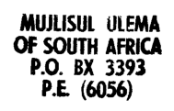
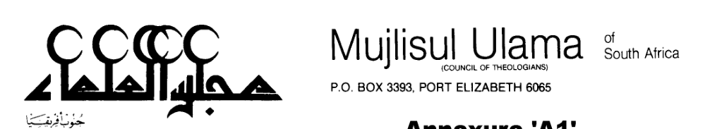
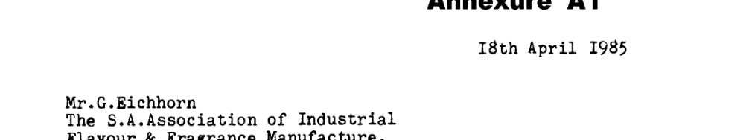
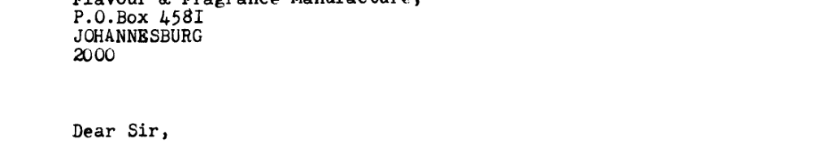
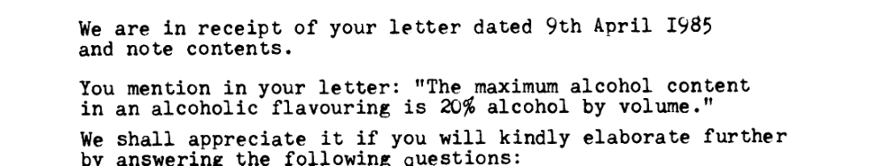
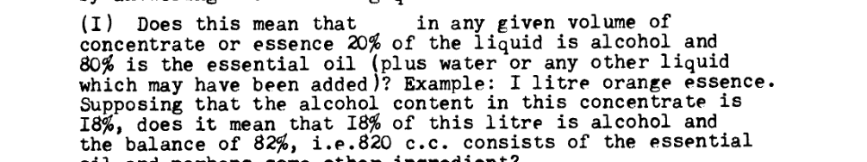
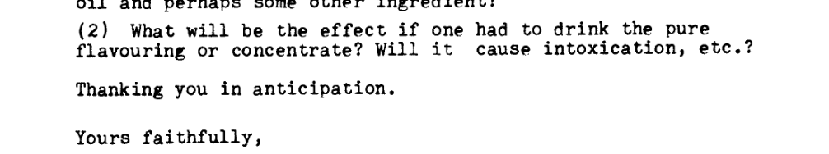
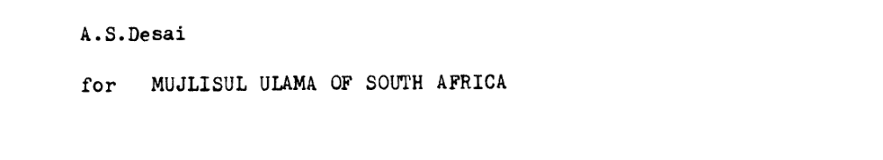
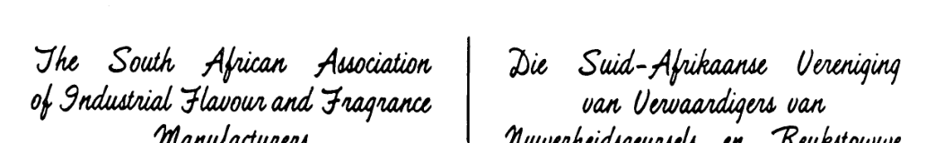
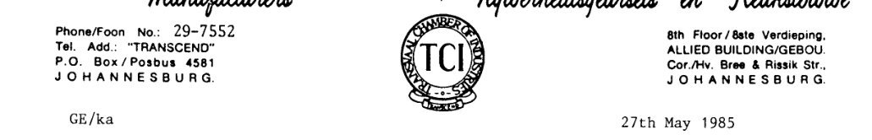
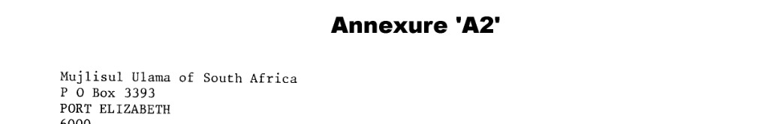
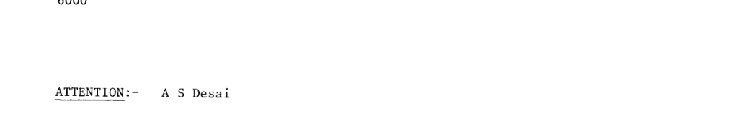
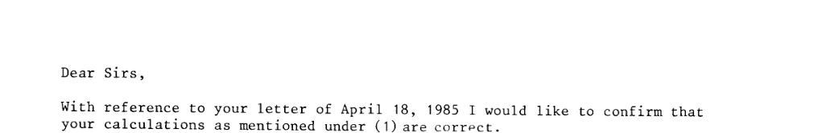
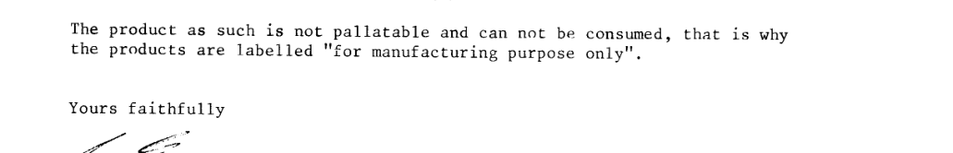
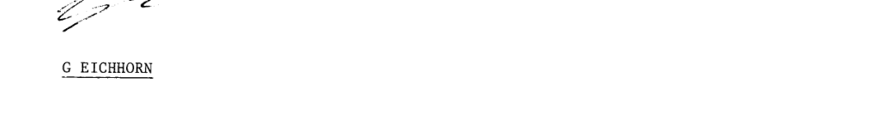
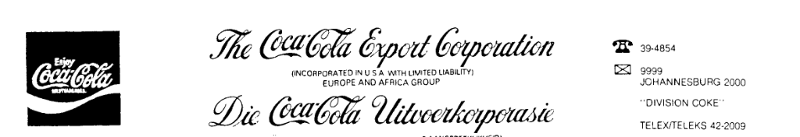
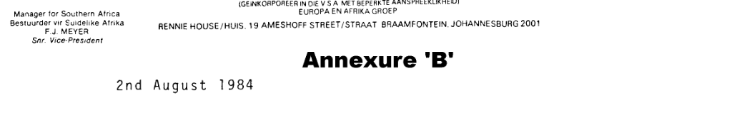
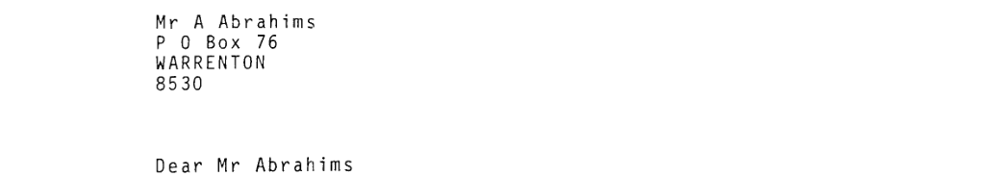
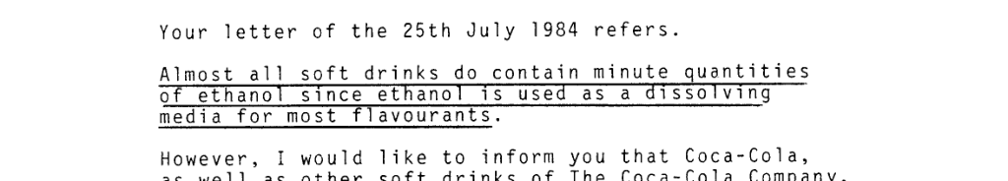
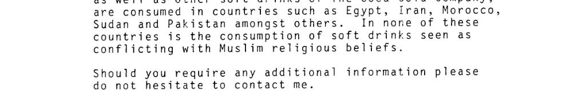
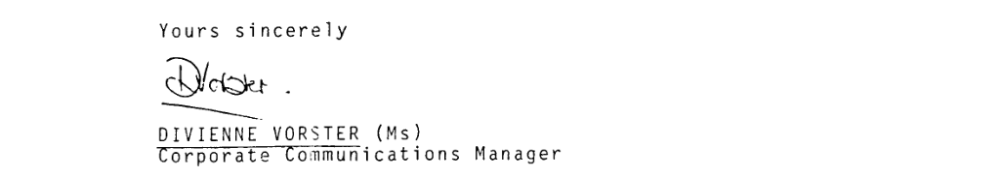
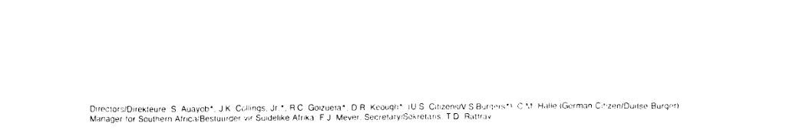
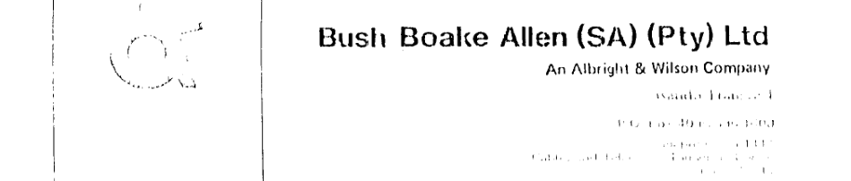
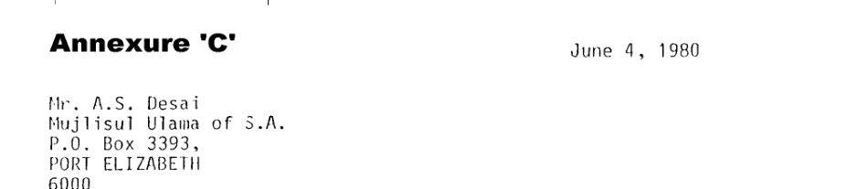
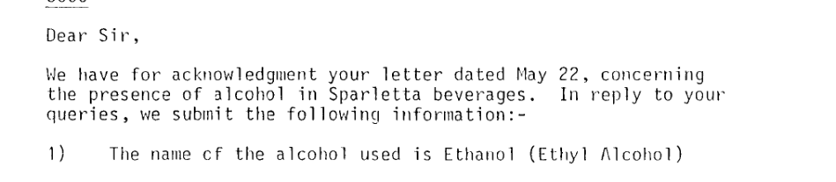
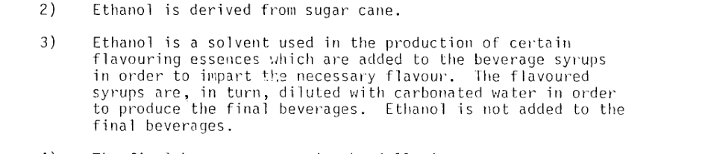
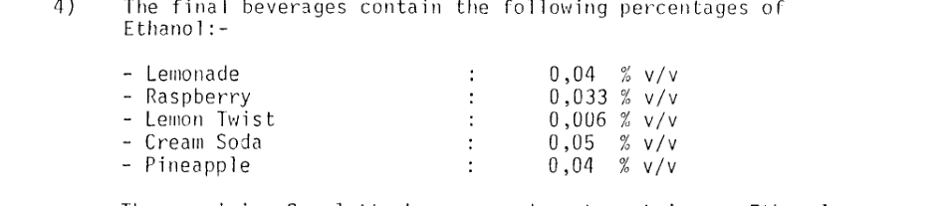
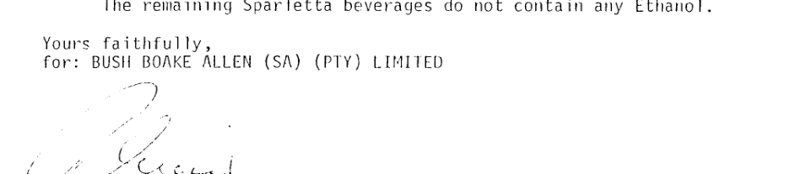
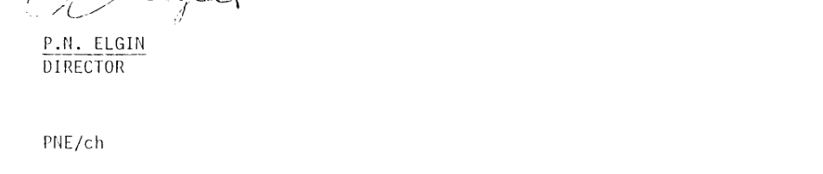
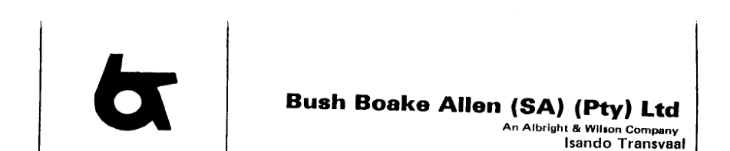
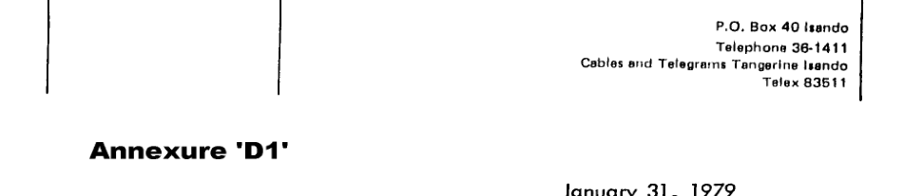
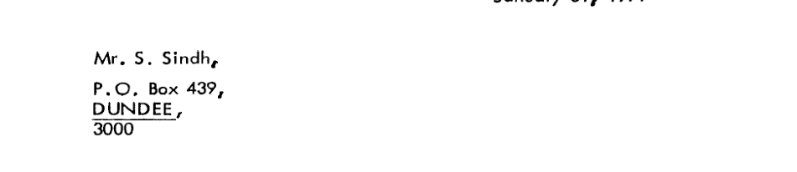
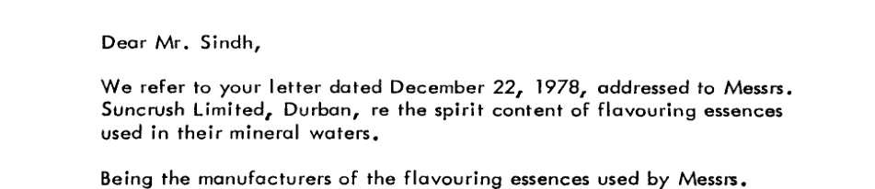
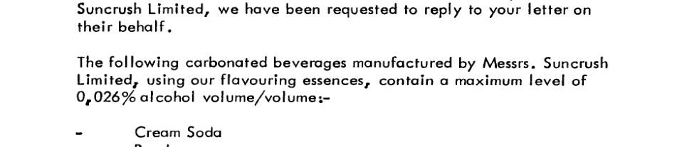
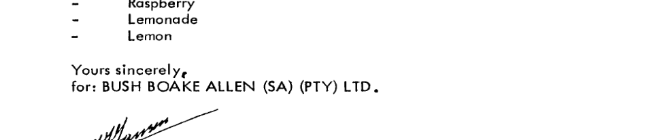
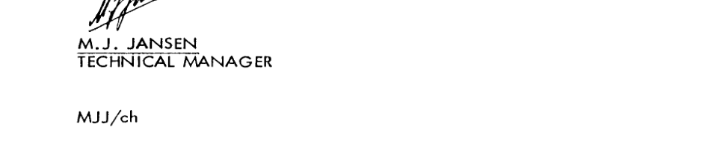
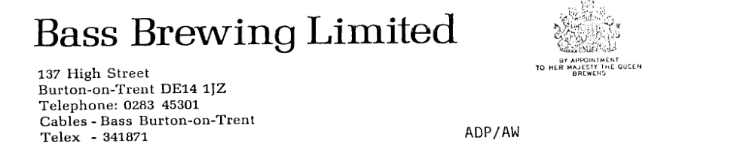
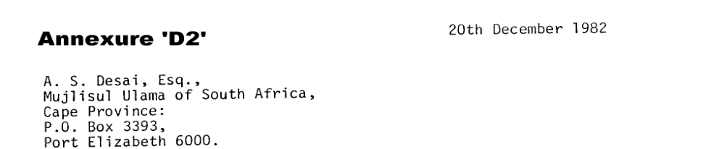
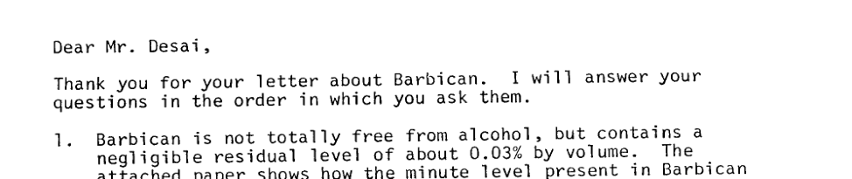
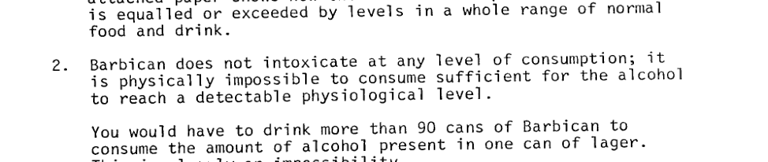
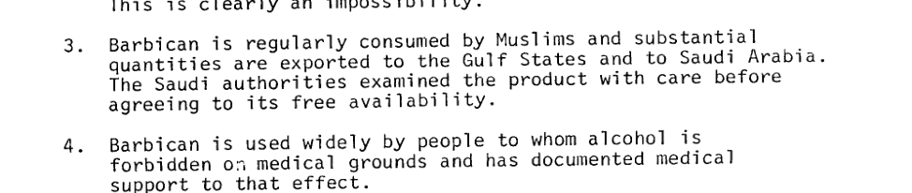
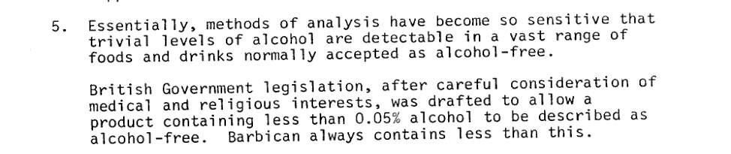
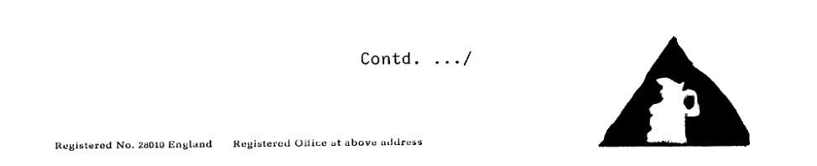
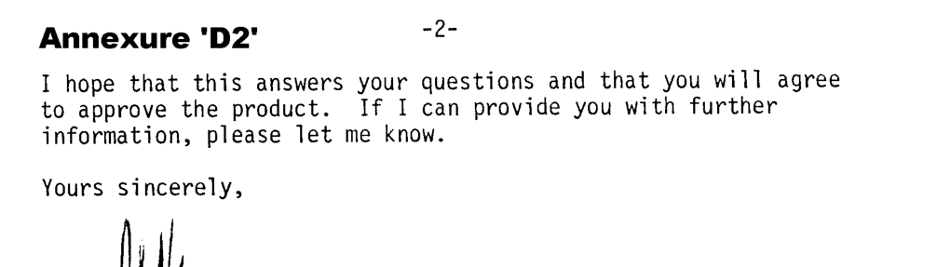
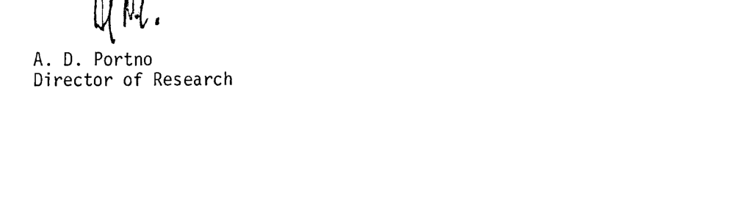

Annexure 'E'
The Pemberton product did not have an altogether agreeable taste, it was unstable, it contained too many things, too much of some ingredients and too little of others.
Father's pharmaceutical knowledge convinced him that the formula had to be changed in certain particulars to improve the taste of the product, to insure its uniformity and its stability. Some of the ingredients were incompatible with others in the formula; the bouquet of several of the volatile essential oils previously used was adversely affected by some ingredients. Several needed materials, one notable for its preservation virtue, were added.
The first thing he did was to discontinue the use of tin can containers for shipping. On account of the inclusion of a very desirable constituent in the formula, the use of tin cans was dangerous.
Here the "people to whom he had paid hard-earned cash" would include
Walker, Dozier, and also the Pempertons, who retained an interest in Coca-Cola for several years. The second ingredient Candler hints at, the one that doesn't go with tin cans, is easy to guess. It's phosphoric acid. Phosphoric acid eats through tin, forming poisonous tin phosphate. (Currently, Coke uses stainless-steel containers.)
That means that the phosphoric acid was Candler's innovation and wasn't in the original formula. But Charles Candler says in the same book that the Pemberton formula included "an acid for zest." Perhaps this acid was one of the ingredients Candler took out of the formula. Or it could have been lime juice.
Lime juice is one of the ingredients that has been reported in chemical analyses of Coke. Several analyses of Coke were offered as evidence in the United States v. Forty Barrels and Twenty Kegs of Coca-Cola trial. In 1909 the federal government seized the latter quantity of Coca-Cola syrup en route from Atlanta to a bottling plant in Chattanooga and charged Coca-Cola with violation of the Pure Food Act. Trial and appeals ran about a decade. One analysis of the syrup claimed:
Caffein (grains per fluid ounce) 0.92–1.30 Phosphoric acid (H3PO4) (percent) 0.26–0.30 Sugar, total (percent) 48.86–58.00 Alcohol (percent by volume) 0.90–1.27 Caramel, glycerin, lime juice, essential oils, and plant extractives
Present
Water (percent)
34.00–41.00
Another analysis from the trial ran:
Caffeine 0.20 per cent or 1.19 grains per ounce.
Phos. Acid 0.19 per cent.
Sugar 48.86 per cent.
Alcohol 1.27 per cent.
Caramel, glycerine, Lime Juice, oil of cassia Water about 41 per cent.
There seems little doubt that Coca-Cola contained lime juice circa 1909. To confirm its presence in Coke today, Big Secrets wrote to the Coca-Cola Company asking about lime juice. Bonita Holder of Coca-Cola replied: "While we are unable to comment specifically on the various flavors utilized in Coca-Cola, I can nonetheless confirm for you that Coca-Cola contains no lime juice, or any fruit juice."
Lime juice is perishable and somewhat cloudy; it varies with each season's crop. Coke therefore might have wanted to replace it with a more stable substitute. A mixture of citric acid and some of the flavouring principles of lime juice (which are distinct from those found in the oil of lime peel) might have been substituted for the original lime juice without anyone noticing much of a change in the taste of Coca-Cola. Citrus juices are easy to fake.
Coca-Cola produces such soft drinks as Hi-C Orange, Hi-C Lemonade, Hi-C Punch, and Hi-C Grape, which don't contain any fruit juice either.
The analyses mention three other ingredients: alcohol, glycerin, and oil of cassia. Evidently glycerin is the preservative Candler described. It is a customary ingredient in soft-drink syrups. It is believed to prevent separation of essential oils on standing.
Coke syrup is about 2 proof. The alcohol probably only enters in as a solvent for the "plant extractives." Oil of cassia seems to be one of the essential oils that provide Coke's flavoring. Cassia is a form of cinnamon, sometimes called Chinese cinnamon to distinguish it from true or Ceylon cinnamon. Most of the stick cinnamon sold in supermarkets is Ceylon cinnamon. Most of the cinnamon used in commercial baked goods such as coffee cakes is cassia.
Conspicuously absent from the above analyses is any mention of coca or kola. This was one of the main issues of the United States v. Forty Barrels and Twenty Kegs of Coca-Cola trial. Coca leaves contain cocaine; ergo, it was claimed that Coca-Cola must either contain that recently outlawed drug, or the coca must have been dropped from the formula. In the latter case, the government charged, it was mislabeling to use "Coca" in the name. Further, it was charged the kola in Coca-Cola was an imposition–a trace ingredient added only so that the company could claim it was there. Thus the "Cola" part of the name was misleading, too.
Indeed, there is precious little coca or kola in Coca-Cola. None of the chemical analysts consulted at the trial were able to detect coca or kola. But there are traces of coca and kola present, in what Coca-Cola calls merchandise no. 5. At the time of the trial, merchandise no. 5 was manufactured by a contractor, the Schaeffer Alkaloid Works of Maywood, New Jersey. Its president, Dr. L. Schaeffer, described the manufacture of Coke's fifth ingredient:
Q. Now, Doctor, do you make Merchandise No. 5 for the Coca-Cola Co.? A. Yes, sir.

Q. From what substance do you make that Merchandise No. 5?
A. Of the Coca leaf and the Cola nut, and of dilute alcohol sir.
Q. What do you use the alcohol for, what is the purpose of putting in the alcohol? A. To extract from the bodies mentioned the extractive matter.
Q. Do you use anything else in that compound except the extracts from the coca leaves and cola nuts and dilute alcohol? A. No, I do not use anything to speak of, or essentially.

Q. Now just state the process, Dr. Schaeffer, by which you
manufacture this Merchandise No. 5? A. The process consists of two parts. The first part is to decocanize the coca leaf, the second part is to use the decocanized coca leaf and cola nut, both of which are in powdered form, to make the infusion, that is, the same extract made by percolation with dilute alcohol.... The proportions which are used in the process as follows: 380 lbs. of coca leaf, 125 lbs. of cola nuts and 900 gallons of dilute alcohol of about twenty per cent strength ...
The cocaine was removed from the coca leaves by rinsing with toluol, a solvent. Cocaine dissolves in toluol; repeated rinsing leaches away the cocaine.
According to Dr. Schaeffer's testimony, there was wine in Coca-Cola. The alcohol used in making merchandise no. 5 was usually a mixture of California white wine and 95 percent commercial alcohol. But Dr. Schaeffer sometimes used an alcohol-water mixture "if California wine is too high in price. It is altogether a matter of price of the wine or of the alcohol."
Merchandise no. 5, according to testimony, was a dark, winey liquid. Several of the witnesses were given samples of merchandise no. 5. One thought it tasted and smelled no different from the wine it was made from. One Coca-Cola witness claimed it had the characteristic odor of coca but proved unable to describe the odor. Another witness said it smelled like toluol, the toxic solvent that isn't supposed to be present in the final product at all.
An experiment was performed for the benefit of the court. Coca-Cola made up a special batch of syrup containing no merchandise no. 5. Witnesses thought it tasted the same as the regular syrup.
In short, neither coca nor kola has much, if anything, to do with the taste of Coca-Cola. Both substances, in fact, have unpleasant, bitter flavors wholly unlike that of Coca-Cola.
Pemberton, remember, was concocting a medicinal syrup. Because his two active ingredients had unpleasant flavors, he masked them with other flavors– the way a codeine cough syrup might be cherry-flavored.
As it happened, Coca-Cola became successful for its flavor rather than for any medicinal value. Dozens of imitations sprang up, most with "Cola" in their name. Thus "cola" became the generic term for soft drinks similar to Coca-Cola. Most–though not all–of these imitations contained kola nuts. But as with Coke, the kola really didn't contribute to the flavor.
Cherry cough syrup tastes like cherries. The "cola" flavor tastes like...nothing familiar. That raises two possibilities. Cola flavor may come from an exotic substance, otherwise unknown to Western taste buds. Or it may be what the soft-drink industry calls a "fantasia" flavor, a new flavor created by the artful combination of other flavors.
The basics of cola flavor are no mystery.
Caramel (32 fluid ounces)
Lime juice (32 fluid ounces)
Glycerin (16 fluid ounces)
Alcohol 95 percent (12 fluid ounces)
Cola flavor base (12 fluid ounces)
Kola nut extract (12 fluid ounces)
Caffeine solution (2 ounces of caffeine in 10 fluid ounces of water)
Vanilla extract (2 fluid ounces)
These are mixed to produce 128 ounces (1 gallon) of cola flavor. Four ounces of this cola flavor, plus .5 fluid ounce of diluted phosphoric acid (one part 85 percent phosphoric acid to seven parts water), are used to flavor a gallon of sugar syrup. The composition of the cola flavor base and the kola nut extract are given in accompanying recipes.
This recipe suggests the identities of the unknown merchandise. Merchandise no. 1, sugar, is the syrup to which the cola flavor is added. Nos. 2 and 3, caramel and caffeine, are in the recipe, caffeine in a water solution. No. 4, phosphoric acid, is added to the sugar syrup. No. 5, in Coca-Cola's recipe, is coca and kola extract in an alcohol-water solution. This corresponds to two ingredients in the Merory recipe: the kola nut extract and the 95 percent alcohol. The kola nut extract is to be prepared according to another Merory recipe, MF 237. This requires that kola nuts be extracted with a solvent, propylene glycol, most of which is then distilled off. Water is added, so the result is a water-based extract of kola. Were alcohol added to this extract, you'd have a sort of merchandise no. 5 (without the coca, though). Of course, the alcohol and kola extract can be treated as separate ingredients–which is how Merory lists them.
There are four remaining ingredients in Merory's list–and four remaining merchandises of the nine Candler claimed. Merory's four are lime juice, glycerin, a cola flavor base, and vanilla extract. Of these, the first two were reported in lab analyses of Coke (though Coke now denies lime juice). The last, vanilla extract, is a generally acknowledged component of the cola flavor.
It is tempting if not compelling to identify these four with merchandise nos. 6 through 9. We can't be sure that Coca-Cola doesn't mix together glycerin and vanilla extract.
According to the Merory recipe for flavor base, the above mixture of oils (100 grams) is mixed with 22 fluid ounces of 95 percent alcohol and shaken. Five ounces of water are added, and the mixture is left to stand for twenty-four hours. A cloudy layer of terpenes will develop; only the clear part of the mixture is taken off and used in recipe MF 241.
There may be other ingredients in the Coca-Cola oil mixture. In The Big Drink, E. J. Kahn, Jr., mentions the possibility of lavender as an ingredient. The alternate Merory cola recipe, which uses citric acid and less orange oil, suggesting a Pepsi-like product, includes coriander in lieu of nutmeg. (Coriander is a spice found in Danish pastries.) Perhaps there is a trace of coriander in Coca-Cola. In another of the occasional breaches of industry closemouthedness, flavorist, A. W. Noling published a pamphlet on colas in 1952. The Hurty Peck Pamphlet on Cola attributed the secret of cola flavor to extracts of decocanized coca leaves and kola nuts, oils of lime, lemon, orange, cassia, nutmeg, neroli, cinnamon, and coriander, and lime juice and vanilla. Noling's analysis seems to have been directed specifically at Coca-Cola. Among modern cola drinks, only Coca-Cola is known to use the coca leaves.
The proportions in the accompanying recipe are based on the analyses of Coke quoted above and Merory's recipes. The amount of caffeine agrees with that stated in Coca-Cola's So you asked about soft drinks...pamphlet; this is about a third of the caffeine found in the trial analyses.
The following recipe produces a gallon of syrup very similar to Coca-Cola's. Mix 2,400 grams of sugar with just enough water to dissolve (high-fructose corn syrup may be substituted for half the sugar). Add 36 grams of caramel, 3.1 grams of caffeine, and 11 grams of phosphoric acid. Extract the cocaine from 1.1 grams of coca leaf (Truxillo growth of coca preferred) with toluol; discard the cocaine extract. Soak the coca leaves and kola nuts (both finely powdered; 0.37 gram of kola nuts) in 22 grams of 20 percent alcohol. California white wine fortified to 20 percent strength was used as the soaking solution circa 1909, but Coca-Cola may have switched to a simple water/alcohol mixture. After soaking, discard the cola and the kola and add the liquid to the syrup. Add 30 grams of lime juice (a former ingredient, evidently, that Coca-Cola now denies) or a substitute such as a water solution of citric acid and sodium citrate at lime-juice strength. Mix together 0.88 gram of lemon oil, 0.47 gram of orange oil, 0.27 gram of lime oil, 0.20 gram of cassia (Chinese cinnamon) oil, 0.07 gram of nutmeg oil, and if desired, traces of coriander, lavender, and neroli oils, and add to 4.9 grams of 95 percent alcohol. Shake. Add 2.7 grams of water to the alcohol/oil mixture and let stand for twenty-four hours at about 60oF. A cloudy layer will separate. Take off the clear part of the liquid only and add to the syrup. Add 19 grams of glycerin (from vegetable sources, not hog fat, so the drink can be sold to Orthodox Jews and Moslems) and 1.5 grams of vanilla extract. Add water (treated with chlorine) to make 1 gallon of syrup.
Yield (used to flavor carbonated water): 128 6.5 ounce bottles.
Coca-Cola: The Real Things?
Coke is 99.5% sugar water.
water sugar
For color. Without it, Coke would be as clear as 7-Up.
caramel caffeine Responsible for acidic tang and science-fair projects where Coke digests hamburger.
For the kids' hyper kinetic rush.
phosphoric acid
Utterly superfluous: Leave out the coca and the kola, and the drink tastes the same. California white wine can be used for the alcohol.
coca leaf kola nut 20% alcohol
The Real Thing no longer contains real lime juice.
lime juice (or substitute)
Citrus and spice oils, not kola nuts, make Coke taste the way it does. There may be traces of coriander, lavender, and neroli oils, too.
lemon oil orange oil lime oil cassia oil nutmeg oil 95% alcohol
A preservative.
glycerin
Slight cream-soda nuance.
vanilla extract
The amount of kola in this recipe–or in any cola–is tiny. Some colas are reported to contain none at all. By this recipe, a gallon of cola is made from 0.37 gram of kola nut. But a gallon of 128 fluid ounces, and each ounce can flavor a bottle of finished, carbonated beverage. So the amount of kola nut used in making a bottle of cola drink is about 3 milligrams. That tiny speck is merely soaked in alcohol and then discarded, only the alcohol going into the cola syrup.
Many Coca-Cola drinkers swear that the drink tastes different in various parts of the country. Coke's standard answer is to blame the mineral content of the water used by the bottling plants. (Now that the syrup plants have the option of using corn syrup for part of the sugar, the Coke in regions where they so use corn syrup ought to taste different from–probably not as good as– the Coke where only cane sugar is used.) Where soda fountains still make Coke from syrup, another variable is the "throw"–the amount of carbonated water added to the syrup. Southerners tend to like Coke on the syrupy side.
Is There Cocaine in Coca-Cola?
Coca-Cola was not always alone in its use of coca. There were coca elixirs and beverages before there were colas. Until 1903, Coca-Cola contained the full cocaine content of its coca extract. Since then, Coca-Cola has taken great pains to remove the cocaine from the coca leaves before they go into merchandise no. 5. According to one source, there were sixty-nine imitations of Coca-Cola still containing measurable cocaine in 1909.
One version of the chestnut about putting an aspirin in Coca-Cola says that the cocaine is thus precipitated. (The more usual version holds that the aspirin-Coke mixture acts as a Mickey, the opposite of what would be expected from cocaine.) Of course, the Coca-Cola Company bristles at any suggestion that there might still be cocaine in the drink.
Even before 1903, the amount of cocaine in Coca-Cola was trifling. One analysis put the cocaine content of an ounce of Coca-Cola syrup–in the pre-extraction days–at 0.04 grain (2.6 milligrams).
Extracts from "UTUSAN KONSUMER #298, MARCH 1994"
HARAM–Coke contains ALCOHOL, according to book COCA-COLA may contain alcohol. This clearly makes it haram (prohibited for consumption) to Muslims.
CAP stumbled upon this shocking fact while scrutinising the drink's "secret" formula exposed in a highly detailed book published recently.
The author of the book came across the original recipe on a yellowing piece of paper marked "X" in a company archive.
Alcohol was one of the ingredients listed in the recipe.
The discovery of this closely kept formula was reported in the British Sunday Times on August 1 last year.
Coca-Cola denies the recipe is genuine. But when the Sunday Times produced a cola based on the formula, it fooled several experts into believing it was "the real thing".
To date, the company has not denied that there is alcohol in the drink. For more than a century, the makers of Coca-Cola have refused to reveal its contents, even under two judges' order.
In 1977, when the Indian government demanded to know the formula, Coca-Cola withdrew from the country rather than reveal it.
On their secret depends a global turnover of close to a reported £9 bil (RM37 bil). Coca-Cola sells in 185 countries worldwide, including Malaysia.
CAP's check on all Coca-Cola drinks sold here shows: that alcohol is not mentioned on the label at all.
This could well mean that under the guise of secrecy, Muslims could be drinking alcohol without knowing it!
Our study also shows that stripped down to its essentials, Coke is just a "Real Nothing" spiced up with plenty of harmful ingredients.
COCA-COLA, popular soft drink sold here, may contain alcohol, says an informed researched, Mark Pendergrast.
A recently published book: by him lists the "secret" century-old formula.
Among the ingredients mentioned in the formula is alcohol.
This makes the drink haram (prohibited for consumption) to Muslims. But Muslims have no way of knowing this since the label does not mention alcohol at all!
The recent Coke revelation has cast a thick shadow of doubt over Coca-Cola's contents. The Quran and the Hadith say that when there is such a doubt, the food is considered haram and must be shunned.
Coca-Cola has all these years, kept their formula and process of manufacture a secret. Because such information is withheld, Muslims could be drinking alcohol, something which their religion strictly forbids.
Utusan Konsumer brings you the exclusive details.
Coke contain alcohol, according to book
"Citrate Caffein 1 oz Ext Vanilla 1 oz Flavouring 2 ½ oz F. E. Coca 4 oz Citric Acid 3 oz Lime Juice 1 Qt Sugar 30 lbs Water 2 ½ Gal Caramel sufficient
Mix Caffeine, Acid and Lime Juice in 1 Qt boiling water. Add vanilla and flavouring when cool.
Flavouring Oil Orange 80
Oil Lemon 120 Oil Nutmeg 40 Oil Cinnamon 40 Oil Corlander 20 Oil Neroli 40 Alcohol 1 Qt
Let stand for 24 hours."
The above is the secret formula for Coca-Cola, a popular soft drink that sells in 185 countries in the world, including Malaysia.
A best-kept secret for over a century, this sacred formula, said to be the original recipe for Coke, was discovered by author Mark Pendergrast on a yellowing piece of paper marked "X" in a company archive.
His findings, published in a book called For God, Country and Coca-Cola in July last year, has grave implications for consumers, especially Muslims.
Our inspection of the formula given, found alcohol–a substance which is haram (prohibited for consumption) to Muslims.
This is a gross violation of over a hundred years of public trust. The exposure of its sacred formula shows that, under the guise of secrecy, Coca-Cola may be misleading many Muslims into consuming alcohol without knowing it.
By doing this, Coca-Cola has trodden on the religious sensitivity of Muslims.
The Quran and Hadith clearly forbid Muslims from consuming food with doubtful ingredients. A food is considered haram when there is doubt as to its contents (see "What the Quran and Hadith say").
According to an Aisaweek article (20.10.93), members of Indonesia's Council of Ulamas have recently issued what may have seemed a declaration of the obvious: that even a drop of alcohol was forbidden to Muslims.
But Muslims have no way of knowing what exactly that was taking in when they drink Coke because its formula and process of manufacture have until now, remained a secret.
For more than a century, the makers of Coca-Cola have refused to reveal its contents, even under two judges' order.
In 1977, when the Indian government demanded to know the formula, Coca-Cola withdrew from the country rather than reveal it.
On their secret depends a global turnover of close to a reported £9 bil
(RM37 bil).
Coca-Cola has denied that the recipe is genuine. But when the British Sunday Times (which reported the matter on August 1 last year) produced a cola based on the formula, it fooled several experts into believing it was "the real thing".
The Sunday Times invited 20 experts to sample 6 brands of drinks, among them Coke, Pepsi and Actonola (the coal the paper brewed on the formula found).
Asked to identify Coke, 2 experts correctly picked Coca-Cola, and 3 picked Actonola.
Meanwhile, our research shows that there could be another haram ingredient in Coke, besides alcohol.
The Sunday Times' recipe for Actonola uses glycerin–a clear, thick liquid used as a solvent for oily chemicals, especially flavourings, that are not very soluble in water.
In Pendergrast's book, it was mentioned that an earlier formula for Coke (described as "a reasonably accurate guestimate of the current mixture" by Pendergrast) given in a 1983 book, Big Secrets, by William Poundstone, also uses glycerin.
To date, Coca-Cola has not denied that there is glycerin (or alcohol) in the drink.
But if glycerin is present, then it could also be haram to Muslims. Glycerin is a by-product of oils and fats obtained in the manufacture of soaps and fatty acids.
If the fats are from pig or other animals sources, and the animals has not been slaughtered according to Islamic procedures, the fat (which is later used in food) is haram to Muslims.
The possible presence of alcohol and glycerin in Coke poses another disturbing question: What other dubious ingredients are there in Coke?
As long as secrecy rules the trade, consumers will never know. Fraser & Neave (Malaya) Sdn Bhd vice-president and general manager, Lim Teow Wan recently mouthed a home-truth (though he did not intend it so) when he said: "Coca-Cola must be reinterpreted for each new generation" (Star, 25.12.93).
We couldn't agree more.
In the light of these revelations, CAP advises Muslims in Malaysia to be cautious and not to fall for the soft drink's latest advertising theme, "Always Coca-Cola".
If what is revealed by Mark Pendergrast is true, this means that children could be consuming alcohol too. It is a common practice for parents to give Coke to young children.
What the Quran and Hadith say Doubtful things are haram "An-Nu'man in Bashir reported that the Messenger of Allah (sallallahu alayhi wasallam) said: "What is lawful is clear and what is unlawful is clear, but between them are certain doubtful things which many people do not recognise. He who guards against doubtful things, keeps his religion and honour blameless. But he who falls into doubtful things, falls into what is unlawful, just as a shepherd who pastures his animals round a preserve will soon pasture them into it."
(Bukhari and Muslim)
Muslims should know what they are eating "O messengers, eat of what is good and act righteously."
(Al Quran Surah Muminun: 23)
"You who believe, eat of the good things We have provided for you."
(Al Quran Surah Al-Baqara: 172)
(In the case of Coke whose ingredients are a secret, Muslims have no way of knowing whether what they are drinking is good or bad. It is best to abstain from it.)
Coke may breach food laws Legal sources say that the findings of Mark Pendergrast, if established, raises several serious concerns. Most importantly, Coke may then be guilty of the following offences under our food laws.
· Alcohol content – Under Regulation 348 of the Food Regulations 1985, a soft drink "shall not contain any added alcohol".
· No label on alcohol – The failure to mention on the label at all may be in clear violation of Regulation 11(1)(d) which says that any food which contains added alcohol must state on its label the words, "CONTAINS ALCOHOL", in capital bold-faced lettering which is not smaller than 6 points.
Alcohol in other cola drinks too?
The Coke story raises the question of whether other brands of colas too contain alcohol and other dangerous ingredients.
Industry sources say this appears likely as they are prepared in the same way, using more or less the same types of ingredients.
Avoid all colas and soft drinks.
This article appeared in the Pietermaritzburg Daily, 7-
May-1993 Coca-Cola. The original recipe for Coca-Cola has been called America's best kept secret. The company says that the formula is in a bank vault, but the author of the new book called For God, Country and Coca-Cola states that he has found it in the company archives. He came across the formula in a packet of papers that belonged to John Pemberton who invented Coca-Cola 107 years ago. The recipe included citrate caffeine, extract of vanilla, seven flavoring oils, fluid extract of coca (cocaine), citric acid, lime juice, sugar, water, caramel and alcohol. Evidently the cocaine was removed in 1903. Coca-Cola continues to dominate the scene after 107 years, and the profits from the sale of it have been enormous.

INVESTIGATIVE REPORT

The World's Best-kept Secret

Coca-Cola Unveiled
Courier Of Kuffaar Evil

The Real Truth
The Secret of Coke – "Poison of the kuffaar"

Introduction
After a detailed investigation it has been proven beyond any doubt that Coke and other cooldrinks are HARAAM for Muslim consumption.
All of the facts gathered during my investigation are found herewith including overwhelming proof from a previous investigation conducted by the Mujlisul Ulama of South Africa.
This subsequently led to the Mujlisul Ulama declaring COKE HARAAM in the early 80's. The UTUSAN KONSUMER declared it HARAAM in 1984 on a thorough investigation of its own.
COKE was given a court order by the Indian government to reveal its secret recipe but chose to rather pull out of the country than to disclose its covert formula.
Since its inception COKE has ignored two court orders to reveal its true contents.
The original recipe for COKE is at this point in time locked up in a bank vault in the USA.
At any one time only the Head Chemist at Coca Cola knows the true contents of COKE. The formula has been passed down from Head Chemist to his predecessor over the years as the Head Chemists have retired.
From all the proof gathered and put together it is astounding how this product could ever have been declared HALAAL.
I have absolutely no doubt in the fact the COKE is HARAAM. I have personally been abstaining for a year as I had had doubt and it was therefore better for me to abstain for the sake of TAQWA.
The Contents of COKE The Secret recipe of COKE is as follows:
Merchandise #1 Sugar Merchandise #2 Caramel Merchandise #3 Caffeine Merchandise #4 Phosphoric Acid Merchandise #5 Coca leaf and Cola nut Extract (20% Alcohol) Merchandise #6 Was Lime juice, but was incorporated into Merchandise #7X as an oil Merchandise #7X Flavouring mixture (see below) Merchandise #8 Vanilla Merchandise #9 Glycerine, but apparently no longer used
Table: The Secret Recipe of Coca-Cola
The Secret Flavourant Merchandise #7X is made up as follows:
1 oz (28.35 grams) Citrate Caffeine 3 oz (85.05 grams) Citric Acid 1 oz (28.35 grams) Extract Vanilla 1 Qt Lime Juice 2.5 oz (70.88 grams) Flavouring 30 lbs Sugar 4 oz (113.4 grams) F.E.Coco 2.5 gal (11.365 litres) Water Caramel sufficient

FLAVOURING
80 Oil Orange 40 Oil Cinnamon 120 Oil Lemon 20 Oil Coriander 40 Oil Nutmeg 40 Oil Neroil 1 Qt Alcohol (95%)

DIRECTIONS
Mix Caffeine Acid and Lime Juice 1 Qt. Boiling water add vanilla and flavouring when cool.
Let stand for 24 hours

THE FACTS
1. Vanilla Extract is HARAAM (see attached proof)
2. Ethanol is in fact HARAAM (see attached proof)
3. Alcohol is used in the preparation of the secret formula called 7X as part of the flavouring (95% Alcohol) – HARAAM 4. Glycerine that is used in the Formula 7X and also in the main recipe is HARAAM. (NB. Glycerine is claimed to not be used in the main recipe anymore)
5. Alcohol is used in the reparation of the Kola leaf and Kola nut mixture (20% Alcohol) – HARAAM Recipe for VANILLA EXTRACT:
2 Whole vanilla beans 1 ½ c Vodka ½ c Water 1 c Granulated sugar
I have attached various recipes for Vanilla Extract from different resources but this is the most common recipe. All recipes for Vanilla Extract contain alcohol, either Brandy or Vodka in most cases.
VANILLA EXTRACT has been overlooked and not been investigated before today, not even by the Mujlisul Ulama or the Utusan Konsumer in their respective investigations.
With regards to ETHANOL below is the following Webster's dictionary definition of ETHANOL:
Main Entry: eth a nol Prounciation: 'e-th&-"nOl, British also 'E-Function: noun Date: 1900
: a colorless volatile flammable liquid C2H5OH that is the INTOXICATING AGENT in liquors and is also used as a solvent – called also ethyl alcohol, grain alcohol (Based on Merriam-Webster's Collegiate(R) Dictionary, Tenth Edition)
Almost all cooldrinks manufactured today contain ethanol since ethanol is used as a dissolving media for most flavourants.
COKE and SPARLETTA amongst others have admitted to having used ethanol in their flavouring essence.
The reasoning that Ethanol is not KHAMR as professed by many scholars is pure deception by shaitaan and the kuffaar.
The first declaration made by Nabi (sallallahu alayhi wasallam) concerning this matter was that not only is wine prohibited but that the definition of KHAMR extends to any substance which intoxicates, in whatever form or under whatever name it may appear. Thus, for example, beer and similar drinks are HARAAM.
Our beloved Nabi (sallallahu alayhi wasallam) was once asked about certain drinks made from honey, corn, or barley by the process of fermenting them until they became alcoholic. Rasulullah (sallallahu alayhi wasallam), blessed as he was with the best of speech, replied succinctly:

"Every intoxicant is KHAMR and every KHAMR is HARAAM."
And Hadhrat Umar (radhiyallahu anhu) declared from the pulpit of Rasulullah (sallallahu alayhi wasallam): "KHAMR is that which befogs the mind."
From the above it is evident that ETHANOL is beyond any doubt HARAAM despite what our deceived brothers choose to believe.
GLYCERINE which has already been declared Haraam by the Jamiatul Ulama is included in COKE in two forms. It is firstly used in the Vanilla Extract as a means to "fix" the aroma of the flavouring. It is also used in the main recipe as a preservative although there are claims that it is not used any more.
The Flavouring part of Merchandise #7X is made up of 95% ALCOHOL together with Lemon, orange, lime, cassia and nutmeg oils mixed together.
Islam takes an uncompromising stand in prohibiting intoxicants, regardless of whether the amount is little or much. If an individual permitted to take but a single step along this road, other steps follow; he starts walking and then running, and does not stop at any stage. This is why our beloved Nabi (sallallahu alayhi wasallam) said:
"Of that which intoxicates in a large amount, a small amount is HARAAM."
And again:

"If a bucketful intoxicates, a sip of it is HARAAM."
In connection with alcohol, Rasulullah (sallallahu alayhi wasallam) cursed ten categories of people saying:
"Truly, Allah has cursed KHAMR and has cursed the one who produces it, the one for whom it is produced, the one who drinks it, the one who serves it, the one who carries it, the one for whom it is carried, the one who sells it, the one who earns from the sale of it, the one who buys it, and the one for whom it is bought."
When the above verse of Surah al-Maaidah was revealed, Rasulullah (sallallahu alayhi wasallam) announced:
"Truly, Allah has prohibited KHAMR. Therefore, whoever hears this verse and possesses some of this substance should neither drink it nor sell it."
The narrator of the Hadith says: "The people brought forth whatever they possessed of it and poured it out in the streets of Madinah."
Islam's stand in prohibiting alcohol and blocking all avenues which lead to drinking is very clear and unequivocal.
The Arab's during the period of jaahiliyyah were very fond of wine and drinking parties. To eradicate this pervasive evil from society, Allah Ta'ala adopted a wise course of education and training, prohibiting it in measured stages. First, He made it clear to them that the harm of drinking wine is greater than its benefit; next, He told them not to come to Salaat while intoxicated; and finally, He revealed the verse in Surah al-Maaidah which prohibited it totally and decisively:
"O you who believe! Truly, intoxicants and gambling and divination by arrows are an abomination of shaitaans' doing; avoid it in order that you may be successful. Assuredly shaitaan desires to sow enmity and hatred among you with intoxicants and gambling, and to hinder you from remembrance of Allah and from Salaat. Will you not then desist?"
The response of the Muslims to these verses was remarkable indeed. At the time some people were drinking, with partly-filled cups in their hands. As soon as they heard someone announcing: "Wine has indeed been prohibited.", they poured the remaining drinks upon the ground and broke the big clay pots in which other drinks were being fermented.
May Allah give us the strength to give up something we love and enjoy, something that has become a part of our daily life. May Allah give us the strength to give it up just as the Muslims of those times gave up wine and drinking parties solely for the pleasure of Allah.
I wish to stress that mere academic knowledge of the HALAAL and HARAAM, and of the limits of these is not sufficient. Although the major sins and principle obligations are known to every Muslim, nonetheless, we find a great many of them indulging in these sins and neglecting those obligations, and rushing toward the Fire with their eyes wide open.
If the Muslim is well-versed in the knowledge of his religion and its Shariah, and at the same time possesses a fully alert conscience which safeguards the limits so that they cannot be overstepped, he is indeed rich in all goodness. Rasulullah (sallallahu alayhi wasallam) spoke the truth when he said:
"When Allah intends good for a person, He makes his own soul a

watcher over him."
Just as Islam has prohibited whatever leads toward the HARAAM, it has also prohibited resorting to technical legalities in order to do what is HARAAM by devious means and excuses inspired by shaitaan. It has reprimanded the Jews for resorting to such practices. Rasulullah (sallallahu alayhi wasallam) said:
"Do not do what the Jews did in order to (technically) legalise Allah's prohibitions by flimsy excuses."
This is a reference to the fact that Allah had prohibited the Jews to hunt on the Sabbath (Saturday). To get around this prohibition they would dig ditches on Friday so that the fish would fall into them on Saturday, to be caught on Sunday. Those who resort to rationalisations to justify their actions consider such practices to be permissible, but the jurists of Islam consider them HARAAM, since Allah's purpose was to prevent them from hunting on the Sabbath, whether by direct or indirect means.
Calling a HARAAM thing by a name other than its own or changing its form while retaining its essence is a devious tactic, since obviously a change of name or of form is of no consequence as long as thing and essence remain unchanged. Thus, when some people invent new terms in order to deal in usury or to consume alcohol, the sin of dealing in usury and drinking remains. As we read in the collections of Ahadith
"A group of people will make peoples' intoxication HALAAL by giving it other names. A time will come when people will devour usury, calling it "trade"."
And among the strange phenomena of our time is that people term obscene dance "art", liquor "preservatives", and usury "interest".
In all its legislation and moral injunctions, Islam lays great stress on nobility of feelings, loftiness of aims, and purity of intentions. Rasulullah (sallallahu alayhi wasallam) said:
"Actions will be judged by intentions, and everyone will be recompensed according to what he intended."
I conclude with the following supplication, which has come to us from the early Muslims:
O Allah, make us independent of HARAAM with HALAAL and of disobedience to You with obedience to You.
All praise is for Allah Ta'ala, Who guided us to this; had He not given us guidance, we could not have been guided.
This investigative report was compiled by Br. Mohamed Rawat (BscEng), 5-Oct-98
All information mentioned above was checked and re-checked via different sources in order to verify the authenticity and accuracy of the information. The information is accurate to the best of my knowledge. Being only human, I stand to be corrected on any error made on any issue discussed.

