
The Answer to Al Azhars Fatwa
The Majlis · Voice of Islam
Mujlisul Ulama of South Africa

About this edition
This is a reproduction by The Majlis Archive (themajlisarchive.com) of a publication of The Majlis, Mujlisul Ulama of South Africa, made and published with their permission.
The PDF as The Majlis issued it is the original. This edition was read from that PDF's own structure and checked against it letter for letter; where the two differ, the PDF is correct.
Checked: 251 paragraphs, 0 differing; a second, independent PDF reader finds 99.1% of the PDF's words here.
Nothing has been reworded, added or removed.

ANSWER TO AL-AZHAR'S FATWA ON CELEBRATING EID ON THE SAME DAY AS MAKKAH
By:

MUJLISUL ULAMA OF S.A

mujlisul.ulama@gmail.com www.themajlis.co.za
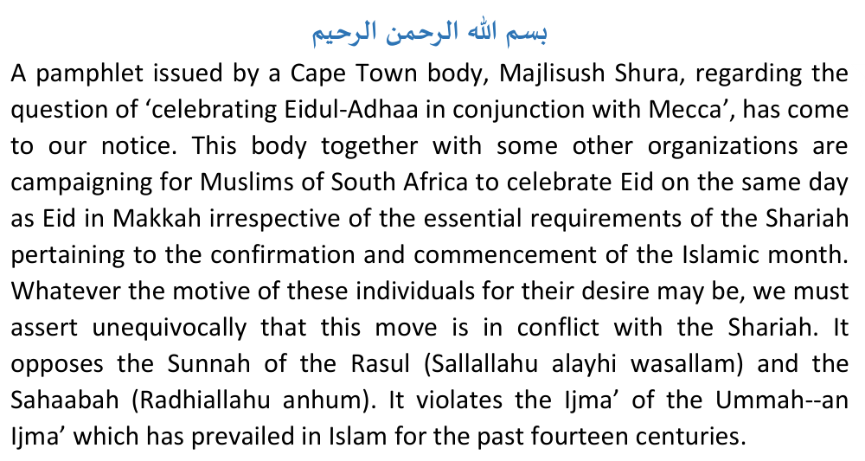
It is indeed astonishing that those contemplating this un-Islamic move have failed to discern the fact that in the past fourteen hundred years of Islam's history no Shar'i authority ever initiated the desire for the global unification of Eid. It is more surprising to note that these persons and organizations have totally ignored the principles and rulings of the Shariah. To bolster its stand of desire the organization for unification of Eid has obtained a fatwa from Al-Azhar which endorses the baatil move for celebrating Eid all over on the same day even if the essential conditions of the Shariah are lacking. In regard to the baseless fatwa issued by Al-Azhar, the Majlisush Shura of Cape Town has the audacity to claim:
"We are all now bound to act accordingly, namely, to our promise we last year made to the Muslim public to celebrate Eidul Adhaa immediately after Wuqoof and secondly, to follow the decree of the Fatwa commanding us to do so...., and we also hope that later the rest of South Africa will follow suit."
Let them hope in vain. The Majlisush Shura should not expect the rest of South Africa to follow blindly the dictates emanating from Cape Town nor should it expect all Muslims to submit to the baatil decree which Al-Azhar has issued on the question of unifying Eid internationally even in violation of the laws of Islam. Insha-Allah, we shall adequately demonstrate the gross error of Al-Azhar's fatwa on this issue. We shall, Insha-Allah, show that Al-Azhar has based its 'fatwa' on pure conjecture, whim and fancy. The 'fatwa' of Al-Azhar in this regard is devoid of the proofs of the Shariah. It is a 'fatwa' which transgresses the Law of Allah Ta'ala. It is a 'fatwa' unbecoming of men learned in the sciences of the Shariah. It is a 'fatwa' which must be dismissed as baatil with contempt. It is a 'fatwa' which purports to carry Shar'i sanction when in actual fact it lacks entirely in Shar'i basis.
It is indeed utterly deplorable for the men of Al-Azhar to ignore the evidence of the Shariah and the unanimous practice of the Ummah since the time of the Sahaabah. The 'fatwa' is a classical example of dhalaal (deviation)--deviation from Siraatul Mustaqeem. Let the votaries of this baatil move understand that we do not make gods of learned men and their 'fatwas'. All fatwas will be subjected to the glare of the Shariah. If any fatwa is found to violate the principles of the Shariah, it will be mercilessly rejected no matter from which quarter it emanates. The Qur'aan Majeed describing the baneful attitude of the Jews, declares:
"They take their learned men and their saints (monks) as gods besides
Allah."
Let all concerned know that the Ulama-e-Haqq do not subscribe to this view and attitude of baatil. The Majlisush Shura of Cape Town should not attempt to browbeat the rest of South Africa with Al-Azhar's fatwa. Its 'fatwa' is not the holy writ. This particular fatwa of Al-Azhar has absolutely no standing in the Shariah since it is in conflict with the Shariah. It is a baseless and a baatil piece of paper. Therefore, do not expect "the rest of South Africa" to be awed by the 'fatwa' of baatil which has emanated from AI-Azhar at the behest of the campaigners for the unification of Eid even though the Shariah's requirements are not met.

THE TRANSLATION OF THE FATWA
The Majlisush Shura of Cape Town has also issued a translation of the Al-Azhar's fatwa. We do not know who is responsible for the translation. Nevertheless, the translation is an exhibition of the gross ineptitude of the one who had attempted it. The pamphlet states: "Translation of the Fatwa". But, it is far from an accurate translation. Copious errors and deletions mark the English translation of the fatwa. The translators should have rather concealed their ineptitude by captioning the English version: "A gist of the fatwa". We shall now point out some inexcusable errors which clutter the English translation of Al-Azhar's fatwa.
1) The Arabic fatwa of Al-Azhar quotes a Hadeeth of Rasulullaah (Sallallaahu alayhi wasallam) narrated by Abu Hurairah (Radhiallahu anhu), on page 2. The Arabic text of the Hadeeth is:
The English translation is given as follows:
"Fast on seeing it and break your fast on seeing it, and if you could not see it then complete Sha'baan thirty days."
But, this translation is incorrect. The correct translation should read as follows:
"Fast at its sighting and terminate the fasting at its sighting. Then if conditions become overcast over you, then complete the number of (the days of) Sha'baan thirty days."
The Hadeeth does not say "if you could not see it". The hadith on the contrary states the cause for non-visibility of the hilaal (crescent moon) and the command to be adopted when the hilaal is not visible on account of clouds or overcast conditions.
Rasulullaah's (Sallallaahu alayhi wasallam) command is explicit. There is no ambiguity in it. If the hilaal is not visible on account of overcast conditions, then simply complete Sha'baan with thirty days. There is no need to institute elaborate methods of obtaining news from distant places. There is no incumbency of imposing the difficulty of sifting information from various sources scattered all over the world. The simplicity of the Deen orders that we simply complete the month of Sha'baan with thirty days if the moon is not visible on account of overcast conditions. But, the votaries of unification of Eid on baseless grounds seek to impose difficulties on the Ummah by their new-fangled innovation--an innovation which has neither origin nor sanction in the Shariah.
2) On page 3 of the Arabic fatwa appears the following statement,
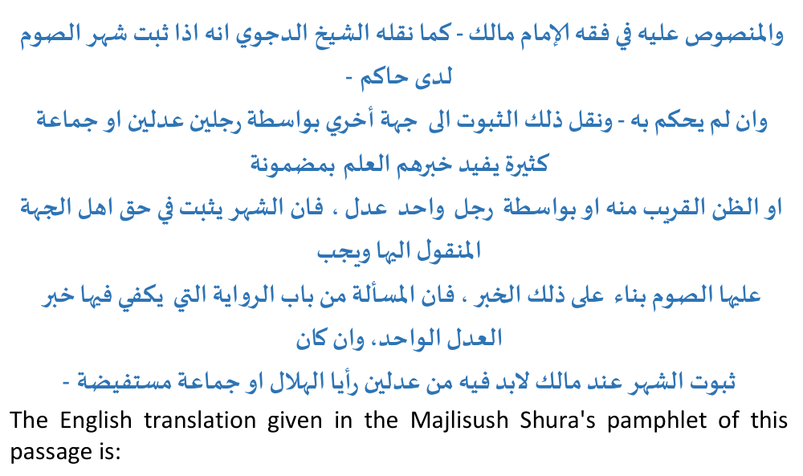
"And what is stated by Imaam Maalik as carried over by Shaikh Al-Dajwy - that if the month of fast is proved by the ruler even if the ruler did not announce it and this proof is carried to another place by two honest men (and many others say that one honest man is enough) then the month of fast is proven to the place that received the message and its people must fast following the message."
This is an exceptionally poor and erroneous translation of the abovementioned passage. The correct translation should read as follows:
"And, that which is explicit in the Fiqh of Imaam Maalik, as has been narrated by Shaikh Ad-Dajwi is: Verily, when the month of fasting is confirmed at (i.e. in the presence of) the ruler, and this confirmation is transmitted to another place by the medium of two uprighteous persons or by such a large group whose information gives the benefit of sure knowledge (al-Ilm) of its subject matter or (produces) such acceptance by the mind (az-zann) which is close to sure knowledge or by way of the transmission (of the information) by one uprighteous man, then although the ruler did not decree it (the commencement of the month of fasting), the month of fasting will (nevertheless) be confirmed in regard to the people of the place to which the information was transmitted. And, fasting will be incumbent on it (that place) on the basis of that (reliably transmitted) information, for verily, the matter pertains to the sphere of riwaayat (narration) for which the information of one uprighteous person suffices inspite of the fact that according to Imaam Maalik, for the confirmation of the month it is necessary that two uprighteous persons or a large group saw the hilaal."
Besides the translation of this passage presented by Majlisush Shura being wholly inadequate and incomplete, this passage does not include the sentence:
"(and many others say that one honest man is enough.)"
While the statement in the Arabic fatwa does say that in regard to matters of narration, the information of one uprighteous man is sufficient, it does not anywhere mention: "many others say that one honest man is enough".
3) Also on page 3 of Azhar's fatwa appears the following statement,
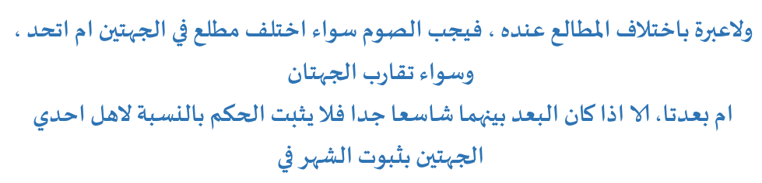

Majlisush Shura's translation of this statement reads as follows:
"And as for Imaam Maalik, there is no concern regarding the differences in the sighting as it is incumbent to fast whether the birth of the crescent is the same or different in the two places and whether the two places are near or far."
Again, the translation is grossly incorrect. The correct translation should read:
"And there is no consideration for difference in the places of rising (of the hilaal) according to Imaam Maalik. Thus fasting will be incumbent whether the matla' (place of rising) of the hilaal is the same in the two places or different, and whether the two places are nearby or far (from one another), except when the distance between them is very great, for then the ruling in regard to one of the places will not be confirmed (and applicable) with regard to the confirmation of the month in the other place."
There is absolutely no mention of "different sightings" as translated by Majlisush Shura of Cape Town. The term mataali' (plural of matla' which means place of rising) has been wrongly translated by Majlisush Shura of Cape Town to mean 'sighting'. Besides this grave error, our translation will indicate other glaring omissions in the incorrect translation presented by Majlisush Shura which for some reason has considered it expedient to delete the fact that even according to Imaam Maalik "great distance" (albu'dush shaasi') is considered valid for the non-applicability of the sighting of one place for another. In other words, ikhtilaaful mataali' is regarded valid for far off places according to Imaam Maalik. The lopsided, incomplete and erroneous translation is thus inexcusable.
4) Majlisush Shura of Cape Town omitted the following statement from its translation:
"An example of such great distance is between Khuraasaan (in the east) and Andalus (in the west)."
This statement acknowledges that in accordance with the Maaliki Math-hab 'great distance' is considered for the validity of ikhtilaaful mataali' and that sightings of distant places are not applicable to one another. The example cited in the fatwa is Khuraasaan and Andalus. The distance between these two places is about 6000 km while the distance between Cape Town and Makkah is far in excess of 6000km. It is therefore ludicrous to attempt to introduce Maaliki views in substantiation of the move to unify Eid with Arabia even though the Islamic month is not confirmed at our end.
5) Majlisush Shura has also omitted the following statement from its translation:

"And it has been said that (the ruling) will differ with ikhtilaaful mataali' (difference of places of risings of the hilaal) because the cause (for Saum) is the Month. And, its (the month's) occurrence in regard to a community on account of sighting does not necessitate its occurrence in regard to another community with ikhtilaaful mataali'."
This important deletion refutes the validity of the claim of Majlisush Shura of Cape Town. It likewise refutes the correctness of the decision given in the fatwa.
6) The English translation presented by Majlisush Shura again deletes the following very important statement which presents the view of the Shaafi Math-hab:

"If they see the hilaal of Ramadhaan in a city and they do not see it in another city, then if the two cities are nearby, the ruling for both cities will be the ruling of a single city, and without difference of opinion fasting on the other (nearby) city will be incumbent. And, if the two cities are far off (i.e. the one is at a great distance from the other), then the authentic version is that fasting is not incumbent on the inhabitants of the other city."
It is thus even stated in the fatwa of Al-Azhar that according to the Shaafi Math-hab ikhtilaaful mataali' is taken into consideration when the places are not in close proximity.
7) On page 2 of its translation, Majlisush Shura of Cape Town presents the following translation of a statement appearing on page 4 of the Arabic fatwa of Al-Azhar:
"that the difference in sighting is of no importance..." Yet the passage which was translated does not contain the phrase, "difference in sighting". The relevant Arabic text is:

"There is no consideration for difference of mataali'." As mentioned earlier, mataali' does not mean 'sighting'. It means the places of the risings of the hilaal. The Arabic word for 'sighting' is rooyah, not mataali'. The meanings of the two terms are different.
8) On page 2 of its translation, Majlisush Shura translates one statement as follows:
"sighting is the origin of knowing that the lunar month started as quoted in the Hadeeth Shareef 'fast on seeing it' and that we can depend on the astronomical calculations."
This translation is incorrect. The Arabic text is:
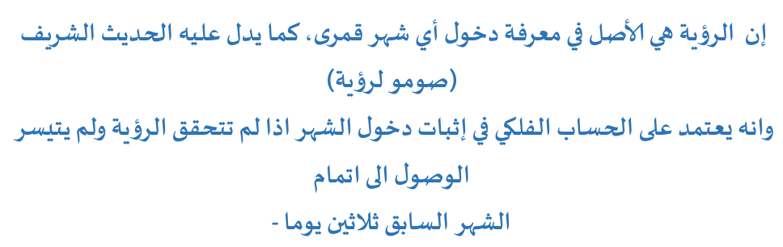
The following is its correct translation,
"Verily, sighting is the principle for knowing the entry of any lunar month as the Hadith Shareef indicates, 'Fast at its sighting'. Verily, astronomical calculations can be relied on for the confirmation of the entry of the month when the sighting has not been established and it is not easy to attain the completion of the previous month with thirty days."
Our translation will demonstrate the inadequacy and error of the translation which Majlisush Shura has presented. The fatwa of Al-Azhar stipulates two conditions (as mentioned above) for the permissibility of resorting to astronomical calculations. This fact is entirely omitted from the translation. We have merely mentioned this fact to indicate the incorrectness of the translation, not by way of acceptance of this baatil view of Al-Azhar. Insha-Allah, we shall later in this discussion conclusively prove the fallacy of Al-Azhar's contention regarding the permissibility of astronomical calculations for the establishment of the Islamic months.
9) On page 2 of its translation, the following version is given:
"The difference in sighting is of no value especially in the places which share in a portion of the night."
The Arabic text for which this translation has been tendered is:
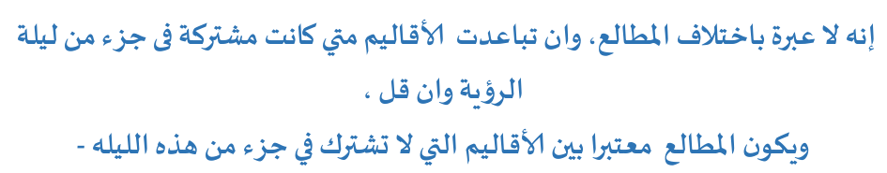
The correct translation of this text is as follows:
"Verily, difference of places of rising (of the hilaal) is of no consideration, even though the regions are far off (from one another) when these regions are common in a portion of the night of the sighting although it (the portion) be little. Ikhtilaaful Mataali' (difference of places of risings) is considered, between such regions which are not common in a portion of this night (of sighting the hilaal)."
The Arabic text makes no reference to 'difference in sighting'. This is an erroneous interpolation of the translators of the fatwa. Furthermore, the translators conveniently deleted the statement regarding the validity of "ikhtilaaful mataali'" since it negates the assertion that such differences are of 'no value' in the Shariah.
Again we have cited this text merely to illustrate the errors in the translation. The claim made in the statement will be discussed later, Insha-Allah.

THE FATWA OF AL - AZHAR
It is necessary to make mention that the fatwa issued by Al-Azhar in response to the question posed by the Muslim Judicial Council of Cape Town, is cluttered with contradictions, citations out of context and opinions unsubstantiated on any Shar'i principle. The conclusion of the fatwa is a product of pure whim and fancy--personal opinion--which is devoid of Shar'i substance. We shall now proceed to show the error of the fatwa.

ASTRONOMICAL CALCULATIONS
Accepting the validity of astronomical calculations for the confirmation of the Islamic months, the fatwa states:
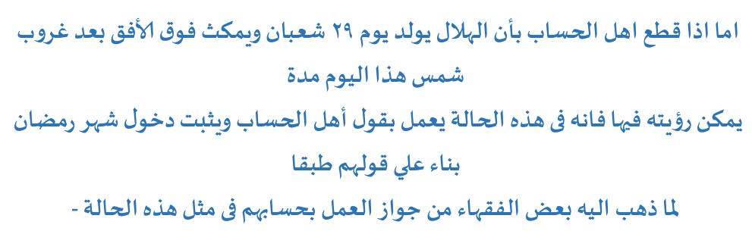
"When the astronomers have decided that the hilaal (crescent moon) shall be born on the 29th Sha'baan and will remain above the horizon after sunset of that day for such a period of time that sighting it therein is possible, then, verily, in this condition the statement of the astronomers will be accepted and the month of Ramadhaan will be confirmed on the basis of their statement in accordance with the view of some Fuqaha (who have opined) the permissibility of acting according to their calculations in the example of this case."
This claim mentions that the view of acceptance of astronomical calculations is that of 'some Fuqaha'. In this is the concession that the Jamhoor Fuqaha (the overwhelming majority of Islamic Jurists) do not accept this view. Let us now examine this view in the light of the Shariah.
The following appears in Fataawaa Allaamah Shamsuddeen Muhammad Ramli:
"He (Ramli) was asked regarding Subki's statement, viz. 'If testimony (shahaadat) is given that the sighting of the hilaal occurred on the thirtieth night of the month and the astronomers claim the impossibility of the sighting of that night, then the statement of the astronomers will be accepted....." Will it be accepted what he has said or not?"
He (Ramli) replied: "Verily, the version which is for practical adoption is that which is (confirmed) by the testimony of shahaadat because the Shaar'i (i.e. Rasulullah - Sallallahu alayhi wasallam) accorded Shahaadat the rank of Yaqeen (certitude). And that what Subki has said is mardood (rejected). A group of the Mutakh-khireen has refuted this view of his. There is no opposition. The reason for our claim for this is that the Shaari (Sallallaahu alayhi wasallam) did not at all place any reliance on (astronomical) calculations. On the contrary he accorded it total irrelevance with his statement: 'We are an unlettered Ummat. We neither write nor calculate. The month is so and so (and he indicated with his fingers).' lbn Daqeequl Eid said: 'Calculation--Reliance on it is not permissible for fasting.'
Shaikh Muhammad Shirbeeni Al-Khateeb states in his Kitaab, Al-Khateeb:
"Fasting does not become incumbent with the statement of the astronomer, it is not permissible."
Ibn Ahmad Dardeer among the Maaliki Fuqaha states in his Sharhus Sagheer:
"The hilaal is not confirmed with a statement of an astronomer, neither in regard to himself or in regard to another because the Shaari' (i.e. Rasulullah - Sallallahu alayhi wasallam) has hinged Saum (fasting), Fitr (ending the fasting for Eid) and Hajj on the sighting of the hilaal, not on its presence".
Commenting on the abovementioned statement, Shaikh Ahmad Ibn Muhammad As-Saawi who is among the Maaliki Fuqaha, says in his Kitaab, Bulghatus Saalik Li Aqrabil Masaalik ilaa Math-habil Imaam Maalik:
"....Verily, it (the sighting of the hilaal) is not confirmed with the statement of the astronomer even if its truth is certified in his heart. And that is in fact so. The Shaafis differ (in this respect). And that (i.e. the non-acceptance of the astronomer's statement) is because we have been commanded to deny him, for verily, it (astronomical calculation) is not among the ways of the Shariah."
The 'differences of the Shaafis' mentioned in the above statement pertains to the fasting being self-imposed on the astronomer himself. If an astronomer is certain of his calculations then according to some Shaafis, it is permissible for him to fast. Ramli as well as other Shaafi Fuqaha state categorically that the confirmation of the hilaal for Ramadhaan, etc., cannot be based on the statements and calculations of astronomers. This has already been mentioned earlier. See Ramli's Fatwa above.
The following appears in Fataawaa Hindiyyah:
"Shall the statement of an uprighteous and qualified astronomer be accepted (regarding the hilaal on the basis of his calculations)? The authentic (ruling) is that it shall not be accepted. So is it said in As- Siraajul Wahhaaj. It is not permissible for the astronomer to act according to his calculations even in regard to himself (i.e. it is not permissible for him to commence fasting on the basis of his calculations). So does it appear in Mi'raajud Diraayah."
The Kitaab, Al-Fiqh 'alal Mathaahibil Arba'ah has the following to say under the title: Shall the statement of the astronomer be considered?:
"The statement of the astronomers is of no consideration. Therefore, fasting is not incumbent on people by the calculation of the astronomers nor on a person who has confidence on their statements, because Rasulullaah (Sallallaahu alayhi wasallam) has based fasting (of Ramadhaan) on such solid grounds which will never change, and that is either the sighting of the hilaal or completion of the number i.e. thirty days (when sighting has not been confirmed)….. This is the opinion of the three Imaams (viz. Abu Hanifah, Maalik and Ahmad Bin Hambal).
The Shaafis say: "The statement of the astronomer will be considered in so far as he himself is concerned and in regard to the one who has confidence in him. And, the accepted view is that fasting is not incumbent on people in general by the statement of the astronomer."
According to some of the Shaafi Fuqahaa astronomers may commence fasting on the basis of their calculations, but their calculations are of no consideration for confirming the month in regard to the Ummah. Even this minority Shaafi view applicable to only the astronomer himself is in conflict with the Jamhoor Fuqaha of all Math-habs. It is thus an unacceptable view which cannot be accepted for practical adoption.
Imaam Nawawi states in his Raudhatut Talibeen:
"Fasting (of Ramadhaan) does not become incumbent by the calculations of the astronomer, neither on him nor on others. Ruyaani said: 'Similar is the one who has knowledge of the phases of the moon. Fasting is not incumbent with it (such calculations) according to the most authentic view.....'
It is said in Tahzeeb: 'It is not permissible to follow the astronomer in his calculation, neither in regard to Saum (Ramadhaan) nor in regard to Fitr (Eidul Fitr)…..'
Qaadhi Tabari said: 'If the phases of the moon become known by way of astronomy, it is not permissible at all to fast on that basis.'"
From the above statements appearing in Raudhatut Taalibeen as well as in other authentic Kitaabs of the Shaafi Math-hab it is quite clear that adoption of astronomical calculations regarding the hilaal is not the official and most authentic view of the Shaafi Math-hab. On the contrary it is a minority view which the Jamhoor Shaafi Fuqaha as well as the Fuqaha of the other three Math-habs refute.
In his Sharhul Muslim, Imaam Nawawi while discussing the Hadith pertaining to enumeration of Sha'baan, states:
"It is not valid (to say) that the meaning (of the Hadith) is the calculation of the astronomers."
In Irshaadus Saari, Qustulaani states:
"The Shaafis say: The statement of the astronomer is of no consideration. Saum does not become incumbent with it nor is it permissible.'"
Ahmad Bin Taimiyyah states in his Fataawa, in regard to statements supporting the calculations of astronomy, which have been attributed to some Shaafi Fuqaha:
"But, if this (narration attributed to Mutarrif Bin 'Abdullaah) is correct, then it is among the slips (errors) of the Ulama."
Rejecting such attributions to lmaam Shaafi, Ibn Taimiyyah says in his Fataawa:
"This (claim) is baatil (baseless) in regard to Shaafi. There is no origin for it from him (Shaafi). On the contrary, that which is (authentically) preserved from him, is in conflict with it (i.e. the claims of the validity of astronomical calculations). His view is the same as the Math-hab of the Jamaa'at."
Stating the ruling of the Shariah regarding the calculation of astronomers for the purpose of the Islamic months, Ibn Taimiyyah states:
"There is no doubt in the fact that the Sunnah, and the consensus of the Sahaabah confirm that it is not permissible to place reliance on the calculations of astronomy, as has been confirmed in Bukhaari and Muslim that verily, Rasulullah (Sallallahu alayhi wasallam) said:
'We are an unlettered Ummat. We neither write nor calculate. Fast at its sighting and terminate the fasting at its sighting.'"
The one who relies on (astronomical) calculations is like one who has deviated in the Shariah. He is an innovator in the Deen. He is mentally deranged.
In his Kitaab, Fathul Aliyyil Maalik, Shaikh Muhammad Ahmad Ileesh (who has been mentioned in Al-Azhar's fatwa) very eloquently and emphatically refutes the validity of astronomical calculations for the purpose of commencing the Islamic months. In Fathul Aliyyil Maalik, the following question is posed to Shaikh Ileesh:
"What do you say regarding a certain Shaafi known for his knowledge and piety, who relies on astronomical calculations for the confirmation of Ramadhaan and Shawwaal while not taking into consideration actual visual sighting of the hilaal? It has happened several times that his fast commenced a day before the fasting of the community and his ending of the fasting, also a day before. He (a certain Shaafi) made this known to his close ones and friends who followed him in this. Frequently this action has been adopted by others besides them. Thus they follow him. This may become more widespread while the Ulama are maintaining silence. What! Is this correct in the Math-hab of lmaam Shaafi? Is it then permissible to conform with them in this regard or is he astray or should he be rejected and prohibited as best as is possible? And is it unlawful to conform with him in this matter?

THE ANSWER
"All praise is due unto Allah for His guidance towards the right road. May peace and blessing descend on our Sayyid Muhammad, on His Family and His Ashaab.
Yes, he (the certain Shaafi referred to in the question) is astray. It is haraam to conform with him in this matter. It is incumbent to reject him and to forbid him from this as best as is possible because it (his practice) is destruction for the Deen and in conflict with the explicit Hadith of Sayyidul Mursaleen. The practice of this man is clear proof of his compound ignorance, his lack of piety, impeachment of his honesty and of his lack of (Islamic) culture. It is proof of the fact that his motive is aggrandizement-- Walaa haula wala quwwata illaa billaah - Innaalillaahi wa innaa ilayhi raaji'oon.
The practice of this person and his followers does not conform to the Math-hab of Imaam Shaafi nor to the Math-habs of the Imaams besides Imaam Shaafi--those Imaams whose Taqleed will be a salvation on the Day of great fear. That (this man's deviation) is because of the enactment of Ijma' (consensus) that it is not permissible for anyone to rely on calculation in the matter of Saum and Fitr, in abandonment of sighting the hilaal.
The Ulama have differed regarding an astronomer on the occasion when the hilaal is concealed: Is it permissible for him to act in accordance with his calculation or not? Mutarrif Bin Shik-kheer among the senior Taabi'een said that he himself can act on his calculation (i.e. not others). In one narration Shaafi has said so as well. However, the known view of his Math-hab adhered to by the Jamhoor is that he should not act on the basis of his calculation.
Naafi' narrates from Maalik that iqtida (following in Salaat) should not be made of an Imaam who relies on calculation, nor should he be followed…..
Certain Taabi'een have said that Ibnul 'Arabi has criticized Ibn Suraij (for his view regarding astronomical calculations) and he has detailed his criticism at length. Imaam Qaraafi said:
'The rule in regard to sighting the hilaal for Ramadhaan is: it is not permissible to confirm it (the month) by means of calculation.'
…..The well-known view in the Math-hab (of Imaam Maalik) is 'the non-acceptance of (astronomical) calculation.' If the Imaam takes into consideration calculation and confirms the hilaal on its basis, he shall not be followed because of the Ijma' of the Salaf in opposition to this. Imaam Qustulaani said in Sharhul Bukhaari that the Shaafi-iyyah (the Fuqaha of the Shaafi Math-hab) say:
"The statement of the astronomer is of no consideration, hence Saum is not incumbent nor is it permissible (on this basis)."
Further refuting the claim of the validity of astronomical calculations, Shaikh Ileesh says:
"Allah Tabaaraka wa Ta'ala did not make the emergence of the hilaal from the sun's rays the sabab (cause) of Saum. On the contrary, He fixed the rooyah (sighting) of the hilaal the sabab.
Thus, when rooyah has not been acquired, then the Shar'i sabab too has not been acquired. And so, the ruling (confirming the Saum) is not established. The statement of Rasulullaah (Sallallaahu alayhi wasallam), viz., 'Fast at its sighting and end the fasting at its sighting', indicates this fact.....
It is a well-known fact that in regard to qadhaa (legal matters), fatwa (Shar'i verdicts) and 'amal (practical adoption) it is incumbent to adopt the mash-hoor and raajih version (i.e. the well-known and most authentic views preferred by the Fuqaha). Obscure and weak views will be totally left aside. According to us (Maalikis) and the Shaafis we do not mention (for practical adoption) the existence of a narration which holds the permissibility of acting according to (astronomical) calculation. But, while acknowledging these views (as existing), they are obscure in both Math-habs (Maaliki and Shaafi) and restricted with the conditions:
(1) That the astronomer may use such calculations for only himself, and (2) when the day is overcast.
It is therefore clear that the practice of this group is dhalaal (error and deviation). It does not conform to even the obscure narration because they proclaim Saum and Fitr before the people and they invite them to it inspite of a clear sky and the impossibility of rooyah on account of the dim light of the hilaal. Therefore, it is incumbent on the one in whose hand Allah Ta'ala has given authority to warn and severely punish them so as to close the door of this fitnah which is directed to producing defect in the fundamental of Deen, and which is in opposition to Sayyidul Mursaleen, peace and blessings on him and all his Family. And Allah Subhaanahu wa Ta'ala knows best." (Fathul Ali Maalik)
The following statements present the view of the Hanafi Math-hab:
"In Durr-e-Mukhtaar it is said: 'The statement of the astronomers is of no consideration according to the Math-hab even though they are uprighteous persons.'
In Al-Wahbaaniyah he (the author) said: 'The statement of the astronomers does not make incumbent anything.'
In Shaami appears the narration of Al-Mi'raaj: 'According to Ijma' (consensus) their (the astronomers') statement will not be considered. And it is not permissible for the astronomer to adopt his calculation (for commencing the fast and ending it).'
In An-Nahr it is said: 'It (Saum) does not become incumbent with the statement of the astronomers that the hilaal will be in the sky (appear on the horizon) on a certain night.'"
(Azeezul Fataawa)
The salient points in the aforementioned references of the Fuqaha of Islam are as follows:
(1) The statements, views and calculations of the astronomers pertaining to the presence, birth and possible visibility or non-visibility of the hilaal are of no significance whatsoever for establishing and confirming the beginning and ending of the Islamic months.
(2) Some views according validity to the statements of the astronomers in this regard are to be found among the statements of some Shaafi and Maaliki Fuqaha. However, these are obscure, weak and rejected by the overwhelming majority of the Fuqaha of both the Maaliki and Shaafi Math-habs. The official and most authentic version is that such obscure views are mardood (rejected).
(3) The obscure and weak narrations are in conflict with the rulings of the Jamhoor Fuqaha of all four Math-habs.
(4) The obscure and weak views are in conflict with the Sunnah and the Ijma' of the Ummah.
(5) Great Fuqaha too commit errors and the obscure view is among such slips (errors) of certain Ulama, hence they have been rejected by all authorities of the Shariah throughout the centuries from the earliest times.
(6) It is highly improper to cite the obscure and weak view in substantiation of a proposed practice which violates and militates against the unanimous practice of the Ummah--a practice which has existed in Islam since the last fourteen centuries.
In view of the Shar'i position outlined above, it must be said that Al-Azhar's claim in regard to the acceptance of the astronomers' statements is baatil (baseless) and in conflict with the Sunnah. It opposes the fourteen century unanimous practice of the Ummah. It seeks to override the authority of the Jamhoor Fuqaha of all Math-habs, but it lacks that authority. Al-Azhar has baselessly claimed that if the astronomers aver that the hilaal will remain above the horizon on the 29th Sha'baan after sunset...., then the month of Ramadhaan will be confirmed. There is absolutely no Shar'i Daleel (Proof) for this claim. It is a product of the fancy of the author of the 'fatwa' seeking to legalize what has been haraam since the time of Rasulullaah (Sallallaahu alayhi wasallam). In this miserable stand, Al-Azhar is guilty of introducing a bid'ah into the Deen and of opening a gateway for fitnah as Shaikh Ileesh has stated in Fathul Aliyyil Maalik.
In its fatwa Al-Azhar acknowledges that this view of accepting the statement of the astronomers is attributed to "some" Fuqaha. However, it has chosen to maintain silence on the category of this view. It cannot claim that it is ignorant of the Jamhoor's ruling. Al-Azhar cannot claim that it is ignorant of the Shar'i principle concerning the acceptance and rejection of conflicting views. It cannot claim that it is ignorant of the fourteen century practice of the Ummah. All Shar'i references are at its disposal. Its view of bid'ah is, therefore, highly suspect and unbecoming of such a grand institution. Ulama who possess any expertise in the sphere of fatwa cannot perform so irresponsibly and in total and flagrant violation of the Shariah and its principles as Al-Azhar has demonstrated in its highly un-Islamic fatwa.

AL-AZHAR'S INCORRECT UNDERSTANDING
In its fatwa, Al-Azhar cites the following Hadith which appears in Bukhaari:
"Fast at its sighting and terminate the fast at its sighting. Then if conditions become overcast on you, then complete the number (of days) of Sha'baan, thirty days."
Commenting on this Hadeeth, Al-Azhar says in its fatwa:
"What is understood from this Hadeeth is that when the sighting of the hilaal of Ramadhaan is confirmed, then fasting in this case will be incumbent on all Muslims. But when the sighting of the hilaal is not confirmed and there are no clouds to impede its sighting, then in this condition it is incumbent to complete Sha'baan with thirty days."
The Hadeeth does not mention the non-existence of clouds obscuring the sighting of the hilaal. On the contrary, the Hadeeth states explicitly:
'If conditions are overcast on you then complete Sha'baan with thirty days.'
There is therefore no substance in Al-Azhar's understanding of this Hadeeth. According to the Hadeeth, if at the end of the 29th day of Sha'baan the sky is overcast and the hilaal is not visible, then the simple and straightforward ruling is to complete Sha'baan with thirty days.

AL-AZHAR'S SELF-CONTRADICTION
While Al-Azhar says in its fatwa that acceptance of the astronomers' statements is the view of "some fuqaha", it contradicts itself in the very same breath by averring:

"This is the opinion of the Jamhoor Fuqahaa".
This conclusion, in addition to it being self-contradictory is false. We have already explained earlier that the Jamhoor Fuqaha of all four Math-habs deny the validity of astronomical calculations in regard to the rooyah (sighting) of the hilaal.

IKHTILAAFUL MATAALI'
Ikhtilaaful Mataali' or difference of places of rising in this context refer to the place of the hilaal's appearance in the western horizon heralding the new Islamic month. While the Jamhoor Fuqaha of the Hanafi, Maaliki and Hambali Math-habs hold the view that such differences are of no consideration in confirming the sighting of the hilaal for various regions, the Jamhoor Fuqaha of the Shaafi Math-hab hold the opposite view. According to the Jamhoor Shaafi Fuqaha Ikhtilaaful Mataali' is a valid factor to take into account for the sighting of the hilaal in relation to various regions. There are copious references to prove that the authentic and official view of the Shaafi Math-hab is the validity of ikhtilaaful mataali'.
Al-Azhar cannot be ignorant of this fact. We do not know whether the Shaikhs of Al-Azhar follow any specific Math-hab or not. But, it appears from the fatwa of Al-Azhar that its Shaikhs are freelancers and do not subscribe to the Shar'i concept of Taqleed, hence the Shaikh of Al-Azhar in his fatwa flits from one Math-hab to another in a futile attempt to bolster his bid'ah ruling. In desperation to find Shar'i substantiation for a baseless view, the Shaikh of Al-Azhar, in his fatwa, behaves most pathetically--in a way unbecoming of an expert Mufti.
On the question of astronomical calculations, the Shaikh of Al-Azhar ignores the ruling of the Jamhoor Fuqaha of all four Math-habs and accepts the obscure view of a small minority of Fuqaha. However, on the question of ikhtilaaful mataali', the Shaikh of Al-Azhar adopts the view of the Jamhoor Fuqaha of three Math-habs (Hanafi, Maaliki and Hambali) inspite of the fact that the Jamhoor Fuqaha of the Shaafi Math-hab hold an opposite view and inspite of the fact that those who posed their question, viz., the Muslims of Cape Town, are overwhelmingly the followers of the Shaafi Math-hab.. For absolutely no pressing need whatever, Al-Azhar has totally ignored the Shaafi viewpoint in relation to the followers of the Shaafi Math-hab. We have discussed the question of Ikhtilaaful Mataali' in some detail in our book, SIGHTING OF THE HILAAL. Those who wish to know more about this question, may write for a free copy to - The Mujlisul Ulama, P.O.Box 3393, Port Elizabeth 1502, South Africa.
Why does the Shaikh of Al-Azhar accept the opinion of the Jamhoor Fuqaha on certain issues and not in others? What is his reason for according preference to the Jamhoor view regarding ikhtilaaful mataali'? And, what is his reason for ignoring the Jamhoor view in regard to astronomical calculations? He has presented no Shar'i daleel for his choice. In fact such picking and choosing without any Shar'i basis are highly unprincipled and in conflict with the Shariah.
In its fatwa, Al-Azhar states:
"An example of such great distance is between Khurasaan in the east and Andalus in the west."
Shaikhul Azhar has acknowledged in his fatwa that ikhtilaaful mataali' (either on the Shaafi or Maaliki Math-hab) is a valid factor if the distance between the two places is great. The example given is Khurasaan and Andalus. The distance between these two places is about 6000km. When the distance between two places is great then the ruling of sighting of one place will not be valid for the other far off place. Thus, Shaikhul Azhar states:
"…..Except when the distance between the two places is very great, for then the hukm (of Saum) in relation to the people of the one place will not be confirmed for the other place (which is situated far away)."
When this is the case for Khuraasaan and Andalus having a distance of 6000km between them, then what should the Shaikh say about Cape Town and Makkah with a distance of about 8000 km between them? Indeed the Shaikh has acted very unprofessionally by ignoring ikhtilaaful mataali' in relation to the Shaafi followers of Cape Town.
The Shaikh commits a further blunder by passing off the view of ikhtilaaful mataali' as the opinion of Shaafis in some narrations. He thus says:

"And, he who has stated this Shaafi opinion in some narrations"
Suffice to say here that this is not a Shaafi view mentioned in 'some narrations'. It is the official and authentic Shaafi ruling in all their Riwaayaat (narrations).
After citing a Shaafi reference on this question, Shaikhul Azhar states:

"The preferred view is the opinion of the Jamhoor that there is no consideration for ikhtilaaful mataali'."
To whom does the Shaikh refer by the term 'Jamhoor'? If he means the Jamhoor Fuqaha of the three Math-habs, then he will be correct. But, if he means the Jamhoor Shaafi Fuqaha, then he is wrong, for the Jamhoor Shaafi Fuqahaa, in fact all Shaafi Fuqaha, adhere to the ikhtilaaful mataali' opinion. A reader will, however, gain the impression that the Shaikh is referring to the Jamhoor Shaafi Fuqaha since his statement follows immediately after the reference in Al-Muhazzab stating the Shaafi view.

UNITY?
Among the reasons which Shaikhul Azhar mentions for the unification of Eid celebrations in all places--Eid on the same day all over-- is Muslim unity. But, this argument is fallacious. Muslim unity cannot be built on a basis which conflicts with the Shariah. To achieve 'Muslim unity' Islamic principles cannot be nullified. There can never be Muslim unity if the rules and teachings of the Shariah are abandoned. Muslim unity cannot become a reality if the Sunnah is violated. But, this is precisely what the Al-Azhar fatwa is advocating. Ignore the fourteen century practice of the Ummah - ignore the rulings of the Shariah for the sake of 'Muslim unity'.
Intelligence does not discern any unity being achieved if Eid is celebrated all over the world on one day even though the confirmation has not taken place on the basis of Shar'i principles. Eid and Ramadhaan were celebrated on different days even during the times of the Sahaabah, but such events never caused disunity in the Ummah. Disunity on this basis is the product of ignorance and ulterior motives. Forging the unity of Eid celebration and Day of Arafaat does not produce unity in the Ummah. Unity of Muslims is inextricably interwoven with obedience to Allah Ta'ala- -with submission to His commands--by means of following the Sunnah of Rasulullaah (Sallallaahu alayhi wasallam). Unity of Muslims can be acquired only if the hearts are purified from the evil and bestial attributes of the nafs and supplanted with high and noble qualities of moral excellence (Akhlaaq-e-Hameedah).
No matter how many fatwas Al-Azhar issues, appealing for the Day of Arafaat and the Days of Eid to be celebrated on the same days all over the world, they can never realize their dreams. Such unification is not practical and will never materialize, do what they wish. On the contrary, greater khilaaf (disunity) and ill-feeling will be the consequences of these baatil attempts. Never will they succeed to deflect all people from the Path of Haqq. Thus, differences will remain. Indeed, this idea of the 9th Zil Hajj being on the same day all over the world is childish and futile. There is no goodness in it. Bid'ah can never have any virtue in it.
Celebrating Eid all over on the same day will not eliminate the causes and the rot which underpin the blood-letting disunity prevailing in the Ummah throughout the world. The disease requires another remedy.

TRANSMISSION OF THE NEWS
An important and essential requirement for the acceptance of news and reports pertaining to the confirmation of a sighting in any place is the principle of Tareeq-e-Moojib. This means that if news of Ramadhaan or Eid or of a sighting of the hilaal is conveyed to another region, the conveyance of such information must be by a way regarded as reliable by the Shariah. This principle of Tareeq-e-Moojib is ignored by the Shaikh of Al-Azhar.
All means of communication such as haraam television, the radio, etc. are accepted by Shaikhul Azhar as sufficient for the transmission of news in this respect. Yet, in terms of Shar'i principles information regarding the hilaal, Ramadhaan and Eid received via the media of the television, radio and telegraph cannot be utilized to confirm and declare the events of rooyah of the hilaal, Ramadhaan and Eid. These ways are not accepted as Tareeq-e-Moojib.
In support of his contention that means of communication such as television and telegraph are viable and valid methods for transmitting the news of the confirmation of the hilaal, Shaikhul Azhar has been able to cite only the view of Shaikh Ileesh who lived just a century ago. According to Shaikh Ileesh telegraphic communication may be used for transmitting the news of the confirmation of the hilaal and that on this basis it will be permissible for those at the other end to declare Ramadhaan and Eid. Indeed it is peculiar that the Shaikh of Al-Azhar considered it correct to ignore Shaikh Ileesh's ruling on the question of astronomical calculations while accepting his view regarding telegraphic transmission of the news of the hilaal. What has constrained Shaikhul Azhar to have made this choice without Shar'i Daleel?
Be that as it may. We must mention that Shaikh Ileesh has erred in respect of his view regarding telegraphic transmission of the news of the hilaal. It should be well understood that we are not claiming that telegraphic communication, radio, etc. are haraam. Yes, we do emphatically claim that television is haraam and it is not permissible under present circumstances to make use of television for any purpose whatsoever. On the contrary, telegraph and radio communication are lawful and beneficial. However, the Shar'i requirement of Tareeq Moojib necessary for the acceptance of the news of hilaal confirmation transmitted from elsewhere is not met by these means of communication. No one will raise any objection if a secular court refuses to accept 'evidence' conveyed by these means of communication since the conditions set by courts of law are not fulfilled by 'evidence' or 'testimony' transmitted via these media. Similarly, the Shariah stipulates that the transmission of news of the hilaal be in such a highly reliable way which totally precludes the possibility of doubt and error. Such a way of transmission is termed Tareeq Moojib in Shar'i terminology. The highest form of Tareeq Moojib is by way of Shahaadat (personal testimony).
Among the ways of reliable conveyance of news of the confirmation of the hilaal's sighting in a particular place is:
(1) Shahaadat alal rooyah (Testimony regarding sighting).
(2) Shahaadat ala Shahaadatir rooyah (Testimony given on the testimony of another's sighting).
(3) Shahaadat alal qadhaa (Testimony given in regard to the decree of the Qaadhi of another place).
We have merely made brief mention of the ways of Tareeq Moojib which is a requisite for the acceptance of the news of the hilaal's confirmation in another region. That the radio and telegraph are not Tareeq Moojib is quite simple to understand. Any tom, dick and harry are nowadays able to despatch a telegram from any distant land. Deceptive telegrams causing dissension and conveying false news or news of the month's commencement not based on the Shariah's principles can be sent. Even the radio is open to abuse. Opposing groups - groups which do not adhere strictly to the Shar'i conditions can find avenues for broadcasting their own announcements regarding the new month, Eid and Ramadhaan. In fact such situations had already arisen in some places where certain secular authorities announced the ending of Ramadhaan while the Ulama in the country declared that Ramadhaan had not ended since confirmation of the hilaal's sighting for Shawwaal was not by Tareeq Moojib.
Shaikhul Azhar has based the case for the transmission of hilaal news via the modern ways of communication on the view expressed by Shaikh Ileesh. While we have the greatest of respect for Shaikh Ileesh who was indeed an Aalim of the Shariah, we respectfully submit that the learned Shaikh had erred in his view. Even great Ulama sometimes commit errors. In his Kitaab, Fathul Aliyyil Maalik, the following question is asked:
"What is your view regarding an event which occurred in 1281 Hijri? After Salaatul Jumu'ah telegraphic news was received from Shaam (Syria) that the hilaal of Ramadhaan was sighted on the present night of Friday. The Mufti decreed the adoption of this news (and Ramadhaan was started)......."
The Answer:
"All praise is due to Allah and peace and blessings be on our Sayyid Muhammad (Sallallaahu alayhi wasallam). The abovementioned Fatwa will be relied on because the Muslim rulers have established the telegraph for transmitting news from near and far off places in the shortest possible time. And, Muslim personnel have been appointed to carry out this function (of transmitting news telegraphically). They (the Muslim kings) have expended considerable sums of money for this (i.e. telegraphic communication). Generally they are free from dispatching false news.... Kings communicate with one another by way of telegraph in important matters and people follow them in this...."
Shaikh Ileesh was speaking of telegraph in its initial stage when perhaps governmental control was such that it was not a simple matter to transmit false messages or perhaps telegraphic communication was not freely available to all and sundry in the initial period. Maybe the medium was not yet open to abuse which is nowadays a simple matter. Anyone can send off a telegram in the name of any person and transmit just any information of desire. The recipient has no means of ascertaining the authenticity of the message arriving by way of telegram. Whatever, Shaikh Ileesh's grounds were for his view, it is quite clear that this system of communicating is not among the Shar'i methods of Tareeq Moojib. It does not produce certitude and reliance.
Besides the question of certitude and reliance, a graver problem and spiritual malady, have set into the Muslim community. The western attitudes of liberalism and the awe for western technology are gripping the Muslim mind. While Muslims in general follow the western kuffaar in this respect, they are utterly inept in this regard. Along with the beneficial systems of technology they have allowed their hearts and brains to be overwhelmed by western attitudes of its liberal culture. In consequence of this baneful development, Muslims, including Ulama, are ever ready to submit the principles of the Shariah to desires in order to find acceptance for every western material medium and agent irrespective of any Shar'i principle or teaching being renounced or abandoned in the process. In view of this unhealthy development, even if certitude could be obtained from any means of communication of news, the information is suspect at the very source of its emanation. For example: news of the month's commencement, news of Eid, Ramadhaan, etc., emanating from Egypt in these days can never be accepted by the Ulama-e-Haqq even if such information is transmitted reliably to us since it is now a known fact that those who are regarded as the highest spiritual authorities in that land, viz., the Shaikhs of Al-Azhar subscribe to the false view of the permissibility of astronomical calculations in regard to Saum and Fitr. Since this is the prevailing situation, it is not possible to accept and abide by the information on the hilaal transmitted by the Shaikhs of Al-Azhar or by any other person or body of similar views and leanings.
Since the error is at the very point of emanation, the question of reliable transmission is now superfluous. Even if persons appear physically giving shahaadat that Ramadhaan/Eid has been declared in Egypt, then too such shahaadat will not be acceptable because the manner in which the Islamic month is confirmed is in conflict with the Shariah.

THE IMPOSITION OF NEEDLESS DIFFICULTIES
The suggestion that committees/organizations be established universally to liase and communicate hilaal sightings is indeed a needless imposition of difficulty which militates against the Islamic ways of simplicity available to every Muslim, city-dweller or villager. The operation of such committees involves huge costs which have to be expended unnecessarily. The Shariah does not command the establishment of such agencies for the purpose of celebrating Eid, etc., on the very same day throughout the world. This notion is in conflict with the fourteen century practice of the Ummah. Rasulullaah's (Sallallaahu alayhi wasallam) directive is clear, simple and straightforward,
"Fast when the hilaal is sighted and end the fasting (of Ramadhaan) when the hilaal (for Shawwaal) is sighted. When conditions are overcast over you then complete Sha'baan with thirty days."
What is the incumbent need to act beyond the scope of this simple order of Rasulullaah (Sallallaahu alayhi wasallam)?
"For every city is its sighting." This is the simple and straightforward pronouncement of the Shariah. Why seek to transgress it?
"Hadhrat Kuraib reported the hilaal's sighting in Shaam. He personally saw it. Hadhrat Muaawiyah saw it and the people saw it. Yet Hadhrat 'Abbaas in Madeenah ordered that Eid will be celebrated only if the hilaal is sighted in Madinah or otherwise the month will be completed with 30 days. Is the news obtained by way of a telegram, radio or telephone then of greater importance and of a greater degree of certitude than the personal testimony of Hadhrat Kuraib? Did Hadhrat 'Abbaas and the other Sahaabah then not understand nor felt the need for the 'unity' of the Ummah as the Al-Azhar fatwa seems so concerned with? In its fatwa, Shaikhul Azhar has ignored Islamic practice--the practice of the Sahaabah, the Taabi'een and those who had followed them down the long corridor of Islam's history.
We must add in conclusion that the 'fatwa' which has emanated from Al-Azhar on this issue exhibits gross ineptitude. It is difficult to accept that expert Muftis have prepared such an unprofessional document. No Shar'i case has been built up in the 'fatwa'. Narrations and views of the Fuqahaa have been cited at random and out of context. Choices have been made without any Shar'i determinant—without Shar'i Daleel. The 'fatwa' of AI-Azhar is in fact a lecture based on personal opinion, presenting the whim and fancy of those who have fallen prey to liberalism. The method of freelancing perpetrated in the 'fatwa' is most unbecoming of Ulama who possess expert knowledge of the Shariah.
We unequivocally declare that the fatwa which has emanated from Al-Azhar is in conflict with the Shariah. It is not permissible for Muslims to abide by the decision handed down in the fatwa. The conclusions in the fatwa that Muslims in South Africa should accept the pronouncements of hilaal confirmation from Saudi Arabia (or Egypt?) as binding on them is baatil (baseless). Muslims are bound to follow the fourteen hundred year old practice of the Ummah—a practice which is based on the sound principles of the Shariah—a practice which was the practice of the Sahaabah—a practice which was the Command of Muhammadur Rasulullaah (Sallallahu alayhi wasallam) who declared,

"FAST AT ITS SIGHTING AND END THE FASTING AT ITS SIGHTING."
And, Allah knows best.
MUJLISUL ULAMA OF SOUTH AFRICA
Port Elizabeth 6056
South Africa

Other publications
1. Sighting the Hilaal 2. I'tikaaf and Eid Mubaarak 3. The Eid Hilaal Matter 1435 4. The Moon Mess Debacle 5. Rooyat-e-Hiaal 6. Merrymaking in the Garb of I'tikaaf 7. Qurbaani 8. Hajj

THESE PUBLICATIONS ARE DISTRIBUTED FREE OF CHARGE
Books can be downloaded at www.asic-sa.co.za
Copies of the books may be requested from:
The Publisher:
The printer:
Mujlisul Ulama Of South Africa P.O. Box 3393, Port Elizabeth, 6056 South Africa mujlisul.ulama@gmail.com www.themajlis.co.za
As-Saadiqeen Islamic Centre P.O. Box 818 De Deur, 1884 South Africa Email:assaadiqeen@gmail.com ww.asic-sa.co.za

Contributions may be forwarded to:
Bank: Nedbank Acc name: As Saadiqeen Islamic Centre (A.S.I.C) Acc no: 1039 363 458 Branch Code: 1284-05 Ref: Publications Swift code: NEDSZAJJ
Please send a confirmation of deposit to: Fax: 086 260 3071 Email: assaadiqeen@gmail.com

