
SOCIAL DISTANCING
The Majlis · Voice of Islam
Mujlisul Ulama of South Africa

About this edition
This is a reproduction by The Majlis Archive (themajlisarchive.com) of a publication of The Majlis, Mujlisul Ulama of South Africa, made and published with their permission.
The PDF as The Majlis issued it is the original. This edition was read from that PDF's own structure and checked against it letter for letter; where the two differ, the PDF is correct.
Checked: 297 paragraphs, 0 differing; a second, independent PDF reader finds 100.0% of the PDF's words here.
Nothing has been reworded, added or removed.

"TARAAS-SOO!" (Shoulder to shoulder – like a Solid steel wall) (Hadith)

HARAAM SATANIC SAFF-FORMATION And the KUFR of 'SOCIAL DISTANCING'

THE MAJLIS PO BOX 3393 PORT ELIZABETH 6056, SOUTH AFRICA

EID! – IT IS A DAY OF MOURNING NOTHING TO CELEBRATE TODAY IS AN OCCASION FOR MURAAQABAH
"Most assuredly, We shall give them to taste of the lesser Punishment, not the Greater Punishment, for perhaps they will return (to Siraatul Mustaqeem and the Sunnah)."
(Qur'aan)
Muslims themselves, by their wanton transgression and rebellion against Allah's Shariah, have been the cause for the defeats the Ummah suffered at the hands of the kuffaar, and for the ultimate loss of the entire glorious Empire established by Ameerul Mu'mineen Hadhrat Umar Ibn Khattaab (Radhiyallahu anhu).
Whatever sovereignty, respect and honour Muslims had were snatched away and the Ummah has laboured and trundled the trajectory of utter defeat and humiliation for centuries. The only spectacles of dignity and little independence left were our Musaajid and Darul Ulooms where we had enjoyed much freedom and the right to worship and teach the Qur'aan and Hadith as ordained by the Shariah.
However, in recent years, added to the cesspools of inequity, fisq, fujoor, bid'ah and kufr of the Muslim community among whom the worst culprits are the molvis and sheikhs, the Musaajid and Darul Ulooms have been pillaged, plundered and desanctified by Muslims themselves. The Musaajid became transformed into halls where najis tourists, men and women, were allowed to enter and pollute. Qawwaali, bid'ah jalsahs such as so-called 'seerat' jalsahs, women entering the Musaajid for Salaat, mass merrymaking I'tikaaf, fussaaq qaaris, allowing zindeeqs the Musjid platform, using the Musaajid as staging platforms for kuffaar sporting teams, introducing shayaateen en masse by means of the haraam spacing, etc., etc., are all acts which defiled the Musaajid.
In addition, one of the worst acts of pillage, is the non-attendance of 90% of the community for the daily Fardh Jamaat Salaat. Another villainous misdeed of the community is to allow absolute scoundrels to be the trustees and committees of the Musaajid. The Fajr and Isha attendance is the evidence for this percentage. These are the times when generally all persons are at home.
The villainy of Muslims have made the Musaajid ornate structures devoid of Deen. About our Musaajid of these times, Rasulullah (Sallallahu alayhi wasallam) said:
"There shall soon dawn an era when nothing of Islam will remain but its name. Nothing of the Qur'aan will remain but its text. The Musaajid of the people will be ornate structures devoid of guidance. The worst of the people under the canopy of the sky will be their ulama. From them will emerge fitnah, and the fitnah will rebound on them."
These Musaajid and the Darul Ulooms were the last remnants of our Islamic heritage. These were our little 'empires' where we held sway. But, Alas! Allah Azza Wa Jal has now snatched away from us these little dominions because we, with our own hands, have abused and defiled the sanctity of the Musaajid and transformed the Madaaris into mercenary and nafsaani institutions totally bereft of the Noor of Ilm. Imagine a Darul Uloom which is supposed to imbue in it the spirit and ethos of Ghaar-e-Hira, having a kuffaar sportsground.
These Musaajid, according to the Hadith, have invoked the La'nat of Allah on us, hence Allah Ta'ala has closed down the Musajid. Just imagine! You can go to the mall to acquire rubbish. But if on the way or next to the mall there is a Musjid, you are not allowed to enter and offer two raka'ts Tahyatul Musjid. This is a lamentable commentary on our own villainy.
The oppression of the government is in fact a mild form of Divine Chastisement. It is Allah Azza Wa Jal Who has empowered the government to evict us from our Musaajid. Rasulullah (Sallallahu alayhi wasallam) said:
"If entire mankind unites to benefit you in any way whatsoever, they will be able to benefit you only to the degree prescribed by Allah, and if entire mankind unites to harm you, they will be able to harm you only to the degree prescribed by Allah."
If Muslims will continue with their drunken stupor of fisq, fujoor, bid'ah and kufr, the Greater Punishment (Al-Athaabul Akbar) mentioned in the Qur'aan will overtake us. Today we have lost the Musaajid and the Madaaris. Tomorrow it can be our homes. Allah forbid! Beware! Look at Burma, Palestine and Syria, and open your brains and heart for Muraaqabah.
"Beware of such a FITNAH (Punishment) which will not be restricted to only the transgressors among you." (Qur'aan)
The Ulama and the Buzroogs will all be swept away in its onslaught. May Allah Ta'ala have mercy on us.

HARAAM SHAITAANI SPACING OF THE SUFOOF "SOCIAL DISTANCING"
When the government decides to somewhat 'ease' its oppression by granting permission for the Musaajid to open, it will obviously attach a host of haraam conditions. One such condition is the shaitaani 'social distancing' which the Munaafiqeen had introduced in Musjids under their illegitimate control.
Ignorant musallis were cast into bewilderment when they had to perform Salaat in a satanic haraam manner by standing a kilometer apart. Even a small gap between two musallis in the Saff is occupied by shaitaan. Regarding this haraam method of standing which the maajin fong kong muftis and munaafiq trustees had introduced, Rasulullah (Sallallahu alayhi wasallam) said: * "Straighten the sufoof, line up the shoulders and close the gaps.."
* "Straighten the sufoof……and do not leave gaps for the shaitaan. He who joins the saff, Allah will join him. He who cuts the saff (leaves gaps), Allah will cut (destroy) him."
* "He who closes the gap in the saff, is forgiven (his sins)."
It was the practice of Hadhrat Uthmaan (Radhiyallahu anhu) before commencing the Salaat to proclaim: "Straighten the sufoof, and line up the shoulders. Verily, correct formation of the sufoof is of the completion of Salaat." Then he would not recite the Takbeer to begin the Salaat. He would wait for some men whom he had appointed to attend to the sufoof. When they would inform him that the sufoof were correctly formed, then only would he commence the Salaat.
Hadhrat Umar (Radhiyallahu anhu) also would wait until the sufoof had been correctly formed as commanded by Rasulullah (Sallallahu alayhi wasallam). Only then would he commence the Salaat. Rasulullah (Sallallahu alayhi wasallam) commanded: "Taraas-soo" – Stand shoulder to shoulder without the slightest gap. There are numerous Ahaadith emphasizing the imperative need to stand shoulder to shoulder, and not to leave any gap for the shaitaan to occupy.
Rasulullah (Sallallahu alayhi wasallam) warned that the effect of gaps in the saff is enmity in the hearts. Allah Ta'ala afflicts disunity among the musallis who are careless in this regard.
Sealing the gaps with shoulders is Waajib. It is haraam to leave gaps in the saff. For this very reason the ruling of the Shariah is that if a musalli arriving in the Musjid sees a gap in the first saff, then he has to pierce through the sufoof to reach the first saff in order to fill the gap thus preventing shaitaan from entering it.
Walking in front of a musalli who is engaged in Salaat is a kabeerah (major) sin. Rasulullah (Sallallahu alayhi wasallam) said that if one is aware of the severity of the sin and punishment for crossing the path of a musalli, one will wait forty years until the musalli had completed his Salaat.
Despite the great importance and significance of the musalli in Salaat, it is necessary to pierce the sufoof to fill the gap in front regardless of this act necessitating walking in front of the musallis. The reason mentioned by the Fuqaha is that those who did not step to fill the gap are deprived of sanctity.
Now when the Shariah attaches such tremendous importance to standing shoulder to shoulder, and when it is haraam to leave gaps, then the satansim of the one or two metre gaps ordered by the Munaafiqeen and the rubbish trustees of some Musaajid in compliance with the kufr theories of the atheists should not be hidden from true Mu'mineen.
Standing in the stupid, fong kong manner, leaving gaps for droves of devils to stand in the sufoof is absolutely haraam. There is no scope for permission. With emphasis we claim that the Salaat is not valid. If one enters the Musjid and finds musallis standing in such a stupid, clownish haraam manner, one should not join in. Perform Salaat alone. Never join rows of devils.
The maajin bootlicking muftis will concoct stupid arguments for the validity of the Salaat conducted in this haraam manner. They will dig out ibaaraat (texts) from the Kutub of Fiqh to extravasate permissibility and validity to soothe the palates of the atheists. Do not heed their silly, zigzag fatwas of jahl. Perform Salaat alone if no valid Jamaat can be found. But do not join in the haraam formation resembling stupid football characters on the field.
The bootlickers will not be able to find any argument from the Kutub of Fiqh or from the Ahaadith any permissibility for justifying gaps in the saff. The 'best' shaitaaniyat with which they can manage to bamboozle the ignorant masses is the rule pertaining to large spaces between the saffs, not between musallis in the saff. The issue of Ittihaade Makaan (unity of place) is misused to justify the haraam fong kong style of spacing which licences admission for the shayaateen to stand in the sufoof. In a Musjid, if there is a large space between the saffs, then despite the Karaahat (detestability) and impermissibility of leaving such spaces between the saffs for no valid reason, the Salaat will be valid. But there is no scope for permissibility of leaving large or even small gaps between the musallis in the saff.
Furthermore, the planned gaps arranged by the munaafiqeen are not the acts of careless musallis – acts which could be overlooked and which will not invalidate the Salaat. These gaps organized by the Munaafiqeen are the effects of the theories of the atheist scientists. Their theories are kufr which deny the explicit command of Rasulullah (Sallallahu alayhi wasallam) and the belief that disease is not contagious. As such it is haraam to adopt the method devised by the atheists and adopted by the bootlicking munaafiqeen and the maajin muftis.
Zigzag fatwas In a weird zigzagging style, one Mufti Sahib abortively justifying these kuffaar-created haraam gaps in the saff, says in his fatwa:
"In principle, joining the rows and not leaving gaps in between the rows is strongly emphasized in Shariah. It is disliked to leave a gap or space in between the rows. However, in the present circumstances we are in due to covid-19, it will be permissible to do so. Hence you should join them in the Masjid."
What is the meaning of "in principle" in the context of saff-formation? The command for arranging the sufoof is explicit and precise just as is the command for Salaat and the number of raka'ts. There is no 'in principle' here which could be waived or subjected to whim and fancy to comply with commands of the atheists.
The conclusion by the Mufti is absolutely baseless. There is absolutely no substantiation in the Shariah for this baatil 'permissibility' which is a pure figment of the mufti's imagination in submission to the current irrational fear and in obedience to the atheist authorities of the land.
The mufti should have searched for an answer in the example of Rasulullah (Sallallahu alayhi wasallam), of the Sahaabah and of the Salafus Saaliheen. How did they conduct themselves in plagues which were a million times more devastating than the Bill Gates 'pandemic'? The example of the Salafus Saaliheen is our standard and our guide, not that which the atheist scientists claim.
While there is massive conflict among the scientists regarding this 'pandemic', there is a shaitaani, bizarre ittifaaq (unanimity) among the bootlicking muftis who fall over themselves in their eagerness to appease the rulers and governments. They simply lap up the najaasat disgorged by the governments all over the world, and find stupid arguments by perpetrating gross distortion of the Nusoos to appease their masters and leaders. It is ludicrous in the extreme to utilize Ahaadith for substantiating the wildly baatil claims of the atheists, fussaaq and fujjaar.
It is also kufr to so callously set aside Rasulullah's proclamation of "Laa adwaa", and to accord precedence to the view of the atheists which totally rejects what our Nabi (Sallallahu alayhi wasallam) said on the issue.
The 'circumstances due to covid-19' cited by the mufti as the basis for his baatil fatwa are the creations of the unbelievers and the atheists. But neither fear nor shame inhibited the mufti sahib from disgorging a fatwa which totally ignores Rasulullah (Sallallahu alayhi wasallam) and the Sahaabah. He acquits himself as if there is no response in the Qur'aan and Sunnah for the likes of this little plague which has sent the world into a pandemic of fear by the Bill Gates cartel.
That Rasulullah (Sallallahu alayhi wasallam) and the Sahaabah have been excised from the equation is absolutely deplorable to say the least.
The mufti has not presented a single vestige of Shar'i evidence for his baatil view. It is haraam to accept his view. While we have used the term zigzag with derision in describing the mufti's fatwa, it has a literal meaning as well. Everyone understands the literal meaning of zigzag. In the context of the mufti's fatwa, the mufti literally zigzags from one extreme to the other.
He commences his fatwa by emphasizing the importance and necessity of observing the Shariah's saff rules. In the Arabic texts accompanying his fatwa, he presents many Ahaadith and texts of the Fuqaha which emphasize the imperative importance of the correct saff formation and of the evil of the shaitaani gaps between musallis standing in the saff.
Then from this correct position, he veers widely into baatil without presenting even a single valid Shar'i daleel for his egregiously erroneous fatwa of 'permissibility' for allowing shayaateen to occupy the wide gaps which the atheists have ordered. It is with zigzag fatwas that the maajin muftis all over the world are concocting a new 'shariat', in the same way as the Yahood and Nasaara clergy had transmogrified and destroyed Islam which their Ambiya had delivered to them from Allah Ta'ala.
Justifying this shaitaani concept and act, another mufti sahib says:
"Social distancing in Shariah can be extracted from the hadeeth shareef that says: 'if you hear of a place where the plague has occurred, then do not go there.'
On the basis of this Hadith, the mufti concludes: "This can be interpreted to mean 'do not associate with all the people living in that area, healthy or sick.'
This is no basis for this wild interpretation which is devoid of Shar'i substance.
This argument is absolutely weird and in total conflict with the Sunnah. The Hadith in question prohibits outsiders – those who are not in the plague-ravaged region – from entering into the epidemic zone. Regardless of the Shariah's rationale for this prohibition, it cannot and may not be cited to override Rasulullah's explicit Hadith: "Laa adwaa" (Disease is not contagious). The Fuqaha have provided suitable interpretations to reconcile the apparently contradictory narrations, but never did any Authority override or abrogate the primary Hadith, viz. Laa adwaa, which is the basis for our aqeedah.
Our Nabi (Sallallahu alayhi wasallam) had forcefully refuted the contagion idea of the mushrikeen by logically presenting an argument for the understanding of those who contended that disease is contagious just as today these filthy copro-munaafiqs are doing.
When the Bedouin sought an explanation regarding his herd of camels which became infected when a scurvy camel mingled with them, Rasulullah (Sallallahu alayhi wasallam), forcefully dispelling the corrupt belief asked: "Who had infected the first camel?"
Our obligation is to only follow the commands of the Shariah. This obedience is not based on understanding the rationale underlying the commands. On the issue of plagues, the commands issued by our Nabi (Sallallahu alayhi wasallam) are simple and unambiguous:
• Disease is not contagious • Do not enter a plague-ravaged place • Do not flee from a plague-ravaged area.
The aforementioned Hadith cited by the mufti bears not the slightest relationship with the 'social distancing' concept of the atheists. Either the Musjid is filled with diseased people or not, or some may be affected while others are healthy.
Those coming to the Musjid to perform Salaat belong to the area where all the musallis belong and reside. They are not outsiders who are entering a plague-ravaged area.
Assuming that it is known that many of the musallis are affected by the disease, then too the unaffected ones, if they flee from the Musjid or from the area, will be guilty of sins akin to kufr for acting in violation of the abovementioned two Ahaadith regarding negation of contagion and the prohibition to flee.
When the term 'social distancing' is mentioned, what is understood? The meaning of the atheists is that people should maintain a distance from one another; they should not dare make musaafaha and muaanaqah; they should remain far, very far from even their parents if they happen to be affected; if healthy persons unaffected with the disease venture to greet one another, they should transform themselves into clowns with their elbows jutting out to venture touching. On the basis of this kufr concept of 'social distancing' have the fong kong, juhhaal, munaafiq molvis introduced the haraam spacing practice in the saff in the Musjid. There is absolutely no daleel in this narration nor in any other narration for this practice of the atheists. To equate the prohibition of entering a plague-ravaged area with the satanic spacing in the saff is weird in the extreme.
Furthermore, what was the example of Rasulullah (Sallallahu alayhi wasallam) and the Sahaabah in the Musjid during plagues? Did they adopt the shaitaani spacing method of the atheists? How did they stand in the sufoof? It is indeed mind boggling that despite being aware of the example of Rasulullah (Sallallahu alayhi wasallam) and the Sahaabah, muftis find it plausible to negate the Sunnah practice with the haraam shaitaani method of the atheists. If such spacing was a valid requisite, our Nabi (Sallallahu alayhi wasallam) and the Sahaabah would have been the very first people who would have introduced it. The Ummah had been ravaged by many plagues from the very era of our Nabi (Sallallahu alayhi wasallam), but never did any one of the Salafus Saaliheen nor Muslims of later eras ever insult their Imaan and intelligence with these silly, stupid, shaitaan-inpsired methods of the atheists.
"Not entering a plague area" and satanic spacing in the saff in a Musjid are two widely different issues. The one has no relationship with the other. For both issues there are clear directives and examples in the Ahaadith and lives of the Salafus Saaliheen. Not by the remotest stretch of logical and Shar'i reasoning will any Hadith have any relationship with the shaitaani spacing in the saff. The Hadith has only one meaning, and that is: Do not enter a plague-ravaged area. This is applicable to those who are not the residents of such an area. To understand saff-formation during a plague there is no need for remote, baseless interpretation. The example of the Salafus Saaliheen is more than adequate. The people attending the Musjid are all local residents who are not subjected to the Hadith prohibiting entry to a plague area.
The people attending the Musaajid are from the Islamic perspective all healthy regardless of what the atheists say and dignose. It is haraam to flee from your father or brother who is healthy, but who is alleged to be 'positive' by the the fraudulent tests of the fraud doctors who have been ordered by the authorities to be record as 'positive' on a wholesale scale to justify their oppression. Massive fraud in this field is being uncovered and reported. A person dying of old age is summarily recorded as a virus case.

The action of Hadhrat Amar Bin Aas (Radhiyallahu anhu)
The mufti sahib cites Hadhrat Amar's reaction of taking the people to the mountains as justification for the shaitaani spacing in the saff. There is no relationship between the two. Saff-spacing cannot be justified by moving from one house to another in the plague-stricken area.
In the context of the 'social distancing' advised by the atheists, the term has a totally different meaning. It means the satanic spacing in the saff, closure of the Musaajid and prohibiting the daily Fardh Salaat, Jumuah Salaat, Taraaweeh Salaat and Eid Salaat in the Musaajid. In fact, the prohibition applies even to performing Jamaat Salaat in the homes. A neighbour is not allowed by the law of the atheists to join one in Jamaat Salaat at home.
Hadhrat Amar's act was in conflict with both the Qur'aan and Sunnah. No matter how his act is interpreted, it cannot be validly reconciled with the prohibition stated in the Qur'aan Majeed and with the Sunnah of Rasulullah (Sallallahu alayhi wasallam). Two very senior Sahaabah had severely criticized Hadhrat Amar (Radhiyallahu anhu) for his decision. Hadhrat Amar (Radhiyallahu anhu) was a Sahaabi. We have no right to criticize him for even an error. Nevertheless, the other senior Sahaabah had this right. In view of the conflict between the Qur'aan and Sunnah on the one hand, and Hadhrat Amar's act on the other hand, it will be set aside.
Any how, the act of Hadhrat Amar (Radhiyallahu anhu) is no justification for the spacing in the saffs. We are discussing 'social distancing' in the meaning of the concept of the atheists.
Spread of disease The mufti argues that spread of disease is a basis for 'social distancing'. This is baatil. Even Hadhrat Amar (Radhiyallahu anhu) who had after some time taken to the mountains during the Amwaas plague did not practice the shaitaani spacing which has been introduced in the Musaajid at the behest of the atheists. Prior to taking to the mountains, he was performing Salaat in the Musjid, not at home, not in isolation. And, in the Musjid there was no shaitaani spacing as ordered by the atheists.
Measures of caution mentioned by the mufti sahib excludes shaitaani saff-spacing. A haraam method is not a valid precautionary method in terms of the Shariah. The mufti sahib mentions injections and medication in his arguments. These forms of medication have no relationship with saff-formation and 'social distancing' even in terms of the kuffaar concept. While medication is permissible, saff-spacing is not.
The mufti says: "…the individual will be allowed to distance himself from such areas on the basis of ihtiyaat or precaution." Even if momentarily assumed to be correct, this does not justify the satanic mode of spacing in the Salaat saff. The example of Rasulullah (Sallallahu alayhi wasallam) and the Saahabah during plagues is more than adequate for us. They never spaced themselves like clowns for fear of the plague virus. They stood shoulder to shoulder despite the ravaging plague. There is no argument and no interpretation of any hadith which can override this glaringly conspicuous amal of Rasulullah (Sallallahu alayhi wasallam) and the Sahaabah in the Musaajid even at the height of the plague.
A conflicting argument of an Aalim regardless of his stature of seniority, will be interpreted to reconcile it with the Nusoos of the Shariah, and if a reconciliation is not possible, it shall be set aside and practical expression shall be given to the Qur'aan and Sunnah which cannot be made subservient to the interpretation of the senior Aalim.
In this discussion the concern is only one aspect, viz., the metre or two metre spacing between musallis in the Musjid. It is this haraam aspect of 'social distancing' which is being discussed here although all the other aspects of the social distancing concept of the atheists are also haraam, the concern here is only the spacing in the saff. As far as the saffs are concerned, we have to only look at the way the saffs were formed during plagues by Rasulullah (Sallallahu alayhi wasallam) and the Sahaabah. It is indeed a grievous and an egregious error to justify the haraam spacing in the saff with Ahaadith which have no relationship with saff-formation.
Lepers The mufti justifies the concept of 'social distancing' of the atheists with the Hadith advising the maintenance of a distance from a leper. Again, this Hadith has no bearing on the saff formation in the Musjid. Even the leper was not debarred from the Musjid. During the plague, the Musjid was full of affected musallis who all stood shoulder to shoulder.
The advice pertaining to lepers was for people of weak Imaan. Rasulullah (Sallallahu alayhi wasallam) ate together with a leper from the same plate. We shall not dwell much on this issue since the concern here is the saff formation, and the Hadith pertaining to the leper has no relevance in this regard.
Whoever has fear of contracting the disease is free to distance himself from the confirmed diseased person if he so wishes. But such distancing cannot be practiced in the Musjid in the saff.
There are also other errors pertaining to distancing in the mufti's article. However, our discussion here pertains to only saff-formation. The other issues could be discussed in another article, Insha-Allah.
A Pakistani mufti's fatwa In his fatwa on this specific issue of spacing in the saff, a Pakistani mufti states:
"…..Saff formation is not related to validity or invalidity of Namaaz."
In the current context, saff formation is most certainly related to validity and invalidity regardless of the mas'alah in another scenario. The spacing in the saff in the current context is at the behest of atheists. It entails the displacement of the Waajib form commanded in many Ahaadith. It is giving preference to a kufr mode over and above the method commanded by Allah Ta'ala. If this evil method is accepted, it will ultimately become the norm in the Musaajid. The imperative importance of standing shoulder to shoulder will be dispelled from the minds of Muslims.
Prolonged practice and acceptance of an evil desensitize the heart. The inherent Imaani inhibition to haraam is desensitized, thus opening the doorway for acceptance of haraam. This is precisely the state of affairs pertaining to many haraam acts which are today accepted as valid, permissible and even preferable over the commands of the Shariah. Shaving the beard, riba, kuffaar dress, kuffaar eating styles, abandonment of purdah, etc. are examples of having become acceptable and respectable in the wake of shaitaan's gradual process of desensitizing Imaani inhibitions to evil.
The mufti is extremely short-sighted, to say the least, in presenting a technicality to justify a kuffaar concept which in turn is the antithesis of the demand of Imaan which negates the contagion belief of the atheists, mushrikeen and kuffaar in general.
With the validity-invalidity argument the Pakistani mufti endeavours to justify the haraam act of spacing in the saff. Irrespective of the validity argument, the mufti is constrained to accept that the official view is the prohibition of spacing in the saff, and that it is Makrooh Tahrimi which in practice is the same as Haraam because the consequence of both Makrooh Tahrimi and Haraam is the Fire of Jahannam. Hence, even if accepted that the Salaat is valid with the satanic spacing at the behest of atheists and fussaaq/fujjaar 'Muslim' doctors, then too it (the spacing) is unacceptable since its consequence is the Fire of Hell.
The validity contention does not mitigate the notoriety and hurmat of the satanic spacing. It remains haraam hence unacceptable.
Then the mufti in a further stupid attempt to justify the spacing says:
"However, the Author of Badaaiush Sanaai', Allaamah Kaasaani wrote: 'This karaahat (i.e. being Makrooh Tahrimi) is when the space in the saffs is without valid reason.' (The mufti concludes): 'And here is a valid reason."
His valid reason is the corona virus. In terms of the Shariah the disease or the virus is not a valid reason. A valid reason is, for example, pillars in the saff or some other real tangible impediment. Fear for a disease is never a valid reason because Rasulullah (Sallallahu alayhi wasallam) and the Sahaabah are our guides, and they never practised this confounded 'social distancing' of the atheists. There is absolutely no valid basis for adopting the haraam shaitaani spacing in the saff.
The oppression of the Pakistani government should not induce the ulama over there to confer respectability and acceptance to the haraam laws. The population should not be led into haraam with the belief that the unlawful act has become permissible due to the virus bogey. Merely on the basis of a handful of sick persons, the ulama are buckling and trading the ahkaam of the Shariah for a miserable price. If the government with its forces of repression and oppression enforces the closure of the Musaajid, it is the better option. That will be acceptable, but not voluntary shaitaaniyat in the Musaajid.
The Pakistani mufti claims that keeping the Musaajid open with the haraam conditions is the lesser of the two evils. We say that it is not. The lesser evil is to accept the oppression of the government – the closure of the Musaajid. The greater evil is the destruction of the ahkaam of the Shariah which should be accepted voluntarily. Step by step the greater part of the Shariah will be devoured by the devil and a new 'shariat' will be substituted. The obligation of the Ulama is to maintain and defend the pristine purity of the Shariah. That is our only duty.
"Upon us is to only deliver the Clear message."
(Qur'aan)

'SOCIAL DISTANCING'
What exactly is social distancing? This is a new phrase which has come into existence in the wake of the bogus coronavirus plotted by the enemies of humanity. When this term is mentioned, a specific picture looms up in the mind. In this picture which has been designed by the conspirators we see:
1) Flight from your parents, children and humanity for the fear of contracting the disease.
2) Do not shake hands with any one, not even with your parents.
3) Transform yourself into a clown by hideously sticking out your elbow to touch another person's elbow when greeting. Elbow-to-elbow displaces the Masnoon Musaafahah and Muaanaqah which are totally prohibited. Such vile Tashabbuh bil Kuffaar is haraam.
4) Spacing 2.2 metres apart in the Salaat saff, if Musaajid are allowed to be open under extremely stringent conditions. Thus, the Musaajid become haunts for the shayaateen.
5) If Musaajid are permitted to operate, the elderly and the sick must be debarred.
6) Perfectly healthy people may not travel more than two persons in a vehicle. They may not sit on the same seat. 7) Dua should not be made with hands raised. More 'dangerous' is to draw the hands over the face at the end of Dua as is the Masnoon method.
8) Visiting close relatives even parents at their homes is prohibited.
9) Visiting a sick relative even if parents, in hospital is prohibited. No contact whatsoever is allowed.
10) Closure of the Musaajid thus prohibiting Fardh Jamaat Salaat, Jumuah Salaat, Taraaweeh and Eid Salaat.
11) The Masnoon Ramadhaan I'tikaaf is banned.
12) Closing shops thus depriving people from their legitimate needs.
13) Lockdowning the entire country thus devastating the economy.
14) Confine people to their homes. Not allowing them access to even their yards.
15) Closure of all Darul Ulooms
16) Banning Hajj and Umrah
17) If one person is tested positive, an entire household or institution must be placed in quarantine.
18) Snitch and spy on Muslims who perform Salaat in Jamaat. Report them to the kuffaar police to be arrested.
19) Kafan and Ghusl for the mayyit are abolished. Even Tayammum on the mayyit is prohibited.
20) In some places. e.g. Sri Lanka, Muslim bodies are by law appropriated by the government's devilish order and cremated. Cremation is strongly advised by the Satanists who have invented their Satanist concept of social distancing.
21) Violation of the draconian social distancing rules is a crime leading to arrest, fines and imprisonment. Yet, even in terms of the secular constitution these draconian measures are unconstitutional and unlawful, hence many senior lawyers are challenging the unconstitutionality of the oppressive laws.
This is the heinous satanic concept of social distancing. No Muslim in his sane Imaani senses will ever accept that this system of Iblees has the slightest support in the Ahaadith.
The primary basis for debunking the entire gamut of terms and conditions of this kuffaar concept of social distancing is the explicit statement of Rasulullah (Sallallahu alayhi wasallam): "Laa adwaa" (Disease is not contagious). Every ingredient in the satanic concept of social distancing is anathema to the Shariah and Imaan.
The Laa adwa command of Allah Ta'ala is fully bolstered by the practical example and conduct of Rasulullah (Sallallahu alayhi wasallam), the Sahaabah and the Salafus Saaliheen of Quroon-e-Thalaathah. There is not the slightest shred of support in the Qur'aan and Sunnah for the kuffaar concept of social distancing which errant muftis of this age are abortively struggling to justify by hook or crook with grotesque misinterpretation of some Hadith narrations which have absolutely no relevance to this shaitaaniyat of social distancing introduced by the agents of Bill Gates.
The Leper The Hadith, "Flee from the leper…." Has specific application. Firstly it is directed to people of weak Imaan. Secondly it applies solely to the disease of leprosy. The body festers with open wounds and sores. The sight is 'disgusting' and causes aversion in most people. It was for only these reasons that this advice was proffered by Rasulullah (Sallallahu alayhi wasallam). But, to negate the kufr idea of disease being contagious, our Nabi (Sallallahu alayhi wasallam) practically refuted it by eating together with a leper from the same bowl.
Furthermore, there is no record of any leper being quarantined or expelled from society or ostracized in any way. Despite the Hadith in this regard, the leper was not ordered to self-isolate himself. He remained amidst the people and attended the Musjid. There was no one to debar him from the Musjid. Not a single one of the satanic stipulations enumerated above applied to the leper.

Hadhrat Amar (Radhiyallahu anhu)
It is indeed lamentable for a mufti to cite Hadhrat Amar's action of taking to the mountains, in the indefensible bid to justify the kufr concept of social distancing with its numerous conditions of kufr and injustices. The mufti sahib has argued in an unprofessional and an unprincipled manner by introducing Hadhrat Amar's act to justify the kuffaar social distancing model which is the invention of scoundrel atheists such as Bill gates who is steering a grotesquely Satanist conspiracy to ensure that every human being on this planet is vaccinated with a 'nano chip'.
Extravasating daleel on the basis of an error of a Senior is dangerous for Imaan. Hadhrat Allaamah Abdul Wahhaab Sha'raani (Rahmatullah alayh) as well as other authorities have said: "He who grabs hold of the obscurities of the Ulama, verily he has made an exit from Islam." This type of extrapolation becomes more grievous when the Hadith or the error of a Senior is used and manipulated to justify a baatil and haraam concept of atheists.
In fact, it is not permissible – it is tantamount to kufr to manipulate Ahaadith to cancel and debunk explicit commands of the Shariah substantiated by Qur'aanic Nusoos and such Ahaadith which are of the Mutawaatur category. A mufti is supposed to be well versed with the Usool of Fiqh. He should correctly employ the Usool to arrive at a proper and valid conclusion.
The mufti is supposed to know that when a Khabr Waahid or Qiyaas conflicts with Kitaabullaah (The Qur'aan Majeed), and if reconciliation is not possible, then the Hadith shall be set aside, and practical expression shall be accorded to Kitaabullaah. It will never be the other way round. The
Qur'aan and Ahaadith Mutawaatur will not be set aside to accommodate Khabr Waahid.
In addition to the amal of Hadhrat Amar (Radhiyallahu anhu) being in glaring conflict with the amal of Rasulullah
(Sallallahu alayhi wasallam) and the vast Body of the Sahaabah, it (taking to the mountains) was in open conflict with Kitaabullaah. The Qur'aan Majeed outlaws quarantine, severely condemning it. Those who had resorted to quarantine and self-isolation during a plague were punished with death by Allah Ta'ala.
Referring to the haraam kuffaar act of quarantine, the Qur'aan Majeed states:
"What! Have you not seen those people who came out (fleeing) from their homes while they were thousands, in fear of Maut (death)? Then Allah said to them: "Perish!" Then (after their death) He resurrected thyem."
(Al-Baqarah, Aayat 242)
In bygone times, during the era of Bani Israaeel, a severe plague spread in a city/town. The inhabitants consisting of approximately 10,000 persons, for fear of contracting the disease and death, fled from the town and went into quarantine in a valley in between two mountains. Their cowardly flight and attempt to flee from Maut invited the Wrath of Allah Ta'ala. Allah Ta'ala killed the entire community. Not a single soul escaped death. They had fled the plague, went into self-imposed quarantine with the notion of saving themselves from death. They miserably failed.
Senior Sahaabah had also criticized Hadhrat Amar's act. Without criticizing Hadhrat Amar Bin Al'As (Radhiyallahu anhu), on the basis of the Dalaail of the Shariah, his amal may not be presented in view of the conflict with the Qur'aan and the standing Sunnah of the Sahaabah. And, it is preposterous to cite his amal to substantiate and justify the satanic concept of the atheist, Bill Gates – a concept replete with kufr and haraam.

GRAND MUFTI OF BANGLADESH ISSUES THE FATWA OF HAQQ
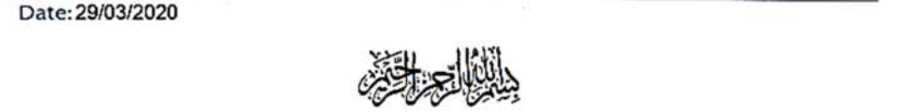

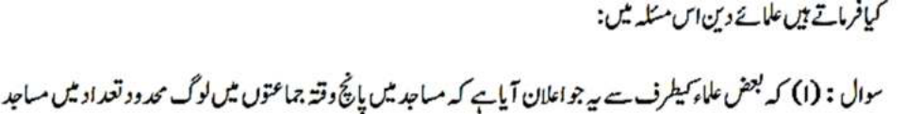
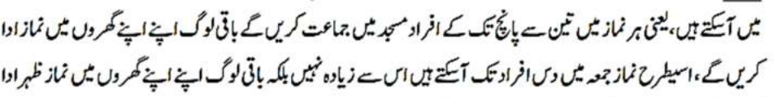
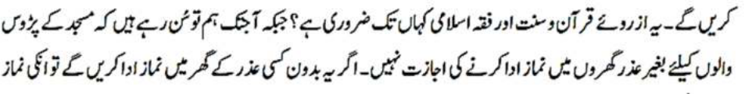
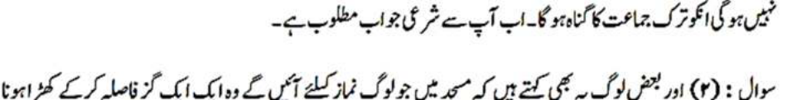
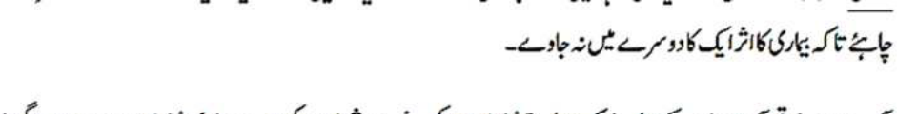
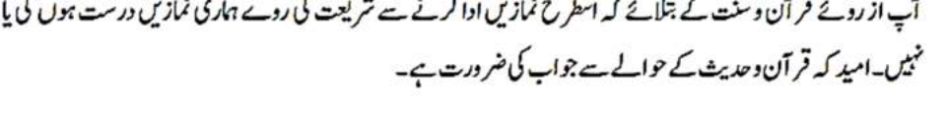


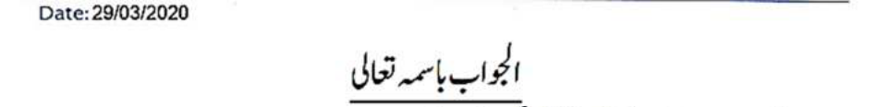
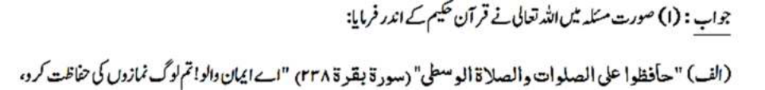
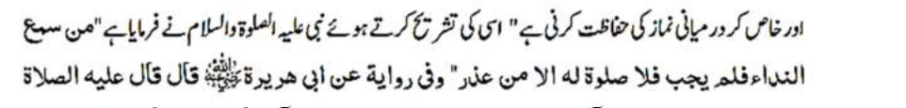
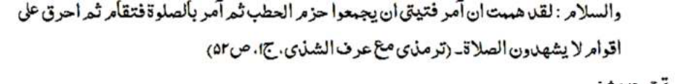
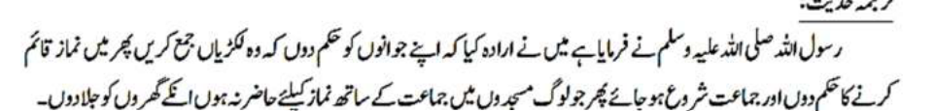
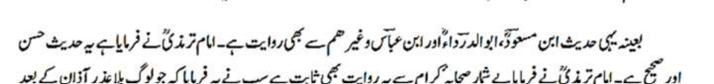
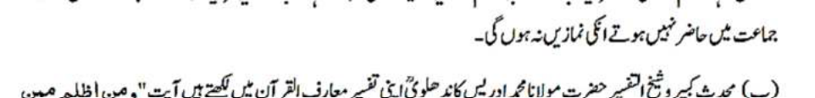
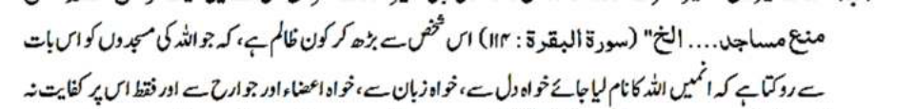
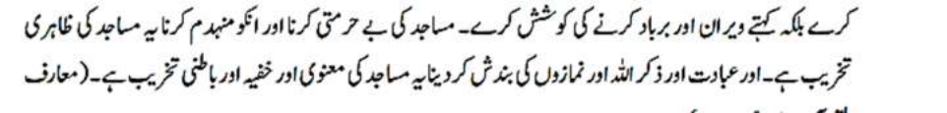
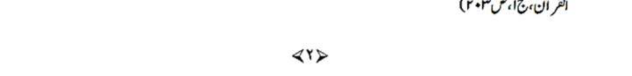
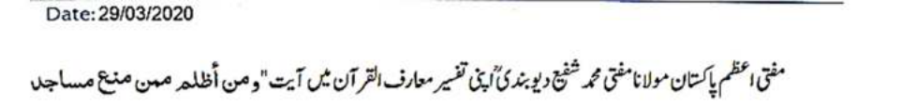
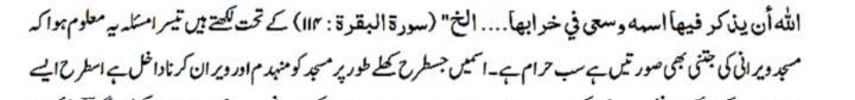
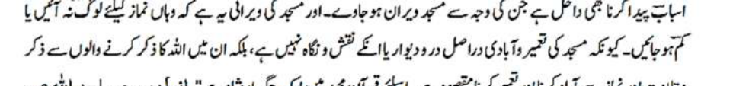
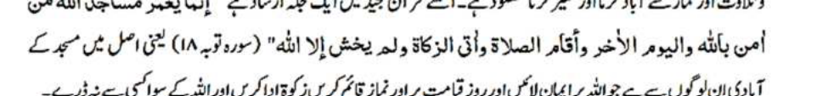
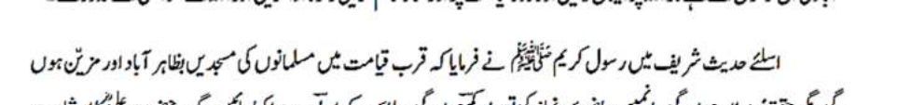
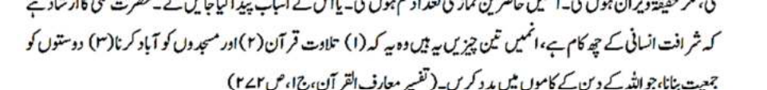
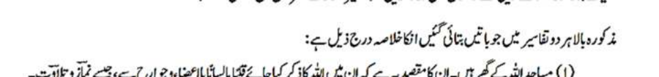
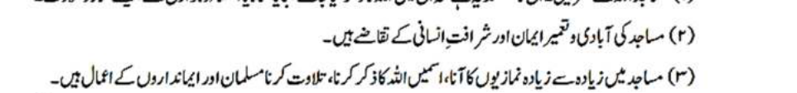
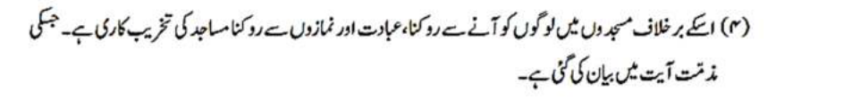

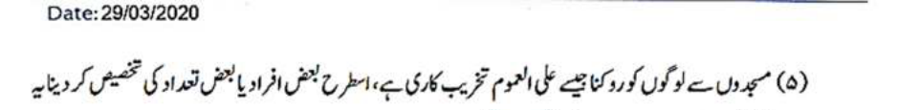
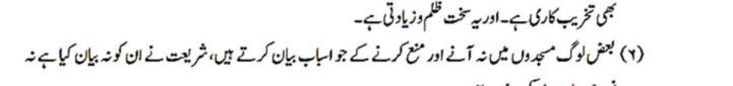
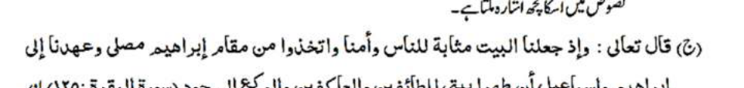
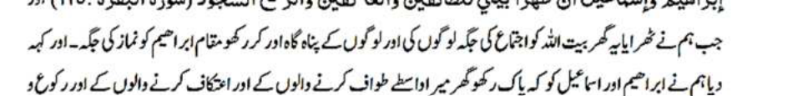
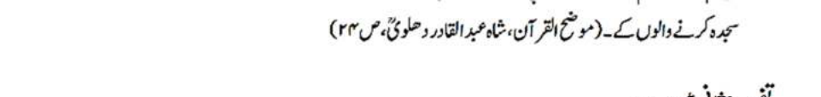
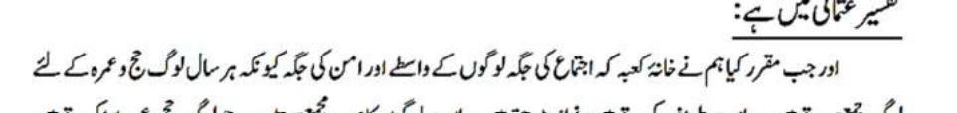
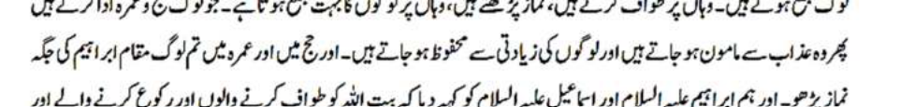
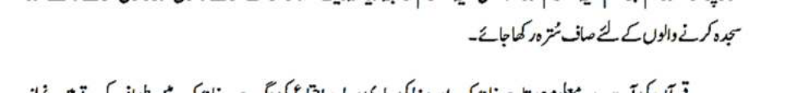
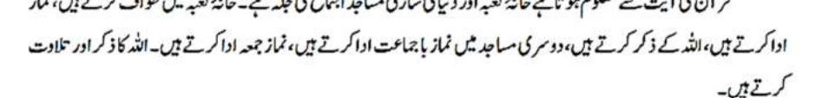
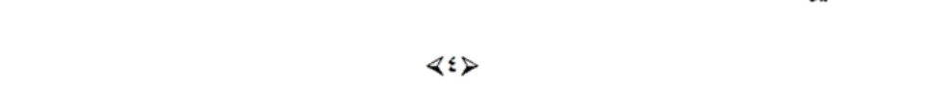
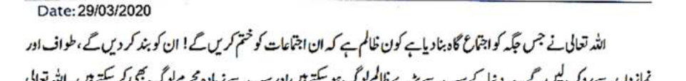
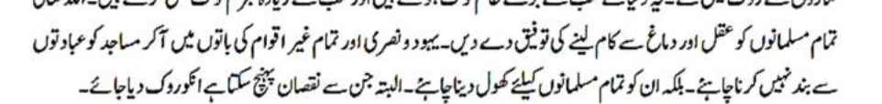
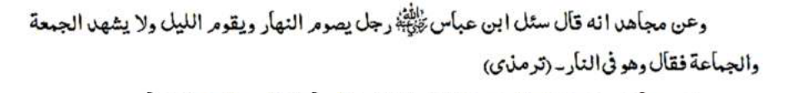
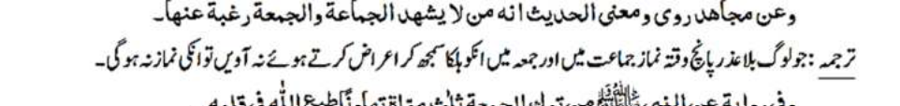
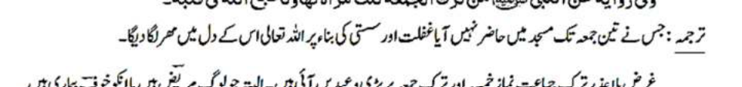
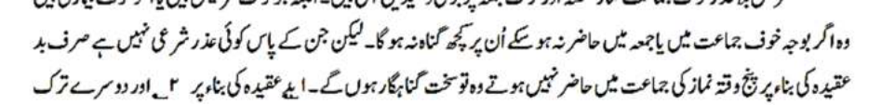
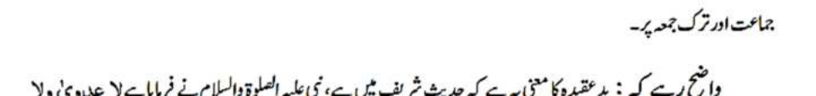
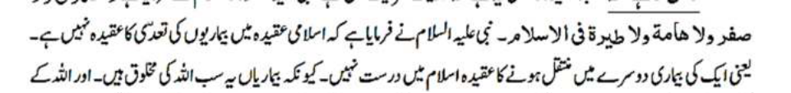
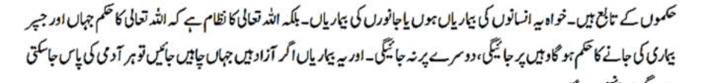
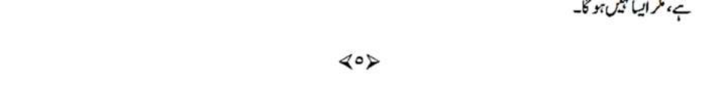
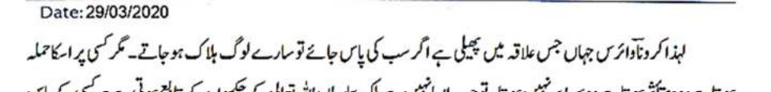
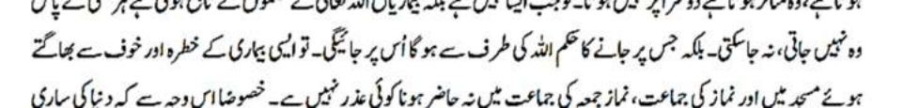
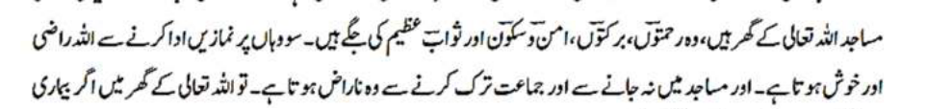
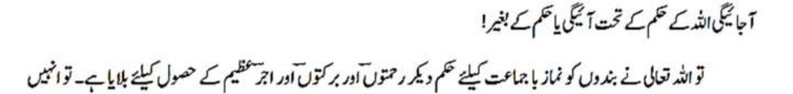
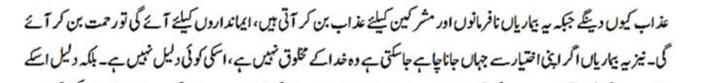
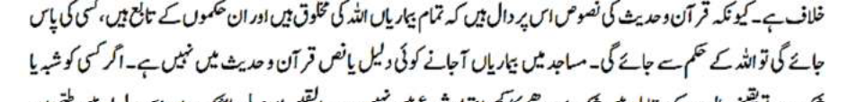
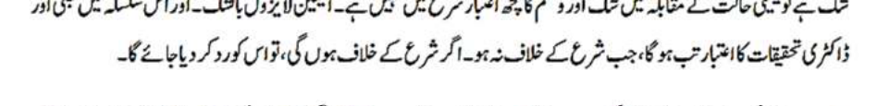
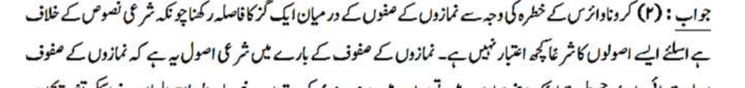
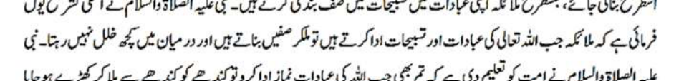
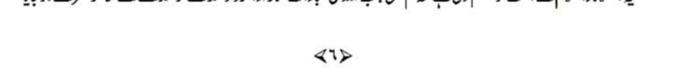
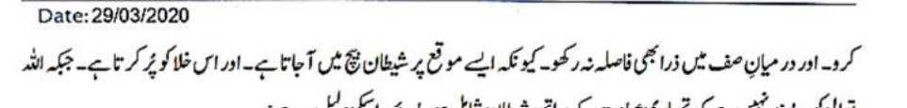
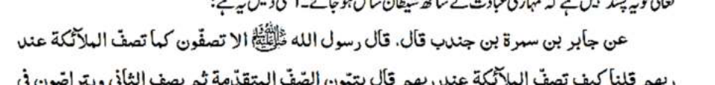
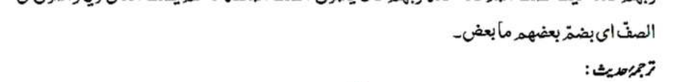
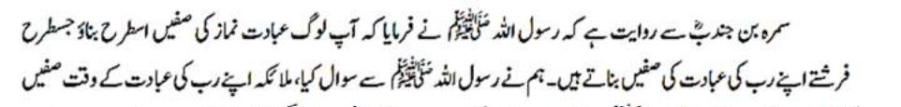
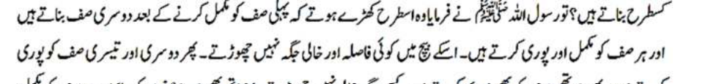
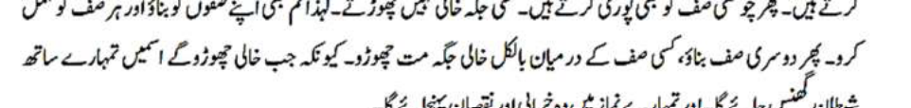
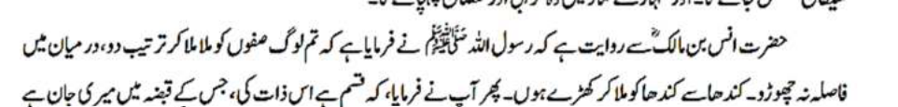
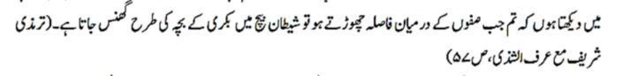
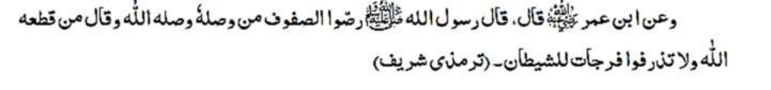

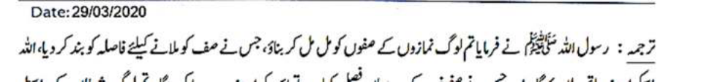
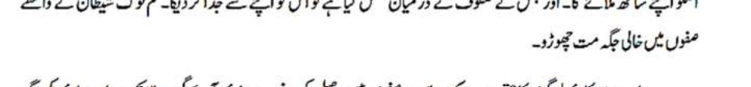
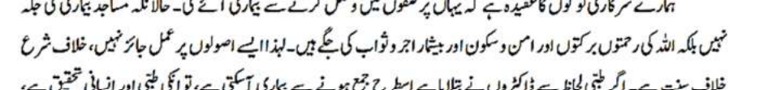
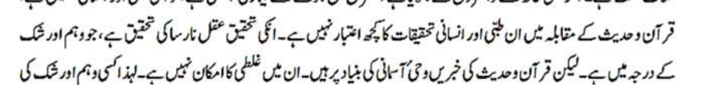
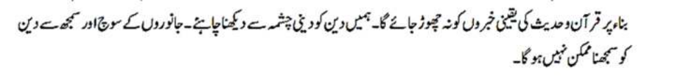

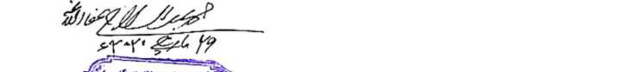


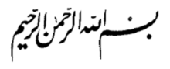

Question:
What is the view of the scholars of Din on the following matters?
1. An announcement has been made by some 'Ulama' that people can come to the Masajid in limited numbers for the five daily Salah, i.e. for every Salah, three to five people will perform in Jama'ah, whilst the rest of the people will perform the Salah at home. Similarly, for Jumu'ah Salah, a maximum of ten people can come and the rest of the people should perform Zuhr Salah at home. To what extent is this necessary in the light of the Noble Qur'an, Sunnah and Islamic Fiqh? Until today, we have been taught that there is no permission for those living nearby a Masjid to perform Salah at home without a valid reason. If a person performs Salah at home without a valid reason, then his Salah will not be valid and he will get the sin of abandoning the Jama'ah. We ask you for the Shar'i response in this regard.
2. Some people say that those who come to the Masjid for Salah, they should stand a metre distance apart from the others so that the effect of the illness does not spread to the others. In the light of the Noble Qur'an and Sunnah, will the Salah performed in this way be correct? Will our Salah be done or not? We hope that you will respond with references from the Noble Qur'an and Hadith.
A few concerned Musallis
Rajah Khali, Chat gam, Bangladesh
Answer:
(a) With regards to the matter at hand, Allah Ta'ala says in the Noble Qur'an,
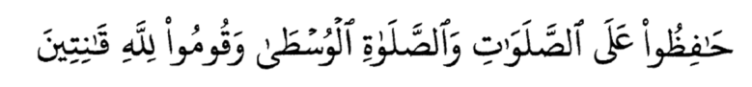
«Maintain with care the [obligatory] prayers and [in particular]
the middle prayer and stand before Allah, devoutly obedient»1
Rasulullah (sallallahu alayhi wasallam) said in explaining this verse, "I had intended to instruct some youngsters to gather firewood, then I give the command for Salah to commence and for the Jama'ah to begin. Then, I would go to the homes of those who do not come for Salah in Jama'ah and burn their homes.2
The same Hadith is narrated from lbn Mas'ud (Radhiyallahu anhu), Abu Ad-Darda' (Radhiyallahu anhu), Ibn 'Abbas (Radhiyallahu anhu) and others. Imam Tirmidhi (rahmatullahi alay) said that this Hadith is Hasan and Sahih. Imam Tirmidhi (rahmatullahi alay) says that this narration is proven from many SaHabah. All of them said that those who do not attend the Jama'ah after the Adhan has been called out, without any excuse, their Salah is not done.
1 Surah Al-Baqarah: 238 2 Tirmidhi
(b) Shaykh-ut-Tafsir Maulana Muhammad Idris Kandehlawi (rahmatullahi alay) writes in his Tafsir, Ma'arif-ul-Qur'an under verse 114 of Surah Al-Baqarah,
«And who are more unjust than those who prevent the name of Allah from being mentioned in His Masajid and strive toward their destruction. It is not for them to enter them except in fear.
For them in this world is disgrace, and they will have in the
Hereafter a great punishment»
'This refers to stopping the name of Allah Ta'ala being taken, whether in the heart, or by the tongue, or by the limbs. Not only this, but the person strives to render them empty and barren. Showing dishonour and destroying the Masajid is outwardly destroying them, whilst preventing worship, the remembrance of Allah a, this is the inner form and the proverbial form of destroying the Masajid .'3
Mufti Muhammad Shafi' writes in his Tafsir under the same verse quoted above, 'The third aspect we learn is that whatever action is adopted to render the Masjid empty and barren is forbidden (Haram). Just as destroying the Masjid is addressed clearly in this verse, in the same way, it refers to creating all those means that will cause the Masjid to be rendered empty and barren. The meaning of rendering the Masjid barren is that people do not come there for Salah, or they come in decreased numbers. This is because, the objective of building the Masjid is not to decorate it,
3 Ma'arif-ul-Qur'an vol.1 p.203 but it is to enliven Dhikr, Tilawat and Salah. This is why the Noble Qur'an states,
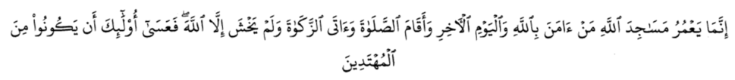
«The Masajid of Allah are only to be maintained by those who believe in Allah and the Last Day and establish prayer and give zakah and do not fear except Allah, for it is expected that those will be of the [rightly] guided»4
In a Hadith, Rasulullah (sallallahu alayhi wasallam) said that closer to Qiyamah, the Masajid of the Muslims will outwardly be beautiful and full of activity, but in reality, they will be barren. The number of those who come for Salah will decrease, or means for this decrease will be created. Sayyiduna 'Ali (Radhiyallahu anhu) said, "Honour of man lies in six things." Three of them are listed here: i. Recitation of the Noble Qur'an ii. Enlivening the Masajid iii. Building unity amongst friends that will help in the work of Din.5
The summary of the two Tafsirs is presented hereunder:
1. The Masajid are the houses of Allah Ta'ala. The objective is that Allah Ta'ala, should be remembered therein, with the heart, tongue and limbs, like in Salah and Tilawat.
2. The demand of honour as a human being is to enliven the Masajid and develop one's iman.
4 Surah At-Taubah: 18 5 Ma'arif-ul-Qur'an vol.1 p.272
3. The actions of Muslims involve the maximum number of MuSallis coming for Salah, remembering Allah Ta'ala, in the Masajid and reciting the Noble Qur'an.
4. Contrary to this, stopping people from coming to the Masjid, preventing them from worship and Salah, this is destroying the Masajid. This is censured in the verse.
5. Stopping the people from the Masjid is like the general destruction of the Masjid. Similarly, limiting the numbers of people or specifying the people to attend also falls under the purview of destroying the Masjid. This is great oppression. 6. The reasons and causes mentioned by those who stop and prevent the people from coming to the Masjid are not explained by the Shari'ah, nor do we find any indication of them in the NuSuS (clear texts).
(C)
Allah Ta'ala says,
«And [mention] when We made the House a place of return for the people and [a place of] security. And take, [O believers], from the standing place of Ibrahim a place of prayer. And We charged Ibrahim and lsma'il, [saying], "Purify My House for those who perform Tawiaf and those who are staying [there] for worship and those who bow and prostrate [in prayer}."»6
Tafsir 'Uthmani states:
6 Surah Al-Baqarah: 125, MudiH-ul-Qur'an, Shah 'Abdul Qadir Dehlawi (Rahmatullah alayh) p.24
'When we stipulated the Ka'bah as a place of gathering for people and as a place of security because people get together there annually for Hajj and 'Umrah, they perform Tawaf there, perform Salah and there are huge crowds. Those who perform Hajj and 'Umrah, they will then be safe from punishment and the oppression of people. Perform Salah at Maqam Ibrahim during Hajj and 'Umrah. We commanded Ibrahim and lsma'il to keep the Baytullah pure for those performing Tawaf, Ruku' and Sajdah.'
From this verse of the Noble Qur'an we learn that the Ka'bah Musharrafah and all the Masajid of the world are places of gathering. At the Ka'bah Musharrafah, TSawaf is done and Salah is performed. People remember Allah Ta'ala there too. In other Masajid, Salah with Jama'ah is held and Jumu'ah is performed. People remember Allah a and recite from the Noble Qur'an.
Who is the oppressor that stops the gathering of people at those places that Allah Ta'ala has made places of gathering?! Who is the oppressor that closes them, prevents the people from TSawaf and Salah? This can only be the greatest oppressors of the world and they are the greatest criminals too. May Allah Ta'ala bless the Muslims with the ability to use their intelligence and intellect. One should not come under the sway of the Jews and Christians and close the Masajid, stopping the different forms of worship. One should open it for all the Muslims. However, those from whom harm can come, they should be stopped.
lbn 'Abbas (Radhiyallahu anhu) was asked about a person that fasts during the day, stands in worship at night, but he does not attend the Jumu'ah and Jama'ah. He said, "He is in the fire."7
7 Tirmidhi"
Mujahid says, "Those who turn away from attending the five times Salah and Jumu'ah, treating it lightly, their Salah will not be done."
A narration from Rasulullah (sallallahu alayhi wasallam) says, "He who leaves three Jumu'ah due to negligence and laziness, Allah Ta'ala will place a seal on his heart."
In short, there are severe warnings for the person that abandons the Jama'ah Salah and Jumu'ah. However, those who are ill, or they have fear of illness, if they cannot attend the Jama'ah, or Jumu'ah, there will be no sin on them. On the other hand, the person that does not have a valid Shar'i reason, and he stays away from the five times Jama'ah due to faulty or defective belief, he will be a severe sinner. Firstly, due to his defective belief.
Secondly, due to leaving the Jama'ah.
It must remain clear that the meaning of faulty or defective belief is that it is stated in the Hadith that according to Islamic belief, there is no contagiousness, i.e. it is not correct to believe that an illness can move from one to another. This is because every illness is the creation of Allah Ta'ala.The illness is subject to the command of Allah Ta'ala, whether it affects man or animals. It is the system of Allah Ta'ala that when He wills an illness to afflict someone, it will afflict him, not anyone else. If these illnesses are free to go wherever they want, they can go to everyone, but this is not the case.
Therefore, the area or locality in which the Corona Virus has spread, if it affects everyone, then everyone will die. However, it affects certain people, not others. When the illness is subject to the command of Allah Ta'ala, it does not afflict every single person. Whoever is subject to the command of Allah Ta'ala to be affected, it goes to him. Therefore, it is not a valid excuse to fear such an illness and not attend the Masjid for Jama'ah and Jumu'ah, especially when all the Masajid are the houses of Allah Ta'ala. They are places of mercy, blessing, safety, security and reward. When a person will perform Salah in the Masjid, Allah Ta'ala becomes pleased, He becomes displeased when a person does not go to the Masjid and abandons the Jama'ah. If the illness comes into the Masjid, it will be under the command of Allah Ta'ala. Period.
Allah Ta'ala, instructs His servants to come for Jama'ah in order for them to acquire mercies, blessings and great reward. He will not punish them because these illnesses come as punishment for the disobedient and polytheists and as a mercy for the believers. In addition, if this illness goes wherever it wants, on its own accord, then it will not be the creation of Allah Ta'ala - there is no proof for this. The proof establishes the contrary because the clear texts of the Noble Qur'an and Hadith show that all illnesses are the creation of Allah Ta'ala and they follow His command. If it affects someone, it will be due to the command of Allah Ta'ala. There is no proof in the Noble Qur'an and Hadith that shows illnesses coming into the Masajid. If anyone has doubt, then there is no consideration given to doubt in SharI'ah in the case of definite and convincing circumstances.
Conviction is not removed by doubt. With regards to this, the research of medical professionals will be considered when it does not contradict the Shari'ah. If it conflicts with the Shari'ah, it will be rejected.
Due to fear for the Corona Virus, if a space of a metre is kept between people in the rows of Salah, then this contradicts the clear Shar'i texts. Therefore, no consideration will be given to this. The principle regarding the rows in the Masjid is that it should be like the rows of the angels in their worship and TasbiH. Rasulullah (sallallahu alayhi wasallam) explained that when the angels worship and glorify Allah Ta'ala, they join one another in a row or rank and there is no space in between. Rasulullah (sallallahu alayhi wasallam) taught the Ummah that when standing in Salah, one should stand in a row, shoulder to shoulder format and there should be no space in between at all. This is because Shaytan comes into the empty place. Allah, does not like that Shaytan has a share in one's worship. The proof is the following narration, 'Samurah Ibn Jundub (Radhiyallahu anhu) narrates that Rasulullah (sallallahu alayhi wasallam) said, "Make your rows in Salah like the angels do by their deity." We asked, "How do the angels make their rows when worshipping their deity?" Rasulullah (sallallahu alayhi wasallam) said, "Complete the first row, then the next. Complete each row, without leaving a space in between because when it is left empty, Shaytan jumps in between and causes harm in your prayer."
Anas (Radhiyallahu anhu) narrates that Rasulullah (sallallahu alayhi wasallam) said, "Join one another in the rows in sequence, do not leave a space in between, join shoulder to shoulder." Then he said, "By the Being in Whose control is my life, I see that when you leave a space in the row, then Shaytan comes in between like the kid of a goat."8
8 Tirmidhi
Rasulullah (sallallahu alayhi wasallam) said, "Form your rows for Salah by joining each other, he who fills a space in order to complete a row, Allah Ta'ala, will join him to Him. He who leaves a gap in between, Allah Ta'ala will keep him away from Him. Do not leave an empty space for Shaytan."9
The belief system of our government is that by joining the rows, the illness will spread, whereas the Masajid are not places of illness, but they are places of the mercy, blessings, safety and reward from Allah Ta'ala. Therefore, it will not be permitted to practice upon such principles. They are in conflict with the Shari'ah and the Sunnah. If according to the medical practitioners, the illness can spread by gathering in this way, then it will be medical and human research. No consideration is given to this research when it conflicts the Noble Qur'an and Hadith. Their research is limited to their intellect, which is of the level of doubt. However, the information given in the Noble Qur'an and Hadith is based on divine revelation. There is no possibility of error in it. Hence, the definite information should not be abandoned for that which is doubtful. We have to look at Din from the sources of Din. It is not possible to understand Din from the intellect of animals.
29 March 2020
Mufti Muhammad Abdus-Salam Chatgami
9 Ibid

