
Kitaabut Tahaarah
The Majlis · Voice of Islam
Mujlisul Ulama of South Africa

About this edition
This is a reproduction by The Majlis Archive (themajlisarchive.com) of a publication of The Majlis, Mujlisul Ulama of South Africa, made and published with their permission.
The PDF as The Majlis issued it is the original. This edition was read from that PDF's own structure and checked against it letter for letter; where the two differ, the PDF is correct.
Checked: 1,121 paragraphs, 0 differing; a second, independent PDF reader finds 99.4% of the PDF's words here.
Nothing has been reworded, added or removed.

THE BOOK OF PURIFICATION AND PURITY (HANAFI)
Published by:
Young Men's Muslim Association
P.O. BOX 18594
Actonville, Benoni
South Africa

"Indeed ALLAH loves those who purify themselves" (Qur'aan Majeed) KITAABUT TAHAARAH THE BOOK OF PURIFICATION AND PURITY (HANAFI)

"Cleanliness is a part of Imaan" (Hadeeth Shareef)
Published by:
Young Men's Muslim Association
P.O. BOX 18594
Actonville, Benoni
1506 South Africa

Isbn: 1-874827-09-5

INTRODUCTION
KITAABUT TAHAARAH (the Book of Purification and Purity) is the second in the series of books on Fiqh which we contemplate to publish, Insha'Allah. The first in the series was KITAABUS SALAAT (the Book of Salaat). Insha'Allah, the third in the series will be Kitaabul Imaan (the Book of Faith); the fourth will be Kitaabus Saum (the Book of Fasting); the fifth, Kitaabuz Zakaat (the Book of Zakaat); the sixth, Kitaabul Hajj (the Book of Hajj). This will be followed by Kitaabun Nikah (the Book of Marriage), Kitaabut Talaaq (the Book of Divorce), and the many other Books on Fiqhi subjects such as trade, commerce, waqf, oaths, sacrifice, zabah, inheritance, etc.
The task of accomplishing this goal is long and arduous. Nevertheless, a sincere niyyat is made in this direction. If Allah Ta'ala Wills success for us, then Insha'Allah, we shall achieve our goal. In the achievement of our aim we require the Duas of as many people as possible. Who knows whose Dua will be efficacious in the attainment of the goal we have set?
The niyyat is to obtain the Pleasure of Allah Ta'ala by serving the "ilmi" (concerning Islamic knowledge) needs and requisites of the Muslim community. We, therefore, request all Muslims to remember the authors, publishers and all those rendering assistance in the preparation of this series of Shar'i books in their moments of Dua. Do supplicate that Allah Ta'ala maintain the sincerity of our niyyat and grant us the resolution and the means to remain engaged in the activity of His Deen unto our very last breath of this ephemeral existence and temporary station in the sojourn back unto Allah Ta'ala from whence we have hailed.
Success and final victory is not necessarily in the fulfilment or realisation of the goal and aim we set for ourselves. Allah Ta'ala, in His Infinite Wisdom, will decide how much of our aim and effort should be manifested for utilisation by the Muslim public. Success does not mean accomplishment of man-set goals. Success means the ending of our life in the service and work of Allah Ta'ala.
Was-salaam, The authors.
1st Jamad-ul-Akhir 1401 / 6th April 1981 ISBN 1-874827-09-5
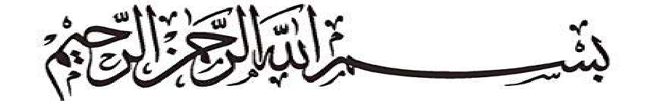
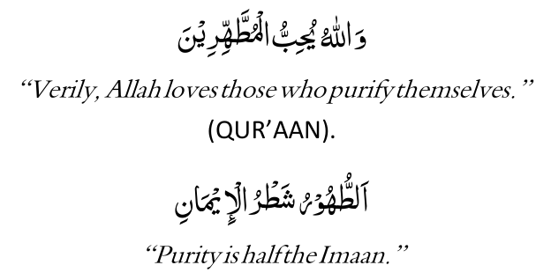
(QUR'AAN).
(HADEETH).
Islam has emphasised the importance and the significance of purity and purification. Purification — that is purification of body, garments, home and heart is commanded by the Shariah as a compulsory duty. Its importance is to be gauged from Allah's declaration of love for those who purify themselves —
"Verily Allah loves those who purify themselves."
The tremendous significance of purity (Tahaarat) is borne out by Rasulullah's (Sallallahu alayhi wasallam) assertion that half of Imaan consists of purity.
Tahaarat is conditional for many forms of Ibaadat, i.e. the Ibaadat without the necessary Tahaarat will not be valid. It is precisely for this reason that all Books of Fiqh commence with "Kitaab-ut-Tahaarah" or "The Book of Purity."
Kitaab-ut-Tahaarah deals with various forms of purification, e.g. Wudhu, Ghusl, Masah Alal Khuf-fain, Tayammum, well-purification, etc. Each will be dealt with separately and in detail, Insha'Allah.

WUDHU
There are two states of impurities which concern the human being. These are: (1) Janaabat. (2) Hadath.
(1) Janaabat also known as "hadathe akbar" (greater impurity), is the condition of impurity which makes "Ghusl" (Bath) compulsory. (Janaabat will be explained in the section dealing with "Ghusl").
(2) Hadath, also known as "hadathe asghar" (lesser impurity), is the condition of impurity effected by the following acts:
(a) Answering the call of nature.
(b) Emergence of matter, worms, etc., from the front and hind private parts. (c) Passing wind from the hind private part. (N.B.: The emission of wind from the front private part — as sometimes happens in certain types of sickness — does not occasion hadathe asghar).
(d) Flowing of blood from any part of the body.
(e) Flowing of pus from any part of the body.
(f) Vomiting a mouthful.
(g) Sleeping while lying down or while leaning against some object.
(h) Unconsciousness.
(i) Audible laughter during Salaat other than Janaazah Salaat.
NOTE: Acts (a) to (i) mentioned above are factors which nullify Wudhu.

AHKAAM OF HADATHE ASGHAR
(1) It is Makrooh Tahrimi to touch the Qur'aan Shareef or even the empty spaces of the pages of the Qur'aan Shareef while in the condition of "hadathe asghar."
If a verse of the Qur'aan Shareef is written on a page or in a book, it will be permissible to touch the book or page, but not the verse.
(2) "Na-baaligh" or minor children may touch the Qur'aan Shareef without Wudhu.
(3) It is not permissible to perform Salaat in the condition of "hadathe asghar."
(4) Although not permissible to touch the Qur'aan Shareef, It is permissible to recite it in the condition of "hadathe asghar."

THE FARDH ACTS OF WUDHU
The Wudhu has four Fardh acts. If any one of these four Fardh acts is omitted or rendered incompletely, the Wudhu will be null.
The following are the four Fardh acts of Wudhu:
(1) Washing the face from ear to ear and from forehead to below the chin once.
(2) Washing both hands and arms including the elbows once.
(3) Making Masah (i.e. wiping with the moist hands) of one quarter of the head once.
(4) Washing both feet, including the ankles, once. These four acts are known as the FARAA-IDH OF WUDHU.

THE SUNNAT ACTS OF WUDHU
Certain acts of Wudhu are classified as Sunnat. It is necessary to execute all the Sunnat factors of Wudhu.The full Sawaab (Reward) and significance of Wudhu depends upon the proper discharge of the Sunnat acts. If the Sunnat acts are omitted the Sawaab will be lost although the Wudhu will still be valid. Deliberate and continuous neglect of the Sunnat factors will be sinful.
The following are the Sunnat acts of Wudhu:
(1) Niyyat for Wudhu.
(2) Tasmiyah, i.e. reciting
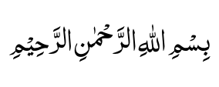

BISMILLA-HIR RAHMANIR-RAHIM.
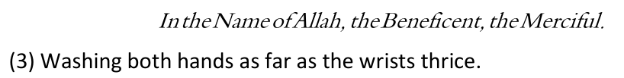
(4) Rinsing the mouth thrice.
(5) Applying water into the nostrils thrice.
(6) Using a Miswaak.
(7) Making Masah1* of the whole head.
(8) Washing every part thrice.
(9) Masah* of the ears.
(10) Khilaal* of the fingers, toes and beard.
(11) Observing Tarteeb, i.e. to observe the order of washing the various parts as will be shown in the "Method of Wudhu."
(12) Washing the various parts in quick succession, i.e. washing the next part before the previous part dries.

THE MUSTAHAB FACTORS OF WUDHU
Certain acts of Wudhu are described as Mustahab. Discharging of the Mustahab acts increases the significance and Sawaab of the Wudhu. It is therefore necessary to render all the Mustahab factors of Wudhu.
The following acts are Mustahab in Wudhu:
(1) Facing the Qiblah.
(2) Sitting while making Wudhu.
1 *EXPLANATORY NOTES:
(a) Masah is the act of wiping with the moist hands.
(b) Khilaal is:
(i)The act of interlacing the fingers of one hand with those of the other and then drawing them out; (ii) Passing the fingers through the beard; (iii) Passing a finger in between the toes.
(3) Masah of the nape (i.e. the back of the neck). (4) Commencing to wash from the right side.

THE MAKROOH FACTORS OF WUDHU
(1) Performing Wudhu at a place which is dirty.
(2) Indulging in worldly talks while engaged in Wudhu.
(3) Performing Wudhu in a manner which is contrary to Sunnat. (4) Using the right hand when cleaning the nose.
(5) To use water excessively, i.e. more than what is necessary. (6) Striking water against the face, giving rise to splashing.
(7) Unnecessarily taking assistance from another person, i.e. another person pouring water for the one who is performing Wudhu.

THE METHOD OF WUDHU
N.B.: The person making Wudhu will be referred to as a mutawad-dhi.
The mutawad-dhi should endeavour to face the Qiblah while making Wudhu. It is best to sit on a raised or high place when making Wudhu in order to be out of reach of water splashing. It is far nobler and meritorious to make Wudhu by pouring water from some container, e.g. a jug. Use of a tap in Wudhu entails great waste of water, and Rasulullah has warned against wasting water even at the river bank.
Making niyyat (intention) of Wudhu, recite
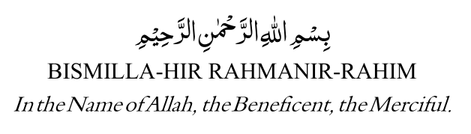

BISMILLA-HIR RAHMANIR-RAHIM
First of all, wash both hands as far as the wrists, thrice, beginning with the right hand.
Thereafter rinse the mouth thrice and use a Miswaak. In the absence of a Miswaak use a coarse cloth to clean the teeth. Remember that a toothbrush is not an adequate substitute for a Miswaak. However, since the use of a cloth is in the Sunnah when a Miswaak is not available, it (cloth) could be regarded as an adequate substitute. If the toothbrush is made of bristles (pig's hairs), its use will be haraam.
If one is not fasting then gargle as well. Thereafter apply water thrice into the nostrils with the right hand and clean the nose with the little finger of the left hand. If the mutawad-dhi is fasting, water should not be drawn higher than the soft or fleshy part of the nostrils.
Wash then the entire face thrice. The limits of the face for Wudhu purpose is from the limits of the hair at the forehead until below the chin, and from ear to ear. Water must reach below the eyebrows as well. This is followed by making khilaal* of the beard.
The right hand, including the arm and elbow, should then be washed thrice. Then wash the left hand in exactly the same manner.
This is followed by making masah of the whole head; masah of the ears; masah* of the nape (i.e. back of the neck).
Thereafter, wash the right foot, including the ankles, thrice; then wash the left foot in the same way. Make khilaal of the toes.
The perfect Wudhu requires that all the Sunnat dua be recited at the appropriate times during Wudhu and after Wudhu.
*See explanatory notes for description of masah and khilaal on Page 10.
HOW TO MAKE MASAH OF THE HEAD, EARS AND NAPE Masah Of The Head Masah of the head, ears and nape during Wudhu is made with the moist hands.
Masah of the head will start by placing the fingers — three fingers of each hand, i.e. the three fingers from the little finger—at the front of the head immediately above the forehead. The thumbs and forefingers will be held separated from the head. The rest of the palms (i.e. besides these six fingers) will be held away from the head.
Now draw these six fingers backward in a straight line over the head until the back of the neck is reached.
Now close the palms onto the head at the back where the finger-masah stopped. Draw the palms forward to the front of the head. In drawing the palms forward, do not let the six fingers (previously used) touch the head. The Masah of the head is now complete.
Masah Of The Ears Immediately after completing the Masah of the head make Masah of the interior of the ears with the forefingers.
Place the forefingers at the entrance of the ear-holes and rotate over the whole interior area of the ear.
With the thumbs make the Masah of the external surface of the ears by passing the thumbs over the back of the ears, starting from the bottom, i.e. the back of the ear-lobes. The Masah of the ears is now complete.
Masah Of The Nape Immediately after completing the Masah of the ears, Masah of the nape has to be made (i.e. Masah of only the back of the neck is made).
Use the back of the six fingers (i.e. the six fingers used when starting the Masah of the head) for making Masah of the back of the neck.
First pass the back of the three right-hand fingers over the right-hand side of the neck, then pass the back of the three left hand fingers over the left side of the neck. Masah of the nape is now complete.
KHILAAL Khilaal Of The Fingers Immediately after washing both arms, Khilaal of the fingers has to be made.
Draw the left-hand fingers through the right-hand fingers over the back of the hand. Thereafter do likewise with the right-hand fingers. This completes the Khilaal of the fingers.
Khilaal Of The Toes Khilaal of the toes will be made after the feet have been washed.
Pass the little finger of the left hand in between the toes of both feet, starting from the little toe of the right foot and ending with the little toe of the left foot. The Khilaal of the toes is now complete.
Khilaal Of The Beard Khilaal of the beard has to be made after washing the face.
Pass the fingers of the right hand through the beard, starting from the bottom of the beard, moving upwards.

THE AADAAB OF WUDHU
Aadaab means etiquette or respects. Certain etiquettes should be observed for the purpose of Wudhu in order to improve the quality and significance of the Wudhu. Since the Wudhu is an Ibaadat which washes away sins as well, it is necessary that it should be discharged, in a beautiful manner. The perfect Wudhu is the Wudhu in which the Aadaab have been observed.
The Aadaab (a) To make preparations, for Wudhu prior to the entry of the Salaat time. (b) Sitting on a raised place while making Wudhu.
(c) Refrain from indulging in worldly talk while making Wudhu.
(d)Reciting the Sunnat Duas during Wudhu. (These will be explained later). (e) Reciting Kalimah Shahaadat when washing each part.
(f) Blowing the nose.
(g) To gargle the mouth.
(h) Rotating the ring if it is loose-fitting.
(N.B. If it fits tightly then it is Waajib to rotate it to enable water to moisten the surface of the finger under the ring).
(i) Water must not be wasted.
(j) To stand up and drink the water remaining after Wudhu has been made. (This is possible only if an utensil is used from which water is poured for Wudhu).
(K) To make two Rakaats Tahyatul Wudhu immediately after Wudhu. (N.B.: This Salaat should not be made during Makrooh times).

MISCELLANEOUS MASAA-IL PERTAINING TO WUDHU
(1) If blood or matter remains within the confines of the wound or sore, Wudhu will not be nullified. Wudhu will only break if the impurity flows out of the wound or sore.
(2) If dots of blood come out of the nose while blowing it, Wudhu is not nullified. Wudhu will break only if the blood is in the fluid state.
(3) A pimple within the eye discharging fluid will break Wudhu if the fluid flowed out of the eye.
(4) If the blood content in the saliva is dominant then Wudhu will break. Therefore, if one's saliva is reddish because of blood, the Wu'dhu will-be nullified.
(5) The blood appearing on a toothpick will not nullify Wudhu if the effect of the blood is not noticeable in the saliva.
(6) Fluid flowing from a paining ear will nullify Wudhu even if there is no sore or pimple in the ear.
(7) Water flowing from the eyes as a result of the eyes paining will nullify Wudhu.
(8) If males fall asleep in the position of Sajdah, but do not topple over, Wudhu is not broken. However, if females fall asleep in the position of Sajdah, Wudhu will break.
(9) A doubt will not nullify Wudhu. One remembers that Wudhu was made, but cannot remember if the Wudhu was broken. In such a case of doubt the Wudhu will be considered valid.
(10) While making Wudhu one doubts whether a certain part was washed. In this case the particular part should be washed. However, if such doubt occurs after completion of Wudhu, it will then be regarded that the Wudhu is complete. No notice of the doubt should then be taken.
(11) If after Wudhu one remembers well that a certain part was not washed or Masah of the head was not made, then the omitted act should be rendered. There is no need to repeat the whole Wudhu.
(12) It is not permissible to touch without Wudhu a tray, plate, etc., on which a verse of the Qur'aan is engraved or written.
(13) It is preferable (Mustahab) to make Wudhu for each Salaat even though one may be in the state of Wudhu. Taking a fresh Wudhu is recommended only if at least two Rakaats Salaat have been performed with the Wudhu. Hence, if after Wudhu has been taken one did not perform any Salaat, it will not be permissible to take a fresh Wudhu before that Wudhu has been either broken or at least two Rakaats Salaat have been performed.
(14) One will be in the state of Wudhu if at least the Faraa-idh of Wudhu has been fulfilled even if all the Sunnat and Mustahab factors have been omitted. However, the Sunnat and Mustahab factors should not be omitted without valid reason.
(15) If one was drenched in the rain and the Faraa-idh of Wudhu were discharged in the rain water, the Wudhu will be valid even if one had no intention of making Wudhu.
(16) If the four parts (Fardh parts) of the body have been washed, e.g. by swimming or taking a bath, Wudhu will be valid even if one had no intention of Wudhu.
(17) There is no need for Wudhu after a bath (Ghusl) has been taken.
(18) While making Wudhu one should take care not to strike the water against the face causing it to splash. To do so is Makrooh.
(19) While making Wudhu the eyes should not be closed so tightly thus preventing water from moistening the eye-lashes or blocking the entry of water into the eye-wells. To do so is Makrooh Tahrimi. If even one eyelash remains dry or water has not entered the eye-wells, the Wudhu will not be valid.
(20) The mouth should not be closed tightly while making Wudhu. To do so is Makrooh Tahrimi. If any part of the lips remain dry, the Wudhu will not be valid.
(21) If any substance which does not allow water to seep through, e.g. gum, paint, cutex (a substance usually applied by women on their finger-nails), etc., sticks on any part of the body which has to be compulsorily washed during Wudhu, the Wudhu will not be valid as long as the substance is not removed and the portion there under washed. Hence, if after Wudhu one realises that some gum is on the finger-nail (for example), then the Wudhu will be valid only if the gum is removed and the nail washed. There is no need to renew the Wudhu.
(22) If removal of the ointment from a sore or wound is harmful then it will not be necessary to remove it. Water may merely be passed over it. If pouring water over the affected part is also harmful then merely make Masah of the affected part. If even Masah will be harmful then omit the affected part.
(23) If the wound or sore is bandaged and one will experience difficulty in opening and tying the bandage for Masah purpose, or Masah on the affected part will be harmful, then Masah should be made over the bandage. If this difficulty does not exist, then it will be necessary to open the bandage, plaster, etc., and make Masah on the affected part.
(24) It is best to make Masah over the whole of the upper surface of the bandage, etc. It is Waajib to make Masah of more than half the bandage, plaster, etc. If only half or less than half the bandage was covered by the Masah, the Wudhu will not be valid.
(25) If after making Masah the bandage, plaster, etc., comes loose and it is realised that the affected part has healed, then the Masah made will not be valid. It will now be necessary to wash the particular part. It is not necessary to renew the Wudhu.

MORE MASAA-IL REGARDING WUDHU
(1) The Beard If the beard is thick then it is not Fardh for the water to reach the skin under it during Wudhu. If the beard grows sparsely so that the skin under it can be seen, then it is Fardh for the water to reach the skin as well.
(2) Doubt A doubt will not invalidate Wudhu. If one is certain that one has made Wudhu, but doubts regarding the breaking of Wudhu, then such doubt will not break Wudhu. The Wudhu will be considered valid.
(3) Long Finger-Nails Nowadays it is considered fashionable for women to keep long finger-nails. Dirt accumulates under such long nails and obstructs the moistening of the parts covered by the dirt. Besides such long nails and dirt- accumulation being contrary to Islamic hygiene and tahaarat rules, Wudhu and Ghusl will not be valid if the dirt is of a nature — non-porous — which does not permit water to seep through.

MASNUN DUAAS OF WUDHU
Regarding Wudhu, our Nabi (Sallallahu alayhi wasallam) said:
"Wudhu is the weapon of the Believer."
Since Wudhu is the "weapon" of the Mu'min, it is essential that we maintain this "weapon" in good order. By observing the various Masnoon dua of Wudhu, we will in fact be beautifying and strengthening this "weapon" of Wudhu. An effort should therefore be made to learn the relevant dua of Wudhu. These duas are all brief and simple to commit to memory. These dua are as follows:

When Commencing Wudhu
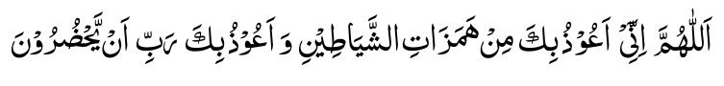
ALLAHUMMA INNEE A-OOTHU-BIKA MIN HAMA ZAA-TISH-SHAYAA-TINI WA A-OOTHU-BIKA RABBI AY-YAH DHUROON.
O Allah! Verily, I seek refuge with You from the mischief of shayaateen and, I seek Your protection from the shayaateen gathering in my proximity.

While Washing The Hands
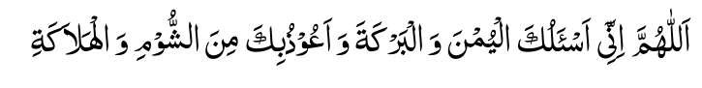
ALLAHUMMA INNEE AS-ALU-KAL-YUMNA WALBAR-KATA WA A-OOZU-BIKA MINASH-SHOOMI WAL-HALAA-KAH.
O Allah! I ask You for virtue and barakat. And, I seek protection with You from misfortune and destruction.

At The Time Of Rinsing The Mouth
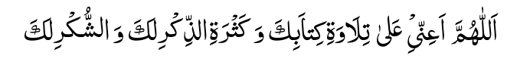
ALLAHUMMA A-INNEE ALAA TILAA-WATI KITAA-BIKA WA KATH-RATI-THIKRI LAKA WASH-SHUKRI LAK.
O Allah! Assist me in the recitation of Your Kitaab (Qur'aan), and in abundance of Your Zikr, and in fulfilling Your Shukr.

At The Time Of Pouring Water Into The Nostrils
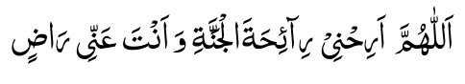

ALLAHUMMA ARIH-NEE RAA-I-HATAL-JANNATI WA ANTA AN-NEE RAA-DH.
O Allah! Grant me comfort with the fragrance of Jannat while You are pleased with me.

At The Time Of Blowing The Nose
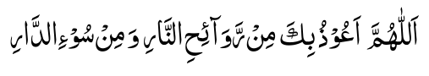

ALLAHUMMA A-OOTHU-BIKA MIR-RAWAA- I-HIN- NAARE WA MIN SOO-ID-DAAR.
O Allah! I seek refuge with You from the scorching winds of the Fire and from the Evil Abode.
The sins of one who makes Wudhu — and beautifies the Wudhu — emerge from his body to the extent that they make their exit from even under his nails. — HADITH. Beautifying Wudhu: i.e. to make Wudhu observing all the
Sunnat and Mustahab factors of Wudhu.
None but the true Mu'min guards the Wudhu.—HADITH.
Guarding Wudhu: i.e. to make Wudhu observing all the Sunnat and Mustahab factors of Wudhu.

While Washing The Face
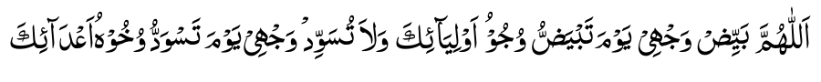
ALLAHUMMA BAY-YIDH WAJ-HEE YAU-MA TAB-YADH-DHU WUJOO-HU AU-LIYAA-IKA WA LAA TU-SAW-WID WAJ-HEE YAU-MA TAS-WADDU WUJOO-HU A'DAA-IK.
O Allah! Brighten my face on the day when the faces of Your friends will glitter. And, do not blacken my face on the day when the faces of Your enemies will blacken.

When Washing The Right Hand
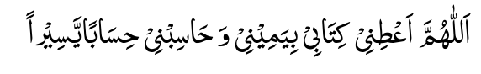

ALLAHUMMA A'TlNEE KITAABEE BI-YA-MEENEE WA HAA-SIBNEE HISAA-BAY-YASEERA.
O Allah! Give my Record of Deeds in my right hand and take from me an easy reckoning.

When Washing The Left Hand
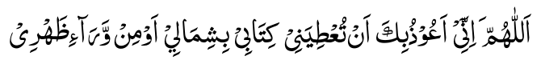
ALLA HUMMA INNEE A-OOTHU-BIKA AN TU' TIYANEE KITAABEE BI-SHIMAALEE AU MIWWARAA-E THAH-REE.
O Allah! I seek refuge with You from Your giving my Record of Deeds in my left hand or from behind my back.
One should never urinate in one's bathroom and then bath or make Wudhu therein, for verily, the majority of waswaas (stray thoughts which Shaitaan whispers into the heart) is the result of it (this practice) — HADITH.

At The Time Of Masah Of The Head
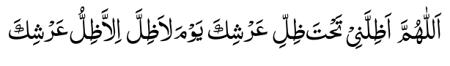
ALLAHUMMA ATHIL-LINEE TAH-TA THILLI ARSHIKA YAU-MA LAA THILLA IL-LAA THILLU ARSHIK.
O Allah! Grant me shade under the Shade of Your Throne on the day when there will be no shade except the Shade of Your Throne.

When Making Masah Of The Ears
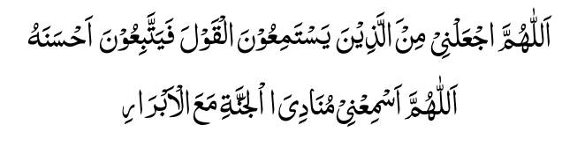
ALLAHUMMAJ-ALNEE MINAL-LATHEENA YASTA -MI-OO-NAL-QAULA FAYAT-TABI-OONA AHSANA-HU. ALLAHUMMA ASMI'-NEE MUNADI-YAL-JANNATI MA-AL-ABRAAR.
O Allah! Make me among those who listen and follow beautiful talks. O Allah! Let me hear the caller of Jannat while I am in the company of the pious.

When Making Masah Of The Neck
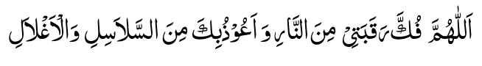
ALLAHUMMA FUK-KA RAQA-BATEE MINANNAARI WA A-OOTHU-BIKA MINAS-SALAASILI WAL AGH-LAAL.
O Allah! Save my neck from the fire. And, I seek refuge with You from chains and leg-irons.

When Washing The Right Foot
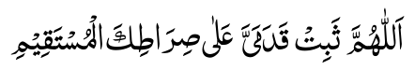

ALLAHUMMA THAB-BIT QADA-MAY-YA ALAA SIRAATIKAL MUSTAQEEM.
O Allah! Establish firmly my feet on Your Straight road.

When Washing The Left Foot
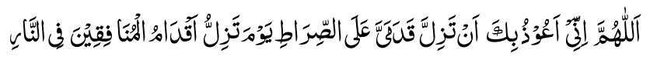
ALLAHUMMA INNEE A-OOZU-BIKA AN TAZILLA QADA-MAY-YA ALAS SIRAATI YAU-MA TAZILLU AQDAA-MUL MUNAFIQEENA FINNAAR.
OAllah! Verily, I seek refuge with You from my feet slipping on the Siraat on the day when the feet of the munaafiqeen will be shuddering in the Fire.
A person having completed his ablutions and proceeding for Salaat, undoubtedly, is aware of his external purity which men behold. He should, however, be ashamed of communing with Allah without first purifying his heart which Allah beholds and sees. He should know that the purity of the heart is achieved by repentance, shunning makruhaat (blameworthy things) and executing laudable practices. — IMAAM GHAZAALI.
Whoever washes (in Wudhu) more than thrice transgresses and commits evil. — HADITH.
He who remembers Allah while making Wudhu will have his body purified (of sins) by Allah. — HADITH.

After Wudhu
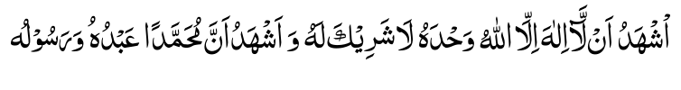
ASH-HADU AL-LAA-ILAA-HA ILLAL-LAAHU WAH-DAHU LAA-SHAREEKA LAHU WA ASHHADU ANNA MUHAMMADAN AB-DUHU WARASOO-LUH.
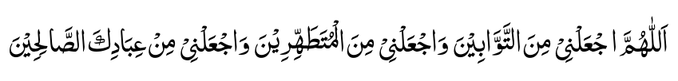
ALLAHUMMAJ-AL-NEE MINAT-TAW-WA-BEENA WAJ-AL-NEE MINAL-MUTA-TAH-HIREENA WAJAL-NEE MIN IBAA-DI-KAS-SAALIHEEN.
I bear witness that there is no object of worship but Allah, the One Who has no partner. And I bear witness that, verily, Muhammad is His servant and His Messenger.
O Allah! Make me among those who make Taubah; and make me among those who thoroughly purify themselves; and make me among Your pious servants.
The Malaa-ikah do not enter a home in which there is a picture (of an animate object), a dog or a Junubi (one who is in the state of Janaabat.--HADITH.
Commenting on this Hadith, Hadhrat Shah Waliullah Dahlawi (Rahmatullah alayh) says: "Since Janaabat is the opposite of the condition (of purity) of the Malaa-ikah, it does not behoove the Believer to indulge in sleeping, eating, etc., while in the state of Janaabat. When Ghusl becomes difficult then (at least before sleeping or eating) make Wudhu, for Nabi (Sallallahu alayhi wasallam) said: 'make wudhu and wash your male organ'

MISWAAK
Rasulullah (Sallallahu alayhi wasallam) laid great stress on the use of the Miswaak (a tree-twig used for cleansing the teeth). One of the Sunnats of Wudhu is to use a Miswaak. Wherever a Miswaak is available and is not used, the full beauty and complete Sawaab of the Wudhu is not realised. There are numerous benefits and advantages in using a Miswaak.
History Of The Miswaak The Miswaak, a tree-twig, was in use for brushing and cleansing the teeth long before the advent of our Holy Nabi (Sallallahu alayhi wasallam). In fact the records of our Nabi Muhammad's (Sallallahu alayhi wasallam) Ahadith indicate that the Miswaak was the "Sunnah" or practice of all the Ambiyaa (Prophets of Allah) — Peace be upon them.
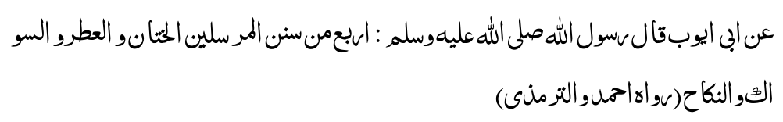
" Abu Ayyub (Radiallahu anhu) narrates that Rasulullah (Sallallahu alayhi wasallam) said: four things are amongst the practices of the Ambiyaa — circumcision, application of perfume, Miswaak and marriage'." (AHMAD AND TIRMIZI)
Several other Ahadith of our Nabi also mention the Miswaak to have been the practice of the Prophets (O.W.B.P.). Thus, we can safely claim that the practice of using the Miswaak is as old as mankind itself since Mankind's origin on the planet was with the appearance of the first Nabi of Allah, viz. Adam (Alayhis salaam). Therefore, among the many advantages and benefits of using the Miswaak, one of the greatest benefits is the good-fortune of being associated with the Ambiyaa in this holy practice. On the other hand, those who neglect the use of the Miswaak invite upon themselves a great misfortune by being deprived of the tremendous amount of Sawaab (Reward) which this noble practice carries.
Allamah Ibn Ismail says:
"It surprises me how people could forgo such a great Sunnah, the significance of which many Ahadith of our Nabi (Sallallahu alayhi wasallam) explain. Remember that it is a great loss to neglect the Miswaak."
The Importance Of The Miswaak In Islam Islam has accorded an elevated status to the Miswaak. Its importance has been stressed in many Ahadith of our Holy Nabi (Sallallahu alayhi wasallam). The statements and examples of the Sahaabahh and the Ulama of Islam regarding this practice bear testimony in abundance of the significance of the Miswaak.
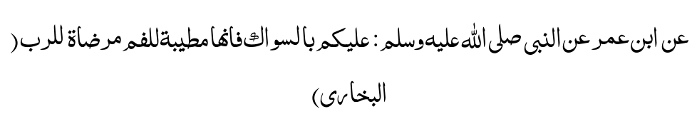
" Ibn Umar (Radiallahu anhu) narrates that the Messenger of Allah (Sallallahu alayhi wasallam) said: 'Make a regular practice of the Miswaak, for verily, it is healthy for the mouth and it is a Pleasure for the Creator (i.e. Allah is pleased with the Muslim who uses the Miswaak)'."
(BUKHARI)
It is clear from this Hadith that two types of benefits occur from the use of the Miswaak. These could be categorised as follows:
(1) UKHRAWI or Benefits which relate to the Hereafter; (2) DUNYAWI or Benefits which relate to this worldly life.
The Ukhrawi category comprises the various Sawaabs (Rewards) which the Servant of Allah will obtain in the Hereafter for using the Miswaak. The Dunyawi category comprises the immediate benefits or advantages accruing in the physical human body by the constant use of the Miswaak.
The prime motive of the true Believer in his use of the Miswaak is his desire to obtain the first category of Benefits, i.e. Ukhrawi, the obtainal of the second category being a necessary corollary. This is so, since the only factor which governs the motive and intention of the Believer in his Ibaadat (Worship) is the Pleasure of Allah, our Creator, Nourisher and Sustainer. Hadhrat Ali
(Radiallahu anhu ) the fourth Khalif of Islam said: "Make the Miswaak (i.e. its use) incumbent upon you, and be constant in this practice because Allah's Pleasure is in it and it increases the Reward of Salaat from ninety-nine times to four hundred times."
In fact, the importance of the Miswaak is such that at one stage our Nabi (Sallallahu alayhi wasallam) was under the impression that Allah Ta'ala might decree the use of the Miswaak Fardh (compulsory) upon the Ummah (Nation of Islam).
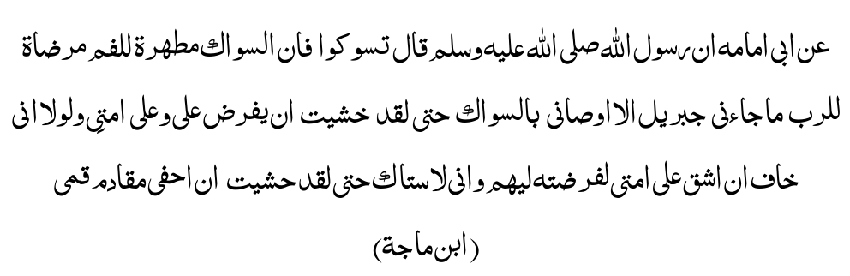
" Abu Umaamah (Radiallahu anhu) narrates that the Messenger of Allah (Sallallahu alayhi wasallam) said: 'Use the Miswaak, for verily, it purifies the mouth, and it is a Pleasure for the Lord. Jib-ra-eel (Alayhis salaam) exhorted me so much to use the Miswaak that I feared that its use would be decreed obligatory upon my Ummah. If I did not fear imposing hardship on my Ummah I would have made its use obligatory upon my people. Verily, I use the Miswaak so much that I fear the front part of my mouth being peeled (by constant and abundant brushing with the Miswaak)'." (IBN MAJAH)
In another Hadith our Nabi (Sallallahu alayhi wasallam) said:
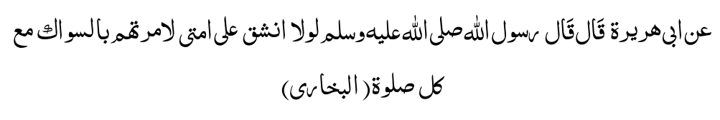
"Abu Hurairah (Radiallahu anhu) narrates that Rasulullah (Sallallahu alayhi wasallam) said: 'Was it not for my fear of imposing a difficulty on my Ummah I would have ordered that the Miswaak be used for every Salaat'." (BUKHARI)
Hadhrat Shah Waliullah (Rahmatullah alayh) relates the following Hadith:
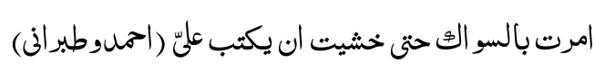
" The Messenger of Allah (Sallallahu alayhi wasallam) said: 'I was commanded to use the Miswaak to such an extent that I thought the Miswaak would be made obligatory'." (AHMAD and TIBRANI)
Ibn Abbas (Radiallahu anhu) narrates the following Hadith:
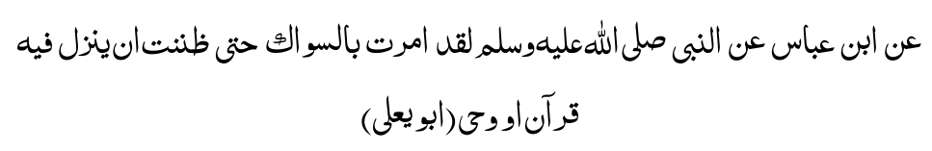
The messenger of Allah said: 'I was commanded so much to use the Miswaak that I thought Wahi of the Qur'aan (Revelation) would be revealed, regarding it (i.e. its use)'." (ABU YA'LAA)
Although the use of the Miswaak was not made Fardh (compulsory) upon the Ummah, nevertheless its use was Fardh upon our Nabi (Sallallahu alayhi wasallam). This is borne out by the following Hadith:
" Aisha (Radiallahu anha) narrates that Rasulullah said: 'These (practices), viz., Miswaak, Witr Salaat and Tahajjud Salaat, are Sunnat for you and Fardh for me'."
Hadhrat Abu Hurairah (Radiallahu anhu) narrates:
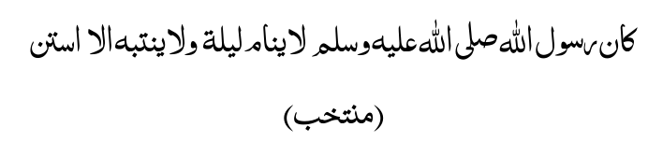
"The Messenger of Allah would use the Miswaak (regularly) prior to sleeping and after rising from sleep." (MUNTAKHAB)
Imam Ghazali (Rahmatullah alayh), in his Ihya-ul-Uloom, has enumerated ten Aadaab (Respects or duties) of sleep. The very first of these being purity and the use of the Miswaak (before sleeping).
Allamah Sha'rani (Rahmatullah alayh) states in the Kitaab, Kashful Ghummah, that Rasulullah (Sallallahu alayhi wasallam) advised: "Whenever you retire for sleep, use the Miswaak."
Abu Hamid (Rahmatullah alayh) has said likewise in his Kitaab known as RAUNAQ.
Hadhrat lbn Umar (Radiallahu anhu) says that many a time Rasulullah (Sallallahu alayhi wasallam) used the Miswaak as much as four times in a single night.
Hadhrat Aishah (Radiallahu anha) narrates:
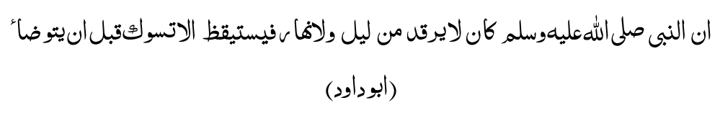
" Verily, the Messenger of Allah would use the Miswaak before making Wudhu (ablutions) whenever he arose from sleep, whether it be during the night or during the day."
(ABU DAWOOD)
Similar Ahadith have been narrated by Imam Ahmad (Rahmatullah alayh) and Abu Ya'laa (Rahmatullah alayh). Imam Ghazaali (Rahmatullah alayh) has mentioned in his Ihya-ul-Uloom that a person before sleeping at night should keep his water and Miswaak ready and close at hand.
As soon as he wakes from sleep during the night he should immediately use the water and the Miswaak, and engage in the remembrance of Allah. Hadhrat Ibn Abbas (Radiallahu anhu) states:
"The Messenger of Allah would use the Miswaak at night time (i.e. Tahajjud time) after every two Rakaats Salaat he performed."
(IBN MAJAH)
Allamah Aini (Rahmatullah alayh) has recorded the following in Bunayah:
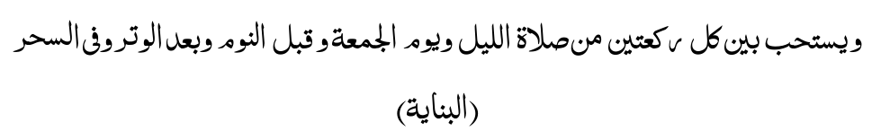
" It is Mustahab to use the Miswaak after every two Rakaats of Tahajjud Salaat (i.e. the Salaat which is performed after midnight), as well as on Fridays, before sleeping, after Witr Salaat and when rising in the morning." (BUNAYAH)
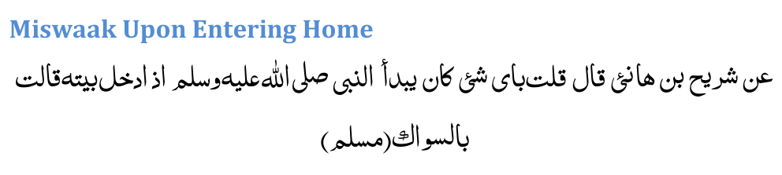
"Shuraih (Radiallahu anhu) narrates that he asked Aisha (Radiallahu anha): 'What was the first thing Rasulullah (Sallallahu alayhi wasallam) did upon entering the house?'
Aisha (Radiallahu anha) replied: 'Rasulullah (Sallallahu alayhi wasallam) would use the Miswaak'." (MUSLIM)

Miswaak Upon Leaving Home
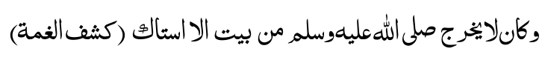
" Whenever Rasulullah (Sallallahu alayhi wasallam) left the house he would use the Miswaak." (KASHFUL GHUMMAH)

Miswaak Before And After Meals
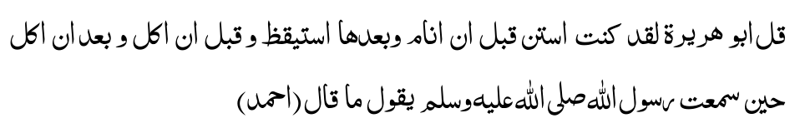
" Abu Hurairah (Radiallahu anhu) said: 'I have used the Miswaak before sleeping, after rising, before eating and after eating, ever since I heard the Nabi (Sallallahu alayhi wasallam) advising so'." (AHMAD)
Wudhu is the weapon of the Mu'min. — HADITH.
One should endeavour to remain in the state of Wudhu at all times. Many misfortunes will be warded off, Insha
Allah.

Miswaak Before Reciting the Holy Qur'aan "Hadhrat Ali (Radiallahu anhu) said:
'Verily, your mouths are the pathways of the Qur'aan (I.e. you recite with your mouth), therefore cleanse your mouth with the Miswaak thoroughly'." (IBN MAJAH)
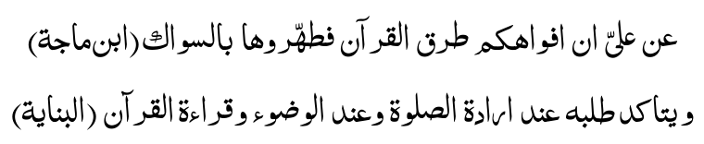
" The use of the Miswaak has greater emphasis when one Intends to perform Salaat, Wudhu and reciting the Qur'aan." (BUNAYAH)
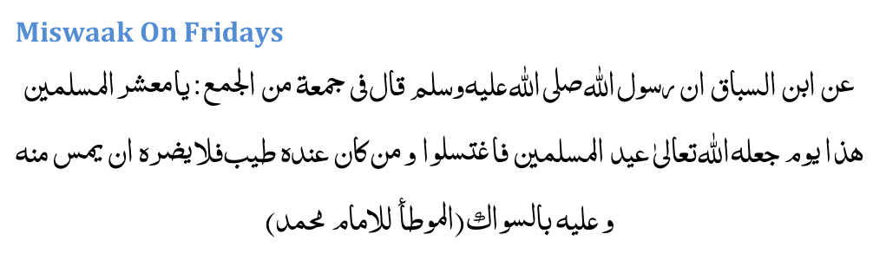
"Ibn Sabah (Radiallahu anhu) narrates that Rasulullah (Sallallahu alayhi wasallam) said on one Friday:
'O Gathering of Muslims, Allah has made this Day (Friday) a Day of Eid for Muslims, therefore, bathe (on this day), use perfume and regard the use of the Miswaak (on this day) as an obligation upon you'." (MUWATTA IMAM MUHAMMAD)
"Suhail Bin Hanief states that Rasulullah (Sallallahu alayhi wasallam) said that to bathe and use the Miswaak on Fridays are of the Huqooq (Rights or Duties) of Friday."

Miswaak During Fasting
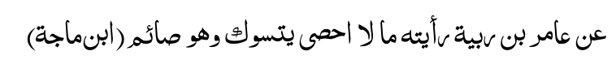
" Aamir Bin Rabiyah (Radiallahu anhu) narrates:
'I have seen Rasulullah (Sallallahu alayhi wasallam) using the Miswaak many a time while fasting'."
(IBN MAJAH)
In another Hadith our Nabi said that one of the best characteristics of a fasting person is his use of the Miswaak.
The majority of the Ulama have opined that it is Sunnat to use the Miswaak while fasting. It is recorded in Fataawa Siraajiah that a fasting person may use a dry or a moist (i.e. fresh, green) Miswaak.
It is recorded in many Ahadith that the Messenger of Allah and his Sahaabahh were in the habit of having their Miswaaks on their persons while on a journey or during battles. In the Kitaab, Kashful Ghummah it is mentioned that during battle the Companions of Rasulullah would store their Miswaaks in the scabbards of their swords for use at the time of Salaat.
Allamah Sha'rani (Rahmatullah alayh) states in Kashful Ghumrnah that the Messenger of Allah (Sallallahu alayhi wasallam) said:
"Whoever spurns or rejects the Miswaak is not of us (Muslims)."
Hadhrat Ibn Mubarak (Rahmatullah alayh) said:
"If the inhabitants of a city spurn and reject the use of the Miswaak, the Ruler should wage battle against them like he would wage war against the renegades or murtad-deen."
(KHAANIYAH)
All the aforegoing Ahadith of our Nabi (Sallallahu alayhi wasallam) and the statements of the learned jurists of Islam point clearly to the tremendous importance of the Miswaak in Islam. However, despite its elevated status, significance and importance, this noble practice is neglected and generally discarded by present day Muslims. Needless to say, this is one of the examples of the spiritual and worldly decadence that have set into the Muslim Nation. The revival of the practice of using the Miswaak instead of the various substitutes is of utmost importance to Muslims. In times such as the present age when we are confronted and surrounded by the satanic forces of irreligiousity, materialism, atheism, vice and immorality, it is of greater importance that Muslims strive most ardently to re-instate the practices or the Sunnah of our beloved Nabi (Sallallahu alayhi wasallam). And, of these is the Miswaak. Substitutes, e.g. tooth-powders, brushes, etc., should only be resorted to in the event of the non-availability of the Miswaak. To revive a "Iost" or a forgotten Sunnah of our Nabi (Sallallahu alayhi wasallam)— a Sunnah which the followers of Islam have murdered — carries a great and mighty Sawaab (Reward). In this regard our Nabi (Sallallahu alayhi wasallam) said:
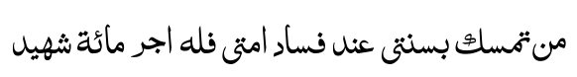
" He who holds on firmly to my Sunnah at a time when my Ummah are (grovelling) in corruption will receive a reward of a hundred martyrs." And, indeed the MISWAAK IS A GREAT SUNNAH.
The Sahaabahs (Companions) And The Miswaak The Sahaabahs (Radiallahu anhuma) who were the best and the noblest examples and teachers of the Sunnah of our Nabi (Sallallahu alayhi wasallam) viewed the Miswaak in a very serious light and regarded it as a practice of supreme holiness. Their constant use of the Miswaak, their continuous exhortations to use the Miswaak and their warnings to those who neglect the Miswaak are ample evidence of the nobility and the importance attached to this practice of using the Miswaak.
Ibn Abbas, Ali and Ataa (Radiallahu anhuma) said:
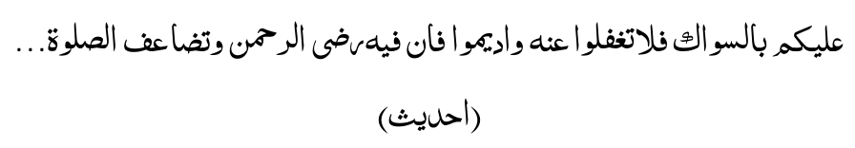
" Regard the Miswaak as an obligation on you, and do not be neglectful of it. Be constant in using it, for verily, in it lies the Pleasure of Allah, The Merciful, and in it is greater reward for Salaat.. ."
Hassaan Bin Atiyyah (Rahmatullah alayh) said:
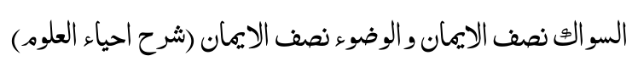
"Miswaak is half of lmaan, and Wudhu is half of Imaan."
(SHARHU IHYA-UL-ULOOM)
Abdul Aziz Abu Dawood (Rahmatullah alayh) said:
"Two things of a Muslim are among the best of practices— (1) Performing Tahajjud Salaat, and (2) Constancy in the use of the Miswaak."
He who is able to go to bed with Wudhu, remembering Allah and is penitent, let him do so, for souls are returned to life in the same condition in which they were taken.

— MUJAHID.

The Ulama And Miswaak Hadhrat Shaukani (Radiallahu anhu) said:
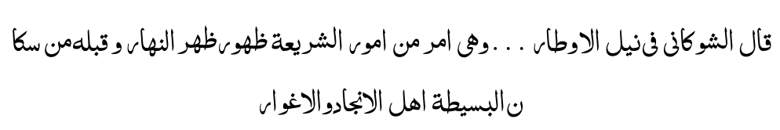
" Miswaak is one of the Laws of Shariah. And, this fact is as clear as daylight. This has been conceded by the peoples of the world."
(NAILIL AUTAAR)
Hadhrat Sha'rani (Radiallahu anhu) said:
"A pledge has been taken from us on behalf of Rasulullah (Sallallahu alayhi wasallam) that we be steadfast in the use of the Miswaak at the time of making Wudhu. Should any of us be forgetful then he should tie the Miswaak with string and hang it around his neck or keep it in his turban (so that it will be at hand when making Wudhu).
The general public has broken this pledge.. . It (constancy in the use of the Miswaak) is indicative of the strength of one's Imaan and the degree of respect one has for the Laws of Allah and His Rasool (Sallallahu alayhi wasallam). The Messenger of Allah (Sallallahu alayhi wasallam) emphasised the use of the Miswaak. And Rasulullah (Sallallahu alayhi wasallam) was not satisfied merely with issuing an order once, but repeatedly exhorted his followers (regarding its use).
"O my Brother. Be constant in the Sunnah of Muhammad (Sallallahu alayhi wasallam) so that you may attain the great rewards of the Hereafter. Verily, for every Sunnah there is a rank in Jannat and this rank is obtained only by fulfilment of that Sunnah."
"To the indolent and neglectful people who say that it is permissible to leave this practice (Miswaak) it will be said on the Day of Qiyaamah: 'Today it is permissible to deprive you of this Rank in Jannat.'
"Abul Qaasim Ibn Qasi (Rahmatullah alayh) has stated this in his Kitaab, Khulun Na'lain." (LAWAAQIUL ANWAAR)
Allamah Aini (Rahmatullah alayh) says:
"Abu Amr (Rahmatullah alayh) said that upon the significance of the Miswaak consensus of opinion exists. There is no difference of opinion on this score. According to all learned men of Islam, Salaat performed after using the Miswaak is far nobler than a Salaat without Miswaak. Auzaai (Rahmatullah alayh) said that Miswaak is half of Wudhu." (AL-BUNAAYAH)
Shaikh Muhammad (Rahmatullah alayh) said:
"Verily, over a hundred Hadith have been narrated regarding the significance of the Miswaak. Therefore, it is a great astonishment to behold that so many among mankind as well as among the learned neglect such an important practice which has been emphasised to such an extent. This is a great loss." (SUBL)
Aadaab or Respects to be Observed Regarding The Miswaak The majority of the Ulama hold the view that the use of the Miswaak is not Fardh (compulsory). However, despite it not being decreed Fardh by the Shariah, it is of utmost importance. It is likewise essential that all the Aadaab pertaining to the Miswaak be observed. Neglect of the Aadaab is a sign of spiritual indolence and weakness of Imaan. In order to achieve the Sawaab of a particular practice in full measure it is necessary that the Aadaab relating to the practice be observed. If neglect is shown towards the Aadaab, the final result will be the neglect of that very practice. In the Kitaab, Ta'leemul Mutaallim the following is stated:
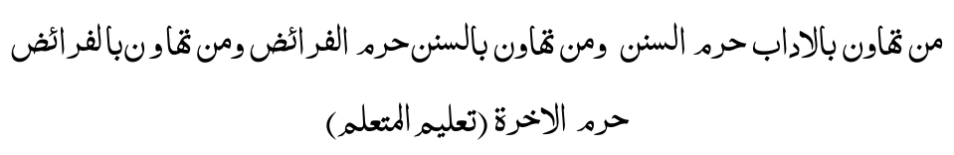
" He who becomes neglectful about the Aadaab is deprived of the Sunnats; and he who becomes neglectful of the Sunnats is deprived of the Faraa-idh (compulsory acts); and he who becomes neglectful of the Faraa-idh is deprived of the Hereafter."
(TA'LEEMUL MUTA-ALLIM)
Faqih Abu Laith Samarqandi (Rahmatullah alayh) states:
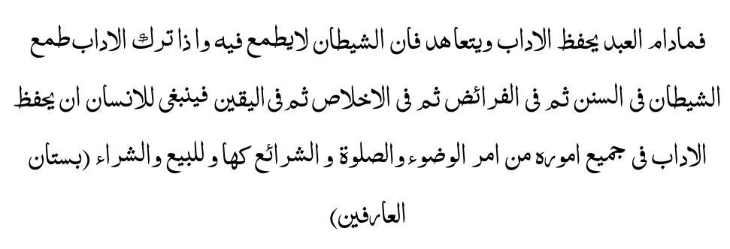
" As long as the Servant of Allah safeguards the Aadaab Satan does not attempt to assault him (i.e. mislead him). However, when he neglects the Aadaab Satan makes advances into the Sunnats (i.e. misleads the Servant from the Sunnats). Thereafter follows Satan's assault on the Faraa-idh (compulsory duties). This is followed by Satan's assault on Ikhlaas (sincerity), and finally on Yaqeen (Faith). Hence, it is necessary for a person to protect the Aadaab of all his affairs and actions, e.g. the Aadaab of Wudhu, Salaat, buying, selling and the Aadaab of all the practices of the Shariah." (BUSTAANUL AARIFEEN)
Types of Miswaaks It is permissible to take for a Miswaak all types of tree- twigs provided these are not harmful or poisonous. It is forbidden to use a Miswaak from a poisonous tree. Miswaaks from the following trees are not permissible: (1) Pomegranate (2) Bamboo (3) Raihaan (4) Chambelie Rasulullah (Sallallahu alayhi wasallam) FORBADE THE USE OF Raihaan as Miswaak because it causes the sickness, Juz-zaam — The following are the types of Miswaak recommended:
(1) Peelo tree (2) Zaitoon or Olive tree (3) Bitam or Any bitter tree (5) Walnut tree

Miswaak of The Peelo Tree
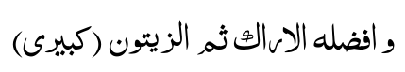
"And, the best of Miswaaks is the Peelo, then the Olive."
(KABIRI)
The best type of Miswaak is that which is taken from the Peelo tree. In the Kitaab, Tas-heelul Manaa-fi' it is mentioned that the Miswaak of the Peelo tree is excellent for obtaining the glow or glitter of the teeth.
Our Nabi (Sallallahu alayhi wasallam) also praised and recommended the Peelo tree for Miswaak purposes. Besides recommending the Peelo tree, Rasulullah as well as the Sahaabas (Radiallahu anhuma) used Miswaaks of this tree.
Ibn Sa'd (Radiallahu anhu) narrates that Abu Khabrah (Radiallahu anhu) said: "Nabi (Sallallahu alayhi wasallam) presented me with a Miswaak of the Peelo tree, and he (Sallallahu alayhi wasallam) said: 'Use the Miswaak of the Peelo tree'."
Ibn Masood (Radiallahu anhu) said: "I always kept a stock of Peelo Miswaaks for Rasulullah (Sallallahu alayhi wasallam)."
In the Kitaab, Mawaahib, it is stated that the Companions of Imam Shaafi (Rahmatullah alayh) have recorded Consensus of opinion among them on the fact that the use of the Peelo Miswaak is Mustahab (i.e. an Islamic practice which carries much Sawaab (Reward) if upheld, and in the event of not fulfilling it no punishment will be meted out).
Miswaak of The Olive Tree Rasulullah (Sallallahu alayhi wasallam) has spoken highly of the Miswaak of this tree as well. The following Hadith brings out the significance of the Olive tree Miswaak:
"Use the Miswaak of the Olive tree. It is the Miswaak of a Mubarak (auspicious or gracious) tree. It purifies and makes wholesome the mouth. It removes the yellowishness of the teeth. It is my (i.e. Rasulullah's ) Miswaak and the Miswaak of the Ambiyaa (Prophets) who came before me." (MUNTAKHAB)
Miswaak of The Bitam Tree In another Hadith it is stated that in the absence of the Peelo tree the Olive tree should be used, and in the absence of the Olive Miswaak, the Bitam tree Miswaak should be used. (MUNTAKHAB)
Miswaak of Some Bitter Tree If none of the three abovementioned types of Miswaak is available, a Miswaak of any bitter tree should be used. (KUHASTANI)
..." Thereafter it is Mustahab to use a Miswaak of a bitter tree because the Miswaak of a bitter tree removes the odour of the mouth to a greater extent."
(KABIRI)
In Alamgiri it is stated that the Miswaak of a bitter tree makes the mouth wholesome, strengthens the teeth and the gums.
Miswaak of The Walnut Tree Miswaak of the Walnut tree has been recommended in the Kitaab, TAISE.
Niyyat or Intention Of Using The Miswaak "Niyyat of using the Miswaak should be made prior to its use."
(SHARE MINHAAJ)
The following dua should also be recited, at the time of using the Miswaak:
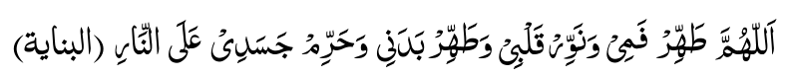
"O Allah Purify my mouth: Enlighten my heart: Purify my body: And, make my body unlawful to the Fire." (BUNAYAH)
Aadaab of The Miswaak (1) The Miswaak should be a straight twig, devoid of roughness.
(2) The Miswaak should be clean.
(3) The Miswaak should not be too hard nor too soft.
(4) The Miswaak should not be used while one is lying down.
(5) The new Miswaak should be approximately 8 inches (a hand- span) in length.
(6) The Miswaak should be the thickness of the forefinger.
(7) Before using the Miswaak, it should be washed.
(8) After use it should be washed as well.
(9) The Miswaak should not be sucked.
(10) The Miswaak should be placed vertically when not in use. It should not be thrown onto the ground.
(11) If the Miswaak is dry it should be moistened with water prior to use. This is Mustahab. It is preferable to moisten it with Rose water.
(12) The Miswaak should not be used in the toilet.
(13) The Miswaak should be used at least thrice (brush three times) for each section of the mouth, e.g. brush the upper layer of teeth thrice, then the lower layer thrice, etc.
(14) The Miswaak should not be used at both ends.
(15) The Miswaak should not be taken from an unknown tree as it may be poisonous.
Advantages and Benefits of The Miswaak (1) Eliminates bad odour and improves the sense of taste Allamah Ibn Daqiq (Rahmatullah alayh) says:
"The wisdom underlying the use of the Miswaak after rising from sleep is that during sleep bad vapours rise from the stomach towards the mouth. This causes bad odour in the mouth as well as a change in the sense of taste. Use of the Miswaak eliminates the bad odour and rectifies the change which occurred in the taste." (NALE WA TA'LEEQ)
(2) Sharpens the Memory
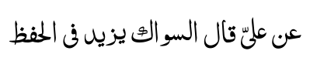
Hadhrat Ali (Radiallahu anhu) said that "Miswaak sharpens the memory."
(3) Sharpens the intelligence
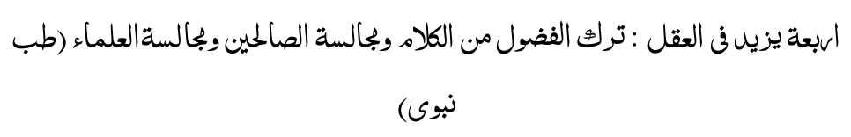
"Four things increase the Intelligence — (i) Shunning of nonsensical talks (ii) Use of the Miswaak (iii) Sitting in the company of the pious, and (iv) Sitting in the company of the Ulama."
(TIBBE NABAWI)
(4) Eliminates Slime
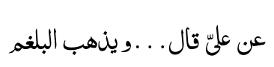
Hadhrat Ali (Radiallahu anhu) said that "Miswaak removes slime." (IHYAUL-ULOOM)
(5) A Cure for Illness
Hadhrat Aisha (Radiallahu anha) said that "Miswaak (its constant use) is a cure for all illness except Death." (REPORTED BY DAILAMI IN FIRDAUS)
(6) Miswaak creates fragrance in the mouth.
(7) Miswaak strengthens the gums.
(8) Miswaak prevents tooth decay.
(9) Miswaak prevents further increase of decay which has already set in the teeth.
(10) Miswaak is a cure for headaches.
(11) Miswaak assists in eliminating toothaches.
(12) Miswaak creates lustre (Noor) on the face of the one who continually uses it.
(13) Miswaak causes the teeth to glow.
(14) Miswaak removes the yellowishness of the teeth.
(15) Miswaak strengthens the eye-sight.
(16) Miswaak is beneficial for the health of the entire body.
(17) Miswaak assists in the process of Digestion.
(18) Miswaak is a cure for a certain mouth disease known as Qilaa' — This is stated in Hujjatul Baaleghah.
(19) Miswaak clears the voice. This is stated in Tibbe Nabawi.
(21) Miswaak facilitates the appetite (Tibbe Nabawi).
(22) Miswaak increases the eloquence of one's speech.
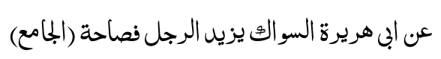
Abu Hurairah (Radiallahu anhu) said that "Miswaak increases the eloquence of a person." (AL-JAAMI')
(23) Miswaak (i.e. its constant use) will be a factor to ease the pangs of Death. The continuous use of the Miswaak makes it easy for the Rooh (Soul) to depart from the body when its appointed time arrives. (SHARHUS SUDOOR) (24) Miswaak increases the Sawaab of Salaat from seventy times to four hundred times. (HADITH)
(25) Miswaak is a factor which will earn higher ranks in Jannat for the one who uses it.
(26) The Angels sing the praises of the one who uses the Miswaak.
(27) Use of the Miswaak displeases Shaitaan.
(28) Use of the Miswaak graces one with the companionship of the Angels. (29) And, the greatest benefit of using the Miswaak is the obtainal of Allah Ta'ala's Pleasure.
Substitutes for The Miswaak (1) The Fingers In the case of the non-availability of the Miswaak the fingers should be used to cleanse the teeth. This method will serve the purpose of the Miswaak as far as the Sawaab is concerned, i.e. if a Miswaak is not available the Sawaab
(Reward) attendant to the Miswaak will be realised by using the fingers as a substitute provided that Niyyat (intention) of Miswaak be made when the fingers are used for this purpose.
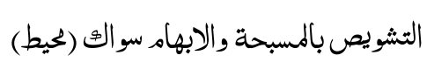
" Rubbing the teeth with the forefinger and the thumb is Miswaak." (MUHEET)
Hadhrat Amr Bin Auf Muzni (Rahmatullah alayh) states that the fingers could be used as an adequate substitute for the Miswaak in the case of the latter's absence.
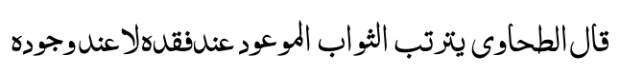
" Imam Tahaawi (Rahmatullah alayh) says: 'The promised Reward (of using the Miswaak) shall be obtained in the event of the non-availability of the Miswaak, and not in the event of its availability."
In other words, if a Miswaak is available and you are able to use same then the Sawaab of it will not be realised by using a substitute.
(2) Cloth A coarse piece of cloth may also be used in case of the non-availability of a Miswaak. Those who have no teeth, should use the fingers or a cloth as substitutes for the Miswaak, and they will obtain the Sawaab. But Niyyat of the Miswaak should be made.
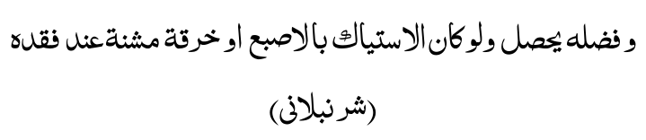
" And, the significance of the Miswaak shall be obtained even though the finger or a cloth be used in the event of the non-availability of the Miswaak." (SHURAMBALI)
(3) Toothbrush If the toothbrush is made of bristles (pig's hair) then its use is not permissible. If bristles are not used, the use of the toothbrush is permissible. However, the toothbrush will not serve as a substitute in the case of the Miswaak—being available. If a Miswaak is available Reward will not be realised by using the toothbrush. The same applies to toothpowder or any other means of cleansing the teeth. It should be remembered here that during the time of our Nabi (Sallallahu alayhi wasallam) substitutes, e.g. toothpowder, etc., existed, but our Nabi never equated these with the Miswaak. Therefore, the argument of the modernist that the toothbrush today takes the place of the Miswaak is fallacious and a good example of the apologetic attitude adopted by modern Muslims of today.
Bad Odour The odour of cigarettes, cigars and tobacco is offensive to both Musallees and Malaa-ikah (Angels). As far as possible one should avoid smoking before attending the Musjid. However, if one has smoked, then wash the mouth thoroughly before entering the Musjid.

GHUSL
GHUSL is the Islamic method of washing the body to obtain purification from "hadathe akbar" or "greater impurity."

HADATHE AKBAR
Hadathe Akbar is caused by the following acts:
(1)Discharge of mani (semen) accompanied by sexual lust, whether such discharge be while sleeping or while awake.
(2) Sexual intercourse.
(3) Haidh (menses).
(4) Nifaas (blood discharge after childbirth).
If any of the above acts results, one will be in the state of Janaabat. Purification is obtained from Janaabat only by means of Ghusl.
Ahkaam of Hadathe Akbar During the state of hadathe akbar or Janaabat the following things are prohibited:
(1) Salaat.
(2) Touching the Qur'aan Shareef.
(3) Reciting the Qur'aan Shareef even without touching.
(4) To enter a Musjid.
(5) To make Tawaaf of the Ka'bah Shareef, (6) In the state of hadathe akbar caused by haidh and nifaas, sexual intercourse is not permissible. (This prohibition is explained fully in the section dealing with haidh).
(7) It is not permissible to remove, cut or break any nails or hair from any part of the body during the state of hadathe akbar or Janaabat.
How To Make Ghusl The following is the Sunnat method of taking Ghusl. Proceed with the Ghusl, step by step, as enumerated hereunder:
(1) First wash both hands as far as the wrists. The hands should not be dipped in the basin of water for washing. Water should either run from the tap on to the hands or poured from a container.
(2) Wash the parts of istinja (the private parts and surrounding area). This should be washed whether there is najaasat (impurity) or not.
(3) Wash the part of the body wherever there be some impurity.
(4) Make a full Wudhu now. However, if Ghusl is being taken in a place where the water pools around the feet, then delay the washing of the feet until the end of the Ghusl.
(5) After Wudhu, pour water thrice over the head.
(6) Thereafter, pour water thrice over the right shoulder.
(7) Then, pour water thrice over the left shoulder. The water should be poured in such a way that the entire body is thoroughly drenched.
(8) If the feet were not washed at the time of Wudhu, wash them now. While pouring the water, rub well on the body to ensure that no spot remains dry.
A perfect Wudhu wards off shaitaan from you.

— UMAR IBN KHATTAAB.
The Faraa-idh of Ghusl The Ghusl has three things which are Fardh (compulsory) and are called the Faraa-idh of Ghusl. These are:
(1) Rinsing the mouth thoroughly.
(2) Taking water into the nostrils to the limit of the tender or fleshy part of the nose, (3) Drenching the whole body — from head to feet — thoroughly.
If these three acts are discharged, the Ghusl is complete and one is purified.

The Sunnan of Ghusl The following acts are the Sunnan of Ghusl:
(1) It is Sunnat to make Niyyat for Ghusl.
(2) First wash both hands.
(3) Then wash the private parts.
(4) Make Wudhu.
(5) Pour water thrice over the head.
(6) Pour water thrice over the right shoulder.
(7) Pour water thrice over the left shoulder.
One obtains much Sawaab by fulfilment of the Sunnat acts. The Sunnan should, therefore, not be neglected or left out unnecessarily. However, the Ghusl will still be valid and complete if the Sunnan have not been discharged. Absolute care should be exercised that no Fardh act of Ghusl is missed out, for then the Ghusl will be incomplete and not valid.
The Makrooh Factors of Ghusl The factors which are Makrooh in Wudhu are also Makrooh in Ghusl (refer section dealing with Wudhu). Besides these the following too are Makrooh factors of Ghusl:
(1) To recite dua during Ghusl.
(2) Facing the Qiblah.
(3) Speaking unnecessarily, while nude.
The Occasions of Ghusl (1) Haidh: Ghusl for purification from haidh is Fardh (compulsory). (See section on Haidh).
(2) Nifaas: Ghusl for purification from nifaas is Fardh. (See section on Haidh and Nifaas).
(3) Sexual Intercourse: Ghusl for purification from the condition of Janaabat produced by sexual intercourse is Fardh, whether there was ejaculation of mani (sperm) or not.
(4) Ihtilaam: Ghusl for purification from the condition of Janaabat produced by ihtilaam is Fardh. Ihtilaam is the ejaculation of mani in a wet dream.
(5) Juma': Ghusl for the occasion of Juma' (Friday) Salaat is Sunnat. The time for this Ghusl is from after Fajr Salaat to the time of Juma'.
(6) Both Eids: Ghusl for the occasions of Eid is Sunnat.
(7) Arafah: Ghusl for the occasion of the Day of Arafah is Sunnat for the Hujjaj (Pilgrims). The time for this Ghusl is after Zawwaal.
(8) Ihraam: Ghusl when donning ihraam is Sunnat.
(9) Conversion: A kaafir in the state of hadathe akbar shall take Ghusl upon embracing Islam. This Ghusl is Waajib (compulsory). If he/she is not in the state of hadathe akbar, this Ghusl will be Mustahab.
(10) Mayyit: It is Fardh Kifaayah to give Ghusl to the mayyit (the dead). N.B.: Fardh Kifaayah is a compulsory act which is the collective responsibility of the whole community. If a few members of the community discharge the act, the whole community is absolved of the duty. If not a single member of the community discharges the act, the whole community will be collectively sinful.
(11) At Age of 15: Upon attaining the age of fifteen years, if no sign of bulugh (maturity, e.g. ihtilaam, haidh), has appeared, it is Mustahab to take Ghusl.
(12) After Unconsciousness and Insanity: Upon passing of the states of unconsciousness and insanity, Ghusl should be taken. This Ghusl is Mustahab. (13) After Giving Ghusl to the Mayyit: Those who gave Ghusl to the Mayyit should themselves take Ghusl. This Ghusl is Mustahab.
(14) Lailatul Baraat: Ghusl should be taken on Lailatul Baraat — 15th Night of Sha'baan. This Ghusl is Mustahab.
(15) Laitul Qadr: Ghusl is Mustahab on who has by the grace of Allah Ta'ala discovered the Night of Qadr.
(16) Entry to Madinah Munawwarah: Ghusl is Mustahab upon entry to Madinah Munawwarah.
(17) At Muzdalifah: Ghusl is Mustahab for one who stops over at Muzdalifah during the Hajj period. The time for this Ghusl is during Fajr time of the 10th Zil-hajj.
(18) Tawaaf Ziyaarah: Ghusl is Mustahab for performing Tawaaf Ziyaarah. (19) Rami Jimaar: Ghusl is Mustahab for the occasion of pelting the Jimaar during Hajj.
(20) Eclipse of the Sun and Moon: It is Mustahab to take Ghusl on the occasions of the eclipse of the sun and the moon.
(21) Salaatul Istisqaa': It is Mustahab to take Ghusl for the occasion of performing Salaatul Istisqaa'.
(22) Salaatul Khauf and Salaatul Haajat: It is Mustahab to take Ghusl for performing Salaat at the time of fear and need.
(23) Salaatut Taubah: It is Mustahab to take Ghusl when performing Salaatut Taubah — seeking Allah's pardon and forgiveness for sins committed. (24) Upon Returning from a Journey: It is Mustahab to take Ghusl upon reaching home after a journey.
(25) Upon Execution: It is Mustahab for one who is to be executed, to take Ghusl prior to his execution.
Masaa-il Pertaining To Ghusl (1) It is improper to face the Qiblah while engaged in Ghusl.
(2) It is improper to engage in talk while taking Ghusl.
(3) Make haste in covering the body. One should not delay in wearing one's clothes after completing the Ghusl. The Shariah emphasises this so much, that if the feet have as yet not been washed, then first don one's garments and thereafter wash the feet.
(4) It is not proper to recite any dua, kalimah, etc, during Ghusl.
(5) If even a single hair remains dry in Ghusl, the Ghusl will not be valid.
(6) If after Ghusl, one recalls that a certain part has not been washed, then that part should now be washed. It is not necessary to repeat the Ghusl. However, if the unwashed part is not washed, the Ghusl is not valid. It is not sufficient to merely rub the moist hand over the unwashed part. Water has to flow over it.
(7) If due to some sickness or ailment, water is harmful if applied to the head, it will be permissible to leave the head dry and wash the rest of the body. However, upon being cured of the ailment it is Wajib to wash the head. There is no need to renew the Ghusl.
(8) Rings, etc., should be removed during Ghusl to enable the water to reach the parts covered by these objects.
(9) If some flour, gum, etc., has hardened on the fingernails or elsewhere, Ghusl will not be valid if these substances were not removed. The same applies to cutex — a substance which modern women apply to their finger-nails — as it also prevents water from reaching the parts covered by it. It is essential to remove these and pass water over the parts which were covered. If after Ghusl it is realised that some gum, etc., was stuck to the nails, etc., then remove the substance and wash the place. It is not necessary to renew the Ghusl. If this was realised only after having performed Salaat, then after removing the substance and washing the part, repeat the Salaat.
(10) It is not necessary to remove the ointment from a cut or wound during Ghusl. Gush water over it.
(11) Any food-particle stuck in between the teeth must be removed, otherwise the Ghusl will not be valid since the space between the teeth will remain dry.
(12) After Ghusl, Wudhu should not be made again since the Ghusl is sufficient.
(13) As mentioned elsewhere, nowadays it is considered fashionable for women to keep long finger-nails. Dirt accumulates under such long nails and obstructs the moistening of the parts covered by the dirt. Besides such long nails and dirt-accumulation being contrary to Islamic hygiene and Tahaarat rules, Wudhu and Ghusl will not be valid if the dirt is of a nature — non-porous — which does not permit water to seep through.

PARING OF NAILS AND THE REMOVAL OF UNWANTED HAIR
Before taking a bath it is preferable to cut the nails of the fingers and toes as well as remove the unwanted hair from under the armpits and below the navel. It should, however, be borne in mind that if one is in a state of Hadathe Akbar or Janaabat then it is not -permissible -to remove, cut or break any nails or hair from any part of the body. The removal of unwanted hair should be attended to preferably once a week. If this is not possible then every alternate week. Care should be taken that it is not left for more than 40 days as this is the limit. Beyond 40 days the neglecter will be guilty of sin.
Do not bath (or make Wudhu) with water heated in the sun, for it causes leprosy. — HADITH.

TAYAMMUM
TAYAMMUM is a form of obtaining Tahaarat (purification) from the states of impurity whether the impure state be "Hadathe Asghar" or "Hadathe Akbar." It will be permissible to resort to this form of purification, i.e. Tayammum, in the absence of water or in case of one's inability to use water due to illness or some other cause.
How To Make Tayammum (1) Form a Niyyat for making Tayammum. It will suffice to intend:
"I am making Tayammum for the purpose of obtaining purity."
(2) Then strike the palms of both hands on pure (Taahir) sand and, after blowing off the excess dust, rub both hands over the whole face in the motion of washing ensuring no part of the face is left out.
(3) Now strike both hands again onto the soil and, after blowing off the excess dust, rub both arms including the elbows in the motion of washing in the following manner:
After placing the four fingers of the left hand under the finger-tips of the right hand, pull them towards the elbow (of the right hand). In like manner, beginning from the elbow, rub over the-inner -part of the right hand up to the fingers ending up by passing the inner part of the left thumb over the outer portion of the right thumb. After completing the right hand do exactly the same with the left hand.
This is followed by making Khilaal of the fingers. In the event of one wearing a ring it should either be removed or rotated.
It is also Sunnat to make Khilaal of the beard.
The Tayammum is now complete.
The Faraa-idh of Tayammum The following are the Faraa-idh or compulsory factors of Tayammum:
(1) Niyyat or Intention.
(2) Striking the hands onto the earth twice as described.
The Factors Which Break Tayammum (1) All those acts which break Wudhu will break Tayammum (2) The sighting of water providing that one has the ability to use the water.

Who Can Take Tayammum?
(1) A Musaafir (Traveller) who cannot find water within a radius of one Shar'i mile (11/8 English miles).
(2) A person (i.e. a non-Musaafir) outside the city boundaries, who does not find water and his distance from the city is one Shar'i mile.
(3) A sick person who fears that if he uses water his sickness will deteriorate.
Fear here means a valid "fear" occasioned by past experience or the statement of a Muslim doctor who is not a Faasiq.
(4) A "junub" (one who is in the state of Janaabat) (even if he is a non-Musaafir) if he has a valid fear that he will become ill if he baths with cold water. This applies when there are no means of heating the water. Masaa-il Pertaining To Tayammum (1) It is permissible to make Tayammum on all substances which are of "earth," e.g. sea-sand, soil, clay, lime, etc.
(2) If the object is of "earth" it will be permissible to, make Tayammum on it even if there be no sand or dust on it. For example: an unpainted earthenware jug, an unbaked brick, etc.
(3) It is Mustahab to delay the Salaat until the end of the valid time if one has hope of obtaining water to make Wudhu.
(4) If the quantity of water available is sufficient to execute the Fardh acts of Wudhu, then Tayammum will not be permissible.
(6) If cold water harms, but warm water does not, it will not be permissible to make Tayammum if means for heating the water are available.
(7) One Tayammum is sufficient for any number of Salaat. Hence, if one Tayammum has not been broken, it will suffice to perform another Salaat with the previous Tayammum.
(8) If water is being sold and one does not have the means to buy it, then Tayammum will be permissible.
(9) If after performing Salaat with Tayammum, one discovers water in the nearby vicinity, then there is no need to repeat the Salaat.
(10) One requires a compulsory Ghusl, but bathing is harmful while Wudhu is not. In such an event Tayammum shall be made for the purpose of Ghusl. If this Tayammum is later broken by any act which nullifies Wudhu, then Wudhu must be made to obtain purification from the state of "Hadathe Asghar." (11) After striking the hands on the "earth," dust them so that the face is not soiled.
(12) It is not permissible to use ash for making Tayammum.
(13) It is permissible to use a dry stone for Tayammum even if there is no sand on it.
(14) If Tayammum was made in order to touch the Qur'aan Shareef then this Tayammum will not be valid for Salaat. Another Tayammum will have to be made again. However, if Tayammum was made with the intention of "obtaining purity" or for "performing Salaat" then this Tayammum will be valid for Salaat as well as touching the Qur'aan Shareef.
(15) Water is available (for the Musaafir or the non-Musaafir outside the city limits) within a Shar'i mile, but the time is so little that if one goes to fetch the water the Salaat time will expire. In this case it will not be permissible to make Tayammum even if the Salaat becomes Qadhaa.
(16) If Tayammum was made for Wudhu then this Tayammum will break if water sufficient to make Wudhu is found. In like manner, if the Tayammum was that of Ghusl, it will break if water sufficient to make Ghusl is found.
(17) The Tayammum occasioned by illness will break once that illness no longer exists.
(18) Tayammum was made because of the non-availability of water. Thereafter an illness which does not permit Wudhu overtakes one. During this illness water becomes available. The Tayammum which was made as a result of the non-availability of water now becomes invalid. A fresh Tayammum will have to be made.
(19) If as a result of engagement in Wudhu, one will miss the Eid Salaat or the Janaazah Salaat, it will be permissible to make Tayammum and perform these Salaats.
(20) However, it is not permissible to perform any other Salaat with the Tayammum performed for the specific purpose of Eid or Janaazah Salaat. (21) "Isti-aab" of the Tayammum parts is compulsory. "Isti-aab" means "to complete,""to render in full measure." Here it means that the total surface of the face, hands and arms must be rubbed just like it is washed in Wudhu. If any portion of the Tayammum area is not rubbed over, the Tayammum will not be valid.
(22) Tayammum is equally effective in removing all states of impurities whether of Hadath, Janaabat, Haidh or Nifaas.
(23) If there is strong indication of the presence of water in the vicinity, Tayammum will not be permissible. A search in such a case, will first have to be made for water.

MASAH ON THE KHUFFAIN
"Khuf-fain" are a special type of socks. "Masah" here means to lightly pass the moist hand over the upper surface of the Khuf-fain.
Throughout this lesson, the act of passing the moist hand over the "socks" will be called "Masah Alal Khuffain."
Instead of washing the feet during Wudhu, Masah Alal Khuffain is permissible. In place of washing the feet, Masah Alal Khuffain will suffice.
The Type of Khuffain Or Socks On Which Masah Is Lawful It is permissible to make Masah on only such Khuf-fain or socks which fulfil the following four requirements:
(1) The socks must be strong enough to enable walking in them on roads for three miles without the socks breaking or tearing.
(2) The socks, if not tied on the foreleg, must not slip down. Socks kept in position by elastic sewn into the socks material will be regarded as being tied.
(3) Water must not be able to seep through.
(4) The socks must not be transparent or even semitransparent.
If any one of the four conditions is lacking, Masah on such socks will not be permissible.
Khuffain on which Masah is made are generally made of leather. The type of socks — woollen, nylon, etc. — generally worn nowadays are not classified as "Khuffain." It is, therefore, not permissible to make Masah on them. If socks are made of a material other than leather and the aforementioned four requirements are met, Masah will be permissible on them.
When to Put On The Khuffain For the Masah Alal Khuffain to be valid it is essential to put on the Khuffain after a complete Wudhu has been made.
If the Khuffain have been put on before a complete Wudhu has been made, Masah on them will not be permissible. Firstly, a complete Wudhu has to be made, then only should the Khuffain be put on. Now when Wudhu breaks, it will be permissible to make Masah Alal Khuffain without washing the feet when Wudhu is being made.
The Duration of Masah Alal Khuffain For a Muqeem (one who is not a traveller—Musaafir) Masah Alal Khuffain is valid for a period of 24 hours and for the Musaafir the period permissible is 72 hours.
The period of 24 hours or 72 hours will be reckoned from the time Wudhu breaks (i.e. the Wudhu after which the Khuffain were put on) and not from the time the Khuffain were put on. For example, a Muqeem makes Wudhu at 6 p.m. and after completing his Wudhu he puts on Khuffain. At 8 p.m. his Wudhu breaks. Twenty-four hours will be reckoned from 8 p.m. Hence, it will be permissible for him to make Masah Alal Khuffain each time he takes Wudhu until 8 p.m. the next day.
Upon expiry of the 24 hours, Masah Alal Khuffain will no longer be valid. When the period (24 hours for the Muqeem and 72 hours for the Musaafir) expires, the Khuffain should be removed and the feet washed. It is not necessary to renew the Wudhu.
How to Make The Masah The method of Masah Alal Khuffain is as follows:
Draw the fingers of both hands at the same time (right hand on the right foot, left hand on the left foot) on the upper surface of the Khuffain starting from the toes and ending (the Masah) at the foreleg (just above the ankle). The Masah should be done once only on each sock.
If the back of the hand was used to make the Masah, it will be valid. However, one should not unnecessarily depart from the correct Sunnat method. It is not permissible to make Masah on the side or at the under surface of the Khuffain. It is Fardh to make Masah on each sock to the extent of three full fingers, i.e. the full surface area of three fingers must be drawn from the toes to the foreleg.
The Factors Which Nullify (Break) Masah Alal Khuffain The following acts will nullify the Masah which was made on the Khuffain:
(1) All things which nullify Wudhu.
(2) Removal of the Khuff (sock).
(3) The expiry of the period, i.e. 24 hours for the Muqeem and 72 hours for the Musaafir.
If only one sock was removed then, too, it is Waajib to remove the other one and wash both feet.
Even if only the foreleg is exposed by lowering the Khuff, it will be regarded as if the whole sock has been removed. It will then be compulsory to remove the Khuffain and wash both feet.

Masaail Pertaining To Masah Alal Khuffain
(1) It is not permissible to make Masah on a Khuff which is torn to the extent that an area on the foot equal to the size of the three smallest toes is exposed. It is permissible to make Masah on the sock if it is torn less than this.
(2) If the seam of the Khuff comes loose, but while walking the foot is not exposed, Masah on such Khuffain will be valid.
(3) If a Muqeem who has made Masah Alal Khuffain goes on a journey before the 24-hour period has expired then his Masah may be extended to 72 hours. His Masah will now be valid for 72 hours.
(4) If a Musaafir who has made Masah Alal Khuffain returns to his home town then his Masah will be valid for only 24 hours.
(5) It is permissible to make Masah on ordinary woollen, etc., socks which have been covered with leather.
(6) If Ghusl becomes compulsory then Masah Alal Khuffain will not be permissible even if the valid period has not yet expired. The Khuffain must be removed when the Ghusl is taken and the feet washed.
(7) If after making Masah Alal Khuffain one sets foot in a puddle of water and water enters the Khuff wetting more than half the foot, then Masah will be nullified. Both Khuffain must be removed and the feet washed.

MASAA-IL PERTAINING TO TOILET
(1) Prior to entering the toilet recite the following dua:


BISMILLAHI ALLAHUMMA INNEE A-OOTHUBIKA MINAL-KHUBU-THI WAL-KHABAA-ITH.
In the Name of Allah.
O Allah! I seek refuge with You from evil male and female jinn.
N.B.: The recitation to be done outside the toilet.
(2) Do not enter the toilet bare-headed.
(3) Do not take into the toilet any paper, bracelet, etc., on which is written or engraved Allah's Name or some Qur'aanic verse or Hadith. A ta'weez securely wrapped or sewn is an exception. It is permissible to enter with such a ta'weez.
(4) If one sneezes inside the toilet, one should not utter


ALHAMDULILLAH
However, one may say


ALHAMDULILLAH
in the mind, i.e. without tongue or lip movement.
(5) Do not spit in the toilet.
(6) It is not permissible to read inside the toilet. Many Westernised Muslims are in the habit of reading the newspaper or some magazine inside the toilet. (7) Do not smoke inside the toilet.
(8) When entering the toilet do so with the left foot.
(9) When coming out, do so with the right foot.
(10) Upon emerging from the toilet, recite the following dua:
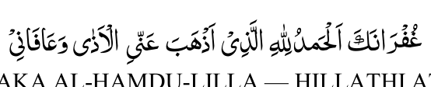

GHUF-RAA-NAKA AL-HAMDU-LILLA — HILLATHI ATH-HABA AN-NIL-ATHA WA-AAFAANI.
O Allah! I seek Your Forgiveness.All Praise to You Who has eliminated from me harmful substances and have protected me.
(11) Do not talk while inside the toilet unless it becomes essential.
(12) It is not permissible to stand while urinating.
(13) It is not permissible to face the Qiblah while relieving oneself nor is it permissible to have one's back towards the Qiblah on this occasion. This applies to little children as well.
Istinja The act of purifying oneself of the impurities excreted via the hind and front private parts is called Istinja.
In effecting Istinja it is best to first use lumps of dried soil. Such lumps tend to absorb moisture and are efficacious in wiping the najaasat of faeces and for absorbing urine drops. Therefore, wherever available and possible, such soil lumps should be used.
After having used the soil lumps the area to be cleaned should be washed with water.
In the absence of soil lumps toilet paper could also be used, but this must be followed by purifying with water.
It is not permissible to use newspaper, writing-paper or any other objects of honour and respect.

SIGNIFICANCE OF BODILY PURIFICATION
Allah Ta'ala says in the Holy Qur'aan:
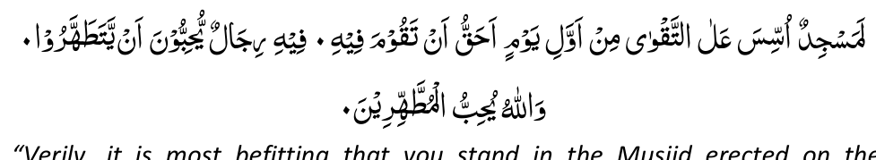
" Verily, it is most befitting that you stand in the Musjid erected on the foundations of Takwaa (piety and fear of Allah) since the very first day. In it (i.e. the Musjid erected on the foundations of Takwaa) are men who love to purify themselves. And, Allah loves those who purify themselves." (QUR'AAN)
Ibn Abbaas (Radiallahu anhu) and Dhh-haaq (Radiallahu anhu) say that the Musjid erected on the basis of Takwaa referred to in this Qur'aanic verse is Musjide Qubaa. Imam Tirmizi (Rahmatullah alayh) and Abu Dawood (Rahmatullah alayh) narrates on the authority of Abu Hurairah (Radiallahu anhu) that the verse,
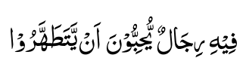
"In it (Musjid of Takwaa) are men who love to purify themselves," was revealed in praise of the people of the town of Qubaa who frequented the Musjid of Qubaa to which this Aayat refers. In this verse of the Holy Qur'aan Allah Ta'ala speaks highly of the people who were the worshippers in Musjide Qubaa, and the reason for Allah Ta'ala bestowing praise upon these men was their habit and practice of thoroughly purifying themselves with water after answering the call of nature. Hence, Allah Ta'ala says:
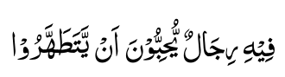
"In this Musjid are men who love to purify themselves." The Tafseer Books of the Holy Qur'aan explain very clearly what is actually meant by "purifying themselves."
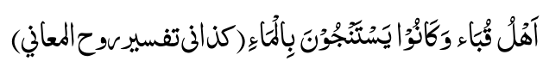
.. ." the people of Qubaa' were in the habit of making Istinja with water." (TAFSEER ROOHUL MA'ANI)
(N.B.: Istinja means to purify oneself from the impurities of urine and faeces).
Allah Ta'ala speaks in glowing terms of the people of Musjidut-Takwaa of the town of Qubaa because they used water in the toilet to purify themselves. This act of purification in the way of the people of Qubaa' (i.e. Istinja with water) is so loved by Allah Ta'ala that He, in His Divine Wisdom, saw it necessary to mention it in the Holy Qur'aan and praise in the highest terms the men who make Istinja with water. Thus He says:
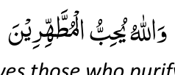
"And, Allah loves those who purify themselves."
There are many important and great practices of the Shariah such as circumcision, the manner of Salaat performance, etc., which Allah Ta'ala does not mention in the Qur'aan. But Allah Ta'ala states the need for purification— for purifying oneself with water — in the Qur'aan. Allah Ta'ala states the beauty and the importance of making Istinja with water in the Holy Qur'aan. The Holy Qur'aan has explained that the practice of Istinja with water is a factor to procure the praise of Allah:
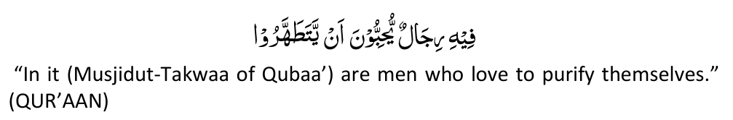
The Holy Qur'aan has explained that the practice of Istinja with water is a factor to obtain the Love of Allah:
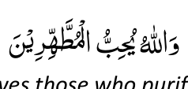
" And, Allah loves those who purify themselves."
What greater felicity and success than Allah's Love can a Muslim hope for? No matter how trivial and unimportant this practice of making Istinja with water may seem to Westernised Muslims, we must remember that Allah Ta'ala, Himself praises this practice in His Book, the Glorious Qur'aan. And, who is the Muslim who can deny the greatness and the importance of the Book of Allah? When this verse (quoted above) was revealed, Rasulullah (Sallallahu alayhi wasallam) addressed the Ansaar and said:
"O gathering of Ansaar! Verily, Allah Ta'ala has highly praised (your) method of purification. What then is your method of purification?"
The Ansaar replied:
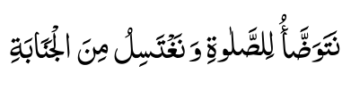
"We perform Wudhu for Salaat and make Ghusl (full bath to obtain purity) from Janaabat."
The Messenger of Allah (Sallallahu alayhi wasallam) said:
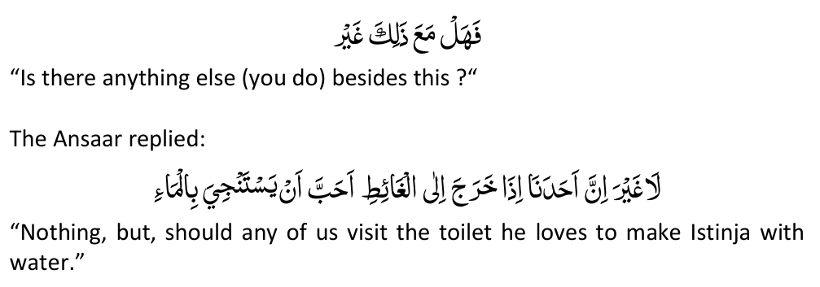
Said Rasulullah (Sallallahu alayhi wasallam):
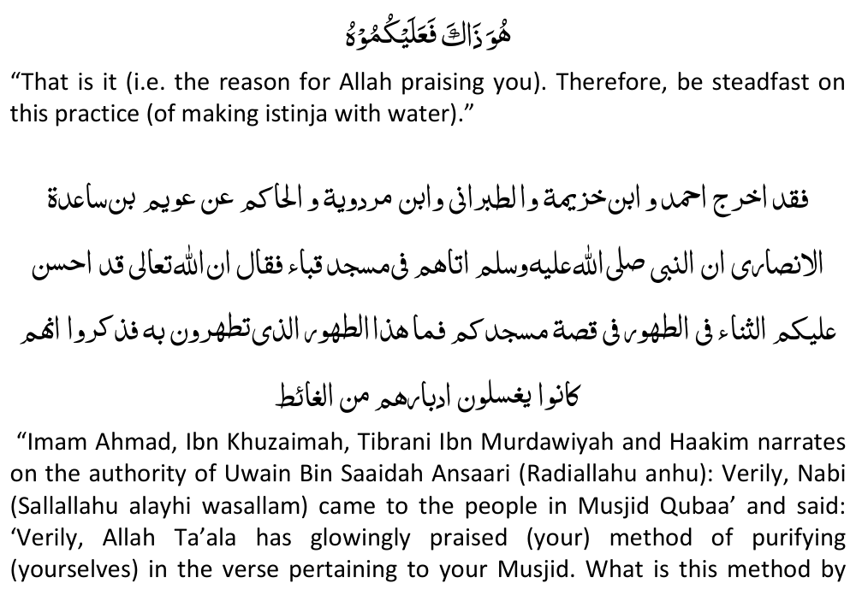
means of which you purify yourselves?' They said in reply that they washed their adbaar after relieving themselves."
(N.B.: Adbaar means the hind private part).
The reader will now realise the essentiality of the practice of purifying with water (Istinja with water). It is a factor and a practice which draws one closer to Allah Ta'ala. Allah Ta'ala showers praise and love on those who maintain this Islamic practice of making Istinja with water. Tahaarat — Purification — is a condition for the validity of our Ibadat. But, it is indeed sad to note that Muslims have fallen prey to the un-Islamic customs and ways of the Kuffaar to such an extent that they are not able to purify themselves in the Islamic method of purification — the method loved by Allah, the method praised in the Holy Qur'aan. It is the trend today — it is considered fashionable and modern to have unhygienic, disease-spreading, Western high-level toilets. The Western Kuffaar have now, after trial, realised the filth and disease — the impurity of the high toilet. For this reason we see that in Europe, Europeans (whom Westernised Muslims are imitating) installing squat-pans (i.e. the flat toilets termed Eastern toilets) by the thousand, yet the Western Muslims have shunned the Islamic practices of gaining purity and are imitating the impure Kuffaar who are the main agents of spreading disease by way of their impurities and unclean habits and unhygienic customs. Allah Ta'ala has branded the Kuffaar as najas (i.e. filth). They are embodiments and symbols of filth and impurity hence Allah Ta'ala states:
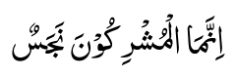
"Verily, the Mushrikeen are impure."
The impurity of kufr and the material and physical impurities of their bodies — filth piled upon filth — have earned for them the epithet of NAJAS. Despite this irrefutable fact, Muslims (Westernised Muslims) deem it honourable to imitate the ways and practices of those decried Allah Ta'ala. Our way of life is Islam, and, Islam has given us a complete and a perfect code of life — right down to the method of cleansing ourselves in the toilet — a method which "modern" Muslims may regard as trivial and unimportant but which Allah Ta'ala and His Rasool (Sallallahu alayhi wasallam) regard as very important. In the Eyes of Allah it is a practice about which Allah Ta'ala declares in the Holy Qur'aan:
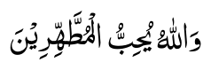
"And Allah loves those who purify themselves."
THE MA'ZOOR Ahkaam (Laws) of The Ma'zoor A person who, due to some illness, etc., continuously remains in the state of impurity, being unable to remain in the state of Tahaarat (purity) long enough to perform Salaat, is called a Ma'zoor.
Once a person qualifies as a Ma'zoor, he/she has to perform Salaat even in the state of "impurity." Because of his/her helpless condition, he/she is excused from the normal state of purity. Ma'zoor means an "excused" person.

When Does One Become A Ma'zoor?
One will become a Ma'zoor only if the state of impurity initially lasts for one complete duration of Salaat time. If throughout this time, blood-or-urine, etc., flowed or dripped continuously, not enabling one to make Wudhu and perform the Fardh Salaat with Tahaarat (purity), then one will be known as a Ma'zoor and the Ahkaam of the Ma'zoor will become applicable.
The time when the cause of continuous impurity (e.g. wound from which blood flows; dripping of urine, etc.) developed, will not be taken into consideration in determining whether a person has become a Ma'zoor. The time will be reckoned from the Salaat time immediately following the Salaat time in which the wound, etc., was sustained.
Example: During Zuhr time, one sustained an injury which caused bleeding. The bleeding was continuous. One shall now have to wait until the approach of the end of Zuhr time, i.e. until so much time remains that the Faraaidh of Wudhu and four rakaats Fardh Salaat could be performed. When this much time remains before the ending of Zuhr time then make Wudhu even while the bleeding continues and perform the four rakaats Fardh of Zuhr.
However, one has not yet become a Ma'zoor since one complete Salaat duration has not passed.
Now if the bleeding continues for the full Asr time which follows immediately after the ending of the Zuhr time in which the bleeding commenced, one will be known as a Ma'zoor.
If during this Asr time (i.e. the Asr time which immediately followed the Zuhr time in which the bleeding started) the bleeding stopped long enough to enable one to make Wudhu (i.e. only the Faraa-idh of Wudhu) and the Fardh Salaat, then one will not be a Ma'zoor.
If, after having qualified as a Ma'zoor, the bleeding stopped for any length of time — but not stopping completely for one Salaat time — and then resumes, one will still be regarded as a Ma'zoor. In the example given above, one became a Ma'zoor at the end of Asr time. During Maghrib time, the bleeding ceased for some time and then resumed. This cessation of bleeding will not be taken into consideration. One will still be a Ma'zoor.
After qualifying as a Ma'zoor, one will remain a Ma'zoor as long as the bleeding, etc., does not stop for one full Salaat time.
Upon becoming a Ma'zoor, it is not necessary for the bleeding to be continuous in the succeeding Salaat times. In the succeeding Salaat times, it will suffice if the bleeding was for just a moment for one to continue to be considered a Ma'zoor.

The Ma'zoor's Tahaarat
(1) A Ma'zoor shall take Wudhu for every Fardh Salaat. When it is time for performing Salaat, Wudhu should be made.
(2) The Wudhu of a Ma'zoor remains valid for the duration of the Salaat time. Example: During Asr time, a Ma'zoor made Wudhu for performing Asr Salaat. This Wudhu will remain valid throughout the Asr duration. When Asr time expires, the Wudhu will become null.
(3) All Nawaqidhe Wudhu (factors which break Wudhu) besides the factor responsible for making one a Ma'zoor, will nullify the Wudhu of a Ma'zoor. Example: A person became a Ma'zoor as a result of continuous bleeding from a particular wound. This person made Wudhu for Salaat, but before performing Salaat, he/ she bled from another wound or had to answer the call of nature. These other acts will now break the Ma'zoor's Wudhu although the bleeding from the particular wound will not.
(4) Wudhu made by a Ma'zoor will become null after sunrise. If the Ma'zoor wishes to perform any Salaat after sunrise, Wudhu will again have to be made.
(5) The Ma'zoor's Wudhu taken after sunrise will remain valid for Zuhr Salaat. This Wudhu taken after sunrise will end only with the expiry of Zuhr time.
(6) The Ma'zoor may perform any type of Salaat with his/her Wudhu, be it Fardh, Sunnat, Witr or Nafl.
(7) The Ma'zoor can touch the Qur'aan Shareef with his/ her Wudhu.

The Clothing And Body Of The Ma'zoor Being Soiled By Bleeding, Etc.
The following two rules will apply to the soiled body and garments of the Ma'zoor:
(a) If the soiled garments — soiled by the bleeding, urine, etc. — are washed, but become soiled again before the Salaat could be completed, then it is not obligatory to wash it. Salaat could be performed with such soiled garments. (b) If, however, the garments or body will not soil so quickly, and one will be able to perform and complete the Salaat with taahir (pure) garments and body, then it will be Waajib to wash the soiled parts when the extent of the najaasat (impurity) becomes more than the size of a dirham (dirham's size is the area of the hollow in the palm of the hand).
Imaamat of A Ma'zoor It is not permissible for a Ma'zoor to become the Imaam of a jamaat (congregation) if all or some of the Muqtadis (congregants) are not Ma'zoor. It is permissible for a Ma'zoor to be the Imaam if all the Muqtadis are also Ma'zoor.
Faaqidut - Tuhurain A person who is neither able to take Wudhu nor Tayammum is described as Faaqidut-Tuhurain. A person who has neither the means or ability to obtain Tahaarat (purification) by means of Wudhu or Tayammum is not permitted to perform Salaat. In such an event Salaat will have to be made Qadhaa upon attaining purity.

HAIDH
Haidh is the female monthly period of menstruation.
The Haidh Period The minimum period of Haidh is 72 hours, i.e. 3 days and 3 nights.
The maximum period is 10 days and 10 nights.
The blood that flows for less than 3 days or more than 10 days is not Haidh, but is known as Istihaadhah. (Istihaadhah will be explained later, Insha' Allah). Haidh does not occur before the age of nine years nor after the age of fifty-five years. Blood which flows before the age of nine years or after fifty-five years is known as Istihaadhah.

The Ahkaam (Injunctions) Of Haidh
A. During the state of Haidh the following are prohibited:
(1) Salaat:
It is not permissible to perform Salaat while menstruation lasts. Salaat missed as a result of Haidh is totally maa'f (waived). Qadhaa of these Salaat is not offered.
(2) Fasting:
Fasting during Haidh is prohibited. Fasts missed as a result of Haidh must be fulfilled after purity from Haidh has been attained.
(3) Sexual Relations:
During the state of Haidh it is not permissible for the husband to look at the portion of the wife's body from the navel to the knees.
(4) Touching or reciting the Qur'aan:
It is not permissible to touch or even recite the Qur'aan Shareef. It is, however, permissible to touch the Qur'aan if it is enclosed in a wrapper or cloth. If the cloth is sewn or attached to the cover, touching will then not be permissible. It is not permissible during the state of Haidh to touch even an object on which a verse of the Qur'aan Shareef is written or engraved, e.g. paper, tray, ta'weez, post card, etc. If such objects are enclosed in a covering, touching will be permissible.
(5) To enter the Musjid.
(6) To make tawaaf of the Ka'bah Shareef.
B. If Haidh stops before ten days, sexual relations will be permissible only after Ghusl has been taken or after one full Salaat time has lapsed. If Haidh stops after the full ten-day period, sexual relations are permissible even before Ghusl.
C. When the period of Haidh comes to an end, Ghusl becomes Waajib (compulsory).
The Types of Blood Which Are Haidh During the period of Haidh all colours of fluid — greenish, red, yellowish, brownish, etc. — excreted, are Haidh. The Haidh period will remain until the pad remains completely white or "clean."
Istihaadhah The blood which flows for less than 3 days (72 hours) and more than ten days (240 hours) is not that of Haidh, but is known as Istihaadhah.
The injunctions (Ahkaam) of Haidh and Istihaadhah differ.
Istihaadhah is the result of some illness. A woman who suffers from Istihaadhah must perform Salaat, keep fast and it is permissible for her to recite and touch the Qur'aan Shareef.
The law regarding such a woman is the same as the law governing the Ma'zoor. (Ma'zoor was explained in an earlier chapter of this book). In brief, a woman of Istihaadhah must make Wudhu for each of the Fardh Salaat. Her Wudhu will last as long as the Salaat time lasts. When the Salaat time expires, her Wudhu becomes null. For example, she makes Wudhu for Zuhr Salaat. With this Wudhu she shall perform Zuhr Salaat or any other Ibaadat. The flow of the Istihaadhah blood will not nullify her Wudhu. Her Wudhu will, remain valid for the whole of Zuhr time. When Zuhr time expires, her Wudhu automatically breaks. Now she will have to make a fresh Wudhu for Asr Salaat. When Asr time expires, her Wudhu breaks again. She must make fresh Wudhu for Maghrib, and so on for all the Fardh Salaat.

Masaa-il Pertaining To Haidh
(1) If the flow of blood was even a couple of minutes less than 72 hours then it (the blood) will not be that of Haidh, but will be Istihaadhah.
(2) Haidh period normally ends at the age of 55 years. However, if after the age of 55 years there is still a flow of blood then the colour of the blood will be taken into consideration. If the blood is red or black then it will be Haidh. If yellowish, greenish or brownish then it will be Istihaadhah. However, if before the age of 55 years the Haidh blood was also yellowish, greenish or brownish then these colours of blood after 55 years will also be Haidh.
(3) If while performing Fardh Salaat Haidh commences, one should immediately discontinue the Salaat. This Salaat is maa'f (waived). Qadhaa of it is not to be made.
(4) If while performing Nafl or Sunnat Salaat, Haidh commences, one should immediately discontinue the Salaat, but upon attaining purity, Qadhaa of this Nafl or Sunnat must be made.
(5) All fasts — Fardh or NafI — missed because of Haidh must be fulfilled upon attaining purity.
(6) If the flow of Haidh ceases before her normal number of days, it is Waajib upon her to take Ghusl and perform Salaat, but it is Makrooh Tahrimi (forbidden) to indulge in sexual relations. Sexual relations will be permissible once her normal number of days has passed. If before the expiry of her normal number of days the flow of blood is resumed then this resumption will be that of her Haidh.
Example: A woman's normal monthly period is five days, but on one occasion ceased after four days. She should take Ghusl and perform Salaat, but not indulge in sexual relations, for the possibility of Haidh-resumption exists. After the fifth day has passed — i.e. her normal number of days — then only will sexual relations be permissible.
(7) The blood which flowed for less than three days (72 hours) is not Haidh, therefore Ghusl is not Waajib. After the flow has stopped (i.e. before three days), Wudhu has to be made and all Salaat missed must be performed, but sexual relations will not be permissible. If before fifteen days pass by, the flow of blood is resumed then that which came for less than three days in the beginning was Haidh. The normal number of days in this case will be regarded as Haidh, and then Ghusl will be Waajib and Salaat shall have to be performed.
If after the cessation of the blood (which stopped before three days) fifteen days of purity passed by — i.e. no blood flowed for full fifteen days — then that which came in the beginning for less than three days was Istihaadhah.
Example: Blood flowed on the 3rd and 4th of the month and stopped (i.e. it stopped before 72 hours). Ghusl is not Waajib on her now. She must make Wudhu and make Qadhaa of her missed Salaat. However, it is not permissible for her to indulge in sexual relations yet. On the 16th (i.e. before the passing of 15 days) the flow was resumed. Her normal period in other months is 7 days.
In this case her period of Haidh will also be 7 days as follows: 3rd, 4th, 5th, 6th, 7th, 8th and 9th. From the 16th onwards will be lstihaadhah.
On the 16th when the blood resumes she must make Ghusl and perform Salaat.
(8) A woman's normal monthly period is three days. However, on one occasion the flow continued after the expiry of her three-day period. In this case she must not yet make Ghusl nor perform Salaat, but wait. If the flow continues and stops either upon the passing of full ten days (240 hours) or less than ten days then all these days that the blood came will be Haidh and it will be regarded henceforth that the number of days of her period has changed.
If the blood continued to flow even on the eleventh day then it will be established that her period is only her normal three days. All days after the third day will be Istihaadhah, Now on this 11th day she must make Ghusl and make Qadhaa of all Salaat missed from the fourth day onwards and continue to make Salaat in the state of Istihaadhah.
(9) In a case where a woman has no fixed number of days for her monthly period — sometimes 3 days, 5 days, 8 days, etc. — then the number of days the blood flowed each month, providing that it is not more than ten days, will be her Haidh period.
In a case where the period varies from month to month, if the blood flows for more than ten days then her Haidh period for this month (in which the blood flowed for more than ten days) will be the number of days of her period of the previous month, the rest will be Istihaadhah.
(10) If a woman's normal monthly period is, for example, 4 days, but this month the blood flowed for 5 days. The following month the blood flowed for more than 10 days, say for 15 days. Now of these 15 days, the first five days will be Haidh and the rest thereafter Istihaadhah. It will henceforth be regarded that her period is five days and not the former four days.
(11) If from the very beginning of attaining puberty the blood continued flowing for several months without stopping then ten days — from the day the blood first commenced—will be Haidh and twenty days Istihaadhah. Her cycle will follow this pattern, viz, ten days Haidh and twenty days Istihaadhah.
(12) A cessation of less than fifteen days will not be regarded as a "cessation" of the flow of blood. In this case the normal number of days of the Haidh period will be considered as Haidh and the rest as Istihaadhah.
Example: A woman's normal Haidh period is the 1st, 2nd and 3rd of every month. This month it so happened that on the 1st, blood flowed and then stopped again on the same day. Fourteen days then passed by in a state of purity, i.e. blood did not flow. On the 16th, blood resumed and then stopped. The intervening 14 days of purity will not be regarded as a cessation of the flow of blood, it will be said that the blood has flowed "continuously" for sixteen days (1st plus 14 days of purity plus 16th). Of these 16 days, 3 days which are her normal period, will be the Haidh period of this month as well, the rest of the 13 days being Istihaadhah. This woman will take Ghusl and make Qadhaa of all Salaat after the 3rd if she had not taken Ghusl after the 3rd. If, however, she had taken Ghusl after the 3rd, then the Salaat thus performed will be valid, and there will be no need to make Qadhaa.
Example: A woman's normal Haidh period is the 4th, 5th and 6th of each month. However, this month the blood started on the 1st and stopped after flowing for the day. The blood stopped for fourteen days, but resumed on the 16th.
Since the period of purity has been less than 15 days it will be said that the blood flowed "continuously" for 16 days (1st plus 14 days of purity plus 16th). Her normal period of Haidh will be established for this month as well — i.e. it will be said that the 4th, 5th and 6th are her days of Haidh and the rest (1st, 2nd, 3rd, 7th, 8th, etc.) — are lstihaadhah. Hence, the Salaat of the
7th and onwards will have to be fulfilled if the Salaat of these days were performed without making Ghusl on the 7th.
(13) A woman's normal Haidh period has always been five days (for example). Of recent her periods have undergone a change. Sometimes only a drop of blood appears and then four days lapse without any blood appearing. On the fifth day again some blood flows and then stops. Sometimes the flow continues for a day or so and stops. The flow then resumes after seven or eight days and then continues flowing for five days. In this case her normal number of five days (i.e. the five particular dates of her normal periods) will be Haidh and the rest Istihaadhah.
(14) If in a case where the Haidh stops before ten days, the flow of blood ceases at such a time that very little time of the Salaat remains — only time for making quickly Ghusl observing just the Fardh duties of Ghusl, and for saying once "Allaahu Akbar — then, too, that Salaat will be Waajib. Qadhaa of it must be made. If the time remaining for the Salaat at the time when the Haidh stops in this case is less than this (i.e. less than the time required to quickly make Ghusl and say "Allaahu Akbar) then the Salaat is maa'f (waived).
(15) If the Haidh blood ceased after the full ten days (240 hours) period and only time remains for saying once "Allaahu Akbar" before the Salaat time expires — there being no time for Ghusl — then the Salaat of that particular time becomes Waajib. After Ghusl it will have to be rendered.
Example: Haidh after ten days stopped at 6.15 p.m. Sun sets (on that particular day) at 6.16 p.m., hence one minute of Asr time still remained when Haidh stopped although this minute is obviously insufficient for Ghusl. Nevertheless, the Asr Salaat now is Waajib. After Ghusl Qadhaa of Asr must be rendered.
(16) Fasting during the state of Haidh is not permissible. However, if in the month of Ramadhaan Haidh ceased during the day, it is not lawful to eat or drink. Although this particular day will not be regarded as a valid fast, it is Waajib to remain like a fasting person and Qadhaa of this fast will have to be rendered.
(17) During Haidh it is Mustahab at the time of Salaat to make Wudhu and sit for a while in solitude and engage in Zikr of Allah Ta'ala.

NIFAAS
(1) Nifaas is the blood which flows after childbirth.
(2) The maximum period of Nifaas is forty days. There is no minimum period of Nifaas. After childbirth the blood which flows for even a minute will be Nifaas.
(3) The Ahkaam (injunctions) of Nifaas are exactly the same as those of Haidh. (See Page 70).
(4) The blood which flows from a pregnant woman before birth or during delivery of the babe (i.e. before the emergence of the baby) is not Nifaas, but is Istihaadhah.
(5) The blood which exceeds the maximum period of 40 days is classified as follows:
(a) First occasion:
If it happens to be the first occasion of childbirth, the blood in excess of forty days will be Istihaadhah.
(b) Set Nifaas Period:
If she had already given birth previously and has a fixed number of days for her Nifaas period then whatever is in excess of her fixed Nifaas period will be Istihaadhah. For example, her previous Nifaas period was 18 days, but on this occasion the blood flowed for 45 days. Her Nifaas period on this occasion, too, will be 18 days. The rest, i.e. 27 days, will be Istihaadhah.
(c) No fixed period:
She gave birth on previous occasions, but had no fixed number of days for her Nifaas. In this case her Nifaas will be 40 days and the excess will be Istihaadhah.
(6) If a set period of Nifaas changes but does not exceed 40 days, the latest number of days will be the new Nifaas period. Example: A woman's previous Nifaas was 19 days. On this occasion the blood continued for 35 days. Her new Nifaas will be 35 days.
(7) In the case of giving birth to twins, the Nifaas is the blood which flows after delivery of the first babe.
(8) If after childbirth no blood flowed, then, too, it is Waajib (compulsory) upon her to make Ghusl.
One who neglects internal purity (purity of the heart) is contemptible. —

IMAAM GHAZAALI.

ANJAAS (IMPURITIES)
Anjaas is the plural of Najas which means "impurity."
The purification of the body, clothing and place of Salaat of the Musalli is Waajib.

Types of Najaasat (Impurity)
There are two classes of Najaasat, viz. Haqeeqi and Hukmi.
(1) Najaasat Haqeeqi
Najaasat Haqeeqi are all forms of material impurities, e.g. urine, stool, blood, pus, water rendered impure by urine, etc., wine, etc.
(2) Najaasat Hukmi
Najaasat Hukmi is a state of impurity. It is not an impurity consisting of a material substance. There are two states of Najaasat Hukmi, viz. hadathe asghar and hadathe akbar. These types of Najaasat Hukmi have been dealt with in the sections dealing with Wudhu and Ghusl.
N.B.: Purification from both classes of Najaasat (i.e. Haqeeqi and Hukmi) is essential for Salaat.
Ways of Purification Purification from Najaasat Hukmi It has already been described in the Wudhu and Ghusl sections how to purify oneself from Najaasat Hukmi.
Purification from Najaasat Haqeeqi Purification from Najaasat Haqeeqi is obtained by removal of the impurity and washing the impure place, garment, etc. In some cases only removal of the impurity, without washing, will be sufficient. Purification is achieved in the following ways:
(a) Water and taahir liquids Water as well as all taahir (pure, paak) liquids such as rose water, vinegar, etc., could be used for purifying an object soiled by Najaasat Haqeeqi.
(b) Drying and removal If the impurity is a solid which has dried, purification could be obtained by rubbing the object (On which the solid impurity has dried) onto earth. This form of purification applies to only non-absorbent materials, e.g. leather, rubber, etc.
(c) Wiping If a solid impurity falls on to glass, mirror or metal, then wiping off this impurity from the mirror, etc., will suffice.
(d) Scratching If mani (semen) which has dried on the clothing is scratched off, the cloth or garment will be regarded as taahir. This form of purification of cloth (viz, scratching) applies to only mani. Cloth rendered impure by any other impurity besides mani can only be purified by washing.
(e) Drying of polluted ground Earth is purified by having been dried by the sun. Hence, if earth which has been rendered impure becomes dry in the sun — no trace of impurity remaining— Salaat will be permissible on such ground. This form of purification applies to only earth and not to a mat, carpet, etc. However, impure earth purified by the sun cannot be used for Tayammum.
*EXPLANATORY NOTE: In the context of Kitaabut Tahaarah, the term "pollution" refers to Najs or substances which the Shariah has declared impure. "Pollution" here should not be confused with industrial pollution or some other form of grime, dust, etc., which although unhygienic and detrimental to the health, but, nevertheless, not Najs in terms of the Shariah. Hence, one's clothing may be covered with dust, soot or other forms of substances which are regarded as industrial pollution, but in terms of the Shariah these will be considered taahir, hence Salaat could be performed with clothing "soiled" in such a manner.

METHODS OF WASHING Solid Impurities
An object rendered impure by a solid impurity shall be washed until the body of the impurity is eliminated. If after thorough ordinary washing (i.e. without using soap, powder, etc.) some impression (i.e. colour or odour) of the impurity still remains, then, too, the object will be regarded as purified.

Liquid Impurities
An object rendered impure by an impure liquid, e.g. urine, shall be washed until one feels satisfied that the impurity has been eliminated.
The Types Of Najaasat Haqeeqi There are two types of Najaasat Haqeeqi, viz. Najaasat Khafeefah and Najaasat Ghaleezah.
Najaasat Khafeefah This is the lesser or lighter impurity. The following are impurities known as Najaasat Khafeefah:
(i) The droppings of all haraam birds, e.g. eagles, falcons, vultures, etc. (ii) The urine of all halaal animals, e.g. sheep, cattle, etc.
(iii) The urine of horses.
(1) If a quarter or more of a part of the garment or cloth is covered with Najaasat Khafeefah then it is Waajib to wash it. Salaat will not be valid if a quarter or more of a part is covered with this type of impurity. If less than a quarter is covered then the Salaat will be valid although washing the impure part is best.
By quarter is meant a quarter of that particular part and not a quarter of the whole garment or whole body, e.g. a quarter of the sleeve, a quarter of the back, a quarter of the arm, etc.
(2) If Najaasat Khafeefah falls into water or any liquid then that liquid, too, becomes Najaasat Khafeefah.
Najaasat Ghaleezah This is the greater or heavier impurity. The following are impurities known as Najaasat Ghaleezah:
(i) Blood of all animals and human beings excluding the blood of fishes and insects.
(ii) Everything — bones, hair, skin, etc. — of a pig.
(iii) Urine of human beings and of all haraam animals.
(iv) Semen.
(v) Faeces of all animals and human beings.
(vi) Droppings of fowls, ducks and wild ducks.
(vii) Wine.
(1) If Najaasat Ghaleezah in the solid state (e.g. faeces) falls on the body or clothing, washing will be Waajib if the weight of the impurity is more than about 3g (one-ninth of an ounce).
(2) If Najaasat Ghaleezah in the liquid state (e.g. blood) falls on the body or clothing, washing is Waajib if the impurity covers an area greater than the size of a dirham. (Dirham is a silver coin which is the size of the hollow of the palm of the hand, — approximately a circle of half an inch-radius). If it is the size of a dirham or less, then Salaat performed in this manner will be discharged.
(3) The stipulation of the minimum quantity of impurities, viz, a quarter of the area for Khafeefah and a dirham's size, etc., for Ghaleezah, does not mean that the impurities in these little quantities should not be washed away. It merely means that if one did perform Salaat with the body or garments soiled by the minimum "allowed" limit of impurity, the Salaat will be valid. Notwithstanding this, to perform Salaat without washing even the minimum "allowed" limit is reprehensible—Makrooh. The Sawaab and spiritual efficacy of the Salaat are reduced by the presence of any impurity, no matter how little.
(4) Najaasat Ghaleezah falling in water or liquid will transform the liquid also into Najaasat Ghaleezah.
Masaa-il Pertaining To Impurities (1) The exereta (urine and faeces) of even a milk-drinking infant is Najaasat Ghaleezah.
(2) Besides fowls, ducks and wild ducks, the droppings of all halaal birds are not regarded as impurities.
(3) The droppings and urine of a bat are not regarded as impurities. (4) The bones, hair, skin, etc., of a pig are impure (Najaasat Ghaleezah). However, if these are burnt and reduced to ash, the ash will be taahir (pure, paak).
(5) The saliva of dogs, pigs and all beasts of prey is Najas (impure). It is of the Ghaleezah type.
(6) The smoke and vapour of an impurity are pure (Taahir).
(7) Fruit worms are Taahir. Their presence does not render the fruit impure. But it is not permissible to eat these worms.
(8) A decayed egg of a halaal bird is Taahir providing that it is not broken. (9) The scales on the skin of a snake are Taahir, but its skin is impure. (10) Water used to wash something impure also becomes impure (Najas). (11) The saliva of a dead person is Najas.
(12) Foodstuff which has decayed is not Najas, but nevertheless should not be eaten.
(13) The saliva which flows from the mouth of a sleeping person is not Najas. (14) Water in which some Taahir (paak pure) object was washed is not Najas. Wudhu could be made with such water provided the flow of the water, i.e. its fluid state, has not been impaired, i.e. the water has not become thick. (15) If a slaughtered fowl or bird is placed in boiling water prior to removing the entrails, it will become impure —Najas. There is no way of purifying it thereafter.
(16) Impure garments cleansed by the dry-cleaning process, remain impure. (17) It is not permissible to utilise "used water" (al-maa-ul musta'mal) for purposes of purification nor for drinking or in foods.
N.B.: The meaning of al-maa-ul musta'mal (used water) will be explained in the next section, Insha' Allah.
(18) Najas (impure) water cannot be used for anything. It is not permissible to give Najas water to animals to drink nor to use it in the mixing of mortar, etc.

AL-MAA-UL MUSTA'MAL (USED WATER)
Al-maa-ul Musta'mal or "used water" is the water which has been used to purify from impurities as well as such water which has been used on the pure (taahir, paak) body for the purpose of obtaining Sawaab (Reward in the Hereafter), e.g. one is already in the state of Wudhu, but makes a fresh Wudhu to obtain Sawaab, by making Niyyat of Wudhu.
It is not permissible to use such "used water" for removing the impurities of Janaabat and Hadath, i.e. Ghusl to remove Janaabat and Wudhu to remove Hadath cannot be made with such "used water."
Such "used water" may be used to remove or eliminate other impurities, e.g. blood, excreta, etc.
If one is in the state of Wudhu and one makes a fresh Wudhu without forming Niyyat (intention) of Sawaab or Niyyat of Wudhu, then the water falling from the body will not be regarded as al-maa-ul musta'mal. Such water will be Taahir.
Najas (Impure) Water Water in which any Najas object was washed also becomes Najas. However, the degree of Najaasat (impurity) of such impure water differs with the number of times the Najas object was washed in it.
Hence:
(i) If an impure object is washed once in water and this impure water falls on to garments, then such garments will become purified (taahir or paak) only after being washed thrice.
(ii) If the impure object which has already been washed once is washed a second time in Taahir (pure) water and then this impure water (i.e. in which the impure object has been washed the second time) falls on to garments, then such garments will become purified after being washed twice.
(iii) If the impure object which has already been washed twice is washed the third time in Taahir water and then this impure water falls on to garments, then such garments will be purified after being washed once only.

SOOR ( LEFT OVER WATER )
"Soor" is the water which remains in a container after drinking.
The soor of people, animals and birds is classified into the following categories:
Taahir, Najas, Makrooh, Mashkook.

Taahir or Pure (Paak)
The Soor of the following is Taahir:
(i) Human beings, even if they be non-Muslim or in the state of Janaabat. (ii) All halaal animals, e.g. goats, sheep, cattle, etc.
(iii) Fowls living in an enclosure.
(iv) Halaal birds, e.g. pigeons, swallows, parrots, etc.
(v) Haraam birds, e.g. falcon, hawk, which have been tamed and do not eat carrion and other impurities.
(vi) Horses.

Najas (Impure)
The Soor of the following is Najas:
(i) Dogs.
(ii) Pigs.
(iii) All beasts of prey, e.g. lions, wolves, etc.

Makrooh (Reprehensible)
The Soor of the following is Makrooh (i) Cats.
(ii) Fowls which are not in an enclosure.
(iii) Birds of prey, e.g. eagles, etc.
(iv) Snakes, lizards, etc.
(v) Mice.
(vi)Ghair Mahram2 — providing that it is known that the soor is of a certain Ghair Mahram.

Mashkook (Doubtful)
The Soor of asses and mules is Mashkook.
Masaa-il Pertaining To Soor (1) It is permissible to use for any purpose, e.g. washing, Wudhu, Ghusl, drinking, etc., soor classified as Taahir.
(2) It is not permissible to use for any purpose soor classified as Najas (impure).
(3) If Taahir water is available then it is not proper to use Makrooh soor. The use of Makrooh soor is not reprehensible where Taahir water is not available. (4) Mashkook soor should only be used when Taahir water is not available. Only in case of the non-availability of Taahir water may Mashkook water be used for Wudhu, etc. If only Mashkook water is available, both Wudhu and Tayammum must be made. Any one of these two acts, viz. Wudhu and Tayammum, may be made first.
(5) Any impurity (Najaasat) on or in the mouth of a person or halaal animal will render the soor Najas. Hence, a person's soor will be Najas immediately after having eaten pork or consumed liquor.
(6) The utensil licked by a dog will become Taahir after washing it thrice. However, it is better and an act of Sawaab to wash it seven times and once, thereafter, with sand.
(7) If immediately after eating a mouse, the cat puts its mouth in the water, etc., then it will be Najas.
Perspiration (1) The perspiration of animals whose soor is Taahir, is also Taahir.
(2) The perspiration of animals whose soor is Najas, is also Najas.
2 A person with whom marriage is not prohibited.
(3) The perspiration of animals, birds, etc., whose soor is Makrooh, is also
Makrooh.
(4) The perspiration of asses and mules is Taahir. However, it is better to wash it if it makes contact with the body, clothing, etc.
Water Purification from the ceremonial impurities of Hadath and Janaabat is possible with only natural water.
The following are examples of natural water:
(a) Rain water (b) River water (c) Lake water (d) Sea water (e) Spring water (f) Well water (g) Water melted from ice and snow.
Stagnant Water Stagnant water becomes impure if Najaasat (impurity) falls in it regardless of the quantity of Najaasat. Even a little quantity of Najaasat will render stagnant water Najas.
Flowing or Running Water Water which flows or runs naturally remains Taahir even if Najaasat falls in it. Najaasat will only render running water impure if any of the effects — colour, taste or odour of the Najaasat is detected in the water.

Large Ponds, Tanks, Etc.
A pond, tank, etc., having an area of 289 square feet is classified, as. "flowing water."
Najaasat will only pollute the large pond, tank, etc., if any of the effects of the impurity is discerned.
If any solid impurity, e.g. a dead animal, falls into a pond or tank, Wudhu, etc., will be permissible at another side or end of the pond.

Masaa-il Pertaining To Water
(1) The death in water of living organisms which do not have flowing blood, e.g. insects, scorpions, etc., will not pollute the water.
(2) The death in water of living organisms which are born and live in the water, e.g. fish, crabs, etc., will not pollute the water.
(3) If some Taahir object, e.g. soap, saffron, etc., is added to water, and it changes the taste, odour or colour of the water without impairing its flow (fluid state) then it is permissible to use such water for Wudhu or Ghusl.
(4) If some Taahir object is added to the water and then heated thus changing any of the properties (colour, odour, taste) of the water, then it is not permissible to use such water for Wudhu or Ghusl.
(5) It is not permissible to use for Wudhu or Ghusl water which has been heated after adding such a large quantity of soap or soap powder that the fluidity of the water has been impaired.
(6) If a small quantity of food substance such as milk, for example, falls in water slightly changing the colour of the water then, too, such water will be permissible for Wudhu and Ghusl. However, if the colour of the water has been completely transformed and the water now appears as milk, etc., then Wudhu and Ghusl is not permissible with such water.
(7) A small pool or quantity of stagnant water located somewhere in the veld, etc., will be regarded as Taahir providing no effect of impurity (Najaasat) appears in the water. One will be obliged to make Wudhu or Ghusl with this water in the absence of any other water. Tayammum will not be permissible on the mere suspicion that this water is impure.
(8) If the colour and taste of the water of a stream, large pond, well, etc., have changed as a result of abundance of sand, leaves and grass which have accumulated in it, but the flow of the water has not been impaired, then Wudhu and Ghusl with such water is permissible. If the fluidity of the water has been impaired, Wudhu and Ghusl will not be permissible with such water.
(9) Water passing over a roof of which half or more is covered with Najaasat, is Najas (impure). If less than half the roof is Najas, the water will be considered Taahir and fit for use.
(10) If Najaasat is lying in the roof-gutter and all the water has to pass over the Najaasat before entering the tank, then such water will be Najas.
(11) If the flow of the water in a stream, etc., is very slow, Wudhu should not be made quickly.
(12) Juice extracted from trees, leaves, fruit, etc., is not water, hence Wudhu and Ghusl with it is not valid.

Wells And Their Water
(1) Najaasat (impurity) falling into a well pollutes all the water in the well. To purify the well, all the water will have to be removed.
(2) Any type of Najaasat, be it Ghaleezah or Khafeefah, will pollute the well. (3) An animal with flowing blood falling and dying in the well, will pollute the well.

Purifying The Well
(a) If Najaasat fell into a well, all the water will have to be removed whether the quantity of Najaasat is much or little.
(b) If an animal with flowing blood dies in the well and its body bloats (swells) or bursts, all the water in the well must be removed regardless of the size of the animal — be it a small bird/animal or a big animal.
(c) If an animal or bird the size of a swallow dies in the well, but neither bloats nor bursts, then after removing the dead animal twenty buckets of water will have to be removed compulsorily to purify the well. Removing twenty buckets in this case is Waajib. Removing thirty buckets is Mustahab.
(d) If an animal or bird the size of a cat, pigeon or fowl dies in the well, but does not bloat or burst, then it is Waajib to remove forty buckets of water after removing the dead animal. It is Mustahab to remove sixty buckets.
(e) If an animal the size of a dog, goat, or a human being dies in the well, but does not bloat or burst, all the water must be taken out after the dead animal has been removed.
(f) The same rules will apply whether the animal died outside the well and fell in or died inside the well.

Which Size Bucket Should Be Used?
(1) Buckets of the size generally used at the well should be used in counting the number of buckets of water to be removed from the well.
(2) If a huge bucket or container is used to remove the water, the "normal bucket-capacity" of the huge container will have to be ascertained. Calculation will then be in terms of the capacity of the huge bucket. Example: The huge bucket has a capacity of 10 buckets generally used at the well. A pigeon died in the well, neither bloating nor bursting. It was decided to remove 60 buckets of water. However, the huge bucket is employed. Since its capacity is 10 normal buckets, six huge buckets of water will have to be removed to purify the well.

Drawing Out The Water
(1) The quantity of water to be removed could be drawn out all at once or at intervals. If, for example, sixty buckets have to be removed, this could be done all at one time or a few buckets could be taken out now, a few at another time and so on until the requisite number has been drawn out.
(2) In some wells the flow or rise of the water from underground is so rapid that it is not possible to empty the well. Water drawn out is continuously replenished, by fresh water entering the well. In such cases if it becomes necessary to remove all the water for the purification of the well, any one of the following measures of estimating the volume of water could be adopted:
(i) The depth of the water is, for example, 2 metres. Remove 100 buckets rapidly and ascertain the depth of the remaining water. If, for example, the depth was reduced to 1 ½ metres, it shall be concluded that ½ metre= 100 buckets. This scale will now be employed to remove the water. Thus, a total of 400 buckets will have to be removed.
(ii) Obtain an estimate of the number of buckets of water in the well. Such an estimate is to be obtained from two uprighteous Muslims having knowledge about wells.
(iii) By ascertaining mathematically the volume of the water in the well and drawing out this volume.
(iv) If any of the above methods cannot be availed of for some reason, then 300 buckets should be removed. The well will then be considered Taahir.
What To Do When The Impure Water Of A Well Has Been Used
(1) A dead animal was discovered in a well, but it is not known when it fell into the well. At the time of discovery the animal had not yet bloated or burst open. All those who had made Wudhu with the water of this well have to repeat the Salaat of the past 24 hours.
Garments which had been washed with the water of this well have to be washed again.
(2) If the dead animal had already bloated or burst open, the Salaat of the past 72 hours has to be repeated.

Miscellaneous Masaa-il Pertaining To Wells
(1) The death of animals which have no flowing blood will not render the water impure. Thus a dead fish, frog, crab, etc., in the well will not pollute the water.
(2) When the necessary quantity of water has been drawn out, the bucket and the rope will be regarded as Taahir. There is no need to wash them separately for purification.
(3) A person in the state of Janaabat descended into the well to retrieve the bucket, the rope, etc. If there was no impurity on his body or clothes, the well will remain Taahir. If it is not certain whether his body or garments had any Najaasat, then, too, the well will be regarded as Taahir. However, it is best in this case of uncertainty to remove 20 or 30 buckets.
The Najaasat (Impurity) In The Well (1)To purify the well in which some Najaasat has fallen, it is essential to first remove the Najaasat. After removal of the Najaasat, the counting of the number of buckets will commence. If, for example, after 20 buckets were removed (because a small bird died in the well) the dead bird was removed, the well will remain Najas (impure). Again, 20 buckets will have to be drawn out.
(2) If all reasonable efforts to extricate the Najaasat from the well fail to secure its removal, the following rules will apply:
(a) If the object is itself Taahir, e.g., a ball, a shoe, a garment, but is regarded as impure because of some Najaasat on it, its removal will be excused. The removal of only the requisite quantity of water will suffice for the purification of the well.
N.B. this applies only after all efforts to extricate the object have failed.
(b) If the impure object is Najas in itself, e.g. dead animal, the well will remain impure until it is established with Yaqeen (firm faith and certainty) that the animal has disintegrated totally and has been transformed into soil. When this certainty (Yaqeen) is attained, all the water has to be removed for the purification of the well.
When Animals Emerge Alive From The Well Different rules will apply to the well in the case of different animals falling into the well and emerging or taken out alive.
(1) If the animal's saliva is Najas (impure), the well, too, becomes Najas. All the water will have to be removed.
(2) If the animal's saliva is Taahir, the well will remain Taahir.
(3) If there was any Najaasat on the animal, the well will become Najas irrespective of the type of animal.
(4) If the animal, irrespective of what type it is, excreted or urinated in the well, it (the well) will become Najas.
Parts Of Animals Skins (1) The skins of all animals, excepting pigs and human beings, are Taahir after having been properly dried in the sun or treated in some other way to thoroughly expel all moisture.
(2) Untreated skins of all dead animals are impure.
(3) Skins of all animals — whether halaal animals (sheep, goats, etc.) or haraam animals (dogs, lions, tigers, etc.) are Taahir if Zabah is effected, (Zabah is the Islamic manner of slaughtering). Skins of Islamically slaughtered animals are Taahir even before having been treated. N.B.: Zabah will render the skins of haraam animals (besides pigs and human beings) Taahir, but the flesh of such animals does not become halaal for consumption nor does the flesh of haraam animals become Taahir by means of Zabah.
(4) All skins classified as Taahir could be used for any purpose.
Stomach And Intestines The stomach and intestines of animals fall in the same category as skins, i.e. like skins are purified by means of drying in the sun and treatment, so, too, do stomach and intestines become purified.

Bone, Teeth And Hair (1) The bone, teeth
and hair of all animals, besides pigs, are Taahir. These things remain Taahir even if the animals are dead.
(2) Although human hair, bone, teeth and nails are Taahir, it is haraam to utilise them for any purpose. After separating these from the body, they should be buried.

Fat
Animal fat is like the flesh of the animals. The fat of all haraam animals is likewise haraam. The fat of all carrion (animals which have died without Islamic Zabah) is also haraam.
Verily, these toilets are gathering places (of jinn and shayaateen). Thus, when you approach the toilet, say:
"I seek protection with Allah from male and female shayaateen." —

HADITH.
Be careful of urine, for verily, most cases of punishment in the grave are because of it. —HADITH.
This Hadith warns us to be careful of urine splashes when urinating. It is for this reason that the Shariah orders us to sit when urinating.
Verily, the Wrath of Allah is upon speech conducted from the toilet while the "aurah" is exposed. — HADITH.
Aurah: that portion of the body which has to be compulsorily concealed.

MASAH ALAL JABAA-IR
Masah alal Jabaa-ir or to make masah on bandages, plasters and the like tied around wounds on the body, is permissible when removal of the jabaa-ir (bandages, etc.) is either harmful or difficult.
Conditions For The Validity Of Masah Alal Jabaa-ir Masah on bandages and plasters will be permissible on account of any of the undermentioned factors.
(1) Water is harmful to the wound.
(2) Removal of the bandage will either harm or delay the healing process. (3) Removing and re-arranging the bandage/plaster is difficult or painful. Masaa-il (1) If there is neither difficulty nor harm in opening up the bandage, then masah on it will not be valid. The bandage/ plaster will have to be opened up and the part washed.
(2) Masah should be made over the whole bandage. The wet hand should be drawn over the whole bandage.
(3) While masah should be made over the whole bandage/plaster, this is not compulsory. The masah will be valid if masah is made on more than half the bandage/plaster.
(4) Masah on bandages can be made as long as the need for it remains. Once the wound has healed, masah will no longer be permissible. There is no time limit.
(5) If the bandage falls off or opens up while one is engaged in Salaat and the wound has not yet healed, one should continue with the Salaat. The masah will still be valid.
If the wound has healed, the Salaat will be rendered invalid and should be repeated after washing the affected part (i.e. the part which was covered by the bandage). It is not necessary to renew wudhu. Only the affected part should be washed.
(6) Even if the bandage/plaster opens up while one is not performing Salaat, then too, wudhu does not have to be renewed if the wound has healed. Only the affected part should be washed.
(7) If the bandage falls off when one is not engaged in Salaat and the wound has not healed, the bandage should simply be tied again.
In this case, it will not be necessary to renew the masah even if a new bandage is tied in place of the one which has fallen off.
(8) After removing the bandage on which masah was made it is discovered that the wound has already healed. Salaat thus performed should not be repeated because masah was made under the impression that the wound had not yet healed.

MISCELLANEOUS MASAA-IL
(1) Soap manufactured from impure (najis) oil or fat is taahir (pure) and permissible to use.
(2) Infihah is a substance extracted from the stomachs of calves which have been slaughtered just after having been suckled. This substance was used in cheese manufacture. The cheese containing infihah will be taahir and halaal even if the animal was not slaughtered according to the rules of the Shariah.
Infihah is also known as rennet. However, present-day rennet is not the infihah described in the Shariah. Present-day rennet is haraam. Such haraam rennet used in cheese renders the cheese haraam. All cheese nowadays containing animal-rennet is haraam. Only cheese containing microbial or plant-rennet is halaal.
(3) Ambergris, used in perfumery, derived from the intestines of whales is taahir and permissible.
(4) Wiping the hands and face with a towel after wudhu is among the aadaab (etiquettes) of wudhu. It is, therefore, mustahab to do so. Some people hold the erroneous belief that wiping or drying after wudhu is in conflict with the Sunnah. While it is permissible to refrain from wiping, to wipe the hands, face, etc., is not in conflict with the Sunnah.
(5) If one is about to make wudhu or is engaged in making wudhu and the Jamaat Salaat commences, wudhu should be made fully. The Sunnat acts of the wudhu should not be omitted.
(6) While making wudhu if anything which breaks wudhu happens, the whole wudhu should be repeated.
(7) When washing the hands and arms during wudhu, it is Masnoon(Sunnat) to start washing from the fingers. It is not correct to wash from the elbows as some people do when making wudhu sitting at a tap.
(8) Milk emerging from a woman's breast does not break her wudhu. (9) If any part of the satr opens up, wudhu will not break.
(10) If the release of Mani (semen) is accompanied by shahwat (lustful sensation), ghusl becomes waajib. This applies to both men and women whether asleep or awake.
(11) If haidh begins during the course of the fasting day, it will be permissible to eat. However, one should not eat in the presence of others, i.e. during the month of Ramadhaan.
(12) After janaabat, ghusl was taken. After ghusl, more Mani (semen) emerged. If this ghusl was taken before having urinated, before sleeping or before having performed Salaat, then ghusl must be renewed. But it is not necessary to repeat the Salaat which was performed after the first ghusl and before the emergence of the mani.
If the mani emerged after Salaat or after having slept or having walked about forty steps, then ghusl need not be made again.
(13) Discharge of mani without shahwat (sexual sensation) does not make ghusl waajib, e.g. discharge of mani because of illness, weakness, tiredness, etc. This does not apply to sexual intercourse. Sexual intercourse makes ghusl incumbent whether mani is discharged with or without shahwat or whether there is no discharge whatsoever.
(14) It is not permissible to enter the Musjid without wudhu. The prohibition is graver if one is in the state of janaabat.
(15) Tayammum was performed because one was prevented from wudhu by human beings, e.g. the jail-warder prevented a prisoner from wudhu or did not allow him water. Salaat performed with such a tayammum should be repeated once the obstacle in the path of wudhu no longer exists.
(16) Although all sea animals are taahir (pure), only fish is halaal for consumption.
(17) An object to which najis colour or najis mendhi (hennah) has been applied will be rendered taahir after washing and removing the impure substance, even if the stain of the colour remains.
(18) The watery discharge which some women frequently experience breaks wudhu and renders impure (najis) the affected parts.

RECYCLED WATER
Recycled water is sewage and other impure water which is chemically, "purified".
Such chemically 'purified' water remains najis (impure) in terms of the Shariah. Chemical treatment of impure water does not render the water taahir (pure).
It is not permissible to use such chemically 'purified' water for drinking, washing or even for the drinking purpose of animals.
If the chemically treated water is pumped into a container/reservoir, etc. which contains only this (recycled) water, then the water may not be used for any of the purposes mentioned above.
If this najis recycled water is pumped into a large dam/reservoir in which there is taahir (pure) water-as normally dams contain - the ruling will be as follows:
(a) The water, in the dam will remain taahir. When an impurity mingles with a large quantity of water without changing any of the properties of the water, it (the water) remains taahir.
Large quantity of water according to the Shariah will be running water (rivers, streams, the sea, lakes, etc.). Large manmade dams/reservoirs are also classified in the category of running water or 'abundant' water which retains its purity (tahaarat) even if impurities mingle with it. Running water or abundant water will, however, be rendered najis (impure) if the quantity of najaasat (impurity) mingling with the pure water is so large as to effect a change in any of the properties of the water.
The properties of water are its colour, odour, taste and density (i.e. its flow).
(b) If the quantity of recycled water pumped into the dam is so large as to change any of the properties of the water in the dam, then all the water in the dam will be regarded as najis (impure).
In some cases it has been reported that such water develops a bad odour overnight. In this case the water will be impure even if it has been acquired from a large dam. The bad odour indicates the manifestation of najaasat.
(c) If the quantity of chemically 'purified' water is equal to or more than the pure water in the reservoir, then all the water in the reservoir will be najis.

HAIDH AND NIFAAS
(1) If, from the beginning of the monthly haidh (menses) period, the flow of blood continues more than ten days and the woman cannot remember the number of days of her haidh of the previous month, then the principle of Taharri should be adopted to determine haidh and istihaadhah. Taharri means to reflect, to ponder, to think.
The woman should accept as her haidh period the number of days indicated by her Taharri. If she is inclined to regard any particular number of days as being her haidh period, then this result of her reflection will be valid. For example, if her Taharri leads her to conclude that her haidh in the previous month was seven days, then she should regard seven days as being haidh and the rest as istihaadha. She should then make Qadha of the Salaat of the 8th, 9th and 10th days.
(2) If her Taharri results in a stalemate, in other words, she is unable to determine any number between two numbers, then she should act on Ihtiyaat, i.e. precaution. She should adopt the safest option. Example: A woman in this situation (i.e. where the flow is more than 10 days) feels equally disposed to two numbers, viz, that her previous haidh could have been six days or eight days. She is unable to decide which of these two numbers was actually her haidh period.
In this cases the Ihtiyaat is to regard the lesser number (i.e. 6 days) as the haidh period. She should make Qadha of the Salaat of the 7th, 8th, 9th and 10th days.
The number of days thus determined, i.e. either by Taharri or Ihtiyaat, should be considered as the haidh period for future as well, provided that the flow continues more than ten days.
If, however, the flow terminates on the tenth day or before, then this number of days (i.e. when the. blood-flow ended) will be her actual haidh period henceforth. Thus, in future, when the number of days accepted as haidh, has ended, she should take ghusl and proceed with Salaat.
(3) If a woman mostly experiences the flow to end before three days, then she should not desist from Salaat and Saum (fasting during Ramadhaan). Since this is a usual occurrence with her, she should consider the flow to be istihaadhah and continue with her Salaat and Saum.
If, however, the flow continues for more than three days (i.e. 72 hours), then only will it transpire that it was haidh. The fasts which she had kept on the first three days will have to be made Qadha.

THE BLOOD OF A MISCARRIAGE
(1) If the foetus has developed any human part, e.g. hand, finger, nail, hair etc., it will be a child in terms of the Shariah. The blood resulting in this miscarriage will be nifaas. Salaat and Saum (fasting) are prohibited in this state and all the ahkaam (rules) regarding a normal nifaas will apply in this case.
This foetus will be given ghusl, wrapped in a cloth without observing the Masnoon kafan method, and buried (dafan) in the normal Masnoon way. However, Janaazah Salaat will not be performed.
(2) If the foetus has not developed any human part, it will then not be a child in terms of the Shariah. In this case there is no ghusl, no kafan and no dafan (normal burial) for it. However, since it is part of the human body, it will merely be buried underground and not discarded as waste as is the practice of the kuffaar.
In this case the blood resulting from the miscarriage is not nifaas. It may either be haidh or istihaadhah. In order to determine what it is, the following facts have to be established.
(a) The number of pure days between the last haidh period and the miscarriage.
(b) The number of days blood of the miscarriage lasts.
If fifteen days of purity or more passed between the last haidh and the miscarriage and the blood of this miscarriage continues for three full days (72 hours) after the miscarriage, then this blood of the miscarriage will be haidh. In this case all rules pertaining to haidh will apply.
If any one of the above two conditions is absent, the blood of this miscarriage will not be haidh, but will be istihaadhah. All rules pertaining to istihaadhah will now apply. The blood of this miscarriage being istihaadhah will apply in the following cases.
(1) The number of pure days between the last haidh and the miscarriage is less than fifteen. It will then be istihaadhah even if the blood continues for three days or more after the miscarriage.
(2) The number of pure days between the last haidh and the miscarriage is fifteen or more, but the blood after the miscarriage continues for less than three days (i.e. less than 72 hours). The blood will then be istihaadhah. The blood of this miscarriage will be haidh ONLY if the number of pure days is fifteen or more AND flows, for a minimum of three days after the miscarriage.

PURIFYING IMPURE OIL
Oil, honey or syrup which has become najis (impure) could be purified as follows:
Add an equal volume of water to the najis oil and boil until all the water has evaporated. Repeat the process three times and the oil will become taahir.
Another method is: Add an equal volume of water, shake thoroughly and allow to stand. When the oil has settled to the bottom, remove the water. Repeat this process thrice and the oil will become taahir.

DRIPPING URINE
A problem experienced by many people is the emergence of some drops of urine after having urinated. This problem is sometimes real and sometimes psychological.
If upon examination it is established that drops have in actual fact emerged, then wudhu breaks and Salaat performed in this condition will not be valid. The wudhu and Salaat should be repeated.
If upon examination no moisture is detected, then it will be a psychological problem. A cure for this problem is to sprinkle some water on the Satr (private part) after having urinated. When a moist feeling is suspected, attribute it to the water which was sprinkled. After sometime the psychological problem will be cured, Insha'Allah.
Impure Fluids Besides urine, three other fluids are also excreted via the front private organ. These are called mani, mathi and wadi. All three of these are najis (impure).
MANI - Mani (semen) is the fluid which is excreted with the accompaniment of sexual lust on the attainment of climax at the time of sexual relations. Ghusl becomes obligatory.
The excretion of mani accompanied by shahwat (sexual lust) makes ghusl obligatory in all cases - whether this happens at the time of sexual relations, in a dream or occasioned by imagination.
The excretion of mani during sleep will make ghusl obligatory whether one can recall shahwat (sexual lust) or not.
The excretion of mani on account of sickness or when a heavy object has been lifted does not make ghusl obligatory.
Only wudhu breaks and the affected parts of the clothing and body should be washed.
If after ghusl which was made as a result of the excretion of mani with shahwat, some more mani emerges without shahwat, then the first ghusl will become invalid, Ghusl will now again be obligatory. However, the obligation of this second ghusl will apply in the following cases; (a) The additional mani was released before sleeping or (b) The additional mani was released before urinating or (c) The additional mani was released before having walked at least 40 steps.
Any Salaat performed prior to the emergence of this additional mani will, however, remain valid.
MATHI - This is a whitish fluid discharged as a result of sexual desire. The difference between mani and mathi is that with the discharge of mani the sexual desire ends. Mani is released only when sexual climax occurs. On the other hand, the sexual desire continues increasing with the emergence of mathi.
Mathi does not make ghusl obligatory, it breaks wudhu and the affected parts should be washed.
WADI - Wadi is also a watery discharge which is denser than mathi. It is usually discharged after urinating or even after lifting a very heavy object.
Mathi does not make ghusl obligatory. It breaks wudhu and the affected parts should be washed.

BLOOD EXTRACTION
Blood extracted from the body by a needle as in the case of blood-testing, breaks the wudhu even if not a drop soils the body.
Blood extracted, as in the case of 'blood-donation', also breaks wudhu. (It should be remembered that 'donating' blood is not permissible).

WUDHU
(1) It is Mustahab to make wudhu when one intends to sleep.
(2) It is Mustahab and highly meritorious to safeguard wudhu, Safeguarding wudhu means to make wudhu immediately after it is nullified to ensure that one is in a perpetual state of wudhu.
Rasulullah (Sallallahu alayhi wasallam) said:
"Wudhu is the weapon of the Mu'min".
(3) It is meritorious (Mustahab) to make wudhu in the following instances: (i) After having indulged in gheebat (back-biting).
(ii) After having spoken a lie.
(iii) After having given ghusl to a mayyit (deceased).
(4) It is highly meritorious to make a fresh wudhu even if one is in the state of wudhu. However, such a fresh wudhu will be permissible during one's state of wudhu only if at least two raka'ts Salaat were performed with the first wudhu.
(5) It is Mustahab to recite Kalimah Shahaadat when washing each part during wudhu. This is in addition to the other Masnoon duas.

